GREDP Fundamental Discussion
Q: As a performance metric, what is the GREDP measuring?
A: GREDP measures performance to energy deployments. Resources that do not follow energy deployments negatively impact reliability.

Q: Is the metric measured equally across Resource type?
A: No. IRRs are measured differently.

Q: Is the metric designed in such a way that reliability impact is taken into consideration?
A: No. Since the pass/fail threshold is calculated based on basepoint, units at lower operational levels have a lower acceptable error when compared to units at higher operational levels.

Q: Can there be instances where the GREDP can be passing and the Resource is unable to follow energy deployments?
A: Yes. Since the GREDP is a monthly metric, large baseload Resources can deviate from their energy deployments and effect system control performance. Below is an example of the CPS1 scores for November. November 9th is noted as having a large Generation control Error and an appreciable drop in the CPS1 score for the day.
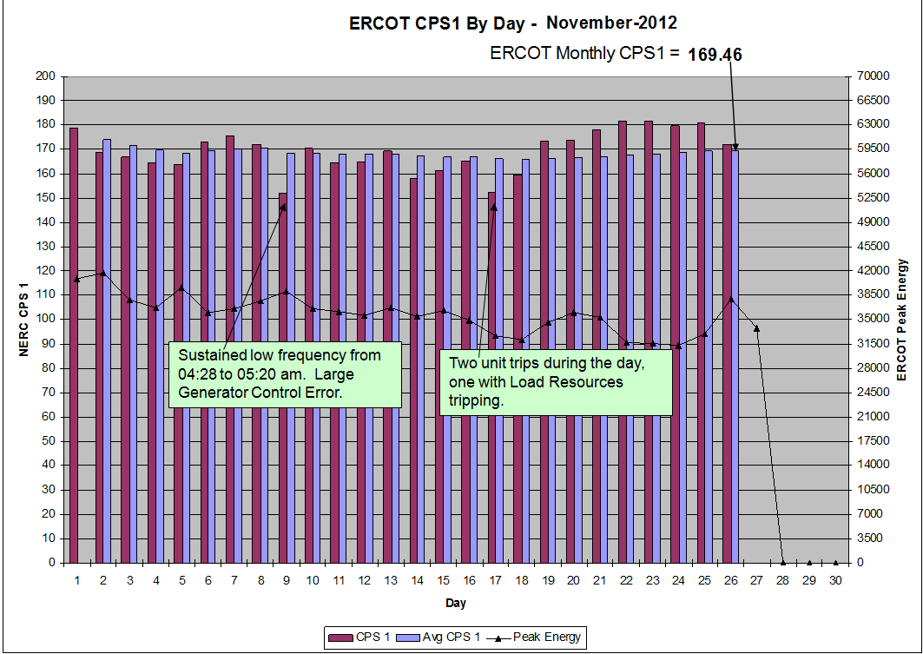

GREDP Identified Issues

- According to ERCOT, generators are to follow UDBP in real time and not the 5 minute base points. This was confirmed by everyone at the meeting. The GREDP calculation uses the 5 minute Base Points and calculates a straight line average between them to calculate Expected Generation. If a generator follows the UDBP in real time and a frequency deviation pauses the UDBP, the generator will get behind and not meet expectations. This is especially true when frequency returns to within limits and UDBP “jumps” to the ramped value instantly. This exceeds the ramp rates of all generators and the generator will not be able to catch up until the end of the next interval.
- When Wind Farms are curtailed to zero MW, the Percent GREDP calculation fails with a divide by zero. This results in the wind farm getting critiqued on only the “actual MW must be less than expected MW” to pass the interval. ERCOT added a one MW dead-band around the target to allow for some minor over-generation. This means the wind farm must be less than 1 MW for the wind farm to pass the interval. This one MW tolerance is entirely too tight and unjustified.
- The GREDP % tolerance is calculated on the average of the 5 Minute Base Points. This is not fair to small generators or large generators with large operating ranges. The percent error should be calculated on a fixed capacity value that is appropriate for the size of the generator. It just doesn’t make sense that a 600 MW generator will be able to control tighter at minimum loads than it does at higher loads.
- QSE cannot measure performance daily with accuracy due to the frequency excursion exclusion. For wind farms this can be significant if a few of the intervals, where performance is good, are eliminated from the average.
- If the Wind generator’s output increases after a SCED run during a non-curtailed interval and the next interval gets curtailed, the Wind Generator’s output can be much higher than the starting point of the previous Base Point and UDBP. The wind generator will start out over generating and not be able to catch up to the UDBP if the MW change is significant. The “performance” UDBP or “Target” used to measure compliance should start from the actual MW output of the Wind Generator instead of the last Base Point value.

Generators that provide Regulation Service will receive deployments that exceed the ramp rate of the service. This is good for the Interconnection but it can cause the generator to fail intervals.

