 |  |  |  | System Planning
Monthly Status Report
October 2012

 |  | Report Highlights
 | - ERCOT is currently tracking 143 active generation interconnection requests totaling over 40,000 MW. This includes almost 21,000 MW of wind generation.
- ERCOT is currently reviewing proposed transmission improvements with a total cost of $228.9 Million
- Transmission Projects endorsed in 2012 total $596.8 Million
- All projects (in engineering, routing, licensing and construction) total approximately $9.68 Billion.
- Transmission Projects energized in 2012 total about $732.2 million.

Table of Contents
1. Generation Interconnection 1
1.1 Signed Generation Interconnection Agreements 1
1.2 New Generation Registering for Commercial Operations 1
1.3 Summary of Generation Interconnection Requests 1
1.4 Projects with Interconnection Agreements 4
1.5 Generation Projects Undergoing Full Interconnection Studies with Confidentiality Waived by Developer 4
1.6 Generation Projects Undergoing Full Interconnection Studies 5
1.7 Wind Generation Capacity Installed by Year 6
2. Regional Planning Group Project Reviews 7
3. Congestion Costs 8
4. Wind Generation as a Percent of Load 11
5. Planning Model Activities 12
6. Other Notable Activities 13

1. Generation Interconnection
Additional information regarding detailed generation interconnection and impact studies is contained in the “Generation Project Interconnection Information” folder in the “Operations and System Planning” area on the ERCOT website: http://planning.ercot.com/login/login.

Signed Generation Interconnection Agreements
08INR0049 – Bobcat Bluff – 113 MW of Wind in Clay County

New Generation Registering for Commercial Operations - none

The total installed wind capacity is now reported as 10,035 MW by the resource owners through the registration process. Capacity by North, South and West is 519 MW, 2,283 MW, and 7,233 MW respectively. 850 MW is able to switch between the West and South zones and is currently shown in the South zone.

Summary of Generation Interconnection Requests
GENERATION INTERCONNECTION REQUESTS CURRENTLY UNDER REVIEW
Currently tracking 154 generation interconnection or change requests
As of October 31, 2012 |  |  |  | Total
Security Screening Study | 9
SSS Completed | 18
Full Interconnect Study | 75
FIS Completed | 14
Suspended Studies | 11
Capacity of Suspended Study Projects | 7,862
Interconnect Agreement Completed | 27
Capacity under Interconnection Agreements | 11,146
Capacity for Grid, MW | 40,032
Wind Capacity, MW | 20,941

Fuel Type | Confidential Projects (MW) | Projects Under Full Study (MW) | Public Projects (MW) | Suspended Studies (MW) | Grand Total (MW)
Gas-AllOther |  |  |  |  | 2,693
Gas-CombinedCycle |  |  | 5,686 |  | 11,606
Total Gas | 5,402 | 3,211 | 5,686 |  | 14,299
Nuclear |  |  |  | 3,200 | 3,200
Coal |  | 850 | 1,165 |  | 2,015
Wind | 3,263 | 14,800 | 2,879 | 4,623 | 25,565
Solar | 664 | 657 | 60 | 38 | 1,419
Biomass
Storage |  | 40 | 36 |  | 76
Petroleum Coke |  |  | 1,320 |  | 1,320
Grand Total | 9,329 | 19,558 | 11,146 | 7,862 | 47,894

County Location of Installed Generation and Interconnection Requests (all fuels)

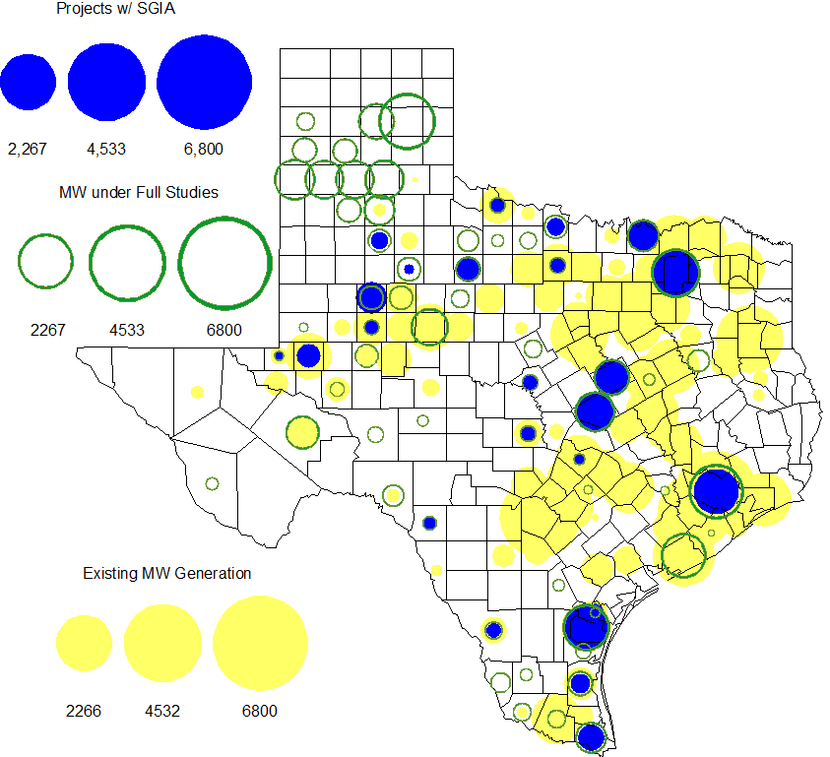

Projects with Interconnection Agreements

Generation Interconnections as of October 31, 2012
INR | Site Name | County | COD | Fuel | MW For Grid | Change from Last Report
12INR0076 | Notrees Battery Storage | Winkler | Nov-12 | Storage | 36 | Date
12INR0075 | Blue Summit Windfarm | Wilbarger | Nov-12 | Wind | 135
08INR0011 | Senate Wind Project | Jack | Dec-12 | Wind | 150
11INR0091 | Whitetail Wind Energy Project | Webb | Dec-12 | Wind | 92
12INR0072 | Anacacho Windfarm | Kinney | Dec-12 | Wind | 100
09INR0061 | WKN Mozart | Kent | Dec-12 | Wind | 30
11INR0033 | Los Vientos | Cameron | Dec-12 | Wind | 400
08INR0049 | Bobcat Bluff (Briar Creek) | Clay | Dec-12 | Wind | 163 | Capacity
09INR0001 | Sandy Creek 1 | McLennan | Apr-13 | Coal | 925 | Date
11INR0086 | RRE Austin Solar | Travis | Oct-13 | Solar | 60
06INR0022c | Penascal Wind Farm 3 | Kenedy | Dec-13 | Wind | 202
11INR0013 | Goldthwaite Wind Energy | Mills | Dec-13 | Wind | 150
11INR0054 | Midway Farms Wind | San Patricio | Dec-13 | Wind | 161
12INR0034 | Stephens-Borlynn Wind Project | Borden | Dec-13 | Wind | 378
13INR0021 | Ferguson Replacement Project | Llano | Jul-14 | Gas-CC | 116
10INR0021 | Panda Sherman Power | Grayson | Aug-14 | Gas-CC | 809 | Date,Capacity
10INR0020a | Panda Temple Power | Bell | Aug-14 | Gas-CC | 809 | Date,Capacity
11INR0050 | Moore Wind 1 | Crosby | Aug-14 | Wind | 149
10INR0023 | Baker Ranch | Haskell | Sep-14 | Wind | 400
09INR0051 | Mesquite Creek | Borden | Mar-15 | Wind | 249
06INR0006 | Cobisa-Greenville | Hunt | May-15 | Gas-CC | 1,792
08INR0018 | Gunsight Mountain | Howard | Aug-15 | Wind | 120 | Date
13INR0023 | Texas Clean Energy Project | Ector | Jan-16 | Coal | 240
10INR0020b | Panda Temple Power | Bell | May-16 | Gas-CC | 780 | Date
10INR0022 | Pondera King Power Project | Harris | Jun-16 | Gas-CC | 1,380
12INR0016a | Las Brisas Energy Center | Nueces | May-18 | PetCoke | 660 | Capacity
12INR0016b | Las Brisas Energy Center | Nueces | May-18 | PetCoke | 660 | Capacity

Generation Projects Undergoing Full Interconnection Studies with Confidentiality Waived by Developer

None

Generation Projects Undergoing Full Interconnection Studies
INR | County | Grid | COD | Fuel |  | INR | County | Grid | COD | Fuel
11INR0093 | San Patricio | 41 | Dec-12 | Wind |  | 13INR0040 | Harris | 0 | Jan-13 | Gas
13INR0054 | Bexar | 0 | Jan-13 | Gas |  | 13INR0010a | Parmer | 200 | Jan-13 | Wind
13INR0045 | Castro | 288 | Apr-13 | Wind |  | 11INR0094 | Kent | 100 | Apr-13 | Solar
12INR0070 | Knox | 300 | Apr-13 | Wind |  | 12INR0086 | Fort Bend | 89 | May-13 | Gas
10INR0089 | Harris | 40 | May-13 | Storage |  | 13INR0020a | Glasscock | 200 | May-13 | Wind
13INR0058 | Bexar | 50 | May-13 | Solar |  | 12INR0045 | Kleberg | 135 | Jun-13 | Wind
13INR0032 | Andrews | 30 | Jun-13 | Solar |  | 13INR0057 | Archer | 65 | Jun-13 | Wind
13INR0049 | Harris | 352 | Jul-13 | Gas |  | 13INR0025 | Randall | 150 | Sep-13 | Wind
13INR0046 | Limestone | 71 | Sep-13 | Wind |  | 13INR0005 | Carson | 600 | Oct-13 | Wind
13INR0059 | Castro | 499 | Oct-13 | Wind |  | 12INR0071 | Caldwell | 30 | Nov-13 | Wind
13INR0028 | Hale | 392 | Nov-13 | Gas |  | 14INR0030a1 | Carson | 322 | Nov-13 | Wind
14INR0030a2 | Carson | 322 | Nov-13 | Wind |  | 12INR0002a | Briscoe | 200 | Dec-13 | Wind
10INR0009 | Castro | 300 | Dec-13 | Wind |  | 11INR0062 | Nueces | 178 | Dec-13 | Wind
11INR0085 | Nolan | 106 | Dec-13 | Wind |  | 12INR0054 | Jones | 200 | Dec-13 | Wind
12INR0059 | Pecos | 50 | Dec-13 | Solar |  | 13INR0007 | Pecos | 200 | Dec-13 | Wind
13INR0026 | Oldham | 201 | Dec-13 | Wind |  | 13INR0036 | Hidalgo | 200 | Dec-13 | Wind
13INR0038 | Swisher | 300 | Dec-13 | Wind |  | 13INR0050 | Comanche | 200 | Dec-13 | Wind
13INR0052 | Starr | 200 | Dec-13 | Wind |  | 13INR0055 | Zapata | 250 | Dec-13 | Wind
13INR0056 | Scurry | 366 | Dec-13 | Wind |  | 12INR0079 | Kenedy | 200 | Dec-13 | Wind
11INR0057 | Cameron | 165 | Dec-13 | Wind |  | 12INR0068 | Jim Hogg | 80 | Dec-13 | Wind
12INR0088 | Crosby | 201 | Dec-13 | Wind |  | 13INR0048 | Oldham | 161 | Dec-13 | Wind
14INR0024 | Kinney | 42 | Dec-13 | Solar |  | 12INR0055 | Baylor | 40 | Jan-14 | Wind
12INR0084 | Randall | 242 | Jan-14 | Wind |  | 13INR0006 | Gray | 750 | Jan-14 | Wind
14INR0013 | Cameron | 103 | Jan-14 | Wind |  | 14INR0014 | Val Verde | 100 | Jan-14 | Solar
13INR0010b | Parmer | 500 | Jan-14 | Wind |  | 12INR0060 | Schleicher | 58 | Apr-14 | Wind
13INR0020b | Glasscock | 150 | May-14 | Wind |  | 14INR0027 | Guadalupe | 471 | May-14 | Gas
14INR0015 | Harris | 192 | Jun-14 | Gas |  | 14INR0016 | Harris | 190 | Jun-14 | Gas
08INR0019a | Gray | 250 | Jun-14 | Wind |  | 08INR0019b | Gray | 250 | Jun-14 | Wind
08INR0019c | Gray | 250 | Jun-14 | Wind |  | 14INR0011 | Swisher | 270 | Jun-14 | Gas
14INR0012 | Gray | 401 | Jun-14 | Wind |  | 14INR0031 | Harris | 0 | Jun-14 | Gas
12INR0085 | Stonewall | 24 | Jul-14 | Wind |  | 14INR0025 | Floyd | 500 | Jul-14 | Wind
12INR0042a | Deaf Smith | 265 | Sep-14 | Wind |  | 12INR0042b | Deaf Smith | 135 | Sep-14 | Wind
09INR0034 | Coryell | 200 | Oct-14 | Wind |  | 11INR0065 | Nueces | 350 | Oct-14 | Wind
13INR0031 | Austin | 30 | Oct-14 | Solar |  | 10INR0085 | Ector | 40 | Dec-14 | Solar
12INR0002b | Briscoe | 200 | Dec-14 | Wind |  | 11INR0081 | Live Oak | 72 | Dec-14 | Wind
11INR0082A | Val Verde | 50 | Dec-14 | Wind |  | 11INR0082B | Val Verde | 150 | Dec-14 | Wind
14INR0009 | Kent | 248 | Dec-14 | Wind |  | 14INR0020 | Floyd | 150 | Dec-14 | Wind
14INR0023 | Briscoe | 361 | Dec-14 | Wind |  | 11INR0079a | Clay | 200 | Dec-14 | Wind
08INR0031 | Childress | 120 | Dec-14 | Wind |  | 12INR0029 | Swisher | 500 | Dec-14 | Wind
13INR0010c | Parmer | 500 | Jan-15 | Wind |  | 12INR0057 | Ector | 40 | Apr-15 | Solar
15INR0013 | Anderson | 324 | Oct-15 | Gas |  | 15INR0014 | Matagorda | 280 | Oct-15 | Gas
12INR0002c | Briscoe | 350 | Dec-15 | Wind |  | 14INR0018 | Nolan | 35 | Dec-15 | Solar
15INR0015 | Pecos | 140 | Dec-15 | Solar |  | 12INR0018 | Gray | 500 | Dec-15 | Wind
16INR0003 | Brazoria | 11 | Jun-16 | Gas |  | 11INR0040 | freestone | 640 | Mar-18 | Gas
14INR0003 | Nolan | 850 | Jun-18 | Coal
Note: Projects that are classified as “Cancelled” or “Suspended” are excluded from this table.

Wind Generation Capacity Installed by Year
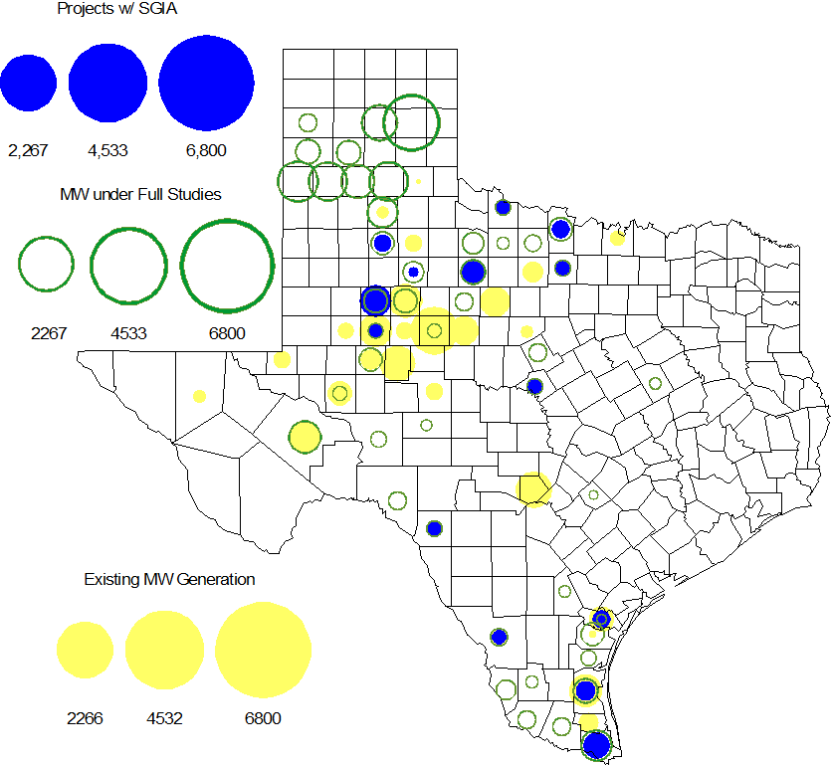

Regional Planning Group Project Reviews

- AEPSC has submitted the Airline/North Padre Island Area Improvements project. This project is submitted as a revision to the Barney Davis to Laguna 138 kV line (AEPSC Corpus Christi Improvements Project ) that was endorsed by ERCOT in November 2009. This is a Tier 1 project that is estimated to cost approximately $58.1 million. This project is currently under ERCOT independent review.

- CPS Energy has submitted the TCC Transmission project to support load growth on the west side of San Antonio. The project is Tier 2 project estimated to cost $10.9 million. This project is currently under ERCOT independent review.

- Sharyland has submitted the Atlas-Driver Load Integration project, this is a Tier 2 project that is estimated to cost approximately $15.4 million. This project is currently under ERCOT independent review.

- American Electric Power Service Corporation (AEPSC) has submitted the Sinton-Beeville-Kenedy Area Improvements project to accommodate load additions due to Eagle Ford Shale development in South Texas. This is a Tier 1 project that is estimated to cost $89.2 million. This project is currently under ERCOT independent review.

- South Texas Electric Cooperative (STEC) has submitted the Coy City Load Addition project to accommodate load additions due to Eagle Ford Shale development in South Texas. This is a Tier 3 project that is estimated to cost $11.65 million. This project has completed the RPG review and ERCOT has sent the RPG acceptance letter.

- CenterPoint Energy has submitted the Fort Bend Area Upgrades project. This is a Tier 3 project that is estimated to cost approximately $16.9 million. This project has completed the RPG review and ERCOT has sent the RPG acceptance letter.

- Texas Municipal Power Agency (TMPA) has submitted the Gibbons Creek Transformer Replacement & Reactor Re-location project. This is a Tier 3 project that is estimated to cost approximately $17.3 million. This project has completed the RPG review and ERCOT has sent the RPG acceptance letter.

- LCRA TSC, Guadalupe Valley Electric Cooperative (GVEC), American Electric Power (AEP), and South Texas Electric Cooperative (STEC) have jointly submitted the Kenedy Switch to Nixon to Seguin Line Upgrade. This is a Tier 1 project that is estimated to cost approximately $55.3 million. This project is currently under ERCOT independent review.

Congestion Costs
Dollars shown in RUC Make Whole payment graph are of settlement quality.

RUC net Make Whole payment in $mm

Monthly Average LMP

Binding Constraints – Year to Date
Contingency | Binding Element | Number of 5-min intervals | Shadow Price Range $/MWh | Estimated Congestion Rent $ (Shadow Price*Limit) | Transmission Project
Amoco North Cowden Tap - Moss 138kV | Odessa North 138/69 kV Autotransformer | 16929 | 0 - 2800 | 134,066,150 | 5YTP [2010-R7, R8]  12TPIT0214, 13TPIT0136
Quail Switch - Odessa EHV 345 kV & Longshore Switch - Odessa EHV 345 kV; Golden Switch - Sun Switch 138 kV; Falcon Seaboard - Midland East 345 kV; etc. | China Grove - Bluff Creek 138 kV | 2650 | 0 - 3500 | 61,898,847 | 13TPIT0098, 13TPIT0093
BASE CASE | West to North Stability Limit | 8408 | 0 - 436 | 27,824,327 | CREZ
Batesville Switching Station - Paloduro Substation 138 kV; Batesville 138/69 kV Autotransformer; West Batesville - Uvalde 138 kV; etc | Moore Switching Station - Downie Switching Station 138 kV | 1971 | 0 - 3500 | 20,422,574 | 08TPIT0018
Midland East - Odessa EHV 345 kV; or Moss Switch 345/138 kV Autotransformer | Odessa - Odessa North 138 kV | 609 | 0 - 3500 | 18,830,852 | 14TPIT0054
Twin Buttes 345/138 kV Autotransformer | San Angelo Red Creek 345/138 kV Autotransformer 2 | 113 low-side; and 262 high-side | 19 - 3500 low-side; and 2 - 4500 high-side | 18,360,051 | 14TPIT0067
Kyle - San Marcos 138 kV; or Lytton Spring - Zorn 345 kV & Austrop - Zorn 345 kV | Turnersville - Buda 138 kV | 568 | 0 - 3500 | 17,352,442 | 09TPIT0060
Lewisville Switch - Carrollton Northwest 345 kV; or Lewisville Switch - Carrollton Northwest 345 kV double-circuit | Lewisville Switch - Jones Street TNP 138 kV | 4666 | 0 - 3500 | 17,099,428 | 12TPIT0209, 12TPIT0210
Morgan Creek SES 345/138 kV Autotransformer 1 | Morgan Creek SES 345/138 kV Autotransformer 4 high-side | 150 | 3 - 4500 | 14,673,592
Salado- Killeen 345 kV double-circuit | Belton - Belton Southwest 138 kV | 258 | 0 - 3500 | 14,490,150
Binding Constraints – Oct 2012
Contingency | Binding Element | Number of 5-min intervals | Shadow Price Range $/MWh | Estimated Congestion Rent $ (Shadow Price*Limit) | Transmission Project | Comments
Golden Switch - Sun Switch 138 kV; or Morgan Creek SES - Sun Switch 138 kV | China Grove - Bluff Creek 138 kV | 1059 | 0 - 3500 | 30,319,996 | 13TPIT0098, 13TPIT0093 | 345 kV Circuit Breaker outages at Quail Switch; 138 kV line outages of Snyder to Sacroc, Aspermont to Paint Creek, and Sun Switch to Sacroc
Morgan Creek SES 345/138 kV Autotransformer 1 | Morgan Creek SES 345/138 kV Autotransformer 4 high-side | 150 | 3 - 4500 | 14,673,592 |  | 138 kV Bus outage at Morgan Creek SES; Morgan Creek SES 345/138 kV Autotransformer 2 outage
Salado- Killeen 345 kV double-circuit | Belton - Belton Southwest 138 kV | 225 | 4 - 3500 | 14,467,241 |  | 138 kV line outages of Killeen Switch to Killeen Elm, Killeen Elm to Killeen Taft Street, and Killeen Elm to Killeen Taft Street
Falcon Seaboard - Morgan Creek SES 345 kV; or Morgan Creek SES - Longshore 345 kV & Morgan Creek SES - Quail Switch 345 kV | Midland West - Windwood 138 kV | 643 | 5 - 3500 | 4,953,444 | 14TPIT0011 | 345 kV Circuit Breaker outages at Quail Switch; 138 kV line outages of Snyder to Sacroc, Aspermont to Paint Creek, and Sun Switch to Sacroc
Falcon Seaboard - Midland East 345 kV; Morgan Creek 345/138 kV Autotransformer 4; or Quail Switch - Longshore Switch | Morgan Creek SES 345/138 kV Autotransformer 1 | 266 high-side; 20 low-side | 2-4500 high-side; 51-3500 low-side | 2,570,457 |  | 345 kV Circuit Breaker outages at Quail Switch; 138 kV line outages of Snyder to Sacroc, Aspermont to Paint Creek, and Sun Switch to Sacroc
Leon Switch - Cisco - Putnam 138 kV | Leon Switch - Putnam 138 kV | 557 | 0 - 1466 | 1,716,533 |  | High west wind
Ennis Creek Switch - Brand 138 kV; or Morgan Creek SES - China Grove 138 kV double-circuit | Morgan Creek SES - Sun Switch 138 kV | 492 | 0 - 3500 | 1,535,014 |  | 345 kV Circuit Breaker outages at Quail Switch; 138 kV line outages of Snyder to Sacroc, Aspermont to Paint Creek, and Sun Switch to Sacroc
Contingency | Binding Element | Number of 5-min intervals | Shadow Price Range $/MWh | Estimated Congestion Rent $ (Shadow Price*Limit) | Transmission Project | Comments
Greens Bayou 345/138 kV Autotransformer A1; Greens Bayou - King 345 kV double-circuit; Northbelt - King 345 kV & Northbelt - Cedar Bayou 345 kV; or base case | Greens Bayou 345/138 kV Autotransformer A2 | 351 | 0 - 5000 | 1,292,813 | 13TPIT0102 | Greens Bayou 345/138 kV Autotransformer A1 outage
South Channel - Shell 138 kV & Esbelt - Pair 138 kV | Conial - Waburn 138 kV | 520 | 0 - 3500 | 1,178,918 |  | Multiple line outages
Meadow - PH Robinson 345 kV | Hastings - Friendswood 138 kV | 179 | 2 - 3500 | 1,133,766 | 15TPIT0015 | Alvin TNP to Freeway Park 138 kV line outage

Wind Generation as a Percent of Load
One-hour average of total wind power output as a percentage of ERCOT load.

Planning Model Activities
- Data Set B work began on August 1, 2012 with a Topology Processor case extracted from NMMS with a build date of January 1, 2013. Process is underway with creation of Pass 1 cases on Aug 31, 2012.
- The short term calendar of major planning model events follows:
  - Nov 16, 2012 Post Sept TPIT update to 12 DSA and 13 DSA cases.
  - Nov 30, 2012 Begin Contingency database update for 13 DSA and DSB cases.
  - Dec 19, 2012 Post Contingency database update for 13 DSA and DSB cases.
- Status update on SCR760, Changes Needed for Information Model Manager and Topology Processor for Planning Models, which was approved by the ERCOT Board in March 2011.
  - Bundle 1 (Items 3, 7 and 8): In Production.
  - Bundle 2 (Items 2a, 4, 9): In Production.
  - Bundle 3 (Item 5, 2b, 2c): In Production
  - Bundle 4 (Items 1, 6): Item 1 considered to be in production. The first draft of Requirements for Item 6 have been completed by ERCOT, reviewed by SSWG, and sent to vendor for review.
SCR Sub Part | SCR Description | Status
SCR760-1 | Upgrade to PSS/E v32 | Production
SCR760-2 | Distribution Capacitor banks | Production
SCR760-3 | Zero Impedance Line Ratings | Production
SCR760-4 | Associate Loads and Capacitor banks with the correct CNG | Production
SCR760-5 | Additional Transformer Data for Planning | Production
SCR760-6 | FACTS Devices | Planning
SCR760-7 | Assign valid PSSE IDs to Breakers/  Switches/ Series Devices | Production
SCR760-8 | Phase shift of Autos for short circuit studies | Production
SCR760-9 | Multisection Line Grouping | Production
Table 1: In the following table:
- Red will be used to show status of Not Submitted, meaning that the SCR sub part has not been submitted to Siemens as a Service Request.
- Yellow will indicate that the SCR sub part has been submitted. The color will remain yellow and the status will change in order to Submitted, Planning (Requirements, SOW, Code Writing), Release (Siemens produces first code to test), and Testing (code has completed internal test and is moving through release management).
- Green will indicate that the code has been tested and installed on the machines that ERCOT uses to produce Topology Processor output for Planning and CRR.

Other Notable Activities
- All of the n-1 reliability projects for the 2012 Five-Year Transmission Plan have been identified and the results posted at the ERCOT POI. The ERCOT 5YTP team is current working on the g-1 + n-1 screening studies and the start case for the economic analysis.

