DRAFT
Market Impacts
Hour Ahead Market
September 29, 2012

This document was prepared as a draft for further market participant and ERCOT input. This draft is based on discussions at prior METF meetings, written responses to ERCOT questions, and general information obtained through contacts with large consumers of electric power.

Introduction
The Brattle report to the PUCT identified demand response as a key missing element to meeting resource adequacy needs in Texas. A solution proposed by EDF Trading is the “Hour Ahead Market” which would provide consumers a vehicle for demand response, and another market for willing buyers and sellers to trade their market positions before Real-Time operations. The purpose of this white paper is to discuss the market impacts of implementing the “Hour Ahead Market” (HAM).

METF anticipates that this document will be presented to ERCOT and market stakeholders for written comments, enhancements and to build a general consensus around the implementation of such a market. On approval of this document by TAC and other appropriate subcommittees, protocol changes will be developed and approved through the stakeholder process prior to implementation by ERCOT.

Demand Response in HAM Explained
One purpose of HAM is to address challenges that exist for demand response in the current market design and the proposed “Look-Ahead SCED”. Those challenges include performance criteria for loads and price responsive behavior by loads in SCED when prices fall back. Stringent operating performance criteria will limit the number of loads willing to participate in “Look-Ahead SCED.” Additionally it is difficult for certain loads to come back online when prices have fallen to levels that may create a financial incentive for them to consume. Either way, there are risks that the dispatch of loads in “Look ahead SCED” could cause price reversals in Real-Time, which in the end negatively impacts generator revenues.

The fundamental premise is that market participants will act reasonably when faced with appropriate financial incentives. The HAM is a new market which will operate between the DAM and the RTM. In essence, the HAM turns the current market structure from a two settlement system to a three settlement system. All awards in the DAM would settle in the HAM and all awards in the HAM would settle in the RTM.There should be a way for a QSE to bid a PTP Obligation in the DAM to automatically create an Obligation in HAM so that CRRs effectively flow through from DAM to RT. However, the transmission system needs to be freed up in the HAM, so that there is convergence from DAM to HAM and HAM to Real Time. [Steel Companies suggest this needs more discussion]

In the original version of this idea, the HAM was to provide an energy only market without any kind of ancillary service co-optimization. This paper will address co-optimization and other associated issues later in this paper.

The deadline for all bids and offers in the HAM would be one hour before flow. Any Market Participant through its QSE could offer bids and offers into the HAM subject to credit requirements similar to those required in the DAM. For example, the HAM window would close at 9:00 for hour ending 11. At this point ERCOT would run the HAM and a notice to MPs would be provided approximately 30 minutes before the operating hour. Market Participants in the HAM would have the option to do one of the following:

- Take existing DAM awards to real time by placing price taker bids/offers
- Settle their DAM awards at the HAM prices
- Enter new offers or bids to optimize their current portfolio in response to changing fundamentals.

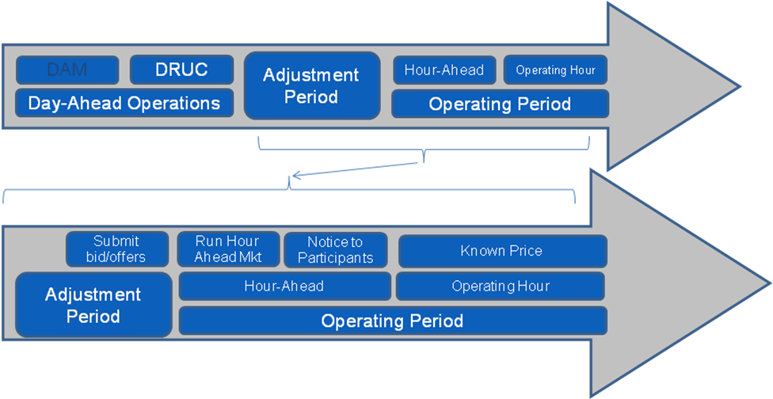

Value Proposition for Loads and Generators
The HAM provides a market solution for Demand Response and a new market opportunity for generators. Being a a purely financial market, willing buyers and willing sellers establish a clearing price for energy in the HAM.

Value Proposition for Loads
For load entities, the HAM provides price certainty, a notice period prior to a potential curtailment and no ERCOT enforced operating performance criteria. The HAM allows a load QSE to purchase or sell on behalf of an LSE for the next hour. If the LSE has a hedge in place that it wants to sell in the HAM, the load QSE would establish that transaction with ERCOT in the HAM and any subsequent settlement of the LSE’s metered consumption happens between the Load QSE and the LSE. Similarly, if an LSE is short in the real time and wants to buy at an “up to” price in the HAM, the load QSE would enter a bid in the HAM; if the LSE is awarded, it continues to consume, and if it is not awarded, then it should be prepared to curtail consumption in Real-Time.
Implicit within this mechanism is the performance criterion that exists between the LSE and the load QSE. There is a strong financial incentive for an LSE to curtail consumption in the real time, if they have sold their existing hedge in the HAM.
The HAM also provides a price signal for LSE’s that are not able to cover their Real- Time price exposure in the HAM. This is a price signal that is developed through the interaction of willing buyers and willing sellers and can give an LSE a price expectation for Real-Time and a notice period to be able to curtail consumption if necessary.

A system that requires stringent operating performance standards for demand response will not work to incentivize sufficient demand response in the ERCOT market. For such a demand response program to work, existing LSEs should be able to operate within the context of the current settlement and invoicing systems. Although the HAM turns the market from a two settlement system to a three settlement system, it does not fundamentally change the relationship between an LSE and a Load QSE. Accordingly, the HAM should attract significantly more demand response than what could be expected from any other program that requires stringent performance standards such as the “Look Ahead SCED”
A good way to understand how HAM works is to “Follow the money” through different scenarios that LSE’s would find themselves in when deciding to participate in the HAM.

Scenario 1 – LSE selling an existing Hedge
Figure 1 below shows the HAM transaction

Fig 1: HAM Transaction (Hedge Sale)
- In this scenario the LSE has a 10MW exposure and a 10MW hedge that the transacting QSE has sold to the LSE through the Load QSE. The Load QSE pays the transacting QSE $300 and receives 10MW for that hour.
- Now the LSE offers to sell 4MWs @ $1000 in the HAM. The Load QSE enters the transaction in the HAM.
- Let’s assume that the HAM clears $1200, which awards the load QSE $4800 for a 4MW sale.
- The Load QSE pays the LSE the difference of the sale in the HAM and purchase from the transacting QSE, which comes to $4500 and 6MWHs
- The LSE now transfers this cost to the end consumer, where it receives $300, and Pays $4800 for a net 6 MWH consumption.
- In Real Time if the price had been $3000, and if the LSE had consumed 7 MWs instead of 6 MWs, there would be a 1MW imbalance and the Load QSE would have paid the LSE $4800-$300-$3000 = $1500. This financial incentive creates implicit performance criteria between the Load QSE and LSE.

Figure 2 below shows the RT transaction
Fig 2: RT Transaction (Hedge Sale)

- Since the LSE has sold 4 MWs in the HAM, it consumes 4 MWs less in RT
- There is an existing hedge for 10MW and accordingly there is no imbalance and the LSE receives $4500 for the entire transaction.
Scenario 2 – LSE buys at an up to price
Fig 3: HAM Transaction (“Up To” Purchase)
- In this scenario the LSE has a 10MW exposure and is short in the Real Time
- LSE Bids to buy 10MWs in the HAM at $35
- Assuming that the HAM clears $30, LSE is awarded 10MWs at $30.

Fig 4: RT Transaction (“Up To” Purchase)
- Since there are no imbalances the LSE continues to consume.
In this scenario if the HAM had cleared $1,200 dollars, the LSE would not have been awarded the 10MWs and also gained a strong price signal to curtail consumption. This gives the LSE an expectation of real time price and notice period of curtailment.
There is a possibility that multiple LSE’s that are not awarded in the HAM due to high HAM prices would curtail consumption that will ultimately result in price reversal in real time. However we should expect such price instances to be self-correcting since market participants will shift their portfolios between the RT and HAM to maximize value.
Value Proposition for Generators
Similar to load entities, generators would have the option of rebalancing their supply portfolios based on changing fundamentals they may be projecting for Real -Time operations. For generators already committed and on in the Real-Time market, the HAM provides an opportunity for them to either sell any un-hedged MW production in the HAM, or buy back existing hedges. For quick start units, the HAM provides an avenue to sell their MWs into the HAM with advance notice for necessary resource start-ups. Similarily if a generating Entitiy’s portfolio is short due to a forced outage of one of its generators, the HAM provides opportunities for the Entity to refine its position prior to full exposure in Real-Time.

Value Proposition for the Market
The value proposition for the overall market is that more loads should be able to participate by selling demand response at higher prices. Since the only performance criteria is between the load QSE and the LSE, this mechanism should incentivize more LSEs to create demand response programs that work within the context of the HAM. Additionally since specific load forecasts or wind forecasts are not enforced in the HAM, any price reversal in Real -Time should be ultimately self-correcting. Furthermore, ERCOT can examine the awards in the HAM and use the result to assist in making a determination of the likelihood of loads reducing demand prior to Real-Time. This will provide ERCOT a basis for modifying its load expectations for the next hour and provide direct input to Short Term Load Forecasting.

Price Reversal Issues
There exists a potential for price reversal. When multiple LSEs are not awarded their “up to” price, it is possible that they could choose to curtail consumption that could potentially lead to a price reversal in the Real-Time market. However, this potential for price reversal in Real-Time is minimized since generators that are currently seeing lower prices in the Real-Time can opt to sell in the HAM. On the other hand, generators that are consistently seeing lower prices in the HAM would opt to buy back their hedges in the HAM to have merchant MWs in Real-Time. This self-correcting nature or convergence between the HAM and RT should result in minimal price reversal in the RT.

Co-Optimization of Energy and Ancillary Services in HAM
An initial version of this idea was to provide ERCOT with an additional band of ancillary service reserves that they could choose to procure in the HAM. These reserves would be of set capacity, and would be procured by ERCOT at their discretion, especially during times, where ERCOT expected higher than anticipated loads. These new band of ancillary services would be co optimized with energy in the HAM and generators already online or expected to be online could sell these additional services to ERCOT.

This additional band of reserves was meant to achieve two specific goals.
- It allows ERCOT the opportunity to procure additional operating reserves at a time they need it the most. This could be particularly important if there has been a large unit outage and ERCOT feels that it might need more reserves than it originally anticipated.
- The co-optimization of these resources could create stronger energy prices in the HAM that would provide a signal to LSE’s to curtail consumption, especially during strong load periods.

Challenges with Co-Optimization
A new idea that has been proposed is that the ancillary services procured in the DAM settle in the HAM and that those same ancillary services be acquired in the HAM, through the co-optimization engine.

There are several issues that occur with either of the two proposals that include any kind of ancillary service co-optimization
- The HAM does not allow generation owners that have already sold ancillary services in the DAM to be able to change their energy offer curves if they have not been awarded any Ancillary services in the HAM. The lock out period for generator COPs would have to be changed to allow generators to change their energy offer curves if they do not maintain their DAM ancillary service awards (need a better explanation of this effect)
- At the same time a generator that has been awarded ancillary services in the HAM may not be able to change its energy offer curves in accordance with the ancillary service they sold in the HAM. Again the lock out period will have to be changed to fix this issue
- The re-acquisition of ancillary services may not create any additional value during times of system scarcity if that time is before HAM has an opportunity to run. When loads are rapidly increasing, generators that have already been awarded ancillary services would be looking to get out of their obligations, because of an expectation of energy scarcity. Similarly existing generators that do not have awards, would be unwilling to provide ancillary services, at a time that they expect scarcity without significant price changes
- The current SASM already allows for an avenue to re-acquire ancillary services when a generator with an existing DAM award can no longer provide the service.
- The ERCOT proposal of dividing the hour into four quarters and then performing a buy back and resell of Ancillary Services has a flaw that the HAM overcomes. The value of Ancillary Services averaged over an hour is different than each quarter of an hour’s value. In other words, the value of Ancillary Services during the last quarter of an hour may be significantly different than the value in the first quarter when considering the lost opportunity cost to a generator. Lost opportunities from one quarter hour to the next while is load increasing hours can be significantly different in value to a generator.

