 |  |  |  | System Planning
Monthly Status Report
September 2012

 |  | Report Highlights
 | - ERCOT is currently tracking 143 active generation interconnection requests totaling almost 39,000 MW. This includes over 21,000 MW of wind generation.
- ERCOT is currently reviewing proposed transmission improvements with a total cost of $257.5 Million
- Transmission Projects endorsed in 2012 total $550.9 Million
- All projects (in engineering, routing, licensing and construction) total approximately $9.68 Billion.
- Transmission Projects energized in 2012 total about $732.2 million.

Table of Contents
1. Generation Interconnection 1
1.1 Signed Generation Interconnection Agreements 1
1.2 New Generation Registering for Commercial Operations 1
1.3 Summary of Generation Interconnection Requests 1
1.4 Projects with Interconnection Agreements 4
1.5 Generation Projects Undergoing Full Interconnection Studies with Confidentiality Waived by Developer 4
1.6 Generation Projects Undergoing Full Interconnection Studies 5
1.7 Wind Generation Capacity Installed by Year 6
2. Regional Planning Group Project Reviews 7
3. Congestion Costs 8
4. Wind Generation as a Percent of Load 11
5. Planning Model Activities 12
6. Other Notable Activities 13

1. Generation Interconnection
Additional information regarding detailed generation interconnection and impact studies is contained in the “Generation Project Interconnection Information” folder in the “Operations and System Planning” area on the ERCOT website: http://planning.ercot.com/login/login.

Signed Generation Interconnection Agreements
11INR0054 – Midway Farms – 161 MW of Wind in San Patricio County
09INR0051 – Mesquite Creek – 249 MW of Wind in Borden County
13INR0023 – Texas Clean Energy – 240 MW of Coal IGCC in Ector County

New Generation Registering for Commercial Operations - none

The total installed wind capacity is now reported as 10,035 MW by the resource owners through the registration process. Capacity by North, South and West is 519 MW, 2,283 MW, and 7,233 MW respectively. 850 MW is able to switch between the West and South zones and is currently shown in the South zone.

Summary of Generation Interconnection Requests
GENERATION INTERCONNECTION REQUESTS CURRENTLY UNDER REVIEW
Currently tracking 159 generation interconnection or change requests
As of September 30, 2012 | North | South | West | Total
Security Screening Study | 4 | 4 | 1 | 9
SSS Completed | 1 | 9 | 8 | 18
Full Interconnect Study | 10 | 21 | 46 | 77
FIS Completed | 1 | 5 | 6 | 12
Suspended Studies | 2 | 1 | 13 | 16
Capacity of Suspended Study Projects | 3,450 | 249 | 6,701 | 10,401
Interconnect Agreement Completed | 9 | 9 | 9 | 27
Capacity under Interconnection Agreements | 5,490 | 3,635 | 1,737 | 10,862
Capacity for Grid, MW | 11,896 | 10,801 | 15,853 | 38,549
Wind Capacity, MW | 3,643 | 4,216 | 13,448 | 21,306

Fuel Type | Confidential Projects (MW) | Projects Under Full Study (MW) | Public Projects (MW) | Suspended Studies (MW) | Grand Total (MW)
Gas-AllOther |  |  |  |  | 2,303
Gas-CombinedCycle |  |  | 5,595 |  | 10,730
Total Gas | 4,227 | 3,211 | 5,595 |  | 13,033
Nuclear |  |  |  | 3,200 | 3,200
Coal |  | 850 | 1,165 |  | 2,015
Wind | 4,196 | 14,345 | 2,766 | 7,162 | 28,469
Solar | 204 | 615 | 60 | 38 | 917
Biomass
Storage |  | 40 | 36 |  | 76
Petroleum Coke |  |  | 1,240 |  | 1,240
Grand Total | 8,627 | 19,061 | 10,862 | 10,400 | 48,950

County Location of Installed Generation and Interconnection Requests (all fuels)

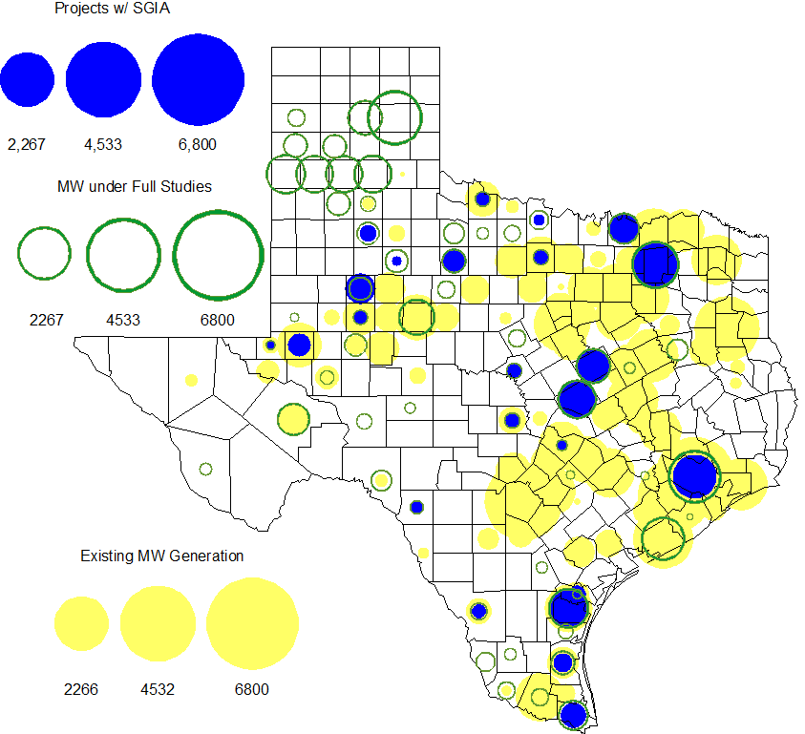

Projects with Interconnection Agreements
(Status: IA=Interconnect Agreement, XX= cancelled)
Generation Interconnections as of September 30, 2012
INR | SiteName | Status | County | Region | COD | Fuel Type |  | MW For Grid |  | Change from Last Report
12INR0076 | Notrees Battery Storage | IA | Winkler | West | Dec-12 |  | Storage |  | 36
12INR0075 | Blue Summit Windfarm | IA | Wilbarger | West | Dec-12 |  | Wind |  | 135
08INR0011 | Senate Wind Project | IA | Jack | North | Dec-12 |  | Wind |  | 150
11INR0091 | Whitetail Wind Energy Project | IA | Webb | South | Dec-12 |  | Wind |  | 92
12INR0072 | Anacacho Windfarm | IA | Kinney | South | Dec-12 |  | Wind |  | 100
09INR0061 | WKN Mozart | IA | Kent | West | Dec-12 |  | Wind |  | 30
08INR0049 | Briar Creek | IA | Clay | North | Dec-12 |  | Wind |  | 50
11INR0033 | Los Vientos | IA | Cameron | South | Dec-12 |  | Wind |  | 400
09INR0001 | Sandy Creek 1 | IA | McLennan | North | Mar-13 |  | Coal |  | 925
11INR0086 | RRE Austin Solar | IA | Travis | South | Oct-13 |  | Solar |  | 60
11INR0013 | Goldthwaite Wind Energy | IA | Mills | North | Dec-13 |  | Wind |  | 150
11INR0054 | Midway Farms Wind | IA | San Patricio | South | Dec-13 |  | Wind |  | 161 | New
06INR0022c | Penascal Wind Farm 3 | IA | Kenedy | South | Dec-13 |  | Wind |  | 202
12INR0034 | Stephens-Borlynn Wind Project | IA | Borden | West | Dec-13 |  | Wind |  | 378
13INR0021 | Ferguson Replacement Project | IA | Llano | North | Jul-14 |  | Gas-CC |  | 116
08INR0018 | Gunsight Mountain | IA | Howard | West | Aug-14 |  | Wind |  | 120
11INR0050 | Moore Wind 1 | IA | Crosby | West | Aug-14 |  | Wind |  | 149
10INR0023 | Baker Ranch | IA | Haskell | West | Sep-14 |  | Wind |  | 400 | Date
10INR0021 | Panda Sherman Power | IA | Grayson | North | Dec-14 |  | Gas-CC |  | 717 | Date
10INR0020a | Panda Temple 1 Power | IA | Bell | North | Dec-14 |  | Gas-CC |  | 780 | Date
09INR0051 | Mesquite Creek | IA | Borden | West | Mar-15 |  | Wind |  | 249 | New
06INR0006 | Cobisa-Greenville | IA | Hunt | North | May-15 |  | Gas-CC |  | 1,792
10INR0020b | Panda Temple 2 Power | IA | Bell | North | Dec-15 |  | Gas-CC |  | 780
13INR0023 | Texas Clean Energy Project | IA | Ector | West | Jan-16 |  | Coal |  | 240 | New
10INR0022 | Pondera King Power Project | IA | Harris | South | Jun-16 |  | Gas-CC |  | 1,380
12INR0016a | Las Brisas Energy Center | IA | Nueces | South | May-18 |  | PetCoke |  | 620
12INR0016b | Las Brisas Energy Center | IA | Nueces | South | May-18 |  | PetCoke |  | 620
 |  |  |  |  |  |  | TOTAL |  | 10,862
Note: Projects that do not have an interconnection agreement but have been publicly disclosed via a Public Letter to ERCOT and were previously reported on this table have been moved to section 1.5 unless Suspended or Cancelled

Generation Projects Undergoing Full Interconnection Studies with Confidentiality Waived by Developer
INR | SiteName | Status | County | Region | COD | Fuel | MW For Grid | Change from Last Report
14INR0005 | White Stallion Energy Center | XX | Matagorda | South | Jul-14 | Coal | 1,200 | Cancelled

Generation Projects Undergoing Full Interconnection Studies
INR | County | Grid | COD | Fuel |  | INR | County | Grid | COD | Fuel
12INR0079 | Kenedy | 200 | Oct-12 | Wind |  | 12INR0089 | Pecos | 230 | Nov-12 | Wind
11INR0093 | San Patricio | 41 | Dec-12 | Wind |  | 12INR0055 | Baylor | 80 | Dec-12 | Wind
12INR0060 | Schleicher | 58 | Dec-12 | Wind |  | 13INR0054 | Bexar |  | Jan-13 | Gas
13INR0040 | Harris |  | Jan-13 | Gas |  | 13INR0010a | Parmer | 200 | Jan-13 | Wind
11INR0082B | Val Verde | 150 | Mar-13 | Wind |  | 11INR0083B | Crockett | 100 | Mar-13 | Wind
13INR0045 | Castro | 288 | Apr-13 | Wind |  | 12INR0070 | Knox | 300 | Apr-13 | Wind
11INR0094 | Kent | 100 | Apr-13 | Solar |  | 10INR0089 | Harris | 40 | May-13 | Storage
12INR0086 | Fort Bend | 89 | May-13 | Gas |  | 13INR0058 | Bexar | 50 | May-13 | Solar
13INR0020a | Glasscock | 200 | May-13 | Wind |  | 12INR0045 | Kleberg | 135 | Jun-13 | Wind
13INR0032 | Andrews | 30 | Jun-13 | Solar |  | 13INR0057 | Archer | 65 | Jun-13 | Wind
13INR0049 | Harris | 352 | Jul-13 | Gas |  | 13INR0046 | Limestone | 71 | Sep-13 | Wind
11INR0082A | Val Verde | 50 | Sep-13 | Wind |  | 11INR0083A | Crockett | 50 | Sep-13 | Wind
13INR0025 | Randall | 150 | Sep-13 | Wind |  | 13INR0005 | Carson | 600 | Oct-13 | Wind
13INR0028 | Hale | 392 | Nov-13 | Gas |  | 14INR0030a1 | Carson | 322 | Nov-13 | Wind
14INR0030a2 | Carson | 322 | Nov-13 | Wind |  | 12INR0071 | Caldwell | 30 | Nov-13 | Wind
13INR0038 | Swisher | 300 | Dec-13 | Wind |  | 13INR0050 | Comanche | 200 | Dec-13 | Wind
11INR0062 | Nueces | 178 | Dec-13 | Wind |  | 13INR0036 | Hidalgo | 200 | Dec-13 | Wind
13INR0052 | Starr | 200 | Dec-13 | Wind |  | 13INR0055 | Zapata | 250 | Dec-13 | Wind
10INR0009 | Castro | 300 | Dec-13 | Wind |  | 11INR0085 | Nolan | 106 | Dec-13 | Wind
12INR0054 | Jones | 200 | Dec-13 | Wind |  | 12INR0059 | Pecos | 50 | Dec-13 | Solar
13INR0007 | Pecos | 200 | Dec-13 | Wind |  | 13INR0026 | Oldham | 201 | Dec-13 | Wind
13INR0030 | Archer | 100 | Dec-13 | Wind |  | 13INR0039 | Castro | 500 | Dec-13 | Wind
12INR0002a | Briscoe | 200 | Dec-13 | Wind |  | 11INR0057 | Cameron | 165 | Dec-13 | Wind
12INR0068 | Jim Hogg | 80 | Dec-13 | Wind |  | 12INR0088 | Crosby | 201 | Dec-13 | Wind
13INR0048 | Oldham | 161 | Dec-13 | Wind |  | 14INR0013 | Cameron | 103 | Jan-14 | Wind
08INR0019a | Gray | 250 | Jan-14 | Wind |  | 08INR0019b | Gray | 250 | Jan-14 | Wind
08INR0019c | Gray | 250 | Jan-14 | Wind |  | 12INR0084 | Randall | 242 | Jan-14 | Wind
13INR0006 | Gray | 750 | Jan-14 | Wind |  | 14INR0014 | Val Verde | 100 | Jan-14 | Solar
13INR0010b | Parmer | 500 | Jan-14 | Wind |  | 14INR0027 | Guadalupe | 471 | May-14 | Gas
13INR0020b | Glasscock | 150 | May-14 | Wind |  | 14INR0011 | Swisher | 270 | Jun-14 | Gas
14INR0012 | Gray | 401 | Jun-14 | Wind |  | 14INR0015 | Harris | 192 | Jun-14 | Gas
14INR0016 | Harris | 190 | Jun-14 | Gas |  | 12INR0085 | Stonewall | 24 | Jul-14 | Wind
12INR0042a | Deaf Smith | 265 | Sep-14 | Wind |  | 12INR0042b | Deaf Smith | 135 | Sep-14 | Wind
09INR0034 | Coryell | 200 | Oct-14 | Wind |  | 13INR0031 | Austin | 30 | Oct-14 | Solar
14INR0023 | Briscoe | 361 | Dec-14 | Wind |  | 11INR0081 | Live Oak | 72 | Dec-14 | Wind
14INR0009 | Kent | 248 | Dec-14 | Wind |  | 14INR0018 | Nolan | 35 | Dec-14 | Solar
14INR0020 | Floyd | 150 | Dec-14 | Wind |  | 10INR0085 | Ector | 40 | Dec-14 | Solar
12INR0002b | Briscoe | 200 | Dec-14 | Wind |  | 11INR0079a | Clay | 200 | Dec-14 | Wind
08INR0031 | Childress | 120 | Dec-14 | Wind |  | 12INR0029 | Swisher | 500 | Dec-14 | Wind
13INR0010c | Parmer | 500 | Jan-15 | Wind |  | 12INR0057 | Ector | 40 | Apr-15 | Solar
15INR0013 | Anderson | 324 | Oct-15 | Gas |  | 15INR0014 | Matagorda | 280 | Oct-15 | Gas
11INR0065 | Nueces | 240 | Oct-15 | Wind |  | 15INR0015 | Pecos | 140 | Dec-15 | Solar
12INR0002c | Briscoe | 350 | Dec-15 | Wind |  | 12INR0018 | Gray | 500 | Dec-15 | Wind
16INR0003 | Brazoria | 11 | Jun-16 | Gas |  | 11INR0040 | Freestone | 640 | Mar-18 | Gas
14INR0003 | Nolan | 850 | Jun-18 | Coal
Note: ERCOT recently requested that the Transmission Service Providers comprehensively review the status of each of their assigned Full Interconnection Studies and report the status of each study back to ERCOT. Projects that were classified as “Cancelled” or “Suspended” as a result of this review are excluded from this table.

Wind Generation Capacity Installed by Year
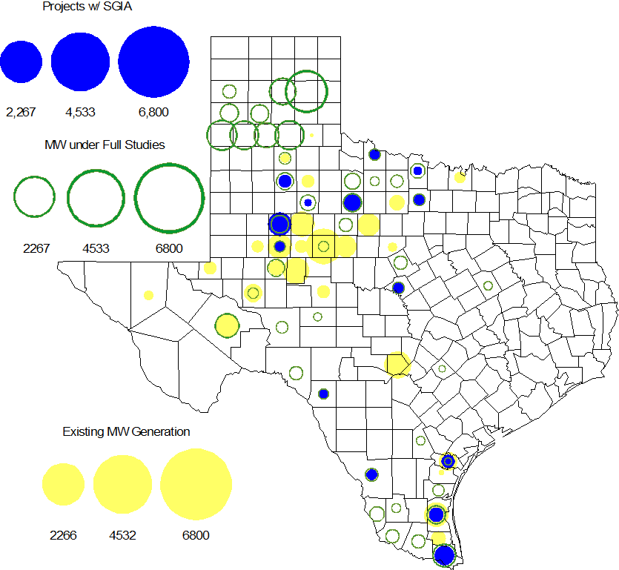

Regional Planning Group Project Reviews

- South Texas Electric Cooperative (STEC) submitted the Karnes Electric Cooperative (KEC) and Medina Electric Cooperative (MEC) load addition project to accommodate 245 MW of new load in Karnes and Atascosa Counties. This is a Tier 1 project that is estimated to cost $57 million. The ERCOT Independent Review was completed in August 2012. The ERCOT Board of Directors endorsed the project on September 18, 2012, and ERCOT has sent the approval letter.

- AEPSC has submitted the Airline/North Padre Island Area Improvements project. This project is submitted as a revision to the Barney Davis to Laguna 138 kV line (AEPSC Corpus Christi Improvements Project ) that was endorsed by ERCOT in November 2009. This is a Tier 1 project that is estimated to cost approximately $58.1 million. This project is currently under ERCOT independent review.

- CPS Energy has submitted the TCC Transmission project to support load growth on the west side of San Antonio. The project is Tier 2 project estimated to cost $10.9 million. This project is currently under ERCOT independent review.

- Sharyland has submitted the Atlas-Driver Load Integration project, this is a Tier 2 project that is estimated to cost approximately $15.4 million. This project is currently under ERCOT independent review.

- American Electric Power Service Corporation (AEPSC) has submitted the Sinton-Beeville-Kenedy Area Improvements project to accommodate load additions due to Eagle Ford Shale development in South Texas. This is a Tier 1 project that is estimated to cost $89.2 million. This project is currently under ERCOT independent review.

- South Texas Electric Cooperative (STEC) has submitted the Coy City Load Addition project to accommodate load additions due to Eagle Ford Shale development in South Texas. This is a Tier 3 project that is estimated to cost $11.65 million. This project has been submitted for RPG comments.

- CenterPoint Energy has submitted the Fort Bend Area Upgrades project, this is a Tier 3 project that is estimated to cost approximately $16.9 million. This project has been submitted for RPG comments.

- LCRA TSC, Guadalupe Valley Electric Cooperative (GVEC), American Electric Power (AEP), and South Texas Electric Cooperative (STEC) have jointly submitted the Kenedy Switch to Nixon to Seguin Line Upgrade, this is a Tier 1 project that is estimated to cost approximately $55.3 million. This project has been submitted for RPG comments.

Congestion Costs
Dollars shown in RUC Make Whole payment graph are of settlement quality.

RUC net Make Whole payment in $mm
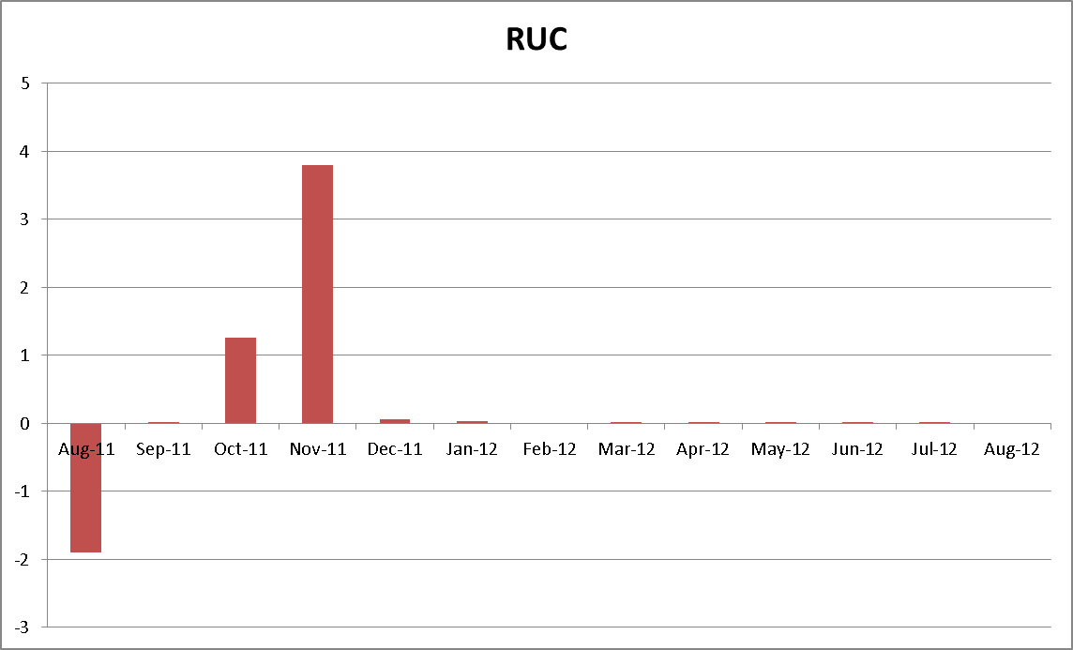

Monthly Average LMP

Binding Constraints – Year to Date
Contingency | Binding Element | Number of 5-min intervals | Shadow Price Range $/MWh | Estimated Congestion Rent $ (Shadow Price*Limit) | Transmission Project
Amoco North Cowden Tap - Moss 138kV | Odessa North 138/69 kV Autotransformer | 16905 | 0 - 2800 | 133,960,488 | 5YTP [2010-R7, R8]  12TPIT0214, 13TPIT0136
Quail Switch - Odessa EHV 345 kV & Longshore Switch - Odessa EHV 345 kV; Golden Switch - Sun Switch 138 kV; Falcon Seaboard - Midland East 345 kV; etc. | China Grove - Bluff Creek 138 kV | 1591 | 0 - 3500 | 31,578,851 | 13TPIT0098, 13TPIT0093
BASE CASE | West to North Stability Limit | 8142 | 0 - 436 | 26,901,966 | CREZ
Batesville Switching Station - Paloduro Substation 138 kV; Batesville 138/69 kV Autotransformer; West Batesville - Uvalde 138 kV; etc | Moore Switching Station - Downie Switching Station 138 kV | 1971 | 0 - 3500 | 20,422,574 | 08TPIT0018
Midland East - Odessa EHV 345 kV; or Moss Switch 345/138 kV Autotransformer | Odessa - Odessa North 138 kV | 609 | 0 - 3500 | 18,830,852 | 14TPIT0054
Twin Buttes 345/138 kV Autotransformer | San Angelo Red Creek 345/138 kV Autotransformer 2 | 113 low-side; and 262 high-side | 19 - 3500 low-side; and 2 - 4500 high-side | 18,360,051 | 14TPIT0067
Kyle - San Marcos 138 kV; or Lytton Spring - Zorn 345 kV & Austrop - Zorn 345 kV | Turnersville - Buda 138 kV | 568 | 0 - 3500 | 17,352,442 | 09TPIT0060
Lewisville Switch - Carrollton Northwest 345 kV; or Lewisville Switch - Carrollton Northwest 345 kV double-circuit | Lewisville Switch - Jones Street TNP 138 kV | 4666 | 0 - 3500 | 17,099,428 | 12TPIT0209, 12TPIT0210
North Alvin - Meadow 138 kV; PH Robinson 345/138 kV Autotransformer A2; or PH Robinson 345/138 kV Autotransformer A4 | PH Robinson 345/138 kV Autotransformer A1 | 48 low-side; and 280 high-side | 0 - 3500 low-side; and 1 - 4500 high-side | 12,216,587 | 14TPIT0077
China Grove - Bluff Creek 138 kV; West Over - Odessa 138 kV; etc. | Moss - Amoco North Cowden Tap 138 kV | 469 | 0 - 3500 | 9,686,322 | 13TPIT0098, 13TPIT0093
Binding Constraints – Sep 2012
Contingency | Binding Element | Number of 5-min intervals | Shadow Price Range $/MWh | Estimated Congestion Rent $ (Shadow Price*Limit) | Transmission Project | Comments
Amoco North Cowden Tap - Moss 138kV | Odessa North 138/69 kV Autotransformer | 2248 | 0 - 2000 | 19,319,292 | 5YTP [2010-R7, R8]  12TPIT0214, 13TPIT0136 | MP is in place
North Alvin - Meadow 138 kV; or PH Robinson 345/138 kV Autotransformer A2 or A4 | PH Robinson 345/138 kV Autotransformer A1 | 42 low-side; and 280 high-side | 0 - 3500 low-side; and 1 - 4500 high-side | 11,742,210 | 14TPIT0077 | Planned Outage on PH Robinson Auto A2 and Forced Outage on PH Robinson Auto A3
La Palma - Los Fresnos 138 kV | La Palma - Villa Cavazos 138 kV | 48 | 3500 - 3500 | 2,940,963 |  | Outage of Price Road - Loma Alta 138 kV
Camp Springs Energy Center - Golden Switch 138 kV; or Green Mountain Energy Wind Farm at Brazos - Sun Switch 138 kV | Morgan Creek SES - Sun Switch 138 kV | 53 | 545 - 3500 | 2,839,374
Midland East - Odessa EHV 345 kV | Odessa North - Odessa 138 kV | 68 | 0 - 3500 | 2,650,530
Amoco North Cowden Tap - Moss 138kV | Odessa North - Odessa Basin Switch 69 kV | 225 | 0 - 2800 | 2,358,599
Meadow - PH Robinson 345 kV | North Alvin - Alvin 138 kV | 344 | 0 - 3500 | 2,332,639 | 13TPIT0079 | Planned Outage on PH Robinson Auto A2 and Forced Outage on PH Robinson Auto A3
Lewisville Switch - Carrollton Northwest 345 kV double-circuit | Euless - Grapevine Highway 360 138 kV | 71 | 0 - 3500 | 2,317,992 | 11TPIT0012
Golden Switch - Sun Switch 138 kV; or Morgan Creek SES - Sun Switch 138 kV | China Grove - Bluff Creek 138 kV | 76 | 0 - 3500 | 2,131,841 | 13TPIT0098, 13TPIT0093
Lewisville Switch - Carrollton Northwest 345 kV double-circuit; or Lewisville Switch - Carrollton Northwest 345 kV (from Roanoke) | Jones Street TNP - Lakepointe TNP 138 kV | 333 | 0 - 3500 | 1,403,440 | 12TPIT0210

Wind Generation as a Percent of Load
One-hour average of total wind power output as a percentage of ERCOT load.

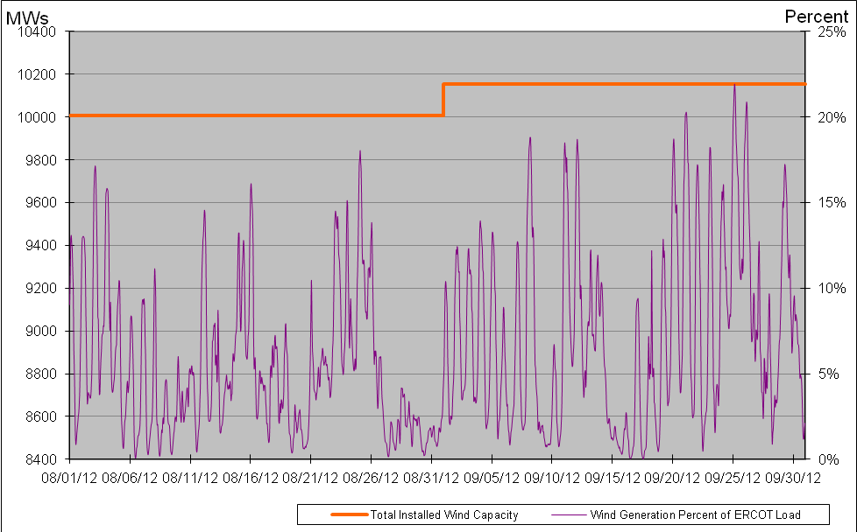

Planning Model Activities
- Data Set B work began on August 1, 2012 with a Topology Processor case extracted from NMMS with a build date of January 1, 2013. Process is underway with creation of Pass 1 cases on Aug 31, 2012.
- The short term calendar of major planning model events follows:
  - Oct 15, 2012 Data Set B cases posted.
  - Oct 19, 2012 Begin Sept TPIT update to 12 DSA and 13 DSA cases.
  - Nov 16, 2012 Post Sept TPIT update to 12 DSA and 13 DSA cases.
  - Nov 30, 2012 Begin Contingency database update for 13 DSA and DSB cases.
  - Dec 19, 2012 Post Contingency database update for 13 DSA and DSB cases.
- Status update on SCR760, Changes Needed for Information Model Manager and Topology Processor for Planning Models, which was approved by the ERCOT Board in March 2011.
  - Bundle 1 (Items 3, 7 and 8): In Production.
  - Bundle 2 (Items 2a, 4, 9): In Production.
  - Bundle 3 (Item 5, 2b, 2c): In Production
  - Bundle 4 (Items 1, 6): Item 1 considered to be in production. The first draft of Requirements for Item 6 have been completed by ERCOT, reviewed by SSWG, and sent to vendor for review.
SCR Sub Part | SCR Description | Status
SCR760-1 | Upgrade to PSS/E v32 | Production
SCR760-2 | Distribution Capacitor banks | Production
SCR760-3 | Zero Impedance Line Ratings | Production
SCR760-4 | Associate Loads and Capacitor banks with the correct CNG | Production
SCR760-5 | Additional Transformer Data for Planning | Production
SCR760-6 | FACTS Devices | Planning
SCR760-7 | Assign valid PSSE IDs to Breakers/  Switches/ Series Devices | Production
SCR760-8 | Phase shift of Autos for short circuit studies | Production
SCR760-9 | Multisection Line Grouping | Production
Table 1: In the following table:
- Red will be used to show status of Not Submitted, meaning that the SCR sub part has not been submitted to Siemens as a Service Request.
- Yellow will indicate that the SCR sub part has been submitted. The color will remain yellow and the status will change in order to Submitted, Planning (Requirements, SOW, Code Writing), Release (Siemens produces first code to test), and Testing (code has completed internal test and is moving through release management).
- Green will indicate that the code has been tested and installed on the machines that ERCOT uses to produce Topology Processor output for Planning and CRR.

Other Notable Activities
- All of the n-1 reliability projects for the 2012 Five-Year Transmission Plan have been identified and the results were sent to the TO’s for comments on Sept. 21, 2012. ERCOT Staff is current working on the g-1 + n-1 screening studies.

