TEMPERATURE SENSITIVE LOAD

See the graph below for a bid example:
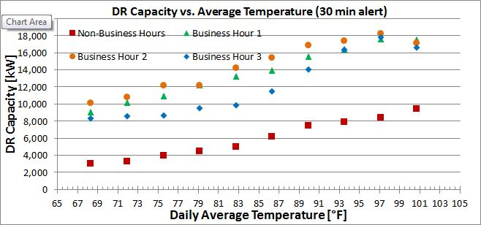

This is from real data we recorded over the last few months in Houston, but for the load from 10,000 houses (I wanted there to be a reasonable amount of load in the example).
Some other thoughts about the process:

- This will require the bidder to get a pretty good understanding of their load, either through actual tests or simulations
- We can make the discreet points curves, if you like
- The above example is for one climate area (Houston), a similar bid would need to be submitted for each Texas climate area, or maybe just the ones that really matter (populated areas)
- It may make sense for ERCOT to publish a list of temperatures for the bid period (based on the historical hi/low data for each climate area), so everyone is bidding on the same temps. If a bidder doesn’t want to bid any capacity at a temperature, say below 70 F, they could bid zero.
- To figure out what capacity the bidder is required to deliver, ERCOT can use the average temp (or temp at the start or end of the event) and come across to the required availability
- In each climate area the temperature yardstick will need to be established (probably the most central National Weather Service Station, such as Houston International in Houston) so everyone is using the same yardstick
- We did not develop similar curves for the other two ERCOT ERS periods since we don’t have data from them, but after a year of running the program, we (and each bidding company) will have enough data to make similar bid curves.
- You will note that for us, business hour 3 is less than the other business hours – while this correlates to the peak - and you would think there would be more capacity in these hours – this is also when people are lowering their set points when returning from work.

