 |  |  |  | System Planning
Monthly Status Report
August 2012

 |  | Report Highlights
 | - ERCOT is currently tracking 140 active generation interconnection requests totaling almost 37,000 MW. This includes almost 21,000 MW of wind generation.
- ERCOT is currently reviewing proposed transmission improvements with a total cost of $126 Million
- Transmission Projects endorsed in 2012 total $493.9 Million
- All projects (in engineering, routing, licensing and construction) total approximately $9.77 Billion.
- Transmission Projects energized in 2012 total about $325.7 million.

Table of Contents
1. Generation Interconnection 1
1.1 Signed Generation Interconnection Agreements 1
1.2 New Generation Registering for Commercial Operations 1
1.3 Summary of Generation Interconnection Requests 1
1.4 Projects with Interconnection Agreements 4
1.5 Generation Projects Undergoing Full Interconnection Studies with Confidentiality Waived by Developer 4
1.6 Generation Projects Undergoing Full Interconnection Studies 5
1.7 Wind Generation Capacity Installed by Year 6
2. Regional Planning Group Project Reviews 7
3. Congestion Costs 8
4. Wind Generation as a Percent of Load 11
5. Planning Model Activities 12
6. Other Notable Activities 13

1. Generation Interconnection
Additional information regarding detailed generation interconnection and impact studies is contained in the “Generation Project Interconnection Information” folder in the “Operations and System Planning” area on the ERCOT website: http://planning.ercot.com/login/login.

Signed Generation Interconnection Agreements
11INR0013 – Goldthwaite Wind Energy – 150 MW in Mills County

New Generation Registering for Commercial Operations - none

The total installed wind capacity is now reported as 10,035 MW by the resource owners through the registration process. Capacity by North, South and West is 519 MW, 2,283 MW, and 7,233 MW respectively. 850 MW is able to switch between the West and South zones and is currently shown in the South zone.

Summary of Generation Interconnection Requests
GENERATION INTERCONNECTION REQUESTS CURRENTLY UNDER REVIEW
Currently tracking 173 generation interconnection or change requests
As of August 31, 2012 | North | South | West | Total
Security Screening Study | 1 | 7 | 3 | 11
SSS Completed | 1 | 8 | 8 | 17
Full Interconnect Study | 8 | 18 | 43 | 69
FIS Completed | 1 | 8 | 11 | 20
Suspended Studies | 7 | 2 | 24 | 33
Capacity of Suspended Study Projects | 5,711 | 489 | 9,620 | 15,820
Interconnect Agreement Completed | 9 | 8 | 7 | 23
Capacity under Interconnection Agreements | 5,490 | 3,474 | 1,248 | 10,212
Capacity for Grid, MW | 9,102 | 11,815 | 15,970 | 36,886
Wind Capacity, MW | 3,443 | 4,070 | 13,483 | 20,996

Fuel Type | Confidential Projects (MW) | Projects Under Full Study (MW) | Public Projects (MW) | Suspended Studies (MW) | Grand Total (MW)
Gas-AllOther |  |  |  |  | 2,303
Gas-CombinedCycle |  |  | 5,595 | 2,115 | 10,251
Total Gas | 2,744 | 2,100 | 5,595 | 2,115 | 12,554
Nuclear |  |  |  | 3,200 | 3,200
Coal |  | 1,090 | 2,125 |  | 3,215
Wind | 4,346 | 14,295 | 2,356 | 10,102 | 31,098
Solar | 354 | 506 | 60 | 353 | 1,273
Biomass |  |  |  | 50 | 50
Storage |  | 40 | 36 |  | 76
Petroleum Coke |  |  | 1,240 |  | 1,240
Grand Total | 7,444 | 18,031 | 11,412 | 15,820 | 52,706

County Location of Installed Generation and Interconnection Requests (all fuels)

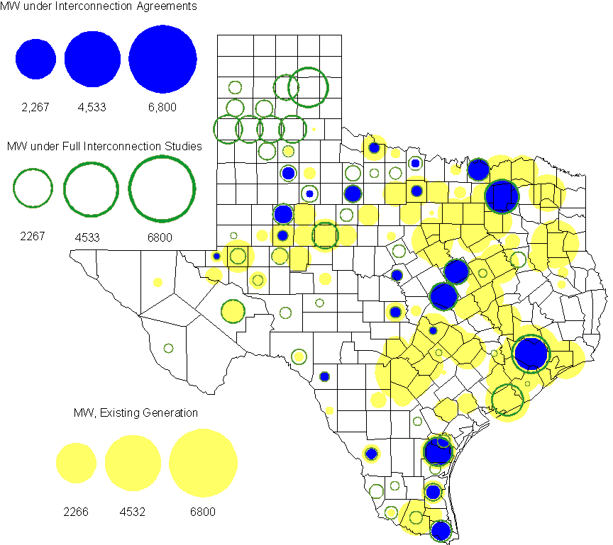

Projects with Interconnection Agreements
(Status: IA=Interconnect Agreement, XX= cancelled)
Generation Interconnections as of August 31, 2012
INR | SiteName | Status | County | Region | COD | Fuel Type |  | MW For Grid |  | Change from Last Report
12INR0075 | Blue Summit Windfarm | IA | Wilbarger | West | Nov-12 |  | Wind |  | 135
12INR0076 | Notrees Battery Storage | IA | Winkler | West | Dec-12 |  | Storage |  | 36 | Date
08INR0011 | Senate Wind Project | IA | Jack | North | Dec-12 |  | Wind |  | 150
12INR0072 | Anacacho Windfarm | IA | Kinney | South | Dec-12 |  | Wind |  | 100
11INR0091 | Whitetail Wind Energy Project | IA | Webb | South | Dec-12 |  | Wind |  | 92
09INR0061 | WKN Mozart | IA | Kent | West | Dec-12 |  | Wind |  | 30
10INR0023 | Baker Ranch | IA | Haskell | West | Dec-12 |  | Wind |  | 400
08INR0049 | Briar Creek | IA | Clay | North | Dec-12 |  | Wind |  | 50
11INR0033 | Los Vientos | IA | Cameron | South | Dec-12 |  | Wind |  | 400
09INR0001 | Sandy Creek 1 | IA | McLennan | North | Mar-13 |  | Coal |  | 925
11INR0086 | RRE Austin Solar | IA | Travis | South | Oct-13 |  | Solar |  | 60 | Date
11INR0013 | Goldthwaite Wind Energy | IA | Mills | North | Dec-13 |  | Wind |  | 150 | New
06INR0022c | Penascal Wind Farm 3 | IA | Kenedy | South | Dec-13 |  | Wind |  | 202
12INR0034 | Stephens-Borlynn Wind Project | IA | Borden | West | Dec-13 |  | Wind |  | 378
13INR0021 | Ferguson Replacement Project | IA | Llano | North | Jul-14 |  | Gas-CC |  | 146
08INR0018 | Gunsight Mountain | IA | Howard | West | Aug-14 |  | Wind |  | 120
11INR0050 | Moore Wind 1 | IA | Crosby | West | Aug-14 |  | Wind |  | 149
10INR0021 | Panda Sherman Power | IA | Grayson | North | Jan-15 |  | Gas-CC |  | 717
06INR0006 | Cobisa-Greenville | IA | Hunt | North | May-15 |  | Gas-CC |  | 1,792
10INR0020a | Panda Temple Power | IA | Bell | North | May-15 |  | Gas-CC |  | 780
10INR0020b | Panda Temple Power | IA | Bell | North | May-16 |  | Gas-CC |  | 780
10INR0022 | Pondera King Power Project | IA | Harris | South | Jun-16 |  | Gas-CC |  | 1,380
12INR0016a | Las Brisas Energy Center | IA | Nueces | South | May-18 |  | PetCoke |  | 620
12INR0016b | Las Brisas Energy Center | IA | Nueces | South | May-18 |  | PetCoke |  | 620
 |  |  |  |  |  |  | TOTAL |  | 10,212
Note: Projects that do not have an interconnection agreement but have been publicly disclosed via a Public Letter to ERCOT and were previously reported on this table have been moved to section 1.5 unless Suspended or Cancelled

Generation Projects Undergoing Full Interconnection Studies with Confidentiality Waived by Developer
INR | SiteName | Status | County | Region | COD | Fuel | MW For Grid | Change from Last Report
14INR0005 | White Stallion Energy Center | PL | Matagorda | South | Jul-14 | Coal | 1,200

Generation Projects Undergoing Full Interconnection Studies
INR | County | Grid | COD | Fuel |  | INR | County | Grid | COD | Fuel
08INR0031 | Childress | 100 | Jun-12 | Wind |  | 12INR0079 | Kenedy | 200 | Aug-12 | Wind
12INR0089 | Pecos | 230 | Nov-12 | Wind |  | 11INR0094 | Kent | 100 | Nov-12 | Solar
11INR0093 | San Patricio | 41 | Dec-12 | Wind |  | 12INR0060 | Schleicher | 58 | Dec-12 | Wind
12INR0067 | Webb | 94 | Dec-12 | Wind |  | 12INR0068 | Jim Hogg | 80 | Dec-12 | Wind
12INR0055 | Baylor | 80 | Dec-12 | Wind |  | 12INR0081 | Upton | 113 | Dec-12 | Wind
13INR0040 | Harris | 0 | Jan-13 | Gas |  | 13INR0054 | Bexar | 0 | Jan-13 | Gas
13INR0010a | Parmer | 200 | Jan-13 | Wind |  | 11INR0082B | Val Verde | 150 | Mar-13 | Wind
11INR0083B | Crockett | 100 | Mar-13 | Wind |  | 09INR0051 | Borden | 249 | Mar-13 | Wind
13INR0045 | Castro | 288 | Apr-13 | Wind |  | 12INR0070 | Knox | 300 | Apr-13 | Wind
12INR0086 | Fort Bend | 89 | May-13 | Gas |  | 13INR0020a | Glasscock | 200 | May-13 | Wind
10INR0089 | Harris | 40 | May-13 | Storage |  | 12INR0045 | Kleberg | 135 | Jun-13 | Wind
13INR0032 | Andrews | 30 | Jun-13 | Solar |  | 13INR0057 | Archer | 65 | Jun-13 | Wind
13INR0023 | Ector | 240 | Jul-13 | Coal |  | 13INR0049 | Harris | 352 | Jul-13 | Gas
13INR0046 | Limestone | 71 | Sep-13 | Wind |  | 11INR0082A | Val Verde | 50 | Sep-13 | Wind
11INR0083A | Crockett | 50 | Sep-13 | Wind |  | 13INR0025 | Randall | 150 | Sep-13 | Wind
13INR0005 | Carson | 600 | Oct-13 | Wind |  | 13INR0028 | Hale | 392 | Nov-13 | Gas
14INR0030a | Carson | 322 | Nov-13 | Wind |  | 12INR0071 | Caldwell | 30 | Nov-13 | Wind
13INR0038 | Swisher | 300 | Dec-13 | Wind |  | 13INR0050 | Comanche | 200 | Dec-13 | Wind
11INR0062 | Nueces | 178 | Dec-13 | Wind |  | 13INR0036 | Hidalgo | 200 | Dec-13 | Wind
13INR0052 | Starr | 200 | Dec-13 | Wind |  | 13INR0055 | Zapata | 250 | Dec-13 | Wind
10INR0009 | Castro | 300 | Dec-13 | Wind |  | 11INR0085 | Nolan | 106 | Dec-13 | Wind
12INR0054 | Jones | 200 | Dec-13 | Wind |  | 12INR0059 | Pecos | 50 | Dec-13 | Solar
13INR0007 | Pecos | 200 | Dec-13 | Wind |  | 13INR0026 | Oldham | 201 | Dec-13 | Wind
13INR0030 | Archer | 100 | Dec-13 | Wind |  | 13INR0039 | Castro | 500 | Dec-13 | Wind
12INR0002a | Briscoe | 200 | Dec-13 | Wind |  | 11INR0057 | Cameron | 165 | Dec-13 | Wind
12INR0088 | Crosby | 201 | Dec-13 | Wind |  | 14INR0013 | Cameron | 103 | Jan-14 | Wind
08INR0019a | Gray | 250 | Jan-14 | Wind |  | 08INR0019b | Gray | 250 | Jan-14 | Wind
08INR0019c | Gray | 250 | Jan-14 | Wind |  | 12INR0084 | Randall | 242 | Jan-14 | Wind
13INR0006 | Gray | 750 | Jan-14 | Wind |  | 14INR0014 | Val Verde | 100 | Jan-14 | Solar
13INR0010b | Parmer | 500 | Jan-14 | Wind |  | 10INR0080 | Presidio | 81 | Jan-14 | Solar
13INR0020b | Glasscock | 150 | May-14 | Wind |  | 14INR0016 | Harris | 190 | Jun-14 | Gas
14INR0011 | Swisher | 270 | Jun-14 | Gas |  | 14INR0012 | Gray | 401 | Jun-14 | Wind
14INR0015 | Harris | 192 | Jun-14 | Gas |  | 11INR0054 | San Patricio | 161 | Jul-14 | Wind
12INR0042a | Deaf Smith | 265 | Sep-14 | Wind |  | 12INR0042b | Deaf Smith | 135 | Sep-14 | Wind
13INR0031 | Austin | 30 | Oct-14 | Solar |  | 14INR0023 | Briscoe | 361 | Dec-14 | Wind
11INR0081 | Live Oak | 72 | Dec-14 | Wind |  | 12INR0018 | Gray | 500 | Dec-14 | Wind
14INR0009 | Kent | 248 | Dec-14 | Wind |  | 14INR0018 | Nolan | 35 | Dec-14 | Solar
14INR0020 | Floyd | 150 | Dec-14 | Wind |  | 10INR0085 | Ector | 40 | Dec-14 | Solar
12INR0002b | Briscoe | 200 | Dec-14 | Wind |  | 11INR0079a | Clay | 200 | Dec-14 | Wind
12INR0029 | Swisher | 500 | Dec-14 | Wind |  | 13INR0010c | Parmer | 500 | Jan-15 | Wind
12INR0057 | Ector | 40 | Apr-15 | Solar |  | 15INR0013 | Anderson | 324 | Oct-15 | Gas
15INR0014 | Matagorda | 280 | Oct-15 | Gas |  | 12INR0002c | Briscoe | 350 | Dec-15 | Wind
14INR0005 | Matagorda | 1,200 | Jan-16 | Coal |  | 16INR0003 | Brazoria | 11 | Jun-16 | Gas
14INR0003 | Nolan | 850 | Jun-18 | Coal |  | 10INR0062a | Pecos | 80 | Oct-18 | Wind
10INR0062b | Pecos | 220 | May-19 | Wind
Note: ERCOT recently requested that the Transmission Service Providers comprehensively review the status of each of their assigned Full Interconnection Studies and report the status of each study back to ERCOT. Projects that were classified as “Cancelled” or “Suspended” as a result of this review are excluded from this table.

Wind Generation Capacity Installed by Year
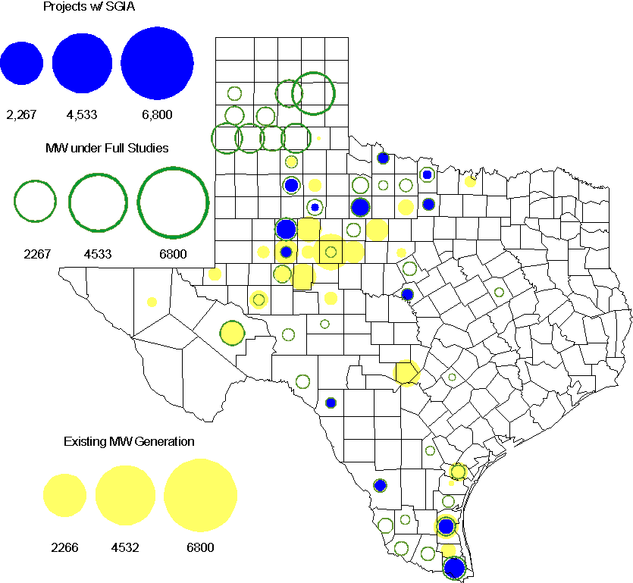

Regional Planning Group Project Reviews

- South Texas Electric Cooperative (STEC) has submitted the Karnes Electric Cooperative (KEC) and Medina Electric Cooperative (MEC) load addition project to accommodate 245 MW of new load in Karnes and Atascosa Counties. This is a Tier 1 project that is estimated to cost $57 million. The ERCOT Independent Review for this project has completed and it is scheduled to be presented to TAC and the ERCOT Board of Directors in September.

- AEPSC has submitted the Airline/North Padre Island Area Improvements project. This project is submitted as a revision to the Barney Davis to Laguna 138 kV line (AEPSC Corpus Christi Improvements Project ) that was endorsed by ERCOT in November 2009. This is a Tier 1 project that is estimated to cost approximately $58.1 million. This project is in Study Mode.

- CPS Energy has submitted the TCC Transmission project to support load growth on the west side of San Antonio. The project is estimated to cost $10.9 million. This Tier 2 project is in the RPG comment phase.

Congestion Costs
Dollars shown in RUC Make Whole payment graph are of settlement quality.

RUC net Make Whole payment in $mm

Monthly Average LMP
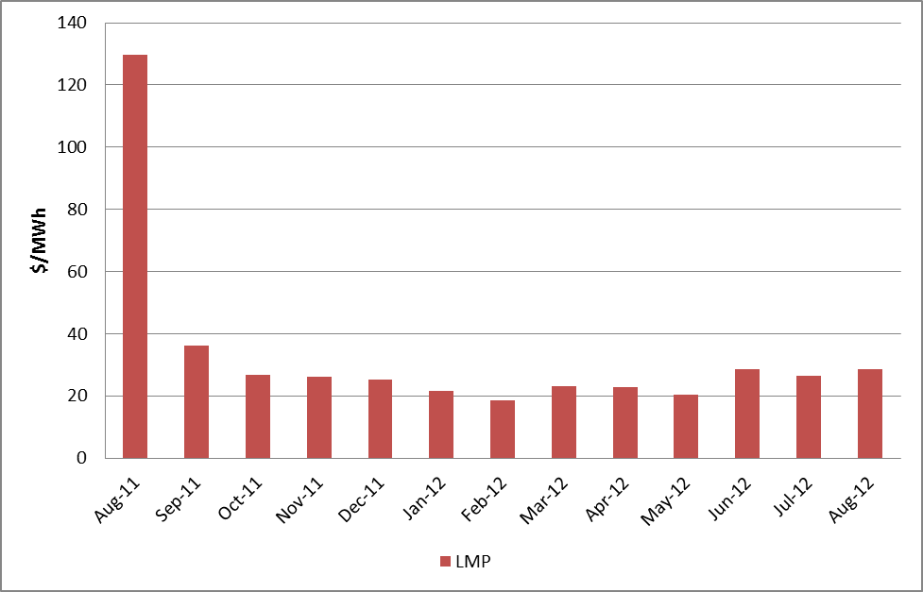

Binding Constraints – Year to Date
Contingency | Binding Element | Number of 5-min intervals | Shadow Price Range $/MWh | Estimated Congestion Rent $ (Shadow Price*Limit) | Transmission Project
Amoco North Cowden Tap - Moss 138kV | Odessa North 138/69 kV Autotransformer | 14657 | 0 - 2800 | 114,641,197 | 5YTP [2010-R7, R8]
Sacroc - Sun Switch 138 kV; or Golden Switch - Sun Switch 138 kV | China Grove - Bluff Creek 138 kV | 1515 | 0 - 3500 | 29,447,011 | 13TPIT0098, 13TPIT0093
BASE CASE | West to North Stability Limit | 8126 | 0 - 436 | 26,848,953 | CREZ
Batesville 138/69 kV Autotransformer; Batesville Switching Station - Paloduro Substation 138 kV; or West Batesville - Uvalde 138 kV | Moore Switching Station - Downie Switching Station 138 kV | 1889 | 0 - 3500 | 20,244,734 | 08TPIT0018
Twin Buttes 345/138 kV Autotransformer | San Angelo Red Creek 345/138 kV Autotransformer 2 | 113 low-side; and 262 high-side | 19 - 3500 low-side; and 2 - 4500 high-side | 18,360,051 | 14TPIT0067
Lewisville Switch - Carrollton Northwest 345 kV | Lewisville Switch - Jones Street Tnp 138 kV | 4632 | 0 - 3500 | 16,918,023 | CREZ, 07TPIT0042
Kyle - San Marcos 138 kV; or Lytton Spring - Zorn 345 kV & Austrop - Zorn 345 kV | Turnersville - Buda 138 kV | 513 | 0 - 3500 | 16,541,138 | 09TPIT0060
Midland East - Odessa EHV 345 kV | Odessa - Odessa North 138 kV | 541 | 0 - 3500 | 16,180,321 | 14TPIT0054
China Grove - Bluff Creek 138 kV; or West Over - Odessa 138 kV | Moss - Amoco North Cowden Tap 138 kV | 466 | 0 - 3500 | 9,667,825 | 13TPIT0098, 13TPIT0093
Marshall Ford - Lago Vista 138 kV | Buttercup - Whitestone 138 kV | 151 | 6 - 3500 | 7,020,443 | 10TPIT0074
Binding Constraints – Aug 2012
Contingency | Binding Element | Number of 5-min intervals | Shadow Price Range $/MWh | Estimated Congestion Rent $ (Shadow Price*Limit) | Transmission Project | Comments
Amoco North Cowden Tap - Moss 138kV | Odessa North 138/69 kV Autotransformer | 4684 | 0 - 2275 | 41,602,776 | 5YTP [2010-R7, R8] | MP has been developed; MP without load shedding is yet under development
Batesville Switching Station - Paloduro Substation 138 kV; or West Batesville - Uvalde 138 kV | Moore Switching Station - Downie Switching Station 138 kV | 430 | 0 - 3500 | 5,310,033 | 08TPIT0018 | Multiple outages;  TOAP has been developed
Kyle - San Marcos 138 kV; or Lytton Spring - Zorn 345 kV & Austrop - Zorn 345 kV | Turnersville - Buda 138 kV | 161 | 0 - 3500 | 3,581,506 | 09TPIT0060 | Kendall CTEC - Mountain Top 138 kV line outage
Lake Hubbard - Centerville Road Switch 138 kV double-circuit; Watermill - Tricorner 345 kV & Watermill -Trinidad 345 kV; or Centerville Road - Parkdale 138 kV double-circuit | Prairie Creek Switch - Prairie Creek (to Parkdale Switch) 138 kV | 294 | 0 - 3500 | 3,536,623 |  | Centervill Road Switch 345/138 kV Autotrasformer 2 outage;  TOAP has been developed
West Over - Odessa 138 kV | Moss - Amoco North Cowden Tap 138 kV | 57 | 1983 - 3500 | 3,059,648 | 13TPIT0098, 13TPIT0093
Amoco North Cowden Tap - Moss 138kV | Odessa North - Odessa Basin Switch 69 kV | 310 | 0 - 2800 | 2,887,906
(Krum West Switch) - Lewisville Switch - Carrollton Northwest 345 kV | Euless - Grapevine Highway 360 138 kV | 44 | 2 - 3500 | 2,418,088 | 11TPIT0012 | RAP was in place
La Palma - Rio Hondo 138 kV | Harlingen Switch - Oleander 138 kV | 39 | 3500 - 3500 | 2,274,767 |  | Forced outage at La Palma
Golden Switch - Sun Switch 138 kV | China Grove - Bluff Creek 138 kV | 61 | 120 - 3500 | 2,263,449 | 13TPIT0098, 13TPIT0093
Allen Switch - Royse Switch 345 kV & Allen Switch - Monticello SES 345 kV | Centerville Road Switch 345/138 kV Autotransformer 1 | 195 | 0 - 3500 | 2,227,943 |  | Centervill Road Switch 345/138 kV Autotrasformer 2 outage;  TOAP has been developed

Wind Generation as a Percent of Load
One-hour average of total wind power output as a percentage of ERCOT load.

Planning Model Activities
- Data Set B work began on August 1, 2012 with a Topology Processor case extracted from NMMS with a build date of January 1, 2013. Process is underway with creation of Pass 1 cases on Aug 31, 2012.
- The short term calendar of major planning model events follows:
  - Oct 15, 2012 Data Set B cases posted.
  - Oct 19, 2012 Begin Sept TPIT update to 12 DSA and 13 DSA cases.
  - Nov 16, 2012 Post Sept TPIT update to 12 DSA and 13 DSA cases.
  - Nov 30, 2012 Begin Contingency database update for 13 DSA and DSB cases.
  - Dec 19, 2012 Post Contingency database update for 13 DSA and DSB cases.
- Status update on SCR760, Changes Needed for Information Model Manager and Topology Processor for Planning Models, which was approved by the ERCOT Board in March 2011.
  - Bundle 1 (Items 3, 7 and 8): In Production.
  - Bundle 2 (Items 2a, 4, 9): In Production.
  - Bundle 3 (Item 5, 2b, 2c): In Production
  - Bundle 4 (Items 1, 6): Item 1 considered to be in production. The first draft of Requirements for Item 6 have been completed by ERCOT, reviewed by SSWG, and sent to vendor for review.
SCR Sub Part | SCR Description | Status
SCR760-1 | Upgrade to PSS/E v32 | Production
SCR760-2 | Distribution Capacitor banks | Production
SCR760-3 | Zero Impedance Line Ratings | Production
SCR760-4 | Associate Loads and Capacitor banks with the correct CNG | Production
SCR760-5 | Additional Transformer Data for Planning | Production
SCR760-6 | FACTS Devices | Planning
SCR760-7 | Assign valid PSSE IDs to Breakers/  Switches/ Series Devices | Production
SCR760-8 | Phase shift of Autos for short circuit studies | Production
SCR760-9 | Multisection Line Grouping | Production
Table 1: In the following table:
- Red will be used to show status of Not Submitted, meaning that the SCR sub part has not been submitted to Siemens as a Service Request.
- Yellow will indicate that the SCR sub part has been submitted. The color will remain yellow and the status will change in order to Submitted, Planning (Requirements, SOW, Code Writing), Release (Siemens produces first code to test), and Testing (code has completed internal test and is moving through release management).
- Green will indicate that the code has been tested and installed on the machines that ERCOT uses to produce Topology Processor output for Planning and CRR.

Other Notable Activities
- The initial set of reliability projects for the 2012 Five-Year Transmission Plan were posted on the ERCOT Planning and Operations Information website in mid-August.

