NPRR Number | 476 | NPRR Title | Market Submitted Energy Offer Curves Disclosures
Date |  | August 22, 2012
Submitter’s Information
Name |  | Matt Mereness
E-mail Address |  | mmereness@ercot.com
Company |  | ERCOT
Phone Number |  | 512.248.3089
Cell Number
Market Segment |  | Not applicable.

Comments

ERCOT offers the following three areas for PRS consideration in the discussion of NPRR476.
(1) Language clean-up to remove references to “Texas Nodal Market Implementation Date” from Section 3.2.5, Publication of Resource and Load Information.
(2) Highlight opportunity to consider whether to post original Energy Offer Curves from Qualified Scheduling Entity (QSE), or Energy Offer Curves with proxy Energy Offer Curve extensions used in Step 1 of Security-Constrained Economic Dispatch (SCED).
(3) Clarify that the language being proposed will remove and replace the current 7-Day Trigger Report with Energy Offer Curve prices that may not contribute to the clearing price formation since they do not reflect the final Energy Offer Curves available to SCED.
Consideration 1: Language clean-up
Consider administrative revisions to the Section 3.2.5 to remove references to “Texas Nodal Market Implementation Date” and to define “Disclosure Area” as the 2003 ERCOT Congestion Management Zones.
Consideration 2: Alternative 60-Day SCED Disclosure Report of Energy Offer Curve values
ERCOT offers an alternative disclosure for the additional 60-day report but does not offer the required language modification.
As proposed in NPRR476, the new report of the Resource Energy Offer Curve “as submitted” would be the Energy Offer Curve that is submitted by the QSE and validated by ERCOT before being passed to SCED and would reflect the original Energy Offer Curve price quantity pairs. An example of a three point Energy Offer Curve is below and would be reflective of the disclosure report as proposed:

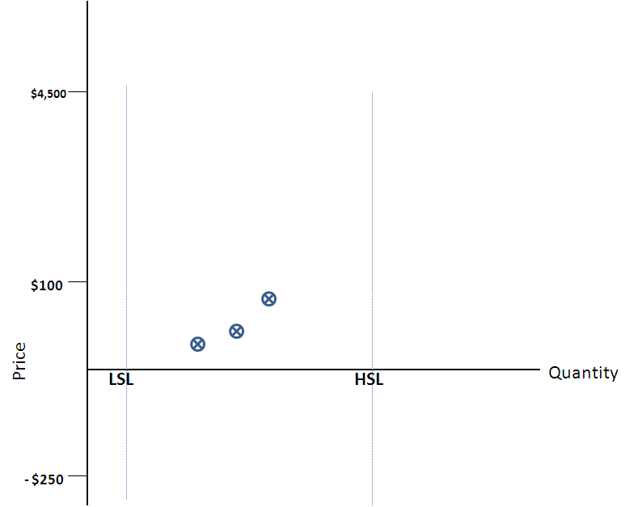

Alternatively, the market could consider disclosure of the Step 1 SCED Energy Offer Curve that is extended (or truncated) with proxy Energy Offer Curve logic by ERCOT to fit to the operational High Sustained Limit (HSL) and Low Sustained Limit (LSL) values that are available to dispatch by SCED (defined in paragraph (3) of Section 6.5.7.3, Security Constrained Economic Dispatch). This would have the potential advantage of ERCOT completing the Energy Offer Curves used in SCED for disclosure in the new report.

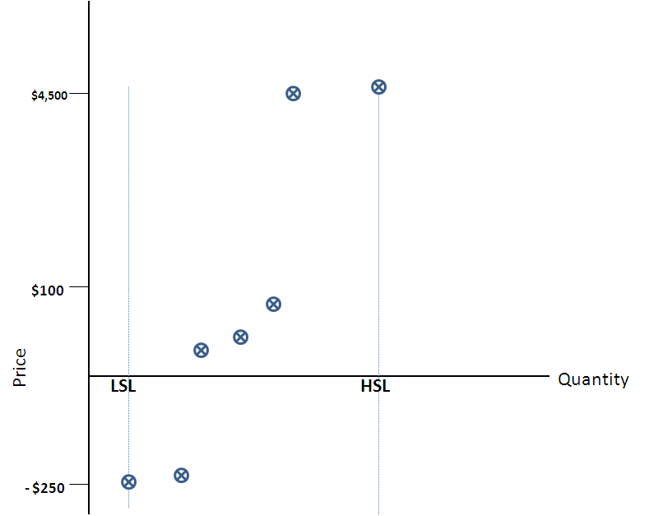

ERCOT has no opinion on which data set to post regarding the “original offers” or the Step1 SCED Energy Offer Curves.
The current available ERCOT posting of the Step 2 mitigated Energy Offer Curves should continue as-is and serve as a valuable disclosure tool to ERCOT for market questions regarding price formation.
Consideration 3 - Clarify loss of Step 2 mitigated Energy Offer Curves in the modified 7-Day Trigger Report.
Although ERCOT has no initial opinion, there is the desire to clarify that the current 7-Day Trigger Report would be replaced and would instead be based on the originally submitted Energy Offer Curves. Without the disclosure of the Step 2 mitigated Energy Offer Curves above the 50xFIP,there may be confusion when the price exceeds 50xFIP but there are no original offers above that level (example of the proxy Energy Offer Curve extensions setting the price). For those companies trying to reconstruct price formation at seven days, this may take away a currently used data set.
ERCOT has no opinion at this time, but wanted to clarify the understanding that the market is retiring an existing data set to disclose a different original Energy Offer Curve data set.
Revised Proposed Protocol Language

3.2.5 Publication of Resource and Load Information
(1) Two days after the applicable Operating Day, ERCOT shall post on the MIS Public Area for the ERCOT System and, if applicable, for each Disclosure Area, the information derived from the first complete execution of SCED in each 15-minute Settlement Interval. The “Disclosure Area” is the 2003 ERCOT Congestion Management Zones. Posting requirements will be applicable to Generation Resources physically located in the defined Disclosure Area. The information posted by ERCOT shall include:
(a) An aggregate energy supply curve based on non-wind Resources with Energy Offer Curves that are available to be dispatched by SCED. The energy supply curves will be calculated in ten MW increments, beginning at the sum of the Low Sustained Limits (LSLs) and ending at the sum of the High Sustained Limits (HSLs) for non-wind Resources with Energy Offer Curves, with the dispatch for each Resource constrained between the Resource’s LSL and HSL. The result will represent the ERCOT System energy supply curve economic dispatch of the non-wind Resources with Energy Offer Curves at various pricing points, not taking into consideration any physical limitations of the ERCOT System;
(b) An aggregate energy supply curve based on Wind-powered Generation Resources (WGRs) with Energy Offer Curves that are available to be dispatched by SCED. The energy supply curves will be calculated in ten MW increments, beginning at the sum of the LSLs and ending at the sum of the HSLs for WGRs with Energy Offer Curves, with the dispatch for each WGR constrained between the WGR’s LSL and HSL. The result will represent the ERCOT System energy supply curve economic dispatch of the WGRs with Energy Offer Curves at various pricing points, not taking into consideration any physical limitations of the ERCOT System;
(c) The sum of LSLs, sum of Output Schedules, and sum of HSLs for Generation Resources without Energy Offer Curves;
(d) The sum of the Base Points, High Ancillary Service Limit (HASL) and Low Ancillary Service Limit (LASL) of non-wind Resources with Energy Offer Curves, sum of the Base Points, HASL and LASL of WGRs with Energy Offer Curves, and the sum of the Base Points, HASL and LASL of all remaining Resources dispatched in SCED; and
(e) The sum of the telemetered Generation Resource net output used in SCED.
(2) Two days after the applicable Operating Day, ERCOT shall post on the MIS Public Area for the ERCOT System the following information derived from the first complete execution of SCED in each 15-minute Settlement Interval:
(a) Each telemetered Dynamically Scheduled Resource (DSR) Load, and the telemetered Resource net output(s) associated with each DSR Load; and
(b) The actual ERCOT Load as determined by subtracting the Direct Current Tie (DC Tie) Resource actual telemetry from the sum of the telemetered Generation Resource net output as used in SCED.
(3) Two days after the applicable Operating Day, ERCOT shall post on the MIS Public Area the following information for the ERCOT System and, if applicable, for each Disclosure Area from the DAM for each hourly Settlement Interval:
(a) An aggregate energy supply curve based on all energy offers that are available to the DAM, not taking into consideration Resource Startup Offer or Minimum-Energy Offer or any physical limitations of the ERCOT System. The energy supply curves will be calculated in ten MW increments. The result will represent the energy supply curve at various pricing points for energy offers available in the DAM;
(b) Aggregate minimum energy supply curves based on all Minimum-Energy Offers that are available to the DAM. The minimum energy supply curves will be calculated in ten MW increments;
(c) An aggregate energy Demand curve based on the DAM Energy Bid curves available to the DAM, not taking into consideration any physical limitations of the ERCOT System. The energy demand curve will be calculated in ten MW increments;
(d) The aggregate amount of cleared energy bids and offers including cleared Minimum-Energy Offer quantities;
(e) The aggregate Ancillary Service Offers (prices and quantities) in the DAM, for each type of Ancillary Service regardless of a Resource’s On-Line or Off-Line status. For Responsive Reserve (RRS) service, ERCOT shall separately post aggregated offers from Generation Resources, Controllable Load Resources, and non-Controllable Load Resources. Linked Ancillary Service Offers will be included as non-linked Ancillary Service Offers;
(f) The aggregate Self-Arranged Ancillary Service Quantity, for each type of service, by hour;
(g) The aggregate amount of cleared Ancillary Service Offers; and
(h) The aggregate Point-to-Point (PTP) Obligation bids (not-to-exceed price and quantities) for the ERCOT System and the aggregate PTP Obligation bids that sink in the Disclosure Area for each Disclosure Area.
(4) ERCOT shall post on the MIS Public Area the following information for each Resource for each 15-minute Settlement Interval 60 days prior to the current Operating Day:
(a) The Resource name and the Resource’s Energy Offer Curve (prices and quantities):
(i) As submitted; and
(ii) As mitigated and extended for use in SCED, including the incremental/decremental Energy Offer Curves for DSRs;
(b) The Resource name and the Resource’s Output Schedule;
(c) The DSR Load and associated Resource name and Resource net output;
(d) The Resource name and actual metered Resource net output;
(e) The self-arranged Ancillary Service by service for each QSE;
(f) The following Generation Resource data using a single snapshot during the first SCED execution in each Settlement Interval:
(i) The Generation Resource name;
(ii) The Generation Resource status;
(iii) The Generation Resource HSL, LSL, HASL, LASL, High Dispatch Limit (HDL), and Low Dispatch Limit (LDL);
(iv) The Generation Resource Base Point from SCED;
(v) The telemetered Generation Resource net output used in SCED;
(vi) The Ancillary Service Resource Responsibility for each Ancillary Service; and
(vii) The Generation Resource Startup Cost and minimum energy cost used in the Reliability Unit Commitment (RUC); and
(g) The following Load Resource data using a single snapshot during the first SCED execution in each Settlement Interval:
(i) The Load Resource name;
(ii) The Load Resource status;
(iii) The Maximum Power Consumption (MPC for a Load Resource);
(iv) The Low Power Consumption (LPC for a Load Resource);
(v) The telemetered real power consumption; and
(vi) The Ancillary Service Resource Responsibility for each Ancillary Service.
(5) If any Real-Time Locational Marginal Price (LMP) exceeds 50 times the Fuel Index Price (FIP) during any 15-minute Settlement Interval for the applicable Operating Day, ERCOT shall post on the MIS Public Area the portion of any Resource’s as-submitted Energy Offer Curve that is at or above 50 times the FIP for each 15-minute Settlement Interval seven days after the applicable Operating Day.
(6) ERCOT shall post on the MIS Public Area the offer price and the name of the Entity submitting the offer for the highest-priced offer selected or Dispatched by SCED two days after the applicable Operating Day. If multiple Entities submitted the highest-priced offers selected, all Entities shall be identified on the MIS Public Area.
(7) ERCOT shall post on the MIS Public Area for each Operating Day the following information for each Resource:
(a) The Resource name;
(b) The names of the Entities providing information to ERCOT;
(c) The names of the Entities controlling each Resource. ERCOT shall determine whether the Entity is in control of each Resource in accordance with subsection (e) of P.U.C. Subst. R. 25.502, Pricing Safeguards in Markets Operated by the Electric Reliability Council of Texas; and
(d) Flag for Reliability Must-Run (RMR) Resources.
(8) ERCOT shall post on the MIS Public Area the following information from the DAM for each hourly Settlement Interval for the applicable Operating Day 60 days prior to the current Operating Day:
(a) The Generation Resource name and the Generation Resource’s Three-Part Supply Offer (prices and quantities), including Startup Offer and Minimum-Energy Offer, available for the DAM;
(b) For each Settlement Point, individual DAM Energy-Only Offer Curves available for the DAM and the name of the QSE submitting the offer;
(c) The Resource name and the Resource’s Ancillary Service Offers available for the DAM;
(d) For each Settlement Point, individual DAM Energy Bids available for the DAM and the name of the QSE submitting the bid;
(e) For each Settlement Point, individual Congestion Revenue Right (CRR) offers available to the DAM that sink at the Settlement Point and the QSE submitting the offer;
(f) For each Settlement Point, individual PTP Obligation bids available to the DAM that sink at the Settlement Point and the QSE submitting the bid;
(g) The awards for each Ancillary Service from DAM for each Generation Resource;
(h) The awards for each Ancillary Service from DAM for each Load Resource;
(i) The award of each Three-Part Supply Offer from the DAM and the name of the QSE receiving the award;
(j) For each Settlement Point, the award of each DAM Energy-Only Offer from the DAM and the name of the QSE receiving the award;
(k) For each Settlement Point, the award of each DAM Energy Bid from the DAM and the name of the QSE receiving the award;
(l) For each Settlement Point, the award of each CRR offer from the DAM that sinks at the Settlement Point and the QSE submitting the offer; and
(m) For each Settlement Point, the award of each PTP Obligation bid from the DAM that sinks at the Settlement Point and the QSE submitting the bid.
[NPRR322: Replace paragraph (8) above with the following upon system implementation:]
(8) ERCOT shall post on the MIS Public Area the following information from the DAM for each hourly Settlement Interval for the applicable Operating Day 60 days prior to the current Operating Day:
(a) The Generation Resource name and the Generation Resource’s Three-Part Supply Offer (prices and quantities), including Startup Offer and Minimum-Energy Offer, available for the DAM;
(b) For each Settlement Point, individual DAM Energy-Only Offer Curves available for the DAM and the name of the QSE submitting the offer;
(c) The Resource name and the Resource’s Ancillary Service Offers available for the DAM;
(d) For each Settlement Point, individual DAM Energy Bids available for the DAM and the name of the QSE submitting the bid;
(e) For each Settlement Point, individual PTP Obligation bids available to the DAM that sink at the Settlement Point and the QSE submitting the bid;
(f) The awards for each Ancillary Service from DAM for each Generation Resource;
(g) The awards for each Ancillary Service from DAM for each Load Resource;
(h) The award of each Three-Part Supply Offer from the DAM and the name of the QSE receiving the award;
(i) For each Settlement Point, the award of each DAM Energy-Only Offer from the DAM and the name of the QSE receiving the award;
(j) For each Settlement Point, the award of each DAM Energy Bid from the DAM and the name of the QSE receiving the award; and
(k) For each Settlement Point, the award of each PTP Obligation bid from the DAM that sinks at the Settlement Point, including whether or not the PTP Obligation bid was Linked to an Option, and the QSE submitting the bid.

