 |  |  |  | System Planning
Monthly Status Report
July 2012

 |  | Report Highlights
 | - ERCOT is currently tracking 133 active generation interconnection requests totaling over 35,000 MW. This includes over 20,000 MW of wind generation.
- ERCOT is currently reviewing proposed transmission improvements with a total cost of $153.7 Million
- Transmission Projects endorsed in 2012 total $446.7 Million
- All projects (in engineering, routing, licensing and construction) total approximately $9.77 Billion.
- Transmission Projects energized in 2012 total about $325.7 million.

Table of Contents
1. Generation Interconnection 1
1.1 Signed Generation Interconnection Agreements 1
1.2 New Generation Registering for Commercial Operations 1
1.3 Summary of Generation Interconnection Requests 1
1.4 Projects with Interconnection Agreements 4
1.5 Generation Projects Undergoing Full Interconnection Studies with Confidentiality Waived by Developer 4
1.6 Generation Projects Undergoing Full Interconnection Studies 5
1.7 Wind Generation Capacity Installed by Year 6
2. Regional Planning Group Project Reviews 7
3. Congestion Costs 8
4. Wind Generation as a Percent of Load 11
5. Planning Model Activities 12
6. Other Notable Activities 13

1. Generation Interconnection
Additional information regarding detailed generation interconnection and impact studies is contained in the “Generation Project Interconnection Information” folder in the “Operations and System Planning” area on the ERCOT website: http://planning.ercot.com/login/login.

Signed Generation Interconnection Agreements
11INR0050 – Moore Wind – 149 MW in Crosby County

New Generation Registering for Commercial Operations - none

The total installed wind capacity is now reported as 10,035 MW by the resource owners through the registration process. Capacity by North, South and West is 519 MW, 2,283 MW, and 7,233 MW respectively. 850 MW is able to switch between the West and South zones and is currently shown in the South zone.

Summary of Generation Interconnection Requests
GENERATION INTERCONNECTION REQUESTS CURRENTLY UNDER REVIEW
Currently tracking 172 generation interconnection or change requests
As of July 31, 2012 | North | South | West | Total
Security Screening Study | 0 | 4 | 6 | 10
SSS Completed | 2 | 6 | 6 | 14
Full Interconnect Study | 8 | 18 | 40 | 66
FIS Completed | 2 | 6 | 11 | 19
Suspended Studies | 8 | 3 | 28 | 39
Capacity of Suspended Study Projects | 6,486 | 638 | 10,212 | 17,336
Interconnect Agreement Completed | 8 | 8 | 7 | 23
Capacity under Interconnection Agreements | 5,340 | 3,474 | 1,248 | 10,062
Capacity for Grid, MW | 8,927 | 10,741 | 15,783 | 35,451
Wind Capacity, MW | 3,443 | 3,292 | 13,351 | 20,086

Fuel Type | Confidential Projects (MW) | Projects Under Full Study (MW) | Public Projects (MW) | Suspended Studies (MW) | Grand Total (MW)
Gas-AllOther |  |  |  |  | 1,862
Gas-CombinedCycle |  |  | 5,595 | 2,890 | 11,026
Total Gas | 2,303 | 2,100 | 5,595 | 2,890 | 12,888
Nuclear |  |  |  | 3,200 | 3,200
Coal |  | 1,090 | 2,125 |  | 3,215
Wind | 4,237 | 13,644 | 2,206 | 10,843 | 30,929
Solar | 270 | 506 | 60 | 353 | 1,189
Biomass |  |  |  | 50 | 50
Storage |  | 40 | 36 |  | 76
Petroleum Coke |  |  | 1,240 |  | 1,240
Grand Total | 6,810 | 17,380 | 11,262 | 17,336 | 52,787

County Location of Installed Generation and Interconnection Requests (all fuels)

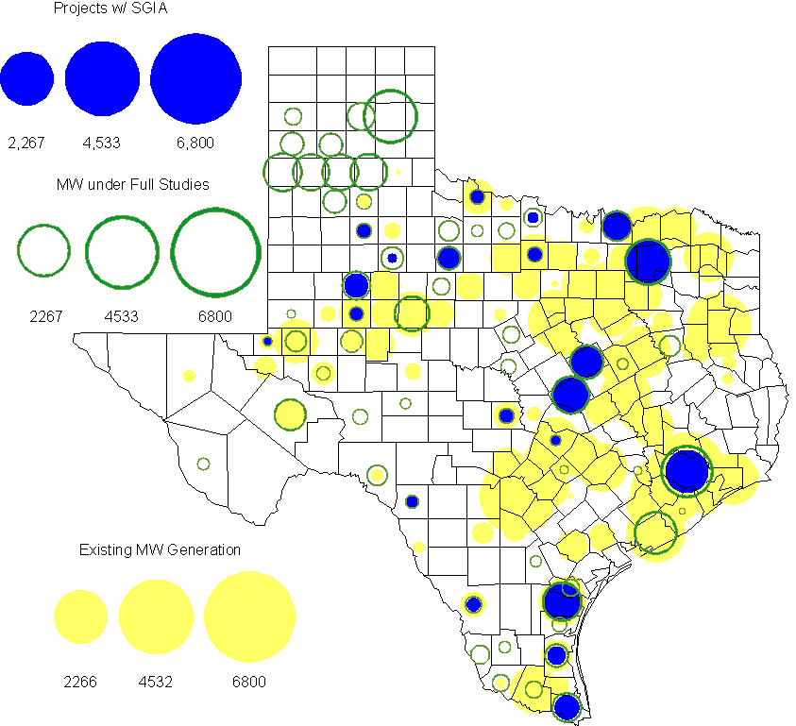

Projects with Interconnection Agreements
(Status: IA=Interconnect Agreement, XX= cancelled)
Generation Interconnections as of July 31, 2012
INR | SiteName | Status | County | Region | COD | Fuel Type |  | MW For Grid |  | Change from Last Report
12INR0076 | Notrees Battery Storage | IA | Winkler | West | Oct-12 |  | Storage |  | 36
11INR0086 | RRE Austin Solar | IA | Travis | South | Oct-12 |  | Solar |  | 60
08INR0011 | Senate Wind Project | IA | Jack | North | Nov-12 |  | Wind |  | 150
12INR0075 | Blue Summit Windfarm | IA | Wilbarger | West | Nov-12 |  | Wind |  | 135 | Capacity
12INR0072 | Anacacho Windfarm | IA | Kinney | South | Dec-12 |  | Wind |  | 100
11INR0091 | Whitetail Wind Energy Project | IA | Webb | South | Dec-12 |  | Wind |  | 92
10INR0023 | Baker Ranch | IA | Haskell | West | Dec-12 |  | Wind |  | 400
09INR0061 | WKN Mozart | IA | Kent | West | Dec-12 |  | Wind |  | 30
08INR0049 | Briar Creek | IA | Clay | North | Dec-12 |  | Wind |  | 50
11INR0033 | Los Vientos | IA | Cameron | South | Dec-12 |  | Wind |  | 400
09INR0001 | Sandy Creek 1 | IA | McLennan | North | Mar-13 |  | Coal |  | 925
06INR0022c | Penascal Wind Farm 3 | IA | Kenedy | South | Dec-13 |  | Wind |  | 202
12INR0034 | Stephens-Borlynn Wind Project | IA | Borden | West | Dec-13 |  | Wind |  | 378
13INR0021 | Ferguson Replacement Project | IA | Llano | North | Jul-14 |  | Gas-CC |  | 146 | Capacity
08INR0018 | Gunsight Mountain | IA | Howard | West | Aug-14 |  | Wind |  | 120
11INR0050 | Moore Wind 1 | IA | Crosby | West | Aug-14 |  | Wind |  | 149 | New
10INR0021 | Panda Sherman Power | IA | Grayson | North | Jan-15 |  | Gas-CC |  | 717
06INR0006 | Cobisa-Greenville | IA | Hunt | North | May-15 |  | Gas-CC |  | 1,792
10INR0020a | Panda Temple Power | IA | Bell | North | May-15 |  | Gas-CC |  | 780
10INR0020b | Panda Temple Power | IA | Bell | North | May-16 |  | Gas-CC |  | 780
10INR0022 | Pondera King Power Project | IA | Harris | South | Jun-16 |  | Gas-CC |  | 1,380
14INR0002 | Coleto Creek Unit 2 | XX | Goliad | South | Jan-17 |  | Coal |  | 660 | Cancelled
12INR0016a | Las Brisas Energy Center | IA | Nueces | South | May-18 |  | PetCoke |  | 620
12INR0016b | Las Brisas Energy Center | IA | Nueces | South | May-18 |  | PetCoke |  | 620
 |  |  |  |  |  |  | TOTAL |  | 10,062
Note: Projects that do not have an interconnection agreement but have been publicly disclosed via a Public Letter to ERCOT and were previously reported on this table have been moved to section 1.5 unless Suspended or Cancelled

Generation Projects Undergoing Full Interconnection Studies with Confidentiality Waived by Developer
INR | SiteName | Status | County | Region | COD | Fuel | MW For Grid | Change from Last Report
12INR0080 | Blanco Canyon Wind | PL | Floyd | West | Dec-12 | Wind | 300 | Cancelled
14INR0005 | White Stallion Energy Center | PL | Matagorda | South | Jul-14 | Coal | 1,200

Generation Projects Undergoing Full Interconnection Studies
INR | County | Grid | COD | Fuel |  | INR | County | Grid | COD | Fuel
10INR0062a | Pecos | 80 | TBD | Wind |  | 12INR0079 | Kenedy | 200 | TBD | Wind
12INR0089 | Pecos | 230 | Nov-12 | Wind |  | 11INR0094 | Kent | 100 | Nov-12 | Solar
12INR0067 | Webb | 94 | Dec-12 | Wind |  | 12INR0068 | Jim Hogg | 80 | Dec-12 | Wind
11INR0093 | San Patricio | 41 | Dec-12 | Wind |  | 12INR0060 | Schleicher | 58 | Dec-12 | Wind
12INR0055 | Baylor | 80 | Dec-12 | Wind |  | 12INR0081 | Upton | 113 | Dec-12 | Wind
13INR0040 | Harris | 0 | Jan-13 | Gas |  | 13INR0054 | Bexar | 0 | Jan-13 | Gas
13INR0010a | Parmer | 200 | Jan-13 | Wind |  | 11INR0082B | Val Verde | 150 | Mar-13 | Wind
11INR0083B | Crockett | 100 | Mar-13 | Wind |  | 09INR0051 | Borden | 249 | Mar-13 | Wind
13INR0045 | Castro | 288 | Apr-13 | Wind |  | 12INR0070 | Knox | 300 | Apr-13 | Wind
10INR0062b | Pecos | 220 | May-13 | Wind |  | 10INR0089 | Harris | 40 | May-13 | Storage
13INR0020a | Glasscock | 200 | May-13 | Wind |  | 12INR0086 | Harris | 89 | May-13 | Gas
12INR0045 | Kleberg | 135 | Jun-13 | Wind |  | 13INR0032 | Andrews | 30 | Jun-13 | Solar
13INR0057 | Archer | 65 | Jun-13 | Wind |  | 13INR0023 | Ector | 240 | Jul-13 | Coal
13INR0049 | Harris | 352 | Jul-13 | Gas |  | 11INR0013 | Mills | 150 | Sep-13 | Wind
11INR0082A | Val Verde | 50 | Sep-13 | Wind |  | 11INR0083A | Crockett | 50 | Sep-13 | Wind
13INR0025 | Randall | 150 | Sep-13 | Wind |  | 13INR0046 | Limestone | 71 | Sep-13 | Wind
13INR0005 | Carson | 600 | Oct-13 | Wind |  | 13INR0028 | Hale | 392 | Nov-13 | Gas
12INR0071 | Caldwell | 30 | Nov-13 | Wind |  | 10INR0009 | Castro | 300 | Dec-13 | Wind
12INR0002a | Briscoe | 200 | Dec-13 | Wind |  | 13INR0007 | Pecos | 200 | Dec-13 | Wind
11INR0085 | Nolan | 106 | Dec-13 | Wind |  | 13INR0026 | Oldham | 201 | Dec-13 | Wind
13INR0036 | Hidalgo | 200 | Dec-13 | Wind |  | 12INR0054 | Jones | 200 | Dec-13 | Wind
13INR0030 | Archer | 100 | Dec-13 | Wind |  | 12INR0059 | Pecos | 50 | Dec-13 | Solar
13INR0039 | Castro | 500 | Dec-13 | Wind |  | 13INR0038 | Swisher | 300 | Dec-13 | Wind
13INR0050 | Comanche | 200 | Dec-13 | Wind |  | 13INR0052 | Starr | 200 | Dec-13 | Wind
13INR0055 | Zapata | 250 | Dec-13 | Wind |  | 11INR0057 | Cameron | 165 | Dec-13 | Wind
08INR0019a | Gray | 250 | Jan-14 | Wind |  | 08INR0019b | Gray | 250 | Jan-14 | Wind
08INR0019c | Gray | 250 | Jan-14 | Wind |  | 13INR0006 | Gray | 750 | Jan-14 | Wind
14INR0013 | Cameron | 103 | Jan-14 | Wind |  | 14INR0014 | Val Verde | 100 | Jan-14 | Solar
12INR0084 | Randall | 242 | Jan-14 | Wind |  | 10INR0080 | Presidio | 81 | Jan-14 | Solar
13INR0010b | Parmer | 500 | Jan-14 | Wind |  | 13INR0020b | Glasscock | 150 | May-14 | Wind
14INR0011 | Swisher | 270 | Jun-14 | Gas |  | 14INR0015 | Harris | 192 | Jun-14 | Gas
14INR0012 | Gray | 401 | Jun-14 | Wind |  | 14INR0016 | Harris | 190 | Jun-14 | Gas
11INR0054 | San Patricio | 161 | Jul-14 | Wind |  | 12INR0042a | Deaf Smith | 265 | Sep-14 | Wind
12INR0042b | Deaf Smith | 135 | Sep-14 | Wind |  | 13INR0031 | Austin | 30 | Oct-14 | Solar
12INR0002b | Briscoe | 200 | Dec-14 | Wind |  | 12INR0018 | Gray | 500 | Dec-14 | Wind
11INR0081 | Live Oak | 72 | Dec-14 | Wind |  | 10INR0085 | Ector | 40 | Dec-14 | Solar
14INR0009 | Kent | 248 | Dec-14 | Wind |  | 14INR0020 | Floyd | 150 | Dec-14 | Wind
14INR0023 | Briscoe | 361 | Dec-14 | Wind |  | 14INR0018 | Nolan | 35 | Dec-14 | Solar
11INR0079a | Clay | 200 | Dec-14 | Wind |  | 12INR0029 | Swisher | 500 | Dec-14 | Wind
13INR0010c | Parmer | 500 | Jan-15 | Wind |  | 12INR0057 | Ector | 40 | Apr-15 | Solar
15INR0013 | Anderson | 324 | Oct-15 | Gas |  | 15INR0014 | Matagorda | 280 | Oct-15 | Gas
12INR0002c | Briscoe | 350 | Dec-15 | Wind |  | 16INR0003 | Brazoria | 11 | Jun-16 | Gas
14INR0003 | Nolan | 850 | Jun-18 | Coal

Note: ERCOT recently requested that the Transmission Service Providers comprehensively review the status of each of their assigned Full Interconnection Studies and report the status of each study back to ERCOT. Projects that were classified as “Cancelled” or “Suspended” as a result of this review are excluded from this table.

Wind Generation Capacity Installed by Year
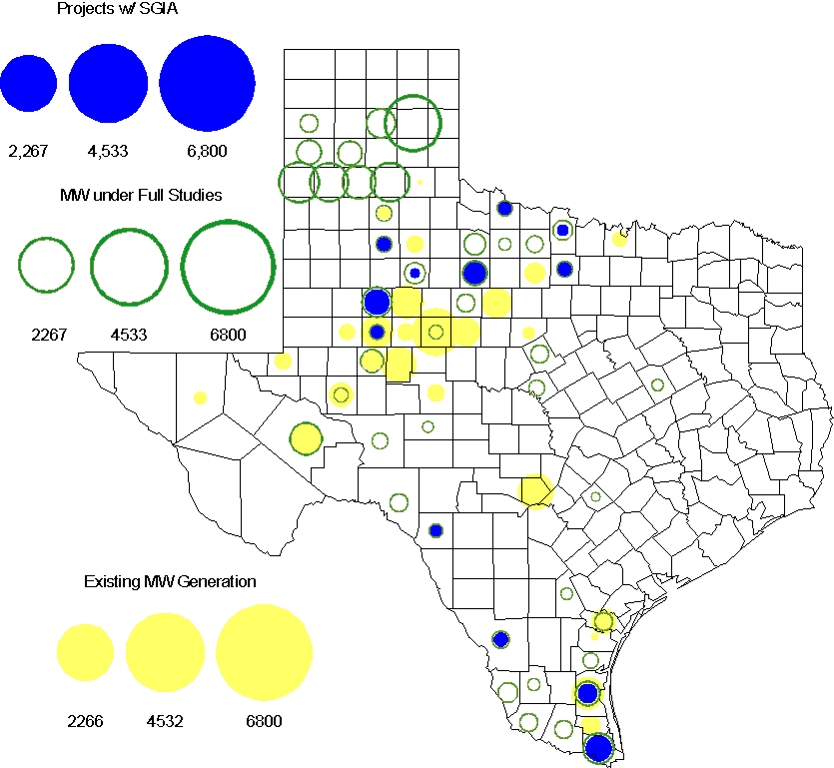

Regional Planning Group Project Reviews

- South Texas Electric Cooperative (STEC) has submitted the Karnes Electric Cooperative (KEC) and Medina Electric Cooperative (MEC) load addition project to accommodate 245 MW of new load in Karnes and Atascosa Counties. This is a Tier 2 project that is estimated to cost $48.4 million. This Tier 2 project is undergoing ERCOT Independent Review.

- CenterPoint Energy has submitted the Freeport Area upgrades project. This is a Tier 3 project that is estimated to cost approximately $47.2 million. This project has completed the RPG review and ERCOT will send the RPG acceptance letter.

- AEPSC has submitted the Airline/North Padre Island Area Improvements project. This project is submitted as a revision to the Barney Davis to Laguna 138 kV line (AEPSC Corpus Christi Improvements Project ) that was endorsed by ERCOT in November 2009. This is a Tier 1 project that is estimated to cost approximately $58.1 million. This project has been submitted for RPG comments.

Congestion Costs
Dollars shown in RUC Make Whole payment graph are of settlement quality.

RUC net Make Whole payment in $mm

Monthly Average LMP

Binding Constraints – Year to Date
Contingency | Binding Element | Number of 5-min intervals | Shadow Price Range $/MWh | Estimated Congestion Rent $ (Shadow Price*Limit) | Transmission Project
Amoco North Cowden Tap - Moss 138kV | Odessa North 138/69 kV Autotransformer | 9973 | 0 - 2800 | 73,038,421 | 5YTP [2010-R7, R8]
Sacroc - Sun Switch 138 kV; or Golden Switch - Sun Switch 138 kV | China Grove - Bluff Creek 138 kV | 1454 | 0 - 3500 | 27,183,561 | 13TPIT0098, 13TPIT0093
BASE CASE | West to North Stability Limit | 8114 | 0 - 436 | 26,831,248 | CREZ
Twin Buttes 345/138 kV Autotransformer | San Angelo Red Creek 345/138 kV Autotransformer 2 | 113 low-side; and 262 high-side | 19 - 3500 low-side; and 2 - 4500 high-side | 18,360,051 | 14TPIT0067
Lewisville - Carrollton Northwest 345 kV | Lewisville - Jones Street TNP 138 kV | 4632 | 0 - 3500 | 16,918,023 | CREZ, 07TPIT0042
Batesville 138/69 kV Autotransformer; or Batesville Switching Station - Paloduro Substation 138 kV | Moore Switching Station - Downie Switching Station 138 kV | 1459 | 0 - 3500 | 14,934,701
Midland East - Odessa EHV 345 kV | Odessa - Odessa North 138 kV | 462 | 0 - 3500 | 14,524,826 | 14TPIT0054
Kyle - San Marcos 138 kV | Turnersville - Buda 138 kV | 352 | 0 - 3500 | 12,959,632 | 09TPIT0060
Marshall Ford - Lago Vista 138 kV | Buttercup - Whitestone 138 kV | 151 | 6 - 3500 | 7,020,443 | 10TPIT0074
China Grove - Bluff Creek 138 kV | Moss - Amoco North Cowden Tap 138 kV | 409 | 0 - 3500 | 6,608,177 | 13TPIT0098, 13TPIT0093
Binding Constraints – May 2012
Contingency | Binding Element | Number of 5-min intervals | Shadow Price Range $/MWh | Estimated Congestion Rent $ (Shadow Price*Limit) | Transmission Project | Comments
Amoco North Cowden Tap - Moss 138kV | Odessa North 138/69 kV Autotransformer | 4067 | 0 - 2275 | 35,410,430 | 5YTP [2010-R7, R8] | Low wind and high loads in West Texas
Midland East - Odessa EHV 345 kV | Odessa - Odessa North 138 kV | 372 | 0 - 3500 | 14,158,477 | 14TPIT0054
Batesville Switching Station - Paloduro Substation 138 kV; or West Batesville - Batesville Switching Station 138 kV | Moore Switching Station - Downie Switching Station 138 kV | 615 | 0 - 3500 | 3,407,846 |  | High loads and multiple outages in the area
Kyle - San Marcos 138 kV | Turnersville - Buda 138 kV | 76 | 0 - 3500 | 2,852,711 | 09TPIT0060
Golden Switch - Sun Switch 138 kV | China Grove - Bluff Creek 138 kV | 97 | 0 - 3500 | 2,508,155 | 13TPIT0098, 13TPIT0093
Big Brown SES - Venus Switch 345 kV; or Watermill Switch - Limestone 345 kV | Richland Chambers - Trinidad SES 345 kV | 134 | 8 - 4500 | 2,478,466 |  | Generator forced outages
Lewisville Switch 345/138 kV Autotransformer 2 | Carrollton Northwest - Lakepointe TNP 138 kV | 63 | 85 - 3500 | 2,427,667 | 14TPIT0014
Farmersville - Monticello SES 345 kV dbl | Monticello SES - Allen Switch 345 kV | 37 | 1 - 4500 | 1,164,438 |  | Substation breaker outage
(Krum West Switch) - Lewisville Switch - Carrollton Northwest 345 kV | Euless - Grapevine Highway 360 138 kV | 16 | 387 - 3500 | 1,077,645 | 11TPIT0012 | A RAP has been developed
Amoco North Cowden Tap - Moss 138kV; or Odessa Basin Switch - Odessa North 69 kV | Odessa North - North Cowden 69 kV | 90 | 1266 - 2800 | 878,060 | 14TPIT0009 | Low wind and high loads in West Texas

Wind Generation as a Percent of Load
One-hour average of total wind power output as a percentage of ERCOT load.

Planning Model Activities
- 2013 Data Set A cases posted on July 9th .
- The June base case TPIT updates are underway with anticipated completion the second week of August.
- Data Set B work began on August 1, 2012 with a Topology Processor case extracted from NMMS with a build date of January 1, 2013.
- The short term calendar of major planning model events follows:
  - July 9, 2012 Post 13 Data Set A cases posted.
  - Aug 1, 2012 Extract Topology Processor case with Jan 1, 2013 build date.
  - Aug 11, 2012 Post 12 Data Set A and B June TPIT updated cases.
  - Oct 15, 2012 Data Set B cases posted
- Status update on SCR760, Changes Needed for Information Model Manager and Topology Processor for Planning Models, which was approved by the ERCOT Board in March 2011.
  - Bundle 1 (Items 3, 7 and 8): In Production.
  - Bundle 2 (Items 2a, 4, 9): In Production.
  - Bundle 3 (Item 5, 2b, 2c): In Production
  - Bundle 4 (Items 1, 6): Item 1 considered to be in production. Requirements for Item 6 are in development.
SCR Sub Part | SCR Description | Status
SCR760-1 | Upgrade to PSS/E v32 | Production
SCR760-2 | Distribution Capacitor banks | Production
SCR760-3 | Zero Impedance Line Ratings | Production
SCR760-4 | Associate Loads and Capacitor banks with the correct CNG | Production
SCR760-5 | Additional Transformer Data for Planning | Production
SCR760-6 | FACTS Devices | Planning
SCR760-7 | Assign valid PSSE IDs to Breakers/  Switches/ Series Devices | Production
SCR760-8 | Phase shift of Autos for short circuit studies | Production
SCR760-9 | Multisection Line Grouping | Production
Table 1: In the following table:
- Red will be used to show status of Not Submitted, meaning that the SCR sub part has not been submitted to Siemens as a Service Request.
- Yellow will indicate that the SCR sub part has been submitted. The color will remain yellow and the status will change in order to Submitted, Planning (Requirements, SOW, Code Writing), Release (Siemens produces first code to test), and Testing (code has completed internal test and is moving through release management).
- Green will indicate that the code has been tested and installed on the machines that ERCOT uses to produce Topology Processor output for Planning and CRR.

Other Notable Activities
- The 2012 Five-Year Transmission Plan study schedule and Reliability start cases were posted at ERCOT POI on July 5. Currently the 2012 5YTP reliability analysis is being performed.
- ERCOT System Planning is reviewing and comparing the dynamic model data submitted through the RARF to the DWG dynamic base case. Review results are being provided to Resource Entities for updates and confirmation.
- ERCOT is spot checking governor model performance by comparing the actual measurement with dynamic model response. Review results will be provided to Resource Entities for updates and confirmation.

