ERCOT RESPONSE TO FRRS PILOT PROJECT QUESTIONS AND COMMENTS
(08-07-2012)
ERCOT provides this written response to stakeholder questions and comments concerning ERCOT’s proposed Fast-Responding Regulation Service (“FRRS”) pilot project. ERCOT’s answers are in blue text. ERCOT has attempted to provide complete answers to all questions, although certain matters will be more definitively addressed by the draft Governing Document. Please note that ERCOT does not provide answers to ETWG comments in this document, as these comments essentially memorialize discussions that took place at those meetings, and do not request a response. Note that the FRRS pilot project program rules ultimately adopted may deviate from the descriptions ERCOT provides in this document for various reasons including the receipt of additional stakeholder input or data.
- PDCWG Questions

At its 6/26/2012 meeting, the PDCWG discussed the pilot for Fast Response Regulation. The main challenge was a complete understanding of the fundamentals of the proposed service. The expectation was that there are technologies that are ready to provide this service and the group was looking to review data to better characterize the reliability aspects of the pilot. Since data was not available for review, the group engaged in theoretical concerns as well as fundamental expectations around the service. The concerns and expectations that were raised during the discussion are summarized below.

- Are we considering an Ancillary Service for system inertia? Since ERCOT says system inertia is an issue...and generators provide inertia, this should be a compensated service.

ERCOT is not currently considering an Ancillary Service for system inertia. However, ERCOT would be willing to review any stakeholder proposal to provide compensation for “inertia service.”

- How will battery charging for the 65 MW up and 35 MW down and discharging values be included in the AS Capacity monitor values? Will there be a separate line in the AS Capacity monitor?

During the pilot, FRRS capacity will not be shown in the AS Capacity Monitor. If the pilot is successful and FRRS becomes an Ancillary Service, ERCOT expects that FRRS would then be reflected in the AS Capacity Monitor as a separate single line-item. However, ERCOT sees no reason to separately denote FRRS capacity provided by batteries.

- Will the batteries be part of LFC? If not, are they only expected to operate at certain levels of frequency deviation?

Resources carrying FRRS (including batteries) will be required to respond to a signal separate from LFC. FRRS will not be deployed for deviations of frequency less than or equal to +/- .03 Hz.

- Is ERCOT trying to work on the existing EMS to improve regulation control and recall?

ERCOT is always looking for ways to improve regulation performance.

- How will the Batteries be settled? Since these are Resources—they should have Resource nodes and resource node prices published like other resources.

All Resources qualified to provide FRRS, including batteries, will be settled in accordance with the ERCOT Protocols. The existing procedures for identifying Resource Node locations, Net Metering Settlement and posting of Resource node prices will be followed for all FRRS Resources. Currently all Resource Node prices are published to the MIS Secure Area.

- How will the costs be allocated to loads?

The costs will be allocated to Load in the same manner as existing Ancillary Service costs.

- How will the performance be evaluated? What are the success metrics for the test?

Performance of FRRS Resources will be evaluated based on the performance criteria below:

- Resources providing FRRS shall provide at least 95% and no more than 110 % of the amount required by the ERCOT deployment instruction for that Resource for 95% of all FRRS deployments within a month.
- If frequency declines to 59.91 Hz or less, Resources obligated to provide FRRS-up shall immediately deploy that service until recalled by ERCOT.
- If frequency reaches 60.09 Hz or more, Resources obligated to provide FRRS-down shall immediately deploy that service until recalled by ERCOT.

- Will ERCOT provide the interconnection points for these Resources? So that other Resources in the area know that they might be impacted by this?

Yes, the Resource nodes for all modeled Generation Resources will be included in the Network Model. Based on our experience with Load Resources, ERCOT does not expect other Generation Resources in the area to be impacted by the interconnection of FRRS Resources.

- What exemptions for GREDP or Base Point Deviation charges will be provided for generators next to batteries if the batteries create local frequency disturbances?

Generators will not be exempted from GREDP or Base Point Deviation charges based on deployments of nearby Resources deploying for FRRS, just as these Resources would not be given any such exemption due to deployments of nearby Resources for any other Ancillary Service. The proposed amount of FRRS Resources in this pilot project is not expected to create any counter impact to the system performance. And unlike voltage, frequency is in general the same for the entire system.

- How will deviations for Basepoint deviation charges be handled during this period? If there is a generator responding to low frequency that would be exempted from BP deviation charge, if frequency “suddenly” turns around due to deployment of FRS and gen is recalled, will there be an exemption for the operation outside of the frequency band for this period?

ERCOT does not intend to change the method of assessing Base Point Deviation Charges. Under current Protocols, QSEs risk incurring base Point Deviation Charges when their Resources deviate from their assigned adjusted aggregated Base Points.

- Is ERCOT worried about oscillation issues or local SSR issues?

No. ERCOT does not expect that FRRS deployment would create any meaningful oscillation or Sub Synchronous Resonance (SSR) issues above and beyond those identified by ERCOT during the Generation interconnection process (which will have presumably already been remedied).

- What are the performance expectations during DCS events?

Each FRRS-committed resource is expected to provide 100% of its obligated capacity during a DCS event and sustain that response for up to 2 minutes. After the deployment limit has been reached or the resource has been recalled, the resource must be immediately ready to respond to a subsequent two-minute deployment.

- What are the performance expectations during frequency events that do not meet the PDCWG threshold for review? (presentation only prescribed an appropriate response)

For frequency deviations of less than or equal to 90 mHz, FRRS Resources will respond to the FRRS signal. For frequency deviations greater than 90 mHz, FRRS Resources will be required to respond automatically by providing 100% of their capacity obligations for up to two minutes.

- Will there be a reduction in the impact of regulation when responding to a DCS event?

No. During the DCS event, ERCOT ACE is typically very high, so all Regulation-up available at that moment should be fully deployed.

- What are the expected test parameter ranges during the pilot phase? (presentation did not provide details around deployment logic).

The FRRS Governing Document will describe all deployment scenarios in detail.

- What is the impact on other reliability metrics?

ERCOT does not expect any impact on other reliability metrics.

- What is the impact on ancillary services and performance to their deployments?

ERCOT does not expect to change its procurement or deployment practices with regard to conventional Regulation Service, nor does it see any reason to alter performance metrics for providers of this service. However, if the deployment of FRRS reduces the need to deploy conventional Regulation Service, this should also eventually reduce the procurement of Regulation Service based on the approach described in the Methodologies for Determining Ancillary Service Requirements document. If FRRS is ultimately integrated into the Protocols, a temporary deviation from the approach described in this document may be needed to ensure ERCOT procures the appropriate amount of Regulation Service.

- What information is available describing the target resource supply? (is there enough capacity to justify the expense and effort of the pilot)

ERCOT has been contacted by several entities that have expressed an interest in providing an FRRS service and participating in this pilot. ERCOT feels relatively certain that it should be able to qualify enough Resources to participate in the pilot to make the pursuit of the pilot fruitful. ERCOT intends to clarify the degree of participation from interested FRRS providers in the near future. In the event ERCOT does not obtain sufficient participation, ERCOT will seek approval to delay or terminate the pilot.

- The deployment expectations describe a step response to frequency deviations which is counter to existing generator frequency response. A better description illustrating why this is desirable will help in characterizing the service.

FRRS is intended to respond to frequency deviation when frequency reaches a certain threshold. The limited size of the FRRS pilot project is not expected to create any counter-impact to system performance. During the pilot ERCOT will test the use of multiple deployment approaches, including options to deploy in multiple steps, to better understand the capability of FRRS Resources and their value to the ERCOT System. Details of these approaches will be provided in the Governing Document. If the pilot is successful, ERCOT will evaluate whether FRRS service should be capped and whether any particular deployment logic should be implemented based on its experience during the pilot project.

- Since this is a new concept, a fundamental understanding of the deployment methodology is desired.

See response to #15.

- How does this parallel with regulation, where do you draw the line between the services?

FRRS is intended to complement conventional Regulation Service. FRRS acts like a shock absorber; it provides an immediate full Response during the period that Resources carrying conventional Regulation are only starting to respond.

- What problem are we trying to solve with this Pilot? If it is "inertia"/Primary Frequency Response as the slide presentation offered, and the new service is adopted, will existing units also be paid for "inertia service" when the service is established?

ERCOT is proposing this pilot in part to evaluate the degree to which FRRS can more effectively and efficiently arrest frequency decay compared to conventional Regulation Service. FRRS would not contribute to system inertia; it would simply provide one of the same benefits: i.e., lessening the need for conventional Regulation. ERCOT is not currently considering an Ancillary Service for system inertia. However, ERCOT would be willing to consider any proposal to provide compensation for “inertia service.”

- Will these service providers be paid 8/60th (13%) of the DAM clearing price for REG Service since they will only be required to perform 8 minutes/hour?

No. FRRS will receive the full hourly capacity payment because they are subject to being deployed multiple times within an hour, depending on system frequency. FRRS providers are not exempt from deployment at any time. FRRS providers will be subject to after-the-fact adjustments to their hourly capacity payments based on performance.

- What is the inclusive list of performance metrics these resources will be judged against in the pilot? (Please identify them from the Protocols, Operating Guides and Other Binding Documents.)

The inclusive list of performance metrics and appropriate citations will be captured in the pilot Governing Document. In general, ERCOT will evaluate performance of an FRRS Resource based on its speed of response and its ability to accurately follow FRRS signals.

- Since additional "system inertia" is the goal of this service, since steady state metrics [CPS1] for the ERCOT Region are easily passed today, how will you measure and quantify the added value of that added inertia during the Pilot Program? (Please provide the calculation methodology that will be used.)

FRRS would not contribute to system inertia, and that is not the “goal” of FRRS. FRRS would provide one of the same benefits as system inertia—namely, more effective response to frequency decay.

- How will you determine (calculate) and inform the market that the total avoided costs of REG Service as a result of the Pilot Program?

ERCOT intends to compare the quantity of Regulation deployment during the pilot with historical quantities of Regulation deployments, with adjustments to compensate for known changes (e.g., increase in the WGR ramp-rate, SCED LFC interaction).

- What amount of data from the Pilot Project is ERCOT considering a representative sample for determining that the end of the Pilot Project and the beginning of the post-pilot analysis period?

ERCOT expects that a six-month pilot will provide sufficient data to assess the value of FRRS.

- How/Where will ERCOT post the data and analysis from the Pilot Project to allow stakeholders to interact with ERCOT in the decision making on the feasibility of this Pilot as a potential A/S?

ERCOT will review and discuss FRRS pilot data with the appropriate stakeholder groups and will share this data on the Pilot Projects web page. Any NPRR to implement FRRS would go through the normal stakeholder process.

- Does the ERCOT Region currently have an identified control performance problem that is causing the Region to fail CPS1?

No. ERCOT is not failing CPS1 metrics.

- Does the ERCOT Region currently have an identified control performance problem that is causing the Region to fail the DCS Standard?

No. ERCOT has not documented any failure of the NERC DCS standard in several years.

- What is the inclusive list of Protocols, Operating Guides and Other Binding Documents requirements pertinent to resources providing REG Service that FRRS resources will be exempted from in the Pilot?

Requirements for providing conventional Regulation service will not apply to FRRS unless ERCOT explicitly establishes otherwise in the Governing Document. ERCOT will also specify in the Governing Document which existing Protocol requirements will not apply to FRRS providers during the pilot.

- How will the Pilot Project be effectively evaluated for a potential ancillary service if the requirements in [the previous question] are not observed in the Pilot yet required under the potential ancillary service?

The exceptions from the Protocols defined in the Governing Document should not inhibit ERCOT’s ability to evaluate FRRS as a potential Ancillary Service.

- Edison Mission Questions
ERCOT’s presentation, states that the goals of the Fast Responding Regulation Service pilot are:
1. Promptly arrest frequency decay during unit trips
2. Diminishing use of traditional regulation
3. Reduction in Regulation capacity procurement
4. Better frequency control at a lower overall cost
- Relative to point 2 above, how will ERCOT measure the “diminishing use of traditional regulation?” Will this solely be measured over periods of system disturbance or is ERCOT intending this service to address the ongoing use of Regulation-Up service to serve load? Is the FRRS service expected to reduce the ongoing use of regulation up to serve load?

ERCOT will measure reduction in Regulation usage over the course of the pilot. To calculate the reduction, ERCOT will compare deployments in pilot months to the same months in the previous year (adjusted for known changes). FRRS is expected to reduce our dependence on conventional Regulation Service by providing faster response to restore frequency.

• Relative to point 3 above, what metrics will ERCOT be evaluating to determine the changes in Regulation that it is procuring?

ERCOT will use FRRS deployment, resource performance, and other data from the pilot to predict the magnitude of any regulation procurement changes. However, ERCOT could see a minor reduction in procurement for certain days during the pilot if FRRS results in a reduction in the deployment of conventional Regulation Service. This is because the current TAC-approved Ancillary Services Procurement Methodology determines procurement by taking the 98.8th percentile of historical deployments for each hour in each of the past 30 days and from each day in the month one year prior. This would not be expected to greatly change procurement until 12 months after the month the pilot begins. That methodology could be changed to introduce any expected reduction in procurement earlier in the process.

• Relative to point 4 above, how will lower overall cost be measured?

After the pilot, ERCOT will determine the expected impact on procurement based on the Ancillary Services Procurement Methodology. The expected cost of this procurement will be compared to past procurements, and will be adjusted for other known factors.

• Would ERCOT consider requiring offers from the FRRS providers to provide the service on a competitive basis? Under such a scenario, ERCOT could accept bids manually for example, once per week-- and run a SASM to determine a weekly clearing price for the up and down service by peak and off-peak. Presumably the cost of the service for some FRRS resources would be changing by season, by up or down service, on-peak, and off-peak etc. Having some estimate of the cost of the service would make the cost saving calculation more defensible and robust. The avoided cost of procuring Regulation service is just that, an avoided cost. Without offers from FRRS providers, how would ERCOT assess and determine whether the cost would be lower overall?

ERCOT intends to pay FRRS providers the DAM clearing prices for Regulation Service for their capacity during the term of the pilot. After the pilot, if the product proves to be of greater operational value than conventional regulation, ERCOT will consider what methodology would yield the most appropriate price going forward, and will propose an NPRR reflecting this approach. ERCOT does not favor competitive procurement of pilot resources because of the lack of competition due to the small number of possible pilot resources.

• How long will the pilot last?

ERCOT expects to conduct the FRRS Pilot for six months. However, if ERCOT determines that it has collected sufficient data to fully evaluate the product, it may request Board approval to terminate the project earlier. ERCOT does not expect to need more than six months, but if that is deemed necessary, ERCOT will request that the Board extend the program for a specified time.

• How will the 65 MW up and 35 MW down values be included in the AS Capacity monitor values? Will there be a separate line in the AS Capacity monitor for this service? If the service is provided by batteries and if they are in a charging state—is the 65 MW of up service expected to be available at all times when it is undeployed?

During the pilot, FRRS capacity will not be shown in the AS Capacity Monitor. If the pilot is successful and FRRS becomes an Ancillary Service, ERCOT expects that FRRS would then be reflected in the AS Capacity Monitor as a separate single line-item. All FRRS Resources will be obligated to deploy for as long as six minutes per deployment. However, ERCOT does not expect to place a limit on the number of deployments or to impose a minimum down time following a deployment.

• Could you provide more information on the passive vs the directed response that is expected from the technologies in the pilot?

FRRS pilot resources will be required to deploy automatically within sixty cycles when frequency exceeds a deadband of +/- .09 Hz. Otherwise, ERCOT may issue a signal to deploy FRRS pilot resources whenever frequency exceeds a deadband of +/- .03 Hz. ERCOT will issue a signal to recall FRRS Resources.

• Will Resource Node LMPs be produced by ERCOT for the locations of these technologies?

Yes. ERCOT will calculate and publish LMPs for any Resource Nodes associated with pilot resources.

• What exemptions for GREDP or Base Point Deviation charges will be provided for generators if deployment (or charging) of pilot participant technologies create local frequency disturbances that would cause generators which were deployed in the correct direction for frequency to have to turn around if there is a local frequency disturbance due to the injection of large amounts of power over a few cycles?

Generators will not be exempted from GREDP or Base Point Deviation charges based on deployments of nearby Resources deploying for FRRS, just as these Resources would not be given any such exemption due to deployments of nearby Resources for any other Ancillary Service. The proposed amount of FRRS Resources in this pilot project is not expected to create any counter impact to the system performance. And unlike voltage, frequency is in general the same for the entire system.

• ERCOT confirmed during a discussion at the PDC on 6/27 that FRRS deployment signal logic will be shared with all resources. When will this occur?

This will be captured in the Governing Document for the pilot program.

• ERCOT’s presentation on the pilot states: “ERCOT may make additional parameter changes during pilot as needed.” What type of parameters will ERCOT be evaluating for potential change?

ERCOT expects that it may wish to test different frequency set points, deployment quantities, and deployment durations to evaluate optimal deployment parameters during the pilot term. Any such changes will be announced with sufficient time prior to implementation.

- Xtreme Power Comments

1. Introduction
Xtreme Power supports the ERCOT proposal to conduct a pilot project for Fast Responding Regulation Service (FRRS). Xtreme Power is in the final stages of developing a battery storage facility in West Texas that will be capable of providing the service envisioned by the ERCOT proposal and looks forward to participating in a pilot that will test a fast regulation service. The proposal is consistent with the rule amendment that the Public Utility Commission recently adopted and represents an opportunity to conduct a practical test of a technology that is new to the bulk power system (energy storage) and a different method of providing Regulation Service that holds promise of improving the operation of the ERCOT system. Xtreme Power recommends two changes to the proposal. First, the limits on the size of the pilot should be increased, and the method for prorating awards of capacity for FRRS should be modified. Second, the documents setting out the terms of the pilot should identify temporary exceptions to certain protocols for participants in the pilot project. Both changes would make the pilot more suitable for energy storage resources (ESRs) and improve the effectiveness of the pilot in investigating new technologies and improved methods for regulating system frequency.

Xtreme Power also offers some closing thoughts on certain issues which have emerged through recent stakeholder discussions and which merit some consideration in the process to draft the pilot governing document.

2. Size of Pilot Project and Proration Methodology
The ERCOT proposal would establish limits for participation of 65 megawatts of FRRS in the up direction and 35 megawatts down. The pilot project proposal also includes a proration methodology for FRRS service that would apply if the offers to provide the service exceed the maximum size of the pilot project. Xtreme Power is concerned that the limits may preclude eligible resources from participating in the pilot, thereby limiting the value of the pilot in evaluating FRRS service. Xtreme Power suggests that limits of 100 MW for FRRS Up and 50 MW for FRRS Down would provide for a better evaluation of the FRRS service, particularly during periods of high demand. The ERCOT Board recently approved a 150 MW pilot for 30-Minute Emergency Response Service, and the concerns that Board members expressed about the value of a small pilot project apply in connection with the FRRS pilot.

Unless the limits for the FRRS service are significantly increased, the proration method should be modified. Under the proposed pilot, if there are offers for an hour that exceed the limit, the capacity to be awarded would be prorated, based on the ratio of the limit to the aggregate capacity offered. For example, if the aggregate offers for FRRS Up were 70 MW, each qualified FRRS resource bidding in the hour would be designated to provide 65/70 times the capacity it offered, so that the amount of capacity awarded would be equal to the limit.

It is not clear whether the limits on FRRS will have an impact on participants in the pilot project, but it is possible that if there are large resources participating in the pilot project, the proration method proposed by ERCOT would impair the effectiveness of the pilot by setting unreasonable limits on the capacity awarded to resources participating in the project. The proposed proration approach appears to be workable unless the total amount of capacity that is capable of providing FRRS is significantly larger than the limit and includes one or more resources that are larger than the limit. For example, suppose a single resource is capable of providing 120 MW of FRRS Up and the total amount of capacity capable of providing FRRS Up is 200 MW. If all of the capacity capable of providing FRRS Up is offered and the 120 MW resource offers to provide 120 WM, all resources would be reduced, through the proration process, to about one-third of their capacity. (The ratio of 65/200 would be applied to the capacity offered by every resource.)

Xtreme Power believes that the pilot project will be more valuable if the rules facilitate participation at meaningful levels by all of the resources that are capable of providing the service. This result would be better achieved by modifying the proration method so that each resource’s offer may not exceed the limit for the service, with the proposed proration formula then applied. Applying such a modified proration methodology to the example set out above would mean that the total FRRS offered would be 145 MW, and each resource would be reduced through proration by a little more than half its offered capacity. (The ratio of 65/145 would be applied to all resources.) This modification of the proration method would allow participants in the pilot project to operate at more meaningful levels, and would facilitate a more robust test of FRRS. This modification to the proration method proposed by ERCOT is consistent with the pilot proposal and would foreclose a possible bidding strategy that would permit large resources to squeeze smaller resources, significantly reducing their level of participation. There may be other approaches to addressing this concern, and Xtreme is receptive to alternatives that effectively address the concern.

ERCOT established the maximum size of the FRRS pilot procurements at 65 MW for Regulation-Up and 35 MW for Regulation-Down following analysis of historical actual load data. These numbers would be optimal for the objective of correcting for frequency deviations of 20 mHz and 10 mHz respectively during average load conditions from November through April. ERCOT believes the ceilings also provide appropriate restraint on the potential expense of the new service during the pilot phase.

For the purposes of this pilot, ERCOT agrees that the maximum FRRS offer from any single Resource for any operating hour should be limited to 65 MW. ERCOT sees value in increasing the quantity of pilot participants, and adopting a 65 MW offer cap per resource should encourage participation by a greater number of participants.

3. Protocols
The rule issued by the PUC permits ERCOT to approve temporary exceptions to protocols in a pilot project. It seems clear that such a temporary exception is an essential element of a pilot. If the technology to be evaluated in a pilot were consistent with the protocols, a market participant could operate within the protocols, without the need for a pilot. Similarly, the purpose of an ERCOT pilot project is to evaluate the provision of a service in a manner different from that prescribed in the protocols. The protocols and other governing documents provide detailed instructions on how existing services are procured and deployed, and intentional variations would not be permitted outside of a pilot. The proposal drafted by ERCOT does not include any temporary exceptions. Xtreme Power believes that temporary exceptions are appropriate, in this case, to make it clear that FRRS will be procured and deployed, to some extent, differently from existing Regulation Service, and to permit storage resources to more effectively participate in the pilot project. Without a temporary exception, an ESR or other resources providing FRRS would face the risk that their operations under the pilot would be contrary to current protocols, subjecting them to possible penalties and other sanctions.

In addition, protocols that will not apply to pilot participants should be identified early and incorporated into the document describing the pilot that is submitted for Board approval. Xtreme power, as noted above, is in the process of completing a storage facility, and it will need to configure the operating capabilities of the storage facility for the pilot project, based on the universe of applicable protocols, to optimize performance and maintain compliance during the pilot. Clearly documenting the rules for the pilot and how they relate to the protocols is important in encouraging broad participation in the pilot and for the overall success of the pilot. Xtreme Power believes that the protocols discussed below should be considered for temporary exceptions for the purpose of the pilot.

ERCOT understands the need for clarity of the rules applicable to pilot projects. The Governing Document will specify which Protocol requirements will not apply to pilot participants.

a. Exceptions Relating to Continuous 60-Minute Service Duration
Regulation service, by its nature, is an intermittent service, and resources providing both RegUp and RegDown can expect that they will be deployed for short periods in both directions. A number of protocol provisions are intended to ensure that ancillary services, which are defined as a one-hour service, can be provided over that period by resources that offer to provide the service. The 60-minute duration assumption in the protocols is not essential for FRRS and is inconsistent with the capabilities of some storage resources. A presentation by ERCOT staff to the Wholesale Market Subcommittee on June 13, 2012, showed the anticipated operation of FRRS in the context of actual changes in system frequency. In a graph of system frequency over the course of an hour, the system frequency graph crossed the 60 hertz line roughly 50 times in an hour, so it may be assumed that the Regulation Services deployed in the hour included a number of short periods of both RegUp and RegDown. The graph also showed periods in which FRRS would have been deployed if the pilot had been in operation. None of these periods was as long as five minutes. The 60-minute requirement in some of the protocols is simply not consistent with the expected operation of FRRS.

An energy storage resource is well suited for providing regulation service, because the ESR can readily charge or discharge to provide the service and also to maintain an appropriate state of charge, so as to be prepared to provide Regulation Service in either direction when it is next called upon to do so. While an ESR is well suited for providing short periods of FRRS Up and FRRS Down, it does not necessarily have the capability to provide energy at maximum capacity for a full hour. However, an ESR is able to provide the expected requirements of FRRS over the course of an hour, or indeed, many hours, because typically short periods of up and down regulation are required, not long periods in the same direction. The FRRS service that ERCOT envisions is consistent with providing large amounts of capacity over short periods, rather than providing an increment of capacity over a half hour or hour. Thus temporary exceptions should be approved for those protocols that contemplate the provision of energy for an hour or half-hour or tests to demonstrate such capability as a condition of unit or QSE qualification to provide ancillary services or similar barrier to market participation. The pilot should be a reasonable test of the capabilities of storage units to provide a fast regulation service and a reasonable test of the fast regulation service itself. For these reasons, temporary exceptions should be granted to the following protocols:

• Section 3.9.1 Current Operating Plan Criteria provisions on 60-minute capability.
• Section 6.4.1.8.3 Replacement of Ancillary Service Due to Failure to Provide provisions for penalties for failure to provide an ancillary service for a full hour.
• Section 6.4.5 Resource Status provisions relating to resource status during the Operating Hour.

Testing and deployment requirements for current providers of Ancillary Services will not necessarily apply to FRRS Resources in the pilot phase. ERCOT intends to propose a two-minute maximum duration for deployment in any one direction. This will apply in all cases except those involving increases of frequency deviation to a new deadband, in which case the maximum deployment in any one direction could reach six minutes. If frequency deviation suddenly changes direction, obligated pilot resources would need to deploy consistent with the appropriate deadband requirement.

b. Exceptions Relating to Characteristics of Energy Storage Resources
As noted above, the nature of regulation service and the capabilities of storage resources are well matched, and the rules for the pilot project should not be an obstacle to the participation of storage resources in the pilot at full capacity. Rather, the pilot project should include temporary exceptions that allows storage devices to participate at full their capacity in both directions. Temporary exceptions should be granted to the following protocols, which would make it difficult for ESRs to operate at optimal capacity:

• Section 3.17.1 Regulation Service provisions that describe regulation capacity using the phrase “the amount of capacity available from a Resource that may be called upon to change output as necessary.”
• Section 4.5.1 DAM Clearing Process provisions that limit a resource’s ability provide both regulation up and down in the same Operating Hour at the maximum capacity of the resource.
• Section 8.1.1.1 Ancillary Services Qualification Testing and Section 8.1.1.2 General Capacity Testing Requirements provisions relating to a one-hour test, including a requirement to hold output at HSL for 30 minutes.

As already noted, ERCOT will not require FRRS participants to deploy in one direction for longer than two minutes in most cases, or six minutes in cases involving gradual increases in frequency deviation. During the pilot, FRRS will not be considered “Regulation Service,” so provisions addressing that product will not necessarily apply.

c. Exceptions to Differentiate FRRS from Current Regulation Service Deployment
Temporary exceptions should be granted to the following protocols to make it clear how FRRS works differently from current Regulation Service:

• Section 6.5.7.6.1 LFC Process Description relating to the Load Frequency Control process and how frequency-control instructions, including provisions relating to the QSE participation factor requirements in Paragraph (5).
• Section 6.5.7.6.2.1 Deployment of Regulation Service provisions relating to an implied ramp rate.
• Section 8.1.1.4.1 GREDP, which is not designed to accommodate an entity with both a GREDP and CLREDP score across dispatch cycles within settlement intervals.
• Section 8.1.1.2.1.1 Regulation Service Qualification provisions relating to a one-hour test with random dispatch instructions.

During the pilot, FRRS will not be considered “Regulation Service,” so provisions addressing that product will not apply.

4. Additional Considerations
Xtreme Power thanks ERCOT for its engagement to date with the stakeholder process, through which many questions about the FRRS proposal have been clarified. Xtreme suggests the issues described below may warrant particular consideration during the pilot project governing document development process.

a. Entry and Exit by Pilot Participants
Consistent with discussion at the ETWG, Xtreme Power urges ERCOT to clarify in the FRRS pilot governing document the process for pilot qualification, entry, and exit. As Xtreme understands ERCOT’s proposal, FRRS-eligible Resources need not qualify to participate on Pilot Day 1 in order to qualify and participate later in the pilot. Likewise, Xtreme understands ERCOT’s proposal to allow pilot participants the freedom to exit and re-enter the pilot by offering or not offering into any of the weekly SASM-like FRRS procurements. Xtreme supports such flexibility for FRRS providers and encourages ERCOT to provide clarity in the governing document on this issue.

ERCOT does not intend to require all possible resources to qualify for participation prior to the commencement date of the pilot. ERCOT does intend to allow participants to decide on a weekly basis whether and at what level to participate.

b. Modifications of Pilot Parameters, Particularly Dispatch Logic
During the FRRS discussion at the PDCWG, a concern was raised regarding the proposed FRRS deployment logic during periods of low system load and the resulting potential to overshoot 60 Hz and begin a process of counteractions leading to oscillation. It was suggested perhaps a FRRS response in proportion to the slope of the frequency excursion might yield more effective results than the full deployment methodology proposed by ERCOT. During the ETWG discussion, it was clarified that although ERCOT intends FRRS Resources to deploy their full awarded amount when triggered, this dispatch methodology may be modified during the pilot to require a step function deployment or other deployment method. Taken together, these discussions point to some degree of ambiguity about the performance expectations for FRRS Resources.

Xtreme Power supports ERCOT’s ability to modify the parameters of the pilot during its conduct, but suggests that the clearer the full range of operational expectations are for pilot participants early in the process, the more prepared they can be to operate in a changing environment – particularly in areas which require specialized control systems coding and areas where tight coordination between ERCOT and FRRS providers is critical.

For example, regarding the concept of proportional response as discussed at PDCWG, at this stage of the conversation Xtreme simply notes that while the idea may have merit and may fit within the FRRS pilot design, there will likely be a number of rather complex technical issues to address in order to program such a response including latency and telemetry issues since they would be expressly programmed into the dispatch logic to achieve the desired performance from the FRRS Resource.

ERCOT in the Governing Document will provide different deployment logic options and parameters subject to change during the pilot. . The pilot project is an appropriate forum for testing different deployment methodologies, and although ERCOT intends to provide notice as far in advance of any changes as possible, ERCOT cannot guarantee that every possible iteration of deployment logic will accommodate full participation by all pilot participants.

c. Lessons learned in other Balancing Authorities
Xtreme Power appreciates the time and effort dedicated by ERCOT to the development of the FRRS proposal and understands ERCOT has studied similar efforts in other bulk electricity systems. Likewise, Xtreme supports ERCOT’s informed hypothesis that the “frequency arrester” function to be performed by the proposed FRRS will provide economic value and enhanced reliability to the ERCOT network. However, Xtreme recommends ERCOT consider adding a more robust dispatch logic similar to the approach taken by other ISOs which have implemented Fast Regulation Service to the list of possible “parameters modifications” in the FRRS pilot so that the value and effectiveness of such a deployment methodology can be assessed and compared to the more-limited “frequency arrester” model if early pilot observations suggest benefit in doing so.

ERCOT intends to publish a more detailed explanation of the possible variations in deployment logic soon. These variations will also be explained in the Governing Document.

- ETWG Comments

ERCOT presented the FRRS Pilot Project Proposal to the ETWG on June 27, 2012. ETWG discussed the proposal at some length. These comments attempt to capture the key issues and themes of that discussion.

Purpose and Scope of FRRS Pilot Project

- Significant differences were noted between the ERCOT proposal and similar pilot projects in PJM and NYISO, primarily that the northeastern pilots deployed their FRRS-like services more often and across a wider spectrum than is contemplated by ERCOT.

- It was noted that ERCOT consistently surpasses the NERC frequency control performance standard using the existing Regulation Services (RGS) (i.e., Reg-Up and Reg-Down) and that the ERCOT Interconnection already requires generators to provide, without compensation, the Primary Frequency Response (PFR) deemed necessary to maintain system frequency in accordance with NERC reliability standards.

- There was discussion and differing views expressed about the varying amounts of mechanical inertia on the system at different times of the year and the relationship between low system inertia and the ability of the various frequency response mechanisms already in place to arrest frequency decay.

- It was noted that the Controllable Load Resources (CLRs) and Energy Storage Resources (ESRs) expected to provide FRRS will not actually contribute much, if any, additional mechanical inertia to the system when providing FRRS. Others, however, stated the required speed and precision of FRRS response as proposed by ERCOT should provide the kind of “faster than Primary Frequency Response” functionality ERCOT argues is of growing value to its system operators.

Potential Benefits of FRRS

- ERCOT stated one potential benefit of FRRS could be better frequency control at a lower overall cost. Many stakeholders commented that such a statement is difficult to evaluate since the likely actual cost of FRRS as a fully-developed, stand-alone ancillary service will not be known, because the FRRS Resources will be price takers at the hourly RGS clearing price during the pilot. The expected total cost of frequency control with FRRS, even assuming some future reduction in RGS procurement, cannot be known until we see how FRRS Resources will actually offer into such a market. Whether such a market would be sufficiently competitive was also a stated concern.

- ERCOT stated another potential benefit of FRRS could be diminishing use of traditional RGS and future reductions of RGS capacity procurements. It was noted that PJM has decreased RGS procurement since transitioning its FRRS-like pilot into a fully functional Fast Regulation Service but that PJM’s “fast responders first” methodology might contribute more to that outcome than ERCOT’s proposed “frequency arrestor” proposal, which is more limited in nature.

- ETWG discussed at length whether the potential benefits of FRRS can be discerned or realized until certain underlying issues are addressed, such as the excessive deployment of Up RGS as discussed below.

Relationship of FRRS to Existing Regulation Service Issues

- ETWG discussed the persistent bias toward Up RGS deployments by ERCOT with the net effect that RGS has long been used for broader purpose than its primary function as Secondary Frequency Response. Many participants commented that to the extent RGS procurement volume is driven by this broader load-serving function, the prospects for diminishing RGS procurement in the future due to the use of FRRS may be murkier than supposed by the ERCOT proposal. Some expressed that this underlying issue should be addressed prior to dedicating resources to testing a new service like FRRS because it may address some of ERCOT’s issues and may have broader market benefit in terms of proper price formation and improved price clarity and transparency.

Relationship of FRRS to Other Ancillary Services-Related Issues

- It was noted that the ERCOT proposal does not address whether any temporary exceptions to the Protocols will be requested as allowed in the Public Utility Commission of Texas (PUCT) Pilot Rule. It was suggested ERCOT examine the relationship between the expected performance requirements of FRRS Resources and the application of base point deviation charges, since each generator’s movement relative to the direction of system frequency is considered in that process.

FRRS Deployment Logic and Modifications of Pilot Parameters

- ERCOT clarified the proposed FRRS deployment logic may be modified during the pilot based on early observations. For example, ERCOT initially plans for FRRS Resources to deploy their full awarded amount when triggered but for each FRRS deployment to be recalled in 3 steps. ERCOT suggested pilot experience may suggest that FRRS should be deployed in steps, rather than all at once, particularly during low system load conditions. ERCOT’s proposal contemplates the modification of such “parameters” if necessary during the course of the pilot. ETWG suggested ERCOT consider the operational and functional challenges associated with modifying such key pilot parameters during the project, particularly those which might require extensive reprogramming of controls systems logic by FRRS Resources and QSEs and similar issues where tight coordination between ERCOT and FRRS Resources is critical.

Pilot Qualification and Participation

- ETWG discussed the process of FRRS Pilot qualification by Resources. ERCOT suggested, and some ETWG participants requested, that FRRS Resources should be able to qualify for pilot participation after the start date to accommodate new Resources which may not be online by November 1, 2012. ERCOT suggested pilot participation could be rather fluid, with FRRS-qualified Resources deciding week to week whether to offer FRRS and, if so, in what amount and during what hours. ETWG suggested ERCOT clarify this point in the FRRS Pilot Governing Document.

- Beacon Power Comments
Beacon Power, LLC appreciates the opportunity to comment on ERCOT’s proposed Pilot Project for Fast Responding Regulation Service (FRRS). Beacon Power is a manufacturer and merchant developer of flywheel energy storage plants that provide fast and accurate Regulation Service. Flywheels provide Regulation by rapidly injecting into and withdrawing power from the grid to follow moment-by-moment changes in Area Control Error (“ACE”) and frequency. They can respond with full up or down power nearly instantaneously after receiving an ISO control signal; by comparison, generators in the ERCOT’s current Regulation markets are allowed to take up to 5 minutes (300 seconds) to ramp to full power.
Beacon Power enthusiastically supports the FRRS pilot program and its objectives to: 1) Gather and analyze data to determine potential improvements in ERCOT’s ability to arrest frequency decay; 2) Gather and analyze data to determine potential regulation procurement reductions; 3) Assess the benefits and challenges of procuring and deploying FRRS; and 4) Gather and analyze data to assist ERCOT in developing settlement methodologies for FRRS and current regulation that use a pay-for-performance approach similar to what is specified in FERC Order 755.
Background on Beacon Power’s Fast Response Flywheel Technology
Beacon Power has been commercially providing fast response frequency regulation on the power grid since November 2008 with up to 3 MWs in ISO-New England and a full-scale 20 MW flywheel plant in NYISO. Prior to 2008, Beacon Power successfully demonstrated its flywheels’ fast response capability in pilot projects in California and New York. Data from these projects, in part, led to FERC’s Order No. 755 which found that fast-responding resources have the potential to lower the total cost of Regulation for ratepayers because they are significantly more effective at responding to system imbalances than most traditional generation resources.
Faster-ramping resources are capable of providing a greater amount of ACE correction per MW of Regulation capacity than slower ramping resources because they can move more quickly to their dispatch target and in turn provide more ACE Correction in real-time. For example, a resource that responds instantaneously with its full output provides twice the amount of energy over 5 minutes than a resource that takes the allowable 5 minutes to respond. (See Figure 1)
Figure 1
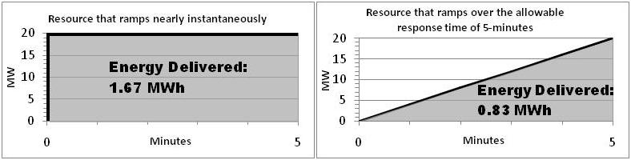
Because the amount of energy that can be provided by fast regulation resources to correct ACE is much greater per MW of procured capacity than would be provided by slower ramping resources, the grid procures less regulation when using fast-responding regulation resources to regulate the grid.
Actual data from Beacon Power’s ISO-NE facility illustrates the potential reduction in total regulation procurement that can be achieved by utilizing fast-ramping resources that are capable of rapidly delivering their full power output versus utilizing slow-ramping resources. For example, Figure 2 below, compares the ACE Correction of Beacon Power’s 1MW flywheel plant responding nearly instantaneously to the control signal sent by ISO-NE (Beacon Power’s flywheels deliver their full 1 MW capacity in under four seconds, i.e. less than one AGC cycle) with the ACE Correction that would have been provided by 1 MW of regulation provided by a resource with a ramp time of 5 minutes, the allowable response time in ISO-NE.
Figure 2
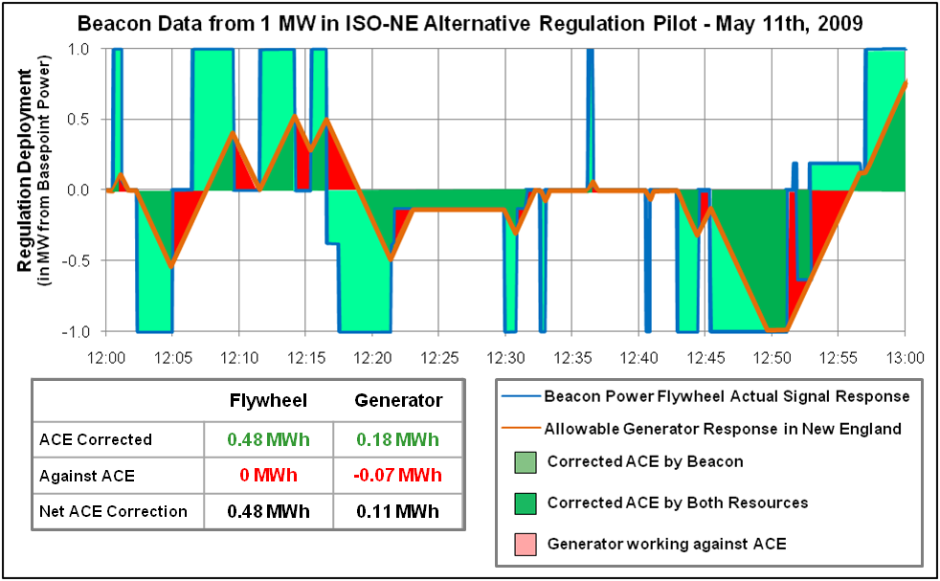

As demonstrated in Figure 2, while both the flywheel and the slow-ramping resources provide ISO-NE with the same amount of Regulation capacity (i.e., 1 MW), the fast responding flywheel provided four times as much regulation value to the grid per MW capacity as the slow resource. Specifically, the data demonstrates that the flywheel provided 0.48 MWh of net ACE correction in this hour whereas the slow-ramping resource provided just 0.11 MWh of net ACE correction. Therefore, if 0.48 MWh of net ACE correction in this hour were desired, 4 MW of regulation capacity would need to be procured by the ISO from slower-ramping generation resources as opposed to 1 MW of regulation capacity using fast-ramping flywheels. Thus, using the fast response flywheel storage resources will reduce the amount of regulation capacity that needs to be procured to provide a specific amount of ACE correction.

Beacon Power’s 20 MW flywheel plant in NYISO further demonstrates the value of fast responding regulation resources. In NYISO flywheels and batteries are defined as Limited Energy Storage Resources (LESRs). Since opening its frequency regulation market to LESRs, NYISO has utilized their ability to respond nearly instantaneously to control signals in its Regulation dispatch. NYISO dispatches LESRs as “first responders” to ACE Correction, meaning the NYISO selects LESRs first to correct ACE and dispatches them to provide their full MW-capacity within one 6-second AGC cycle, resulting in LESRs being deployed disproportionately more to correct ACE than other resources. For example, on September 25, 2011, at hour ending 16, Beacon’s flywheel regulation plant supplied 20 MW of Regulation capacity to the NYISO regulation market, or 11% of the total 175 MW of Regulation capacity procured during the hour. Based upon data provided by NYISO, during that hour the Area Control Error (“ACE”) positive and negative energy was 44.3 MWh (the sum of positive ACE MWh with the absolute value of negative ACE MWh) and Beacon’s 20 MW flywheel plant was dispatched to provide 14.2 MWh of energy to correct ACE or 32.2% of the total ACE Correction. For the same hour, Beacon Power modeled a slow-ramping generator supplying 20 MW of Regulation capacity with the allowable 5-minute response time following NYISO’s pro-rated control signal derived from ACE. Based on its models, the generator would be dispatched to provide 3.7 MWh of energy to correct ACE, or just 8.3% of the total ACE Correction needed. See Figure 3, the blue line is the actual amount of regulation service provided by Beacon Power’s 20 MW flywheel plant by responding every 6-seconds to the NYISO dispatch signal and the red line shows the amount of regulation service provided by a 20 MW resource with a 5-minute response time.

Figure 3
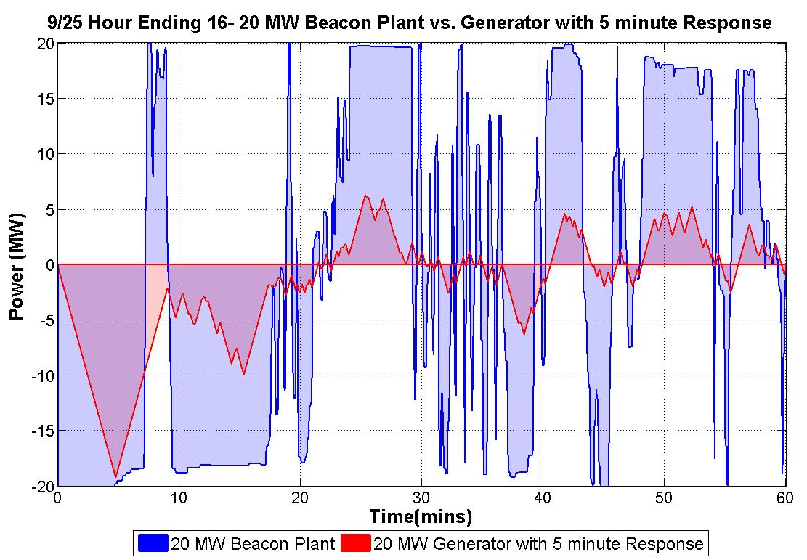
In this hour the fast-ramping flywheel provided almost four times the ACE Correction (or frequency regulation) as the slow-ramping resource. On average Beacon Power’s 20 MW flywheel plant makes up approximately 10% of the total Regulation market capacity, but provides 25 – 35% of the total ACE Correction required in NYISO.
Traditional regulation resources displaced by fast response regulation resources, such as Beacon Power’s flywheel storage, can be shifted to provide a corresponding amount of added generation capacity improving the overall reliability of the ERCOT system. Furthermore, by not needing to provide regulation service, traditional plants can run at full capacity, improving their energy efficiency, reducing wear and tear on their equipment, thereby potentially lowering prices in the energy market.
Pilot Program Design Recommendations
Beacon Power recommends that the following changes and/or additional design specifications be included in the pilot program design:
- Deployment Logic: Beacon Power recommends that ERCOT use the pilot program to evaluate various dispatch signals for fast resources in order to determine the deployment logic that results in the highest benefit to the system.

ERCOT is proposing to utilize fast response regulation resources to correct frequency deviations when frequency is outside a +/-0.03 Hz deadband. While this may ultimately be the best use of fast regulation resources in ERCOT, Beacon Power recommends that ERCOT consider using the pilot program to study alternative signal logics in addition to the one currently proposed by ERCOT.
For example, PJM is employing a two-signal approach for dispatching regulation resources: 1) a slow regulation signal designed for traditional resources with limited ramping capability, and 2) a fast energy-neutral dynamic regulation signal designed for new fast-ramping regulation technologies that can respond nearly instantaneously to system imbalances but lack the ability to maintain a sustained response to regulation control signals in either direction for long periods of time. The philosophy underlying the this approach is that the flexible, fast-ramping resources following the dynamic fast regulation signal should be utilized first to counteract sudden Area Control Error (“ACE”) movements and then slowly reset to a midpoint – where they are ready to correct the next ACE movement. The slower resources respond to the longer duration movements, while the fast-following resource are reset. A KEMA study of PJM’s signal logic, found that the use of fast-following resources, in conjunction with traditional regulating resources, provided more accurate control of ACE, which will allow PJM to maintain similar CPS1 scores achieved today while reducing the total amount of regulation capacity required. In other words, fast-following resources decrease the total regulation requirements necessary to maintain reliability requirements, which in turn decreases the total cost of the regulation service and energy. (PJM has stated that a reduction in total Regulation requirements allows the full capacity of traditional resources to remain in the PJM Interchange Energy market which will lead to lower costs for energy.) Similarly, as discussed above, the NYISO utilizes fast regulation resources as “first responders” to all ACE deviations. ERCOT may find that this type of signal logic provides more benefit to ERCOT than only using fast response resources to arrest frequency decay during unit trips and large frequency excursions. For these reasons Beacon Power recommends that ERCOT use the pilot program to study various deployment logics for fast response resources in addition to those proposed.
ERCOT may use the pilot project to study various deployment parameters.
- Minimum Size to Participate: Beacon Power recommends that ERCOT allow a minimum size of 0.1 MW (100 kW) to participate in the pilot program.

Since ERCOT is proposing a short term pilot, it will be very difficult for new resources to find financing to install large projects until there is more certainty on the market design. Therefore, Beacon Power recommends that resources with a minimum size of 0.1 MW (100 kW) be allowed to participate in the pilot program which will enable new resource types, such as flywheels to participate in the pilot, yet be a large enough minimum specification size to address ERCOT’s concern (stated at the June 27, 2012 ETWG meeting) that the minimum size not be so small as to allow individual electric vehicles to participate (electric vehicle batteries are approximately 20 kW in size). In addition, Beacon Power believes that the 100 kW minimum size is large enough for ERCOT to study the benefits of an individual technology’s fast response.
For example Beacon Power participated in two fast response regulation demonstration programs using a 100 kW flywheel system: 1) In 2006 and 2007, Beacon Power successfully demonstrated the ability of its 100kW flywheel to provide fast regulation service to CAISO through an 18-month trial sponsored by the California Energy Commission, and 2) Beacon Power successfully tested its 100kW flywheel energy storage technology on the New York power grid in a project funded jointly by the New York State Energy Research and Development Authority (“NYSERDA”) and the Department of Energy (“DOE”). Both of these projects demonstrated the fast response capability of flywheels. Figure 4 details the speed and precision of response of flywheels to a fast-changing AGC signal and Figure 5 shows the results of what was dubbed the ‘Slam’ test -- the capability that flywheels have to ‘slam’ back and forth between its maximum injection power and its maximum withdrawal power. The ability of flywheels to ramp from one end of its regulation range to the other nearly instantaneously is likely impossible to be accomplished by conventional technologies that require several minutes to move within its regulation range.
Figure 4
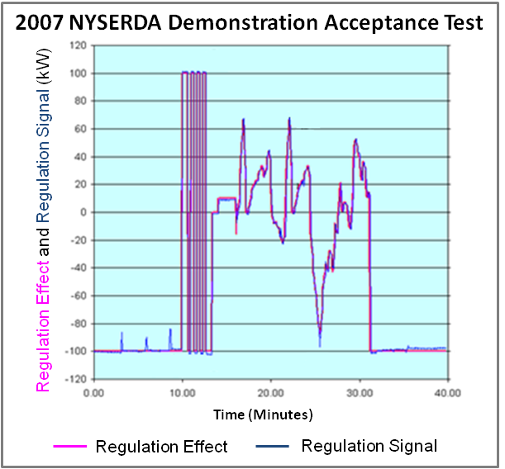

Figure 5
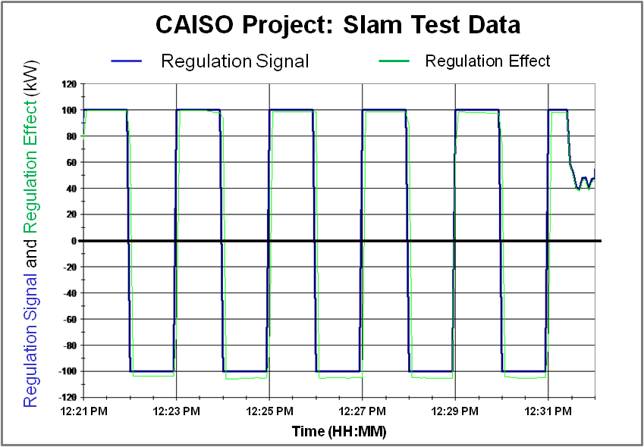
In a letter from CAISO to Beacon Power Corporation, dated December 26, 2006, CAISO stated:
“The California ISO is pleased to certify that the 100 KW high speed flywheel technology demonstrated by Beacon Power is an acceptable technology for potential use as a regulation resource for the power grid…. The unit’s high speed response rate and outstanding performance was clearly demonstrated to the California ISO, the CEC and documented in the report provided to the Department of Energy.”
The 100 kW (0.1 MW) flywheel system that was used in the successful fast response regulation demonstration program in California has recently been refurbished and is available immediately to be used in the ERCOT pilot. The resource is a complete system with a flywheel and all the necessary associated power electronics and supporting equipment, and thus is ready for interconnection. Therefore, if ERCOT will allow a 0.1 MW (100 kW) resource to participate in the pilot this would be the ideal flywheel resource to interconnect by November.
ERCOT intends to qualify and permit offers from FRRS Resources equal to or greater than 100 kW.
- Qualification Performance Criteria: Beacon Power recommends that ERCOT consider two changes to the performance criteria to qualify to participate in the pilot.

Most fast-response storage resources currently providing fast regulation on the grid today, including Beacon Power’s flywheels and many lithium-ion battery technologies, have a 4:1 power to energy ratio, which means they can inject power at maximum MW output rating (from a full state) for 15 minutes and can absorb maximum MW power rating for 15 minutes (from an empty state). From its mid-point state-of-charge it is capable of either providing 7.5 minutes of up regulation at its maximum MW output level or 7.5 minutes of down regulation at its maximum MW level. ERCOT is proposing to require resources providing FRRS (Up and Down) to be able to continuously remain deployed for up to 8 minutes with 95% or more of the requested MW for successful qualification. This is easily achievable for these technologies if they start from a full or empty state. However, ERCOT may want to consider changing the requirement to 7.5 minutes which, based on the discussion at the June 28, 2012 ETWG meeting, would seem to cover a majority of the worst frequency decay periods and would align with most storage technologies capabilities from their mid-point state-of-charge. Alternatively, ERCOT should ensure that the qualification test allow resources to qualify for Up Regulation for 8 minutes from a full state-of-charge and to qualify for Down Regulation for 8 minutes from an empty state-of-charge.
ERCOT intends to allow resources to qualify to provide Fast Responding Regulation-Up Service separate from Fast Responding Regulation-Down Service. ERCOT will not require storage resources to be at any particular state of charge when the pre-announced qualification test begins.
ERCOT is proposing to mandate that resources providing FRRS must provide full MW response within 60 cycles (1 second). Most storage technologies have designed their software systems to respond with their full output within one AGC cycle (i.e. 4 seconds). While it would be possible to respond in 1 second, it may be worth considering allowing resources to respond with their full MW response within 4 seconds (one AGC cycle) which is a speed-of-response far greater than that required of existing resources (which is 300 seconds). This has proven to provide significant benefit in other markets (as noted above), and will likely enable a greater pool of resources to provide fast response regulation service.
ERCOT believes that a 60-cycle response time could provide far more operational value. However, if ERCOT finds that the 60-cycle requirement precludes the participation of resources that would not otherwise participate, ERCOT may need to reconsider this requirement.

- TESA Comments
The Texas Energy Storage Alliance (TESA) appreciates the time and effort that has been put into crafting the Fast Responding Regulation Service (FRRS) pilot. Fast responding resources will improve the efficiency and reliability of the grid by providing new, useful capabilities for ERCOT to operate the grid in a more effective and efficient manner. Based on the proposed qualification and performance criteria, we believe that some of our members will be able to participate in the pilot, and we look forward to working with you as the project moves forward. We are eager to help find permanent solutions for integrating resources with fast response capabilities, such as battery storage resources, into the grid and ensuring that the benefits of these resources are fully realized by the market.
In that spirit, we respectfully offer the following comments on the proposed FRRS pilot because we do not believe that the current structure of the pilot will demonstrate the full system benefits of energy storage. For example, by using fast responding resources more frequently and earlier in the proposed process, they could reduce the Regulation service requirements of ERCOT more significantly while still maintaining ERCOT’s excellent CPS1 scores. This would allow additional resources to enter the energy market, rather than being committed to Regulation service, and thereby help alleviate our state’s resource adequacy concerns.
Specifically, TESA respectfully offers the following suggested improvements to the FRRS pilot:
1. Retain Flexibility to Adjust Parameters During the Pilot
There is significant value in demonstrating the capabilities of fast responding resources as proposed in the current pilot parameters; however additional benefits could be recognized with modified parameters, e.g., with a modified “deadband.” We encourage ERCOT to clearly reserve the right to adjust parameters during the pilot and maintain flexibility to do so (with adequate notice to pilot participants, of course). TESA would gladly work with ERCOT during the pilot to evaluate all parameters and propose beneficial modifications.
For example, other ISOs have found it beneficial to utilize fast responding resources to arrest frequency deviations and improve the efficiency of Regulation service by deploying these resources earlier and more often. Other ISOs also have found that proper implementation of fast response regulation decreases overall regulation procurements. TESA proposes that ERCOT maintain the flexibility to modify key parameters during the pilot. Additional benefits could be recognized by modifying the deadband to +/- .02 Hz or +/- .01 Hz, for example.
As ERCOT gains experience with the service, FRRS could be called more frequently to demonstrate a wider range of capabilities and utilization for increased benefit to the grid. This would also allow ERCOT to compare the experience of using FRRS on a more regular basis and better assess the impact of the service using this approach. ERCOT would also be able to demonstrate that FRRS would be available when the designated deadband is reached, even if used more frequently on a wider basis. Energy storage is designed to be used frequently for both Regulation Up and Down, and this pilot is the time for ERCOT to explore that capability.
ERCOT will consider testing different deployment parameters such as duration of deployment, size of deployment steps and trigger points. Any such parameter changes will be announced well in advance of implementation.
2. Deployment: Symmetrical Procurement
TESA is concerned with the asymmetric proposal of procuring 65 MW of FRRS-up and only 35 MW of FRRS-down. Storage resources are designed to charge and discharge in order to offer the maximum benefits and efficiency to the grid. TESA suggests ERCOT procure 65 MW of both FRRS-up and FRRS-down in an effort to maximize the benefits and participation of energy storage resources. Under the current proposal, an energy storage resource might need to purchase energy in order to maintain its charge for the provision of FRRS-up service. TESA recognizes that the ERCOT market calls REG-UP more frequently, so we understand the rationale, however we suggest symmetrical procurement for the pilot to better demonstrate and accommodate the true capabilities of fast responding resources.
Historical data shows that both the incidence and magnitude of frequency excursions below 59.91 Hz significantly exceed those for excursions above 60.09 Hz. ERCOT therefore anticipates a greater need for FRRS-Up capacity than for FRRS-Down.
3. Limits on Participation
The proposed language states that ERCOT will prorate procured FRRS amounts to pilot resources as necessary based on the number of qualified resources than have offered into a given period, however no maximum limits on those offers are set. Therefore, resources with more than 65 MW of FRRS-up capacity or 35 MW of FRRS-down capacity could be encouraged to offer much more capacity than needed (e.g., 100 MW+) in an attempt to get a larger pro rata share of the available payments. TESA proposes that any qualifying resource be limited to a maximum offer of the total amount of the service being procured in a given period, or at least not receive compensation for any capacity offered in excess of the maximum amount procured. ERCOT may also want to consider offering a mechanism for resources to rescind their offer, or modify their offer, for a given period if it is significantly over-subscribed.
ERCOT intends to cap the capacity qualification of any one resource at 65 MW, to accept all offers in full from Resources with capacity of 5 MW or less (subject to the overall 65 MW ceiling), and to designate a minimum capacity level below which the offer would not be awarded.
4. Pilot Duration
As proposed, the pilot would last for six months. TESA recommends that the six-month period be extended to one year. TESA is concerned that six months may not be enough time to allow development of a sufficient amount of resources to produce a rich and robust pilot. In addition, a one-year pilot would allow ERCOT to gather data in all the seasons and lead to a greater understanding of the service and its benefits. In fact, the recently approved 30-minute ERS pilot was approved to last for a full year in order to give ERCOT the chance to fully review the potential benefits of the service. Likewise, a service that is completely new to ERCOT should be given a sufficient amount of time to prove its value to an efficient grid.

Alternatively, TESA suggests that the six-month period begin when qualified resources have been identified and are available to offer FRRS. If there are no resources available for a part of the six-month pilot period, the pilot and its results will not be complete and may lead to an erroneous analysis. TESA believes it is critical to allow these new resources and this new service sufficient time and experience to operate so that reliable recommendations can be made at the conclusion of the pilot.
ERCOT intends to propose a six-month pilot because it believes the data necessary to determine the comparative value of FRRS can be gathered in this time frame. If additional time is needed, ERCOT will request an extension of the pilot project as necessary.
5. Protocol Waivers
The proposed pilot concept does not include a listing of protocols that will be waived as part of the pilot implementation. Although the pilot is for a new service and the proposal delineates the qualification and performance requirements, TESA is concerned that any participating resources will be required to register as generation or load, or both, and will be subject to the protocols applicable to that resource. The application of some protocols to FRRS resources may disqualify resources that are able to provide FRRS service, but may not be able to comply with other unrelated protocols. TESA recommends reviewing the performance protocols such as GREDP to ensure that there are no barriers to entry for these new resources.
TESA will gladly work with ERCOT to identify specific protocols that may need to be waived. Alternatively, a blanket waiver could be granted that would waive protocols that present a barrier to resources providing this service, as long as the requirements for the service are otherwise met.
ERCOT will address the applicability of the Protocols in the Governing Document. However, ERCOT does not intend to exempt FRRS participants from the requirement to register as a Resource (if applicable).
6. Note: Faster Response Possible
TESA would also like to note that faster response is possible from energy storage resources; however we do not have a specific recommended improvement for the pilot. Many energy storage resources are capable of providing a full MW response much quicker than in 60 cycles. In the future, ERCOT may want to modify FRRS in order to structure compensation for FRRS participants in proportion to value provided by faster response. TESA would welcome the opportunity to discuss this and how other “pay for performance” concepts could be applied in Texas so that our grid can maximize the benefits from the superior performance of fast acting resources.

- NRG Comments
1. NRG concurs with ERCOT's requirement that fast responders monitor and respond to frequency deviations on their own. Delaying to wait for ICCP responses can push responses past 7 or more seconds, when a fast response (within 3 seconds, for contingencies like large unit trips) are more desirable.
Pilot participants will be required to monitor and detect frequency, and to respond automatically within 60 cycles of reaching a frequency deviation greater than +/- .09 Hz. For frequency deviations greater than +/- .03 Hz and equal to or less than +/-.09 Hz, pilot participants will be required to respond within 60 cycles of receiving the FRRS signal.
2. NRG recommends that ERCOT implement the requirements for fast responders so that the they have a smaller deadband, respond proportionally rather than a stepped response, and have droop settings so that the entire capacity is deployed prior to deploying load resources. Proportional response is critical to avoid frequency overshoot (already a problem that this could make worse). Without a proportional response, generators will have additional unnecessary wear and tear that should be avoided.
ERCOT plans to deploy all committed FRRS Resources well in advance of Load Resources providing RRS, which have a requirement for UFR settings no lower than 59.70 Hz. ERCOT will develop multiple deployment approaches, and does not expect deployment of FRRS to lead to frequency overshoot. One such deployment approach could be to direct a proportional response as well as incorporate a smaller deadband.
3. NRG recommends that ERCOT procure fast response in a similar fashion to the proposal put forward by PJM. In PJM, the ISO will buy as much fast response as they can without reducing the response needed from traditional regulation providers during extended deployments. As PJM (and ERCOT in their presentation to the Wholesale Market Subcommittee) recognize, this dual procurement will lead to lower overall costs for loads. To minimize the amount of fast response that can be procured and have potential negative effects during the pilot, ERCOT can (1) Rely on the additional 500 MW of responsive reserves that have been procured (2) Set a maximum of some number of MW that it will procure from fast response on an hourly basis (3) Run a Supplemental Ancillary Service Market (SASM) if the state of charge of fast responders is currently inadequate. Implementing this pilot using the PJM (or similar) procurement methodology will result in a pilot project ERCOT can be proud of.
During the FRRS pilot, ERCOT does not plan to change either the amount of conventional Regulation Service procured or the deployment logic for conventional Regulation. Similar to the PJM methodology, ERCOT is developing and providing a separate FRRS signal. If the pilot demonstrates that the use of FRRS can reduce the amount of conventional Regulation procured, ERCOT expects that it would eventually procure less conventional Regulation so as to ensure the efficiency gains of FRRS. In any case, details of procurement will not be determined in this pilot, but rather in the NPRR that would be filed to formally integrate FRRS into the Protocols.

- Clayton Greer and Dan Bailey Emails

Clayton Greer email 7-10-12 1:48:
I think this has been touched on at other committees, but can someone explain why this is being considered a "Regulation" product? The descriptions below relate to frequency response provided by governor action and not AGC. Given that frequency response is provided for free by generators in the market it would seem that the "price is right". That may not be the view of the service providers though.

While FRRS shares some similarities to conventional Regulation Service, ERCOT is not committed to using this name for the service, and would be willing to consider other name suggestions. ERCOT intends to use FRRS to help correct frequency deviation. FRRS provides full response much faster than that provided by Governor Response or conventional Regulation Service. For example, a conventional Resource of 65 MW will only provide Governor Response proportional to 2.19 MW/0.1 Hz compared to 65 MW/0.1 Hz from a Resource with 65 MW FRRS responsibility. A conventional Resource will provide this 2.19 MW/0.1 Hz response in approximately 12 to 16 seconds while an FRRS-qualified Resource will provide the full 65 MW response in approximately 1 second. ERCOT would be willing to review any stakeholder proposal to provide compensation for a Governor Response-type service.
Dan Bailey email 7-11-12 10:09:
I agree with Clayton (Yikes)! Quick response service, by definition, sounds very similar to the current governor response required by the operation guides. It's true that governor response provided as a market product has been discussed several times at several different committees . . . back in the old Zonal days it was discussed at WMS, ROS, QSE Managers and PDCWG. Later, some MPs made a run at it in TNT, where it was considered a good product but too complex to measure and not worthy of implementation consideration while transitioning to the Nodal market. In our opinion, governor response would appear to be an excellent product for the market. The product would provide correct incentives to generators to insure continued reliability in frequency disturbances and remove some of the ambiguity associated with the operating guide requirements on resources currently providing the service. Unfortunately, to date, governor response as a product has not gained enough traction to make it up the MP hill.
ERCOT would be willing to review any stakeholder proposal to provide compensation for a Governor Response-type service.

Limited Energy Storage Resources (LESRs) are defined as: A Generator authorized to offer Regulation Service only and characterized by limited Energy storage, that is the inability to sustain continuous operation at maximum Energy withdrawal or maximum Energy injection for a minimum period of one hour. LESRs must bid as ISO-Committed Flexible Resources. See Services Tariff at § 2.12.
NYISO Ancillary Services Manual, Section 4.3.4 Regulation Service. “The AGC function calculates an area control error and allocates this error to selected Regulation Service scheduled by RTD (Real Time Dispatch). LESR devices are selected first and assigned UDGs (Unit Desired Generation) at the maximum values required, up to the regulation limits of the device, to address the regulation error. If additional regulation energy deployments are required, the remaining Regulation Service resources will be assigned the error in proportion to the amount of their Regulation Service capacity scheduled.”
KEMA KERMIT Study Report “To determine the effectiveness of the AGC in controlling fast and conventional resources in the PJM frequency regulation market”, December 13, 2011. http://www.pjm.com/committees-and-groups/task-forces/rpstf.aspx

