 |  |  |  | System Planning
Monthly Status Report
June 2012

 |  | Report Highlights
 | - ERCOT is currently tracking 131 active generation interconnection requests totaling over 35,000 MW. This includes over 19,000 MW of wind generation.
- ERCOT is currently reviewing proposed transmission improvements with a total cost of $95.6 Million
- Transmission Projects endorsed in 2012 total $446.7 Million
- All projects (in engineering, routing, licensing and construction) total approximately $9.77 Billion
- Transmission Projects energized in 2012 total about $208.4 million

Table of Contents
1. Generation Interconnection 1
1.1 Signed Generation Interconnection Agreements 1
1.2 New Generation Registering for Commercial Operations 1
1.3 Summary of Generation Interconnection Requests 1
1.4 Projects with Interconnection Agreements 4
1.5 Generation Projects Undergoing Full Interconnection Studies with Confidentiality Waived by Developer 4
1.6 Generation Projects Undergoing Full Interconnection Studies 5
1.7 Wind Generation Capacity Installed by Year 6
2. Regional Planning Group Project Reviews 7
3. Congestion Costs 8
4. Wind Generation as a Percent of Load 11
5. Planning Model Activities 12
6. Other Notable Activities 13

1. Generation Interconnection
Additional information regarding detailed generation interconnection and impact studies is contained in the “Generation Project Interconnection Information” folder in the “Operations and System Planning” area on the ERCOT website: http://planning.ercot.com/login/login.

Signed Generation Interconnection Agreements
13INR0021 – Ferguson Replacement Project – 570 MW Natural Gas in Llano County
12INR0076 – NoTrees Battery Storage – 36 MW Storage in Winkler County

New Generation Registering for Commercial Operations
Non-modeled – Somerset North – 5.6 Solar in Bexar County
Non-modeled – Somerset South – 4.9 Solar in Bexar County

The total installed wind capacity is now reported as 10,035 MW by the resource owners through the registration process. Capacity by North, South and West is 519 MW, 2,283 MW, and 7,233 MW respectively. 850 MW is able to switch between the West and South zones and is currently shown in the South zone.

Summary of Generation Interconnection Requests
GENERATION INTERCONNECTION REQUESTS CURRENTLY UNDER REVIEW
Currently tracking 172 generation interconnection or change requests
As of June 30, 2012 | North | South | West | Total
Security Screening Study | 0 | 5 | 1 | 6
SSS Completed | 2 | 4 | 6 | 12
Full Interconnect Study | 8 | 19 | 47 | 74
FIS Completed | 2 | 5 | 9 | 16
Suspended Studies | 8 | 3 | 30 | 41
Capacity of Suspended Study Projects | 6,486 | 638 | 11,348 | 18,472
Interconnect Agreement Completed | 8 | 9 | 6 | 23
Capacity under Interconnection Agreements | 5,764 | 4,134 | 1,134 | 10,426
Capacity for Grid, MW | 9,351 | 10,288 | 15,398 | 35,037
Wind Capacity, MW | 3,443 | 3,092 | 12,966 | 19,501

Fuel Type | Confidential Projects (MW) | Projects Under Full Study (MW) | Public Projects (MW) | Suspended Studies (MW) | Grand Total (MW)
Gas-AllOther |  |  |  |  | 1,862
Gas-CombinedCycle |  |  | 6,019 | 2,890 | 10,537
Total Gas | 1,390 | 2,100 | 6,019 | 2,890 | 12,399
Nuclear |  |  |  | 3,200 | 3,200
Coal |  | 1,090 | 2,785 |  | 3,875
Wind | 2,070 | 15,039 | 2,392 | 11,979 | 31,480
Solar | 270 | 506 | 60 | 353 | 1,189
Biomass |  |  |  | 50 | 50
Storage |  | 40 | 36 |  | 76
Petroleum Coke |  |  | 1,240 |  | 1,240
Grand Total | 3,730 | 18,775 | 12,532 | 18,472 | 53,509

County Location of Installed Generation and Interconnection Requests (all fuels)

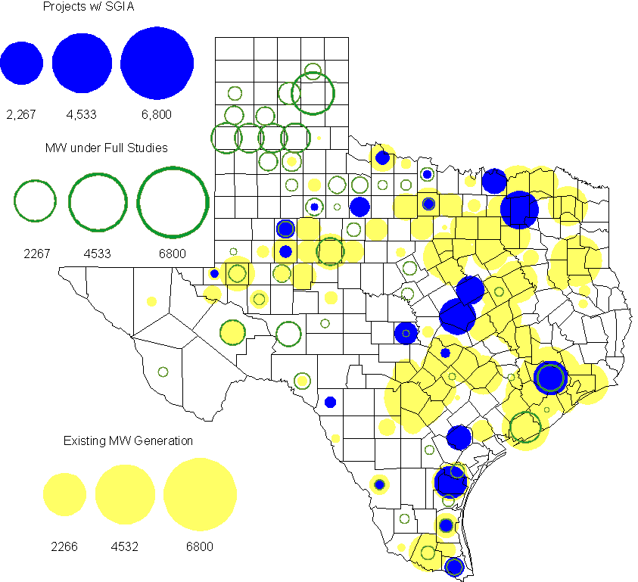

Projects with Interconnection Agreements
(Status: IA=Interconnect Agreement, XX= cancelled)
Generation Interconnections as of June 30, 2012
INR | SiteName | Status | County | Region | COD | Fuel Type |  | MW For Grid |  | Change from Last Report
12INR0076 | Notrees Battery Storage | IA | Winkler | West | Oct-12 |  | Storage |  | 36 | New
11INR0086 | RRE Austin Solar | IA | Travis | South | Oct-12 |  | Solar |  | 60
08INR0011 | Senate Wind Project | IA | Jack | North | Nov-12 |  | Wind |  | 150
12INR0075 | Blue Summit Windfarm | IA | Wilbarger | West | Nov-12 |  | Wind |  | 170
12INR0072 | Anacacho Windfarm | IA | Kinney | South | Dec-12 |  | Wind |  | 100
11INR0091 | Whitetail Wind Energy Project | IA | Webb | South | Dec-12 |  | Wind |  | 92
10INR0023 | Baker Ranch | IA | Haskell | West | Dec-12 |  | Wind |  | 400
09INR0061 | WKN Mozart | IA | Kent | West | Dec-12 |  | Wind |  | 30
08INR0049 | Briar Creek | IA | Clay | North | Dec-12 |  | Wind |  | 50
11INR0033 | Los Vientos | IA | Cameron | South | Dec-12 |  | Wind |  | 400
09INR0001 | Sandy Creek 1 | IA | McLennan | North | Mar-13 |  | Coal |  | 925
06INR0022c | Penascal Wind Farm 3 | IA | Kenedy | South | Dec-13 |  | Wind |  | 202
12INR0034 | Stephens-Borlynn Wind Project | IA | Borden | West | Dec-13 |  | Wind |  | 378
13INR0021 | Ferguson Replacement Project | IA | Llano | North | Jul-14 |  | Gas-CC |  | 570 | New
08INR0018 | Gunsight Mountain | IA | Howard | West | Aug-14 |  | Wind |  | 120
10INR0021 | Panda Sherman Power | IA | Grayson | North | Jan-15 |  | Gas-CC |  | 717
06INR0006 | Cobisa-Greenville | IA | Hunt | North | May-15 |  | Gas-CC |  | 1,792
10INR0020a | Panda Temple Power | IA | Bell | North | May-15 |  | Gas-CC |  | 780
10INR0020b | Panda Temple Power | IA | Bell | North | May-16 |  | Gas-CC |  | 780
10INR0022 | Pondera King Power Project | IA | Harris | South | Jun-16 |  | Gas-CC |  | 1,380
14INR0002 | Coleto Creek Unit 2 | IA | Goliad | South | Jan-17 |  | Coal |  | 660
12INR0016a | Las Brisas Energy Center | IA | Nueces | South | May-18 |  | PetCoke |  | 620
12INR0016b | Las Brisas Energy Center | IA | Nueces | South | May-18 |  | PetCoke |  | 620
 |  |  |  |  |  |  | TOTAL |  | 11,032
Note: Projects that do not have an interconnection agreement but have been publicly disclosed via a Public Letter to ERCOT and were previously reported on this table have been moved to section 1.5 unless Suspended or Cancelled

Generation Projects Undergoing Full Interconnection Studies with Confidentiality Waived by Developer
INR | SiteName | Status | County | Region | COD | Fuel | MW For Grid | Change from Last Report
12INR0080 | Blanco Canyon Wind | PL | Floyd | West | Dec-12 | Wind | 300
14INR0005 | White Stallion Energy Center | PL | Matagorda | South | Jul-14 | Coal | 1,200

Generation Projects Undergoing Full Interconnection Studies
INR | County | Grid | COD | Fuel |  | INR | County | Grid | COD | Fuel
10INR0062a | Pecos | 80 | TBD | Wind |  | 11INR0094 | Kent | 100 | TBD | Solar
12INR0086 | Harris | 89 | TBD | Gas |  | 12INR0053 | Crockett | 615 | TBD | Wind
12INR0050 | King | 332 | TBD | Wind |  | 12INR0079 | Kenedy | 200 | Aug-12 | Wind
12INR0089 | Pecos | 230 | Nov-12 | Wind |  | 11INR0081 | Live Oak | 72 | Dec-12 | Wind
12INR0059 | Pecos | 50 | Dec-12 | Solar |  | 12INR0067 | Webb | 94 | Dec-12 | Wind
12INR0055 | Baylor | 80 | Dec-12 | Wind |  | 11INR0093 | San Patricio | 41 | Dec-12 | Wind
12INR0060 | Schleicher | 58 | Dec-12 | Wind |  | 12INR0080 | Floyd | 300 | Dec-12 | Wind
12INR0068 | Jim Hogg | 80 | Dec-12 | Wind |  | 12INR0081 | Upton | 113 | Dec-12 | Wind
13INR0040 | Harris | 0 | Jan-13 | Gas |  | 13INR0010a | Parmer | 200 | Jan-13 | Wind
11INR0082B | Val Verde | 150 | Mar-13 | Wind |  | 11INR0083B | Crockett | 100 | Mar-13 | Wind
11INR0050 | Crosby | 149 | Mar-13 | Wind |  | 09INR0051 | Borden | 249 | Mar-13 | Wind
13INR0045 | Castro | 288 | Apr-13 | Wind |  | 12INR0070 | Knox | 300 | Apr-13 | Wind
13INR0020a | Glasscock | 200 | May-13 | Wind |  | 10INR0089 | Harris | 40 | May-13 | Storage
10INR0062b | Pecos | 220 | May-13 | Wind |  | 12INR0045 | Kleberg | 135 | Jun-13 | Wind
13INR0032 | Andrews | 30 | Jun-13 | Solar |  | 13INR0057 | Archer | 65 | Jun-13 | Wind
13INR0023 | Ector | 240 | Jul-13 | Coal |  | 13INR0049 | Harris | 352 | Jul-13 | Gas
13INR0046 | Limestone | 71 | Sep-13 | Wind |  | 11INR0082A | Val Verde | 50 | Sep-13 | Wind
11INR0083A | Crockett | 50 | Sep-13 | Wind |  | 13INR0025 | Randall | 150 | Sep-13 | Wind
11INR0013 | Mills | 150 | Sep-13 | Wind |  | 13INR0005 | Carson | 600 | Oct-13 | Wind
13INR0028 | Hale | 392 | Nov-13 | Gas |  | 12INR0071 | Caldwell | 30 | Nov-13 | Wind
13INR0052 | Starr | 200 | Dec-13 | Wind |  | 11INR0085 | Nolan | 106 | Dec-13 | Wind
12INR0054 | Jones | 200 | Dec-13 | Wind |  | 13INR0055 | Zapata | 250 | Dec-13 | Wind
13INR0038 | Swisher | 300 | Dec-13 | Wind |  | 13INR0050 | Comanche | 200 | Dec-13 | Wind
13INR0036 | Hidalgo | 200 | Dec-13 | Wind |  | 10INR0009 | Castro | 300 | Dec-13 | Wind
12INR0002a | Briscoe | 200 | Dec-13 | Wind |  | 13INR0007 | Pecos | 200 | Dec-13 | Wind
13INR0026 | Oldham | 201 | Dec-13 | Wind |  | 13INR0030 | Archer | 100 | Dec-13 | Wind
13INR0039 | Castro | 500 | Dec-13 | Wind |  | 11INR0057 | Cameron | 165 | Dec-13 | Wind
08INR0019a | Gray | 250 | Jan-14 | Wind |  | 08INR0019c | Gray | 250 | Jan-14 | Wind
12INR0084 | Randall | 242 | Jan-14 | Wind |  | 13INR0006 | Gray | 750 | Jan-14 | Wind
14INR0013 | Cameron | 103 | Jan-14 | Wind |  | 08INR0019b | Gray | 250 | Jan-14 | Wind
14INR0014 | Val Verde | 100 | Jan-14 | Solar |  | 10INR0080 | Presidio | 81 | Jan-14 | Solar
13INR0010b | Parmer | 500 | Jan-14 | Wind |  | 13INR0020b | Glasscock | 150 | May-14 | Wind
14INR0015 | Harris | 192 | Jun-14 | Gas |  | 14INR0012 | Gray | 401 | Jun-14 | Wind
14INR0016 | Harris | 190 | Jun-14 | Gas |  | 14INR0011 | Swisher | 270 | Jun-14 | Gas
14INR0010 | Roberts | 300 | Jul-14 | Wind |  | 11INR0054 | San Patricio | 161 | Jul-14 | Wind
12INR0042a | Deaf Smith | 265 | Sep-14 | Wind |  | 12INR0042b | Deaf Smith | 135 | Sep-14 | Wind
13INR0031 | Austin | 30 | Oct-14 | Solar |  | 14INR0023 | Briscoe | 361 | Dec-14 | Wind
12INR0002b | Briscoe | 200 | Dec-14 | Wind |  | 12INR0018 | Gray | 500 | Dec-14 | Wind
14INR0018 | Nolan | 35 | Dec-14 | Solar |  | 14INR0009 | Kent | 248 | Dec-14 | Wind
14INR0020 | Floyd | 150 | Dec-14 | Wind |  | 10INR0085 | Ector | 40 | Dec-14 | Solar
11INR0079a | Clay | 200 | Dec-14 | Wind |  | 12INR0029 | Swisher | 500 | Dec-14 | Wind
13INR0010c | Parmer | 500 | Jan-15 | Wind |  | 12INR0057 | Ector | 40 | Apr-15 | Solar
15INR0014 | Matagorda | 280 | Oct-15 | Gas |  | 15INR0013 | Anderson | 324 | Oct-15 | Gas
12INR0002c | Briscoe | 350 | Dec-15 | Wind |  | 14INR0005 | Matagorda | 1,200 | Jan-16 | Coal
16INR0003 | Brazoria | 11 | Jun-16 | Gas |  | 14INR0003 | Nolan | 850 | Jun-18 | Coal
Note: ERCOT recently requested that the Transmission Service Providers comprehensively review the status of each of their assigned Full Interconnection Studies and report the status of each study back to ERCOT. Projects that were classified as “Cancelled” or “Suspended” as a result of this review are excluded from this table.

Wind Generation Capacity Installed by Year
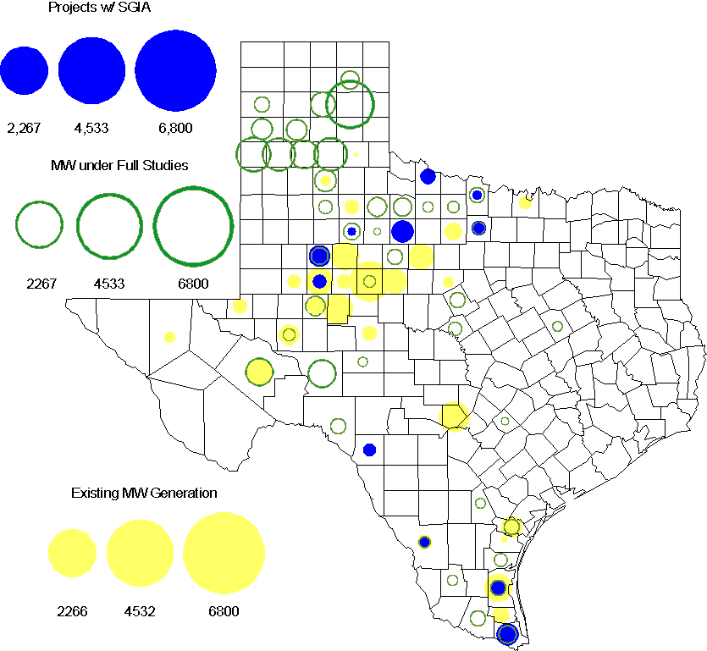

Regional Planning Group Project Reviews

- South Texas Electric Cooperative (STEC) has submitted the Karnes Electric Cooperative (KEC) and Medina Electric Cooperative (MEC) load addition project to accommodate 245 MW of new load in Karnes and Atascosa Counties. This is a Tier 2 project that is estimated to cost $48.4 million. This Tier 2 project is undergoing ERCOT Independent Review.

- CenterPoint Energy has submitted the Freeport Area upgrades project. This is a Tier 3 project that is estimated to cost approximately $47.2 million. This project has been submitted for RPG comments.

Congestion Costs
Dollars shown in RUC Make Whole payment graph are of settlement quality.

RUC net Make Whole payment in $mm

Monthly Average LMP

Binding Constraints – Year to Date
Contingency | Binding Element | Number of 5-min intervals | Shadow Price Range $/MWh | Estimated Congestion Rent $ (Shadow Price*Limit) | Transmission Project
Amoco North Cowden Tap - Moss 138kV | Odessa North 138/69 kV Autotransformer | 5906 | 0 - 2800 | 37,627,990 | 5YTP [2010-R7, R8]
BASE CASE | West to North Stability Limit | 8109 | 0 - 436 | 26,823,063 | CREZ
Sacroc - Sun Switch 138 kV; or Golden Switch - Sun Switch 138 kV | China Grove - Bluff Creek 138 kV | 1357 | 0 - 3500 | 24,675,406 | 13TPIT0093
Twin Buttes 345/138/ kV Autotransformer | San Angelo Red Creek 345/138 kV Autotransformer 2 | 113 low-side; and 262 high-side | 19 - 3500 low-side; and 2 - 4500 high-side | 18,360,051 | 14TPIT0067
Lewisville - Carrollton Northwest 345 kV | Lewisville - Jones Street Tnp 138 kV | 4632 | 0 - 3500 | 16,918,023 | CREZ, 07TPIT0042
Batesville 138/69 kV Autotransformer; or Batesville Switching Station - Paloduro Substation 138 kV | Moore Switching Station - Downie Switching Station 138 kV | 844 | 0 - 3500 | 11,526,855
Kyle - San Marcos 138 kV | Turnersville - Buda 138 kV | 276 | 0 - 3500 | 10,106,920 | 09TPIT0060
Marshall Ford - Lago Vista 138 kV | Buttercup - Whitestone 138 kV | 151 | 6 - 3500 | 7,020,443 | 10TPIT0074
China Grove - Bluff Creek 138 kV | Moss - Amoco North Cowden Tap 138 kV | 396 | 0 - 3500 | 5,898,186 | 13TPIT0093
Comanche Peak 1 & 2 | Austrop - Sandow 345 kV | 247 | 0 - 4500 | 5,526,564
Binding Constraints – May 2012
Contingency | Binding Element | Number of 5-min intervals | Shadow Price Range $/MWh | Estimated Congestion Rent $ (Shadow Price*Limit) | Transmission Project | Comments
Amoco North Cowden Tap - Moss 138kV; or Moss - Odessa EHV 345 kV & Moss - Midland East 345 kV | Odessa North 138/69 kV Autotransformer | 2615 | 0 - 2275 | 20,210,515 | 5YTP [2010-R7, R8]
Twin Buttes 345/138 kV Autotransformer | San Angelo Red Creek 345/138 kV Autotransformer 2 | 226 | 2 - 4500 | 11,787,813 | 14TPIT0067 | Forced outage of San Angelo Red Creek 345/138 kV Autotransformer 1
Batesville 138/69 kV Autotransformer; or Batesville Switching Station - Paloduro Substation 138 kV | Moore Switching Station - Downie Switching Station 138 kV | 726 | 0 - 3500 | 9,381,324 |  | PCAP has been developed
Kyle - San Marcos 138 kV | Turnersville - Buda 138 kV | 241 | 0 - 3500 | 7,842,507 | 09TPIT0060 | Kendall 138 kV bus outage
Marshall Ford - Lago Vista 138 kV | Buttercup - Whitestone 138 kV | 151 | 6 - 3500 | 7,020,443 | 10TPIT0074 | Glasscock - Andice 138 kV line outage
Farmersville - Monticello SES 345 kV double-circuit | Monticello SES - Allen Switch 345 kV | 66 | 6 - 4500 | 3,126,906 | 07TPIT0119
Brownwood - Comanche Switch 138 kV | Brownwood Switch - Camp Bowie 138 kV | 107 | 247 - 3500 | 2,777,558
Sacroc - Sun Switch 138 kV; or Golden Switch - Sun Switch 138 kV | China Grove - Bluff Creek 138 kV | 81 | 8 - 3500 | 2,550,017 | 13TPIT0093
Lytton Springs - Fayette Plant 2 345 kV & Holman - Fayette Plant 2 345 kV; or Austrop - Lost Pines 345 kV double-circuit | Fayetteville 345/138 kV Autotransformer | 1089 | 0 - 3157 | 2,371,040
Allen Switch - Royse Switch 345 kV & Allen Switch - Monticello SES 345 kV | Apollo - Richardson East 138 kV | 89 | 6 - 3500 | 2,168,449 | 09TPIT0044  10TPIT0013

Wind Generation as a Percent of Load
One-hour average of total wind power output as a percentage of ERCOT load.

Planning Model Activities
- Work on the development of the 2013 Data Set A cases continues with an expected completion the second week of July.
- The June base case TPIT updates will begin the second week of July with anticipated completion the second week of August.
- Data Set B is expected to begin the first week of August with the Topology Processor case extracted from NMMS on August 1 with a build date of January 1, 2013.
- The short term calendar of major planning model events follows:
  - July 9, 2012 Post 13 Data Set A cases.
  - Aug 1, 2012 Extract Topology Processor case with Jan 1, 2013 build date.
  - Aug 10, 2012 Post 12 Data Set A and B June TPIT updated cases.
  - Oct 15, 2012 Data Set B cases posted
- Status update on SCR760, Changes Needed for Information Model Manager and Topology Processor for Planning Models, which was approved by the ERCOT Board in March 2011.
  - Bundle 1 (Items 3, 7 and 8): In Production.
  - Bundle 2 (Items 2a, 4, 9): In Production.
  - Bundle 3 (Item 5, 2b, 2c): In Production
  - Bundle 4 (Items 1, 6): Item 1 considered to be in production. Requirements for Item 6 are in development.
SCR Sub Part | SCR Description | Status
SCR760-1 | Upgrade to PSS/E v32 | Production
SCR760-2 | Distribution Capacitor banks | Production
SCR760-3 | Zero Impedance Line Ratings | Production
SCR760-4 | Associate Loads and Capacitor banks with the correct CNG | Production
SCR760-5 | Additional Transformer Data for Planning | Production
SCR760-6 | FACTS Devices | Planning
SCR760-7 | Assign valid PSSE IDs to Breakers/  Switches/ Series Devices | Production
SCR760-8 | Phase shift of Autos for short circuit studies | Production
SCR760-9 | Multisection Line Grouping | Production
Table 1: In the following table:
- Red will be used to show status of Not Submitted, meaning that the SCR sub part has not been submitted to Siemens as a Service Request.
- Yellow will indicate that the SCR sub part has been submitted. The color will remain yellow and the status will change in order to Submitted, Planning (Requirements, SOW, Code Writing), Release (Siemens produces first code to test), and Testing (code has completed internal test and is moving through release management).
- Green will indicate that the code has been tested and installed on the machines that ERCOT uses to produce Topology Processor output for Planning and CRR.

Other Notable Activities
- The System Protection Working Group 2012 Future Year (FY) cases are complete and posted. This year, five future year cases instead of four were built for the first time, from 2013 to 2017.
- The 2012 Five-Year Transmission Plan study final scope and Reliability start cases were posted at ERCOT POI on June 14. Currently the 2012 5YTP reliability analysis is being performed.
- ERCOT System Planning is reviewing and comparing the dynamic model data submitted through the RARF to the DWG dynamic base case. Review results are being provided to Resource Entities for updates and confirmation.
- ERCOT is spot checking governor model performance by comparing the actual measurement with dynamic model response. Review results will be provided to Resource Entities for updates and confirmation.

