 |  |  |  | System Planning
Monthly Status Report
May 2012

 |  | Report Highlights
 | - ERCOT is currently tracking 129 active generation interconnection requests totaling over 35,000 MW. This includes almost 19,000 MW of wind generation.
- ERCOT is currently reviewing proposed transmission improvements with a total cost of $48.3 Million
- Transmission Projects endorsed in 2012 total $446.7 Million
- All projects (in engineering, routing, licensing and construction) total approximately $9.84 Billion
- Transmission Projects energized in 2012 total about $108.8 million

Table of Contents
1. Generation Interconnection 1
1.1 Signed Generation Interconnection Agreements 1
1.2 New Generation Registering for Commercial Operations 1
1.3 Summary of Generation Interconnection Requests 1
1.4 Projects with Interconnection Agreements 4
1.5 Generation Projects Undergoing Full Interconnection Studies with Confidentiality Waived by Developer 4
1.6 Generation Projects Undergoing Full Interconnection Studies 5
1.7 Wind Generation Capacity Installed by Year 6
2. Regional Planning Group Project Reviews 7
3. Congestion Costs 8
4. Wind Generation as a Percent of Load 12
5. Planning Model Activities 12
6. Other Notable Activities 12

1. Generation Interconnection
Additional information regarding detailed generation interconnection and impact studies is contained in the “Generation Project Interconnection Information” folder in the “Operations and System Planning” area on the ERCOT website: http://planning.ercot.com/login/login.

Signed Generation Interconnection Agreements
None

New Generation Registering for Commercial Operations
None

The total installed wind capacity is now reported as 10,035 MW by the resource owners through the registration process. Capacity by North, South and West is 232 MW, 2,281 MW, and 7,522 MW respectively. 850 MW is able to switch between the West and South zones and is currently shown in the South zone.

Summary of Generation Interconnection Requests
GENERATION INTERCONNECTION REQUESTS CURRENTLY UNDER REVIEW
Currently tracking 169 generation interconnection or change requests
As of May 31, 2012 | North | South | West | Total
Security Screening Study | 0 | 2 | 1 | 3
SSS Completed | 3 | 6 | 6 | 15
Full Interconnect Study | 8 | 16 | 47 | 71
FIS Completed | 3 | 5 | 9 | 17
Suspended Studies | 8 | 3 | 29 | 40
Capacity of Suspended Study Projects | 6,486 | 638 | 11,323 | 18,447
Interconnect Agreement Completed | 7 | 9 | 5 | 21
Capacity under Interconnection Agreements | 5,194 | 4,134 | 1,098 | 10,426
Capacity for Grid, MW | 9,450 | 10,796 | 15,002 | 35,248
Wind Capacity, MW | 3,556 | 2,792 | 12,560 | 18,908

Fuel Type | Confidential Projects (MW) | Projects Under Full Study (MW) | Public Projects (MW) | Suspended Studies (MW) | Grand Total (MW)
Gas-AllOther |  |  |  |  | 1,548
Gas-CombinedCycle |  |  | 5,449 | 2,890 | 11,417
Total Gas | 2,800 | 1,826 | 5,449 | 2,890 | 12,965
Nuclear |  |  |  | 3,200 | 3,200
Coal |  | 850 | 2,785 |  | 3,635
Wind | 1,404 | 15,112 | 2,392 | 11,954 | 30,862
Solar | 263 | 481 | 60 | 353 | 1,157
Biomass |  |  |  | 50 | 50
Storage |  | 346 |  |  | 346
Other |  | 240 | 1,240 |  | 1,480
Grand Total | 4,467 | 18,855 | 11,926 | 18,447 | 53,695

County Location of Installed Generation and Interconnection Requests (all fuels)

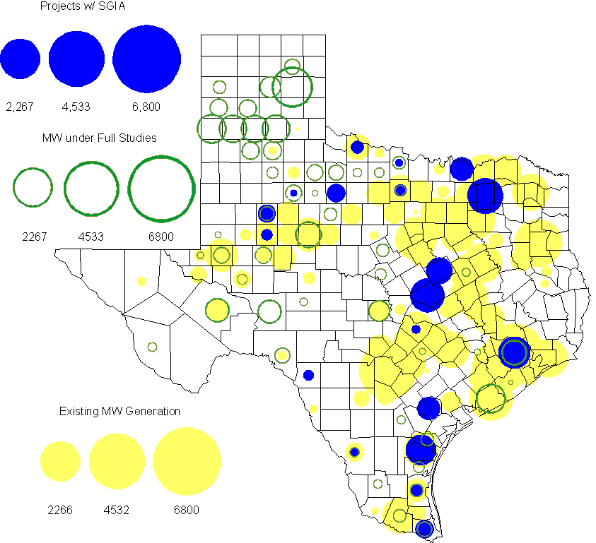

Projects with Interconnection Agreements
(Status: IA=Interconnect Agreement, XX= cancelled)
Generation Interconnections as of May 31, 2012
INR | SiteName | Status | County | Region | COD | Fuel Type |  | MW For Grid |  | Change from Last Report
11INR0086 | RRE Austin Solar | IA | Travis | South | Oct-12 |  | Solar |  | 60
08INR0011 | Senate Wind Project | IA | Jack | North | Nov-12 |  | Wind |  | 150
12INR0075 | Blue Summit Windfarm | IA | Wilbarger | West | Nov-12 |  | Wind |  | 170
12INR0072 | Anacacho Windfarm | IA | Kinney | South | Dec-12 |  | Wind |  | 100
11INR0091 | Whitetail Wind Energy Project | IA | Webb | South | Dec-12 |  | Wind |  | 92
09INR0061 | WKN Mozart | IA | Kent | West | Dec-12 |  | Wind |  | 30
10INR0023 | Baker Ranch | IA | Haskell | West | Dec-12 |  | Wind |  | 400
08INR0049 | Briar Creek | IA | Clay | North | Dec-12 |  | Wind |  | 50
11INR0033 | Los Vientos | IA | Cameron | South | Dec-12 |  | Wind |  | 400
09INR0001 | Sandy Creek 1 | IA | McLennan | North | Mar-13 |  | Coal |  | 925
06INR0022c | Penascal Wind Farm 3 | IA | Kenedy | South | Dec-13 |  | Wind |  | 202
12INR0034 | Stephens-Borlynn Wind | IA | Borden | West | Dec-13 |  | Wind |  | 378
10INR0021 | Panda Sherman Power | IA | Grayson | North | Jan-15 |  | Gas-CC |  | 717 | Date
08INR0018 | Gunsight Mountain | IA | Howard | West | Aug-14 |  | Wind |  | 120
10INR0020a | Panda Temple Power | IA | Bell | North | May-15 |  | Gas-CC |  | 780 | Date
06INR0006 | Cobisa-Greenville | IA | Hunt | North | May-15 |  | Gas-CC |  | 1,792
12INR0016a | Las Brisas Energy Center | IA | Nueces | South | May-18 |  | Other |  | 620 | Date
10INR0020b | Panda Temple Power | IA | Bell | North | May-16 |  | Gas-CC |  | 780 | Date
10INR0022 | Pondera King Power Project | IA | Harris | South | Jan-16 |  | Gas-CC |  | 1,380
12INR0016b | Las Brisas Energy Center | IA | Nueces | South | May-18 |  | Other |  | 620 | Date
14INR0002 | Coleto Creek Unit 2 | IA | Goliad | South | Jan-17 |  | Coal |  | 660
 |  |  |  |  |  |  | TOTAL |  | 10,426
Note: Projects that do not have an interconnection agreement but have been publicly disclosed via a Public Letter to ERCOT and were previously reported on this table have been moved to section 1.5 unless Suspended or Cancelled

Generation Projects Undergoing Full Interconnection Studies with Confidentiality Waived by Developer
INR | SiteName | Status | County | Region | COD | Fuel | MW For Grid | Change from Last Report
12INR0080 | Blanco Canyon Wind | PL | Floyd | West | Dec-12 | Wind | 300
14INR0005 | White Stallion Energy Center | PL | Matagorda | South | Jul-14 | Coal | 1,200

Generation Projects Undergoing Full Interconnection Studies
INR | County | Grid | COD | Fuel |  | INR | County | Grid | COD | Fuel
10INR0062a | Pecos | 80 | Oct-11 | Wind |  | 11INR0094 | Kent | 100 | Nov-11 | Solar
12INR0086 | Harris | 89 | Jun-12 | Gas |  | 12INR0053 | Crockett | 615 | Jun-12 | Wind
12INR0050 | King | 332 | Jun-12 | Wind |  | 12INR0079 | Kenedy | 200 | Aug-12 | Wind
12INR0076 | Winkler | 36 | Oct-12 | Other |  | 12INR0089 | Pecos | 230 | Nov-12 | Wind
12INR0067 | Webb | 94 | Dec-12 | Wind |  | 12INR0068 | Jim Hogg | 80 | Dec-12 | Wind
12INR0055 | Baylor | 80 | Dec-12 | Wind |  | 11INR0081 | Live Oak | 72 | Dec-12 | Wind
11INR0093 | San Patricio | 41 | Dec-12 | Wind |  | 12INR0057 | Ector | 50 | Dec-12 | Solar
12INR0059 | Pecos | 50 | Dec-12 | Solar |  | 12INR0060 | Schleicher | 58 | Dec-12 | Wind
12INR0080 | Floyd | 300 | Dec-12 | Wind |  | 12INR0081 | Upton | 113 | Dec-12 | Wind
09INR0048 | Jack | 113 | Dec-12 | Wind |  | 12INR0029 | Swisher | 500 | Dec-12 | Wind
12INR0085 | Stonewall | 25 | Dec-12 | Wind |  | 13INR0040 | Harris |  | Jan-13 | Gas
13INR0010a | Parmer | 200 | Jan-13 | Wind |  | 11INR0082B | Val Verde | 150 | Mar-13 | Wind
11INR0083B | Crockett | 100 | Mar-13 | Wind |  | 09INR0051 | Borden | 249 | Mar-13 | Wind
11INR0050 | Crosby | 149 | Mar-13 | Wind |  | 13INR0045 | Castro | 288 | Apr-13 | Wind
12INR0070 | Knox | 300 | Apr-13 | Wind |  | 10INR0089 | Harris | 40 | May-13 | Other
10INR0062b | Pecos | 220 | May-13 | Wind |  | 13INR0020a | Glasscock | 200 | May-13 | Wind
12INR0045 | Kleberg | 135 | Jun-13 | Wind |  | 13INR0032 | Andrews | 30 | Jun-13 | Solar
13INR0023 | Ector | 240 | Jul-13 | Other |  | 13INR0049 | Harris | 352 | Jul-13 | Gas
13INR0046 | Limestone | 71 | Sep-13 | Wind |  | 11INR0082A | Val Verde | 50 | Sep-13 | Wind
11INR0083A | Crockett | 50 | Sep-13 | Wind |  | 13INR0025 | Randall | 150 | Sep-13 | Wind
13INR0005 | Carson | 600 | Oct-13 | Wind |  | 12INR0071 | Caldwell | 30 | Nov-13 | Wind
13INR0028 | Hale | 392 | Nov-13 | Gas |  | 11INR0013 | Mills | 150 | Dec-13 | Wind
13INR0038 | Swisher | 300 | Dec-13 | Wind |  | 13INR0050 | Comanche | 200 | Dec-13 | Wind
13INR0036 | Hidalgo | 200 | Dec-13 | Wind |  | 10INR0009 | Castro | 300 | Dec-13 | Wind
11INR0085 | Nolan | 106 | Dec-13 | Wind |  | 12INR0002a | Briscoe | 200 | Dec-13 | Wind
12INR0054 | Jones | 200 | Dec-13 | Wind |  | 13INR0007 | Pecos | 200 | Dec-13 | Wind
13INR0026 | Oldham | 201 | Dec-13 | Wind |  | 13INR0030 | Archer | 100 | Dec-13 | Wind
13INR0039 | Castro | 500 | Dec-13 | Wind |  | 11INR0057 | Cameron | 165 | Dec-13 | Wind
14INR0013 | Cameron | 103 | Jan-14 | Wind |  | 08INR0019a | Gray | 250 | Jan-14 | Wind
08INR0019b | Gray | 250 | Jan-14 | Wind |  | 08INR0019c | Gray | 250 | Jan-14 | Wind
12INR0084 | Randall | 242 | Jan-14 | Wind |  | 13INR0006 | Gray | 750 | Jan-14 | Wind
14INR0014 | Val Verde | 100 | Jan-14 | Solar |  | 10INR0080 | Presidio | 81 | Jan-14 | Solar
13INR0010b | Parmer | 500 | Jan-14 | Wind |  | 13INR0020b | Glasscock | 150 | May-14 | Wind
14INR0015 | Harris | 192 | Jun-14 | Gas |  | 14INR0016 | Harris | 190 | Jun-14 | Gas
14INR0011 | Swisher | 270 | Jun-14 | Gas |  | 14INR0012 | Gray | 401 | Jun-14 | Wind
11INR0054 | San Patricio | 161 | Jul-14 | Wind |  | 14INR0010 | Roberts | 300 | Jul-14 | Wind
12INR0042a | Deaf Smith | 265 | Sep-14 | Wind |  | 12INR0042b | Deaf Smith | 135 | Sep-14 | Wind
13INR0031 | Austin | 30 | Oct-14 | Solar |  | 13INR0021 | Llano | 600 | Dec-14 | Gas
10INR0085 | Ector | 40 | Dec-14 | Solar |  | 14INR0023 | Briscoe | 361 | Dec-14 | Wind
12INR0002b | Briscoe | 200 | Dec-14 | Wind |  | 12INR0018 | Gray | 500 | Dec-14 | Wind
14INR0009 | Kent | 248 | Dec-14 | Wind |  | 14INR0020 | Floyd | 150 | Dec-14 | Wind
11INR0079a | Clay | 200 | Dec-14 | Wind |  | 13INR0010c | Parmer | 500 | Jan-15 | Wind
12INR0002c | Briscoe | 350 | Dec-15 | Wind |  | 14INR0005 | Matagorda | 1,200 | Jan-16 | Coal
16INR0003 | Brazoria | 11 | Jun-16 | Gas |  | 14INR0003 | Nolan | 850 | Jun-18 | Coal

Note: ERCOT recently requested that the Transmission Service Providers comprehensively review the status of each of their assigned Full Interconnection Studies and report the status of each study back to ERCOT. Projects that were classified as “Cancelled” or “Suspended” as a result of this review are excluded from this table.

Wind Generation Capacity Installed by Year
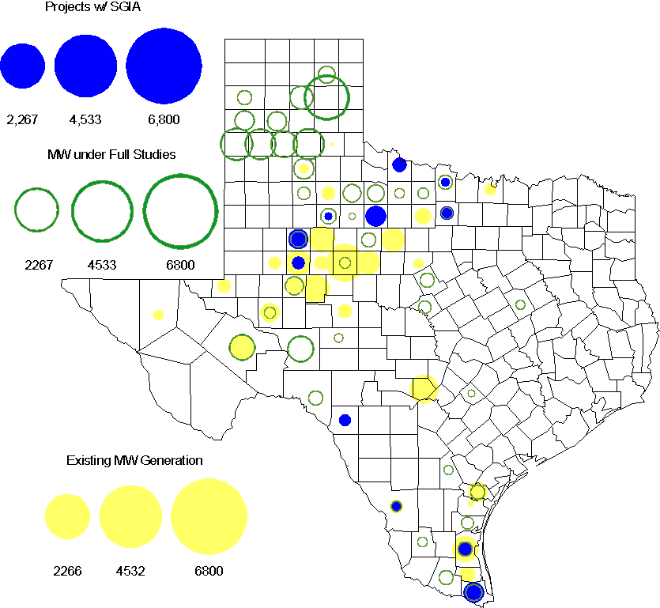

Regional Planning Group Project Reviews

- South Texas Electric Cooperative (STEC) has submitted the Karnes Electric Cooperative (KEC) and Medina Electric Cooperative (MEC) load addition project to accommodate 245 MW of new load in Karnes and Atascosa Counties. This is a Tier 2 project that is estimated to cost $48.4 million. This Tier 2 project is undergoing ERCOT Independent Review.

- Oncor submitted the Wink-Mason 138 kV Rebuild project. This is a Tier 3 project that is estimated to cost approximately $30 million. This project has completed the RPG review and ERCOT will send the RPG acceptance letter.

Congestion Costs
Dollars shown in RUC Make Whole payment graph are of settlement quality.

RUC net Make Whole payment in $mm

Monthly Average LMP

Binding Constraints – Year to Date
Contingency | Binding Element | Number of 5-min intervals | Shadow Price Range $/MWh | Estimated Congestion Rent $ (Shadow Price*Limit) | Transmission Project
BASE CASE | West to North Stability Limit | 7610 | 0 - 436 | 25,424,614 | CREZ
Quail - Odessa EHV 345 kV & Longshore - Odessa EHV 345 kV; Golden Switch - Camp Springs Energy Center 138 kV; Lamesa - Willow Valley 138 kV; or Holt - Andrews North 138 kV | China Grove - Bluff Creek 138 kV | 1276 | 0 - 3500 | 22,125,389
Amoco North Cowden Tap - Moss 138kV | Odessa North 138/69 kV Autotransformer | 3291 | 0 - 2800 | 17,417,475 | 5YTP [2010-R7, R8]
Lewisville - Carrollton Northwest 345 kV | Lewisville - Jones Street Tnp 138 kV | 3949 | 0 - 2870 | 14,780,056 | CREZ, 07TPIT0042
Twin Buttes 345/138 kV Autotransformer | San Angelo Red Creek 345/138 kV Autotransformer 2 | 113 low-side; and 36 high-side | 19-3500 low-side; and  3-4500 high-side | 6,572,237 | 14TPIT0067
Comanche Peak 1 & 2 | Austrop - Sandow 345 kV | 247 | 0 - 4500 | 5,526,564
Ajo - Rio Hondo 345 kV | North Edinburg - Lon Hill 345 kV | 62 | 0 - 4500 | 5,215,549 | 14TPIT0050
China Grove - Bluff Creek 138 kV | Moss - Amoco North Cowden Tap 138 kV | 370 | 0 - 3500 | 4,431,919
Barrilla - Fort Stockton Plant 138 kV | Barrilla - Fort Stockton Switch 69 kV | 5392 | 0 - 1263 | 4,363,799 | CREZ
San Angelo Red Creek - Bluff Creek 345 kV; Abilene Mulberry Creek - Bluff Creek 345 kV; or Graham - Long Creek 345 kV | Nicole - Orient 138 kV | 1264 | 0 - 3500 | 3,696,393 | CREZ
Binding Constraints – May 2012
Contingency | Binding Element | Number of 5-min intervals | Shadow Price Range $/MWh | Estimated Congestion Rent $ (Shadow Price*Limit) | Transmission Project | Comments
Amoco North Cowden Tap - Moss 138kV; Moss 345/138 kV Autotransformer; or Moss - Odessa EHV 345 kV & Moss - Midland East 345 kV | Odessa North 138/69 kV Autotransformer | 1562 | 0 - 2800 | 8,264,814 | 5YTP [2010-R7, R8] | Low wind and high loads in West Texas
Twin Buttes 345/138 kV Autotransformer | San Angelo Red Creek 345/138 kV Autotransformer 2 | 50 low-side; and  36 high-side | 19-3500 low-side; and  3-4500 high-side | 4,463,365 | 14TPIT0067 | San Angelo Red Creek 345/138 kV Autotransformer 1 outage
Quail - Odessa EHV 345 kV & Longshore - Odessa EHV 345 kV; Golden Switch - Camp Springs Energy Center 138 kV; or Gails - Willow Valley 138 kV | China Grove - Bluff Creek 138 kV | 415 | 0 - 3500 | 4,321,768 |  | Low wind and high loads in West Texas
Calmont Switch - Benbrook Switch 138 kV Double Circuit | Saginaw - American MFG Tap 138 kV | 61 | 3500 - 3500 | 3,674,213 | 11TPIT0033 | Incorrect telemetry
Lewisville Switch - Carrollton Northwest 345 kV | Lewisville Switch - Jones Street Tnp 138 kV | 929 | 0 - 527 | 3,207,485 | CREZ, 07TPIT0042 | High West - North transfers; and low load
San Angelo Red Creek - Bluff Creek 345 kV | Nicole - Orient 138 kV | 740 | 0 - 3500 | 2,864,099 | CREZ
Lytton Springs 345/138 kV Autotransformer 3 | Lytton Springs 345/138 kV Autotransformer 1 | 250 | 0 - 4500 | 2,783,475 |  | Lytton Springs 138 kV Bus MB4 and Lytton Springs 345/138 kV Autotransformer 2 outages
Long Creek - Sweetwater East 345 kV | Sweetwater East - Abilene Mulberry Creek 345 kV | 1294 | 0 - 58 | 2,544,173 |  | High West - North transfers; and open end on the Sweetwater East - Central Bluff 345 kV double circuit line
Contingency | Binding Element | Number of 5-min intervals | Shadow Price Range $/MWh | Estimated Congestion Rent $ (Shadow Price*Limit) | Transmission Project | Comments
Kyle - San Marcos 138 kV | Turnersville - Buda 138 kV | 28 | 0 - 3500 | 2,158,312 | 09TPIT0060 | Lytton Springs 138 kV Bus MB4 and Lytton Springs 345/138 kV Autotransformer 2 outages
Norwood - Liggett 345 kV & Norwood - Cedar Hill 345 kV | Amelia Street - UT Southwest Medical Center 138 kV | 55 | 107 - 3500 | 2,051,413 |  | Norwood - East Levee , Norwood - Irving Hunter Ferrell Tap 2 - Trinity River Authority - Mountain Creek SES, and Irving Hunter Ferrell Tap 2 - Irving Hunter Ferrell 138 kV outages

Wind Generation as a Percent of Load
One-hour average of total wind power output as a percentage of ERCOT load.

Planning Model Activities
- The March TPIT updates are complete utilizing for the first time the topology from the NMMS Topology Processor (TP) in the Model on Demand (MOD) case building environment. The completion of these cases constitutes the completion of Planning Go-Live.
- Work on the development of the 2013 Data Set A cases has begun.
- The short term calendar of major events during Planning Go-Live follows:
  - May 19, 2012 March TPIT update of 12DSA/DSB cases utilizing Topology Processor output posted on POI.
  - Jun 26-28, 2012 13 SSWG DSA case tuning and business meeting.
  - Aug 2, 2012 13DSA Cases to be posted on POI.
- Status update on SCR760, Changes Needed for Information Model Manager and Topology Processor for Planning Models, which was approved by the ERCOT Board in March 2011.
  - Bundle 1 (Items 3, 7 and 8): In Production.
  - Bundle 2 (Items 2a, 4, 9): In Production.
  - Bundle 3 (Item 5, 2b, 2c): TP Release received and tested. In release management phase. Target late June/early July 2012 production date.
  - Bundle 4 (Items 1, 6): Item 1 considered to be in production. Requirements for Item 6 are in development.
SCR Sub Part | SCR Description | Status
SCR760-1 | Upgrade to PSS/E v32 | Production
SCR760-2 | Distribution Capacitor banks | Production
SCR760-3 | Zero Impedance Line Ratings | Production
SCR760-4 | Associate Loads and Capacitor banks with the correct CNG | Production
SCR760-5 | Additional Transformer Data for Planning | Testing
SCR760-6 | FACTS Devices | Planning
SCR760-7 | Assign valid PSSE IDs to Breakers/  Switches/ Series Devices | Production
SCR760-8 | Phase shift of Autos for short circuit studies | Production
SCR760-9 | Multisection Line Grouping | Production
Table 1: In the following table:
- Red will be used to show status of Not Submitted, meaning that the SCR sub part has not been submitted to Siemens as a Service Request.
- Yellow will indicate that the SCR sub part has been submitted. The color will remain yellow and the status will change in order to Submitted, Planning (Requirements, SOW, Code Writing), Release (Siemens produces first code to test), and Testing (code has completed internal test and is moving through release management).
- Green will indicate that the code has been tested and installed on the machines that ERCOT uses to produce Topology Processor output for Planning and CRR.

Other Notable Activities
- The System Protection Working Group 2012 Future Year (FY) case building is underway. This year, five future year cases instead of four are being built for the first time, for 2013 to 2017.
- The revised 2012 Five-Year Transmission Plan study scope including the stakeholder’s comments/feedback were discussed in the last RPG meeting (May 11) and ERCOT is currently finalizing the scope. The 2012 5YTP start case building process for reliability analysis is currently on-going.
- ERCOT System Planning is reviewing and comparing the dynamic model data submitted through the RARF to the DWG dynamic base case. Review results are being provided to Resource Entities for updates and confirmation.
- ERCOT is spot checking governor model performance by comparing the actual measurement with dynamic model response. Review results will be provided to Resource Entities for updates and confirmation.

