 |  |  |  | System Planning
Monthly Status Report
April 2012

 |  | Report Highlights
 | - ERCOT is currently tracking 125 active generation interconnection requests totaling over 34,000 MW. This includes over 18,000 MW of wind generation.
- ERCOT is currently reviewing proposed transmission improvements with a total cost of $81.5 Million
- Transmission Projects endorsed in 2012 total $413 Million
- All projects (in engineering, routing, licensing and construction) total approximately $9.84 Billion
- Transmission Projects energized in 2012 total about $108.8 million

Table of Contents
1. Generation Interconnection 1
1.1 Signed Generation Interconnection Agreements 1
1.2 New Generation Registering for Commercial Operations 1
1.3 Summary of Generation Interconnection Requests 1
1.4 Projects with Interconnection Agreements 4
1.5 Generation Projects Undergoing Full Interconnection Studies with Confidentiality Waived by Developer 4
1.6 Generation Projects Undergoing Full Interconnection Studies 5
1.7 Wind Generation Capacity Installed by Year 6
2. Regional Planning Group Project Reviews 7
3. Congestion Costs 8
4. Wind Generation as a Percent of Load 11
5. Planning Model Activities 12
6. Other Notable Activities 13

1. Generation Interconnection
Additional information regarding detailed generation interconnection and impact studies is contained in the “Generation Project Interconnection Information” folder in the “Operations and System Planning” area on the ERCOT website: http://planning.ercot.com/login/login.

Signed Generation Interconnection Agreements
None for April 2012

New Generation Registering for Commercial Operations
09INR0007 Nacogdoches Project – 105 MW Biomass in Nacogdoches County
10INR0060 Redfish Wind Farm – 206 MW Wind in Willacy County

The total installed wind capacity is now reported as 10,044 MW by the resource owners through the registration process. Capacity by North, South and West is 232 MW, 2,281 MW, and 7,531 MW respectively. 850 MW is able to switch between the West and South zones and is currently shown in the South zone.

Summary of Generation Interconnection Requests
GENERATION INTERCONNECTION REQUESTS CURRENTLY UNDER REVIEW
Currently tracking 166 generation interconnection or change requests
As of April 30, 2012 | North | South | West | Total
Security Screening Study | 1 | 1 | 2 | 4
SSS Completed | 3 | 6 | 7 | 16
Full Interconnect Study | 7 | 15 | 47 | 69
FIS Completed | 3 | 5 | 7 | 15
Suspended Studies | 8 | 3 | 30 | 41
Capacity of Suspended Study Projects | 6,486 | 638 | 11,524 | 18,648
Interconnect Agreement Completed | 7 | 9 | 5 | 21
Capacity under Interconnection Agreements | 5,194 | 4,134 | 1,098 | 10,426
Capacity for Grid, MW | 9,510 | 9,597 | 15,002 | 34,109
Wind Capacity, MW | 3,616 | 2,342 | 12,560 | 18,518

Fuel Type | Confidential Projects (MW) | Projects Under Full Study (MW) | Projects w/ Interconnect Agreement (MW) | Suspended Studies (MW) | Grand Total (MW)
Gas-AllOther |  |  |  |  | 1,014
Gas-CombinedCycle |  |  | 5,449 | 2,890 | 10,642
Total Gas | 1,843 | 1,474 | 5,449 | 2,890 | 11,656
Nuclear |  |  |  | 3,200 | 3,200
Coal |  | 2,050 | 1,585 |  | 3,635
Wind | 2,295 | 14,131 | 2,092 | 12,154 | 30,672
Solar | 263 | 481 | 60 | 353 | 1,157
Biomass |  |  |  | 50 | 50
Storage | 560 | 346 |  |  | 906
Other |  | 240 | 1,240 |  | 1,480
Grand Total | 4,961 | 18,722 | 10,426 | 18,647 | 52,756

County Location of Installed Generation and Interconncection Requests (all fuels)

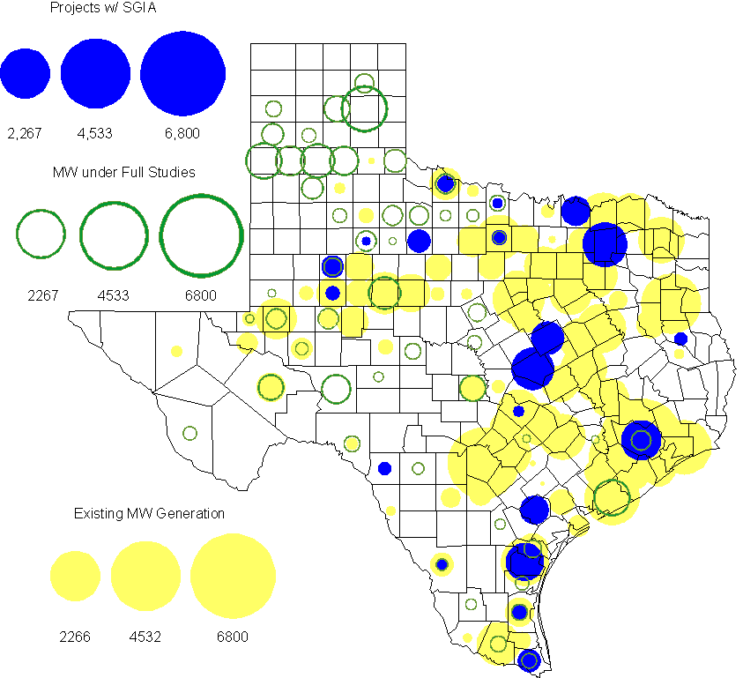

Projects with Interconnection Agreements
(Status: IA=Interconnect Agreement, XX= cancelled)
Generation Interconnections as of April 30, 2012
INR | SiteName | Status | County | Region | COD | Fuel Type |  | MW For Grid |  | Change from Last Report
11INR0086 | RRE Austin Solar | IA | Travis | South | Oct-12 |  | Solar |  | 60
08INR0011 | Senate Wind Project | IA | Jack | North | Nov-12 |  | Wind |  | 150
12INR0075 | Blue Summit Windfarm | IA | Wilbarger | West | Nov-12 |  | Wind |  | 170
12INR0072 | Anacacho Windfarm | IA | Kinney | South | Dec-12 |  | Wind |  | 100
11INR0091 | Whitetail Wind Energy Project | IA | Webb | South | Dec-12 |  | Wind |  | 92
09INR0061 | WKN Mozart | IA | Kent | West | Dec-12 |  | Wind |  | 30
10INR0023 | Baker Ranch | IA | Haskell | West | Dec-12 |  | Wind |  | 400
08INR0049 | Briar Creek | IA | Clay | North | Dec-12 |  | Wind |  | 50
11INR0033 | Los Vientos | IA | Cameron | South | Dec-12 |  | Wind |  | 400
09INR0001 | Sandy Creek 1 | IA | McLennan | North | Mar-13 |  | Coal |  | 925
06INR0022c | Penascal Wind Farm 3 | IA | Kenedy | South | Dec-13 |  | Wind |  | 202
12INR0034 | Stephens-Borlynn Wind | IA | Borden | West | Dec-13 |  | Wind |  | 378
10INR0021 | Panda Sherman Power | IA | Grayson | North | Jul-14 |  | Gas-CC |  | 717
08INR0018 | Gunsight Mountain | IA | Howard | West | Aug-14 |  | Wind |  | 120
10INR0020a | Panda Temple Power | IA | Bell | North | Jan-15 |  | Gas-CC |  | 780
06INR0006 | Cobisa-Greenville | IA | Hunt | North | May-15 |  | Gas-CC |  | 1,792
12INR0016a | Las Brisas Energy Center | IA | Nueces | South | Oct-15 |  | Other |  | 620
10INR0020b | Panda Temple Power | IA | Bell | North | Jan-16 |  | Gas-CC |  | 780
10INR0022 | Pondera King Power Project | IA | Harris | South | Jan-16 |  | Gas-CC |  | 1,380
12INR0016b | Las Brisas Energy Center | IA | Nueces | South | Oct-16 |  | Other |  | 620
14INR0002 | Coleto Creek Unit 2 | IA | Goliad | South | Jan-17 |  | Coal |  | 660
 |  |  |  |  |  |  | TOTAL |  | 10,426
Note: Projects that do not have an interconnection agreement but have been publicly disclosed via a Public Letter to ERCOT and were previously reported on this table have been moved to section 1.5 unless Suspended or Cancelled

Generation Projects Undergoing Full Interconnection Studies with Confidentiality Waived by Developer
INR | SiteName | Status | County | Region | COD | Fuel | MW For Grid | Change from Last Report
12INR0080 | Blanco Canyon Wind | PL | Floyd | West | Dec-12 | Wind | 300
14INR0005 | White Stallion Energy Center | PL | Matagorda | South | Jul-14 | Coal | 1,200

Generation Projects Undergoing Full Interconnection Studies
INR | County | Grid | COD | Fuel |  | INR | County | Grid | COD | Fuel
10INR0062a | Pecos | 80 | TBD | Wind |  | 11INR0094 | Kent | 100 | TBD | Solar
12INR0053 | Crockett | 615 | Jun-12 | Wind |  | 12INR0086 | Harris | 89 | Jun-12 | Gas
12INR0050 | King | 332 | Jun-12 | Wind |  | 12INR0079 | Kenedy | 200 | Aug-12 | Wind
12INR0076 | Winkler | 36 | Oct-12 | Other |  | 12INR0089 | Pecos | 230 | Nov-12 | Wind
11INR0081 | Live Oak | 72 | Dec-12 | Wind |  | 11INR0093 | San Patricio | 41 | Dec-12 | Wind
12INR0055 | Baylor | 80 | Dec-12 | Wind |  | 12INR0057 | Ector | 50 | Dec-12 | Solar
12INR0059 | Pecos | 50 | Dec-12 | Solar |  | 12INR0060 | Schleicher | 58 | Dec-12 | Wind
12INR0067 | Webb | 94 | Dec-12 | Wind |  | 12INR0068 | Jim Hogg | 80 | Dec-12 | Wind
12INR0080 | Floyd | 300 | Dec-12 | Wind |  | 09INR0048 | Jack | 113 | Dec-12 | Wind
12INR0029 | Swisher | 500 | Dec-12 | Wind |  | 12INR0081 | Upton | 113 | Dec-12 | Wind
12INR0085 | Stonewall | 25 | Dec-12 | Wind |  | 13INR0040 | Harris |  | Jan-13 | Gas
13INR0010a | Parmer | 200 | Jan-13 | Wind |  | 11INR0082B | Val Verde | 150 | Mar-13 | Wind
11INR0083B | Crockett | 100 | Mar-13 | Wind |  | 09INR0051 | Borden | 249 | Mar-13 | Wind
11INR0050 | Crosby | 149 | Mar-13 | Wind |  | 12INR0018 | Gray | 500 | Apr-13 | Wind
12INR0070 | Knox | 300 | Apr-13 | Wind |  | 10INR0062b | Pecos | 220 | May-13 | Wind
10INR0089 | Harris | 40 | May-13 | Other |  | 13INR0020a | Glasscock | 200 | May-13 | Wind
12INR0045 | Kleberg | 135 | Jun-13 | Wind |  | 13INR0031 | Austin | 30 | Jun-13 | Solar
13INR0032 | Andrews | 30 | Jun-13 | Solar |  | 13INR0023 | Ector | 240 | Jul-13 | Other
11INR0082A | Val Verde | 50 | Sep-13 | Wind |  | 11INR0083A | Crockett | 50 | Sep-13 | Wind
13INR0025 | Randall | 150 | Sep-13 | Wind |  | 13INR0046 | Limestone | 71 | Sep-13 | Wind
13INR0005 | Carson | 600 | Oct-13 | Wind |  | 12INR0071 | Caldwell | 30 | Nov-13 | Wind
13INR0028 | Hale | 392 | Nov-13 | Gas |  | 10INR0009 | Castro | 300 | Dec-13 | Wind
11INR0013 | Mills | 150 | Dec-13 | Wind |  | 11INR0085 | Nolan | 106 | Dec-13 | Wind
12INR0002a | Briscoe | 200 | Dec-13 | Wind |  | 13INR0007 | Pecos | 200 | Dec-13 | Wind
13INR0026 | Oldham | 201 | Dec-13 | Wind |  | 13INR0030 | Archer | 100 | Dec-13 | Wind
13INR0036 | Hidalgo | 200 | Dec-13 | Wind |  | 13INR0038 | Swisher | 300 | Dec-13 | Wind
13INR0039 | Castro | 500 | Dec-13 | Wind |  | 13INR0050 | Comanche | 260 | Dec-13 | Wind
13INR0052 | Starr | 200 | Dec-13 | Wind |  | 11INR0057 | Cameron | 165 | Dec-13 | Wind
08INR0019a | Gray | 250 | Jan-14 | Wind |  | 08INR0019b | Gray | 250 | Jan-14 | Wind
08INR0019c | Gray | 250 | Jan-14 | Wind |  | 13INR0006 | Gray | 750 | Jan-14 | Wind
14INR0013 | Cameron | 103 | Jan-14 | Wind |  | 14INR0014 | Val Verde | 100 | Jan-14 | Solar
10INR0080 | Presidio | 81 | Jan-14 | Solar |  | 13INR0010b | Parmer | 500 | Jan-14 | Wind
13INR0020b | Glasscock | 150 | May-14 | Wind |  | 14INR0011 | Swisher | 270 | Jun-14 | Gas
14INR0012 | Gray | 401 | Jun-14 | Wind |  | 14INR0015 | Harris | 192 | Jun-14 | Gas
14INR0016 | Harris | 190 | Jun-14 | Gas |  | 11INR0054 | San Patricio | 161 | Jul-14 | Wind
14INR0005 | Matagorda | 1,200 | Jul-14 | Coal |  | 14INR0010 | Roberts | 300 | Jul-14 | Wind
12INR0042a | Deaf Smith | 265 | Sep-14 | Wind |  | 12INR0042b | Deaf Smith | 135 | Sep-14 | Wind
10INR0085 | Ector | 40 | Dec-14 | Solar |  | 12INR0002b | Briscoe | 200 | Dec-14 | Wind
13INR0021 | Llano | 600 | Dec-14 | Gas |  | 14INR0009 | Kent | 248 | Dec-14 | Wind
14INR0020 | Floyd | 150 | Dec-14 | Wind |  | 11INR0079a | Clay | 200 | Dec-14 | Wind
13INR0010c | Parmer | 500 | Jan-15 | Wind |  | 12INR0002c | Briscoe | 350 | Dec-15 | Wind
16INR0003 | Brazoria | 11 | Jun-16 | Gas |  | 14INR0003 | Nolan | 850 | Jun-18 | Coal

Note: ERCOT recently requested that the Transmission Service Providers comprehensively review the status of each of their assigned Full Interconnection Studies and report the status of each study back to ERCOT. Projects that were classified as “Cancelled” or “Suspended” as a result of this review are excluded from this table.

Wind Generation Capacity Installed by Year
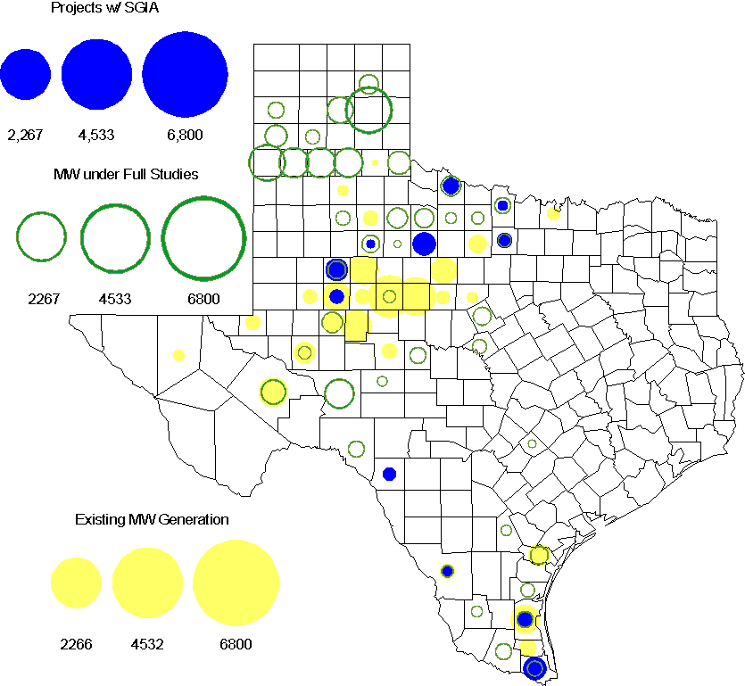

Regional Planning Group Project Reviews

- South Texas Electric Cooperative (STEC) submitted the Karnes Electric Cooperative (KEC) load addition project to accommodate 167 MW of new load in Karnes and Atascosa Counties. This is a Tier 2 project that is estimated to cost $23.1 million. This Tier 2 project has completed ERCOT Independent Review and ERCOT will send the RPG acceptance letter.

- Texas Municipal Power Agency (TMPA) submitted the Denton 138 kV loop upgrades project. This is a Tier 3 project that is estimated to cost approximately $21.1 million. This project has completed the RPG review and ERCOT has sent the RPG acceptance letter.

- AEPSC submitted the Lobo – Rio Bravo 138 kV line project. This is a Tier 3 project that is estimated to cost approximately $20 million. This project has completed the RPG review and ERCOT will send the RPG acceptance letter.

- South Texas Electric Cooperative (STEC) has submitted the Karnes Electric Cooperative (KEC) and Medina Electric Cooperative (MEC) load addition project to accommodate 245 MW of new load in Karnes and Atascosa Counties. This is a Tier 2 project that is estimated to cost $48.4 million. This project has been submitted for RPG comments.

- Oncor has submitted the Wink-Mason 138 kV Rebuild project. This is a Tier 3 project that is estimated to cost approximately $30 million. This project has been submitted for RPG comments.

Congestion Costs
Dollars shown in RUC Make Whole payment graph are of settlement quality.

RUC net Make Whole payment in $mm
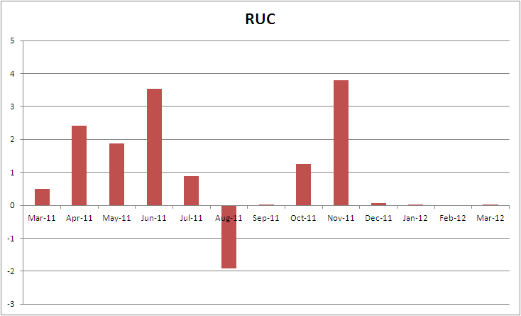

Monthly Average LMP
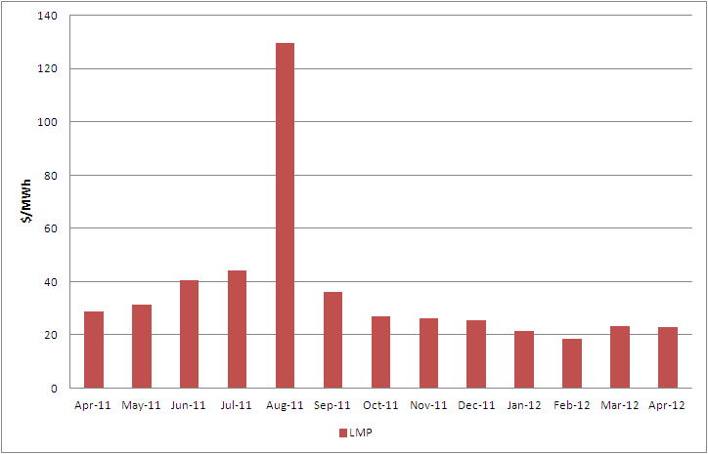

Binding Constraints – Year to Date
Contingency | Binding Element | Number of 5-min intervals | Shadow Price Range $/MWh | Estimated Congestion Rent $ (Shadow Price*Limit) | Transmission Project
BASE CASE | West to North Stability Limit | 7039 | 0 - 436 | 23,851,256 | CREZ
Quail - Odessa EHV 345 kV & Longshore - Odessa EHV 345 kV; Golden Switch - Camp Springs Energy Center 138 kV; Lamesa - Willow Valley 138 kV; or Holt - Andrews North 138 kV | China Grove - Bluff Creek 138 kV | 861 | 0 - 3500 | 17,803,622
Lewisville - Carrollton Northwest 345 kV | Lewisville - Jones Street Tnp 138 kV | 3020 | 0 - 2870 | 11,572,571 | CREZ, 07TPIT0042
Amoco North Cowden Tap - Moss 138kV | Odessa North 138/69 kV Autotransformer | 1729 | 0 - 2800 | 9,152,661 | 5YTP [2010-R7, R8]
Comanche Peak 1 & 2 | Austrop - Sandow 345 kV | 247 | 0 - 4500 | 5,526,564
Ajo - Rio Hondo 345 kV | North Edinburg - Lon Hill 345 kV | 62 | 0 - 4500 | 5,215,549 | 14TPIT0050
China Grove - Bluff Creek 138 kV | Moss - Amoco North Cowden Tap 138 kV | 370 | 0 - 3500 | 4,431,919
Barrilla - Fort Stockton Plant 138 kV | Barrilla - Fort Stockton Switch 69 kV | 4340 | 0 - 1263 | 3,733,738 | CREZ
Bluff Creek Auto 345/138 kV Autotransformer 2 | Nicole - Oak Creek 138kV | 2629 | 0 - 132 | 3,254,766 | CREZ
Spur - Aspermont 138 kV; Spur - Scurry 138 kV; or Sun - Scurry 138 kV | Spur - Girard 69 kV | 4677 | 0 - 2800 | 3,136,124 | CREZ
Binding Constraints – April 2012
Contingency | Binding Element | Number of 5-min intervals | Shadow Price Range $/MWh | Estimated Congestion Rent $ (Shadow Price*Limit) | Transmission Project | Comments
Quail - Odessa EHV 345 kV & Longshore - Odessa EHV 345 kV; Golden Switch - Camp Springs Energy Center 138 kV; Lamesa - Willow Valley 138 kV; or Holt - Andrews North 138 kV | China Grove - Bluff Creek 138 kV | 645 | 0 - 3500 | 11,580,993 |  | High west wind and Brand to Golden Switch 138 kV outage
Comanche Peak 1 & 2 | Austrop - Sandow 345 kV | 247 | 0 - 4500 | 5,526,564
China Grove - Bluff Creek 138 kV | Moss - Amoco North Cowden Tap 138 kV | 370 | 0 - 3500 | 4,431,919 |  | High west wind and Brand to Golden Switch 138 kV outage
BASE CASE | West to North Stability Limit | 1288 | 0 - 55 | 4,384,669 | CREZ | High west wind
North Laredo - Dilley Switch AEP 138 kV | Pleasanton - Big Foot 138 kV | 112 | 17 - 3500 | 2,482,233 | 14TPIT0049, 07TPIT0077 | High load and San Miguel to Pearsall Switching Station 138 kV outage
San Angelo Red Creek - Twin Buttes 345 kV | San Angelo Red Creek 345/138 Autotransformer 2 | 63 | 47 - 3500 | 2,108,872 | 14TPIT0067
Barrilla - Fort Stockton Plant 138 kV | Barrilla - Fort Stockton Switch 69 kV | 1535 | 0 - 1057 | 1,482,858 | CREZ | High west and McCamey wind
Amoco North Cowden Tap - Moss 138kV | Odessa North 138/69 kV Autotransformer | 221 | 0 - 2275 | 1,402,429 | 5YTP [2010-R7, R8] | High west wind and Brand to Golden Switch 138 kV outage
Roanoke - West Denton 345 kV and Roanoke - Lewisville 345 kV | Fort Worth - West Denton 138 kV | 253 | 0 - 732 | 883,077 | 14TPIT0047 | West Denton to Jim Christal 138 kV outage
Amoco North Cowden Tap - Moss 138kV | Odessa North - North Cowden 69 kV | 87 | 1548 - 2800 | 866,041 | 14TPIT0009 | High west wind and Brand to Golden Switch 138 kV outage

Wind Generation as a Percent of Load
One-hour average of total wind power output as a percentage of ERCOT load.
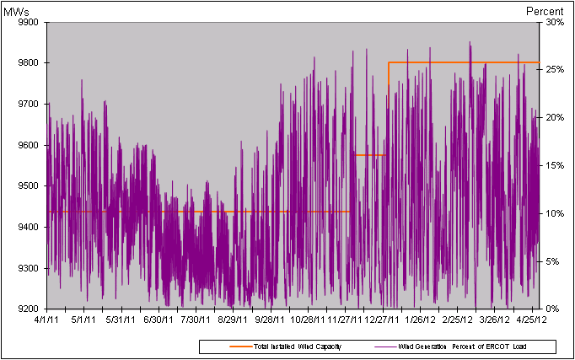

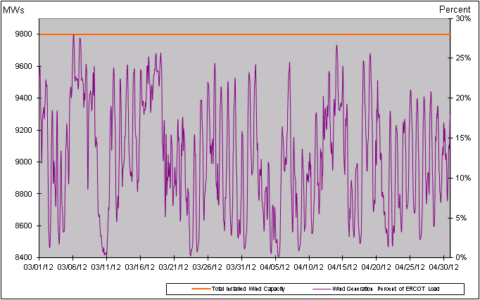

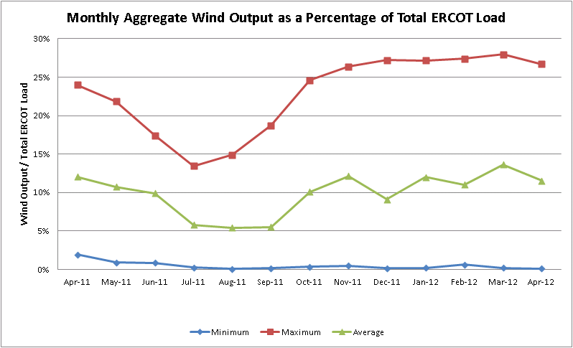

Planning Model Activities
- The March TPIT update is underway utilizing for the first time the topology from the NMMS Topology Processor (TP) in the Model on Demand (MOD) case building environment. Pass 1 has been completed and Pass 2 underway.
- Network Operations Model Change Requests (NOMCR’s) were submitted by TSP’s to populate data for new data types recently made available by completion of Bundle 2 of SCR760, which included sub parts 2, 4, and 9 from the table below. An incremental update to the NMMS Topology Processed base case in MOD was made to insert the data as a Planning Model Change Request (PMCR).
- The short term calendar of major events during Planning Go-Live follows:
  - Feb 27, 2012 ERCOT produces TP case with 7/1/2012 energization date and uses this output as the new base case in MOD.
  - Feb 29, 2012 Planning Go-Live initiated with creation of a MOD base case utilizing the TP case produced two days earlier.
  - Apr 30, 2012 Creation of 13DSA Pass 1 cases
  - May 7, 2012 Creation of 12DSA/DSB Pass 2 cases
  - May 11, 2012 March TPIT case posted on POI.
  - Aug 1, 2012 13DSA cases completed and posted on POI.
- Status update on SCR760, Changes Needed for Information Model Manager and Topology Processor for Planning Models, which was approved by the ERCOT Board in March 2011.
  - Bundle 1 (Items 3, 7 and 8): In Production.
  - Bundle 2 (Items 2a, 4, 9): In Production.
  - Bundle 3 (Item 5, 2b, 2c): TP Release received by ERCOT during week of Apr 23rd. Target June production date.
  - Bundle 4 (Items 1, 6): ERCOT and TSPs have identified new fields or records added between version 33 and version 30 of the PSS/E RAWD format and are decided which new fields need to be implemented. The evaluation process for Item 1 has been added to the SSWG Procedure Manual as section 5.3. Item 1 considered to be in production.
SCR Sub Part | SCR Description | Status
SCR760-1 | Upgrade to PSS/E v32 | Production
SCR760-2 | Distribution Capacitor banks | Production
SCR760-3 | Zero Impedance Line Ratings | Production
SCR760-4 | Associate Loads and Capacitor banks with the correct CNG | Production
SCR760-5 | Additional Transformer Data for Planning | Release
SCR760-6 | FACTS Devices | Submitted
SCR760-7 | Assign valid PSSE IDs to Breakers/  Switches/ Series Devices | Production
SCR760-8 | Phase shift of Autos for short circuit studies | Production
SCR760-9 | Multisection Line Grouping | Production
Table 1: In the following table:
- Red will be used to show status of Not Submitted, meaning that the SCR sub part has not been submitted to Siemens as a Service Request.
- Yellow will indicate that the SCR sub part has been submitted. The color will remain yellow and the status will change in order to Submitted, Planning (Requirements, SOW, Code Writing), Release (Siemens produces first code to test), and Testing (code has completed internal test and is moving through release management).
- Green will indicate that the code has been tested and installed on the machines that ERCOT uses to produce Topology Processor output for Planning and CRR.

Other Notable Activities
- The System Protection Working Group 2012 Future Year (FY) case building is underway. This year, five future year cases instead of four are being built for the first time, for 2013 to 2017.
- The 2011 Five-Year Transmission Plan analysis has been completed and the final report was posted at the ERCOT POI site on April 13, 2012.
- The 2012 Five-Year Transmission Plan study scope was discussed in the last RPG meeting (April 13) and ERCOT is currently reviewing the stakeholder’s comments/feedback received.
- ERCOT System Planning is reviewing and comparing the dynamic model data submitted through the RARF to the DWG dynamic base case. Review results are being provided to Resource Entities for updates and confirmation.
- ERCOT is spot checking governor model performance by comparing the actual measurement with dynamic model response. Review results will be provided to Resource Entities for updates and confirmation.

