NPRR425 discussion
Scope of Problem:
NPRR425 focus is on the creation of a WGR Group for GREDP and Base Point Deviation Evaluation. However, the scope of the remaining problems facing NPRR425 revolves around 1) modeled unit(s) paired with corresponding GSU transformer(s), and 2) the allowable differences between physical and modeled units. These two basic needs to fulfill IRO-010-1a: Reliability Coordinator Data Specification and Collection prevent a few WGRs from further reducing a Resource site to a single WGR Group. It is ERCOTs position that the additional stakeholder concerns raised be addressed in a separate NPRR to develop additional tools that can work around ERCOT’s need.
For item 1 with the existing model, the scope of the problem is limited to 10 of the 93 modeled wind units that would need to be modified. The change is needed for ERCOT to accurately model post-contingency conditions used in real-time operations for GSU transformers. In order for ERCOT, as the RC, to meet its obligations, Resources will be required to model low side kV bus-tie(s), if physically present, that connects GSU transformer(s). Existence of a low side kV bus-tie will result in the Resource being required to model, at a minimum, a single equivalent generator per single step-up transformer. Other modeling requirements of item 2 may result in multiple equivalent generators per single step-up transformer.
For any potential situation where the GSU transformer’s Emergency MVA rating is exceeded, ERCOT may constrain output, depending on whether a SPS or RAP exists. A SPS/RAP library can be created for known conditions where WGR sites physically have the low-side kV bus tie Closed, or no low side kV bus-tie, as well as situations where GSU transformers are de-rated in temporary conditions.
For Item 2, an ERCOT determination was made upon the allowable differences.
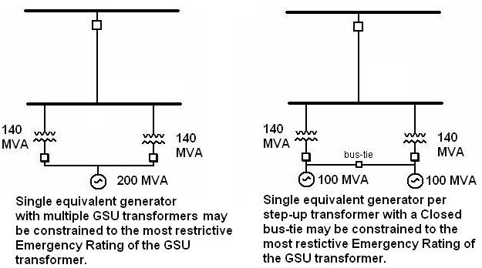

IRO-010-1a: Reliability Coordinator Data Specification and Collection
R1. The Reliability Coordinator shall have a documented specification for data and information to build and maintain models to support Real-time monitoring, Operational Planning Analyses, and Real-time Assessments of its Reliability Coordinator Area to prevent instability, uncontrolled separation, and cascading outages. The specification shall include the following:
R1.1. List of required data and information needed by the Reliability Coordinator to support Real-Time Monitoring, Operational Planning Analyses, and Real-Time Assessments.
R1.2. Mutually agreeable format.
R1.3. Timeframe and periodicity for providing data and information (based on its hardware and software requirements, and the time needed to do its Operational Planning Analyses).
R1.4. Process for data provision when automated Real-Time system operating data is unavailable.
R2. The Reliability Coordinator shall distribute its data specification to entities that have Facilities monitored by the Reliability Coordinator and to entities that provide Facility status to the Reliability Coordinator.
R3. Each Balancing Authority, Generator Owner, Generator Operator, Interchange Authority, Load-serving Entity, Reliability Coordinator, Transmission Operator, and Transmission Owner shall provide data and information, as specified, to the Reliability Coordinator(s) with which it has a reliability relationship.

