 |  |  |  | System Planning
Monthly Status Report
March 2012

 |  | Report Highlights
 | - ERCOT is currently tracking 128 active generation interconnection requests totaling over 34,000 MW. This includes over 19,000 MW of wind generation.
- ERCOT is currently reviewing proposed transmission improvements with a total cost of $74.2 Million
- Transmission Projects endorsed in 2012 total $394 Million
- All projects (in engineering, routing, licensing and construction) total approximately $9.84 Billion
- Transmission Projects energized in 2012 total about $108.8 million

Table of Contents
1. Generation Interconnection 1
1.1 Signed Generation Interconnection Agreements 1
1.2 New Generation Registering for Commercial Operations 1
1.3 Summary of Generation Interconnection Requests 1
1.4 Projects with Interconnection Agreements 4
1.5 Generation Projects Undergoing Full Interconnection Studies with Confidentiality Waived by Developer 4
1.6 Generation Projects Undergoing Full Interconnection Studies 5
1.7 Wind Generation Capacity Installed by Year 6
2. Regional Planning Group Project Reviews 7
3. Congestion Costs 8
4. Wind Generation as a Percent of Load 11
5. Planning Model Activities 12
6. Other Notable Activities 13

1. Generation Interconnection
Additional information regarding detailed generation interconnection and impact studies is contained in the “Generation Project Interconnection Information” folder in the “Operations and System Planning” area on the ERCOT website: http://planning.ercot.com/login/login.

Signed Generation Interconnection Agreements
12INR0034 Stephens-Borlynn Wind – 378 MW in Borden County

New Generation Registering for Commercial Operations
Non-Modeled SUNEDISON VALLEY ROAD – 9.9 MW Solar in Bexar County
Non-Modeled SUNEDISON RABEL ROAD – 9.9 MW Solar in Bexar County

The total installed wind capacity is now reported as 9,838 MW by the resource owners through the registration process. Capacity by North, South and West is 232 MW, 2075 MW, and 7531 MW respectively. 850 MW is able to switch between the West and South zones and is currently shown in the South zone.

Summary of Generation Interconnection Requests
GENERATION INTERCONNECTION REQUESTS CURRENTLY UNDER REVIEW
Currently tracking 168 generation interconnection or change requests
As of March 31, 2012 | North | South | West | Total
Security Screening Study | 0 | 2 | 2 | 4
SSS Completed | 3 | 5 | 7 | 15
Full Interconnect Study | 7 | 17 | 48 | 72
FIS Completed | 2 | 5 | 7 | 14
Suspended Studies | 8 | 3 | 28 | 39
Capacity of Suspended Study Projects | 6,486 | 638 | 11,273 | 18,397
Interconnect Agreement Completed | 8 | 10 | 5 | 23
Capacity under Interconnection Agreements | 5,294 | 4,340 | 1,098 | 10,732
Capacity for Grid, MW | 9,610 | 10,653 | 14,524 | 34,787
Wind Capacity, MW | 3,616 | 3,398 | 12,110 | 19,124

Fuel Type | Confidential Projects (MW) | Projects Under Full Study (MW) | Projects w/ Interconnect Agreement/Public Letter (MW) | Suspended Studies (MW) | Grand Total (MW)
Gas-AllOther |  |  |  |  | 1,014
Gas-CombinedCycle |  |  | 5,449 | 2,890 | 10,642
Total Gas | 1,843 | 1,474 | 5,449 | 2,890 | 11,656
Nuclear |  |  |  | 3,200 | 3,200
Coal |  | 850 | 2,785 |  | 3,635
Wind | 2,266 | 14,260 | 2,598 | 11,904 | 31,028
Solar | 235 | 481 | 60 | 353 | 1,129
Biomass |  |  | 100 | 50 | 150
Storage | 560 | 346 |  |  | 906
Other |  | 240 | 1,240 |  | 1,480
Grand Total | 4,904 | 17,651 | 12,232 | 18,397 | 53,184
County Location of Installed Generation and Interconncection Requests (all fuels)

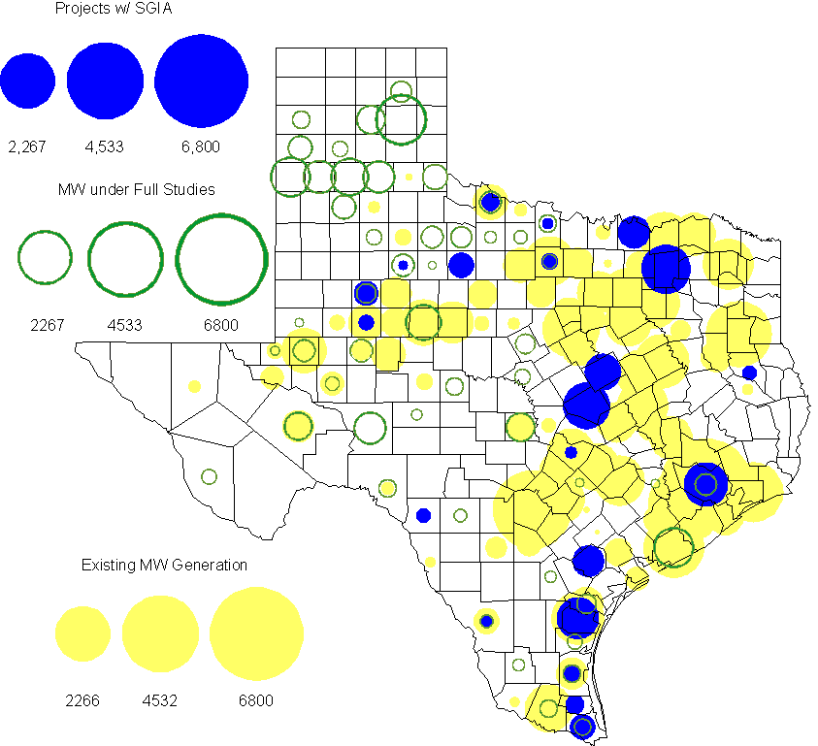

Projects with Interconnection Agreements
(Status: IA=Interconnect Agreement, XX= cancelled)
Generation Interconnections as of March 31, 2012
INR | SiteName | Status | County | Region | COD | Fuel Type |  | MW For Grid |  | Change from Last Report
09INR0007 | Nacogdoches Project | IA | Nacogdoches | North | Jun-12 |  | Biomass |  | 100
10INR0060 | Redfish Wind Project | IA | Willacy | South | Jun-12 |  | Wind |  | 206
11INR0086 | RRE Austin Solar | IA | Travis | South | Oct-12 |  | Solar |  | 60
08INR0011 | Senate Wind Project | IA | Jack | North | Nov-12 |  | Wind |  | 150
12INR0075 | Blue Summit Windfarm | IA | Wilbarger | West | Nov-12 |  | Wind |  | 170
09INR0061 | WKN Mozart | IA | Kent | West | Dec-12 |  | Wind |  | 30
12INR0072 | Anacacho Windfarm | IA | Kinney | South | Dec-12 |  | Wind |  | 100
11INR0091 | Whitetail Wind Energy Project | IA | Webb | South | Dec-12 |  | Wind |  | 92
10INR0023 | Baker Ranch | IA | Haskell | West | Dec-12 |  | Wind |  | 400
11INR0033 | Los Vientos | IA | Cameron | South | Dec-12 |  | Wind |  | 400
08INR0049 | Briar Creek | IA | Clay | North | Dec-12 |  | Wind |  | 50
12INR0034 | Stephens-Borlynn Wind | IA | Borden | West | Dec-13 |  | Wind |  | 378 | New
09INR0001 | Sandy Creek 1 | IA | McLennan | North | Mar-13 |  | Coal |  | 925
06INR0022c | Penascal Wind Farm 3 | IA | Kenedy | South | Dec-13 |  | Wind |  | 202
10INR0021 | Panda Sherman Power | IA | Grayson | North | Jul-14 |  | Gas-CC |  | 717
08INR0018 | Gunsight Mountain | IA | Howard | West | Aug-14 |  | Wind |  | 120
10INR0020a | Panda Temple Power | IA | Bell | North | Jan-15 |  | Gas-CC |  | 780
06INR0006 | Cobisa-Greenville | IA | Hunt | North | May-15 |  | Gas-CC |  | 1,792
12INR0016a | Las Brisas Energy Center | IA | Nueces | South | Oct-15 |  | Other |  | 620
10INR0020b | Panda Temple Power | IA | Bell | North | Jan-16 |  | Gas-CC |  | 780
10INR0022 | Pondera King Power Project | IA | Harris | South | Jan-16 |  | Gas-CC |  | 1,380
12INR0016b | Las Brisas Energy Center | IA | Nueces | South | Oct-16 |  | Other |  | 620
14INR0002 | Coleto Creek Unit 2 | IA | Goliad | South | Jan-17 |  | Coal |  | 660
 |  |  |  |  |  |  | Total |  | 10,732
Note: Projects that do not have an interconnection agreement but have been publicly disclosed via a Public Letter to ERCOT and were previously reported on this table have been moved to section 1.5 unless Suspended or Cancelled

Generation Projects Undergoing Full Interconnection Studies with Confidentiality Waived by Developer
INR | SiteName | Status | County | Region | COD | Fuel | MW For Grid | Change from Last Report
12INR0080 | Blanco Canyon Wind | PL | Floyd | West | Dec-12 | Wind | 300
14INR0005 | White Stallion Energy Center | PL | Matagorda | South | Jul-14 | Coal | 1,200

Generation Projects Undergoing Full Interconnection Studies
INR | County | Grid | COD | Fuel |  | INR | County | Grid | COD | Fuel
10INR0016 | Childress | 150 | TBD | Wind |  | 10INR0062a | Pecos | 80 | TBD | Wind
11INR0094 | Kent | 100 | TBD | Solar |  | 12INR0087 | Harris | 144 | Jun-12 | Gas
12INR0086 | Harris | 89 | Jun-12 | Gas |  | 12INR0053 | Crockett | 615 | Jun-12 | Wind
08INR0031 | Childress | 100 | Jun-12 | Wind |  | 12INR0050 | King | 332 | Jun-12 | Wind
12INR0079 | Kenedy | 200 | Aug-12 | Wind |  | 12INR0076 | Winkler | 36 | Oct-12 | Other
12INR0089 | Pecos | 230 | Nov-12 | Wind |  | 12INR0068 | Jim Hogg | 80 | Dec-12 | Wind
12INR0067 | Webb | 94 | Dec-12 | Wind |  | 11INR0093 | San Patricio | 41 | Dec-12 | Wind
11INR0081 | Live Oak | 72 | Dec-12 | Wind |  | 12INR0059 | Pecos | 50 | Dec-12 | Solar
12INR0057 | Ector | 50 | Dec-12 | Solar |  | 12INR0060 | Schleicher | 58 | Dec-12 | Wind
12INR0055 | Baylor | 80 | Dec-12 | Wind |  | 09INR0048 | Jack | 113 | Dec-12 | Wind
12INR0088 | Crosby | 201 | Dec-12 | Wind |  | 12INR0085 | Stonewall | 25 | Dec-12 | Wind
12INR0081 | Upton | 113 | Dec-12 | Wind |  | 12INR0029 | Swisher | 500 | Dec-12 | Wind
13INR0040 | Harris |  | Jan-13 | Gas |  | 13INR0051 | Cameron | 67 | Jan-13 | Wind
13INR0010a | Parmer | 200 | Jan-13 | Wind |  | 11INR0083B | Crockett | 100 | Mar-13 | Wind
11INR0082B | Val Verde | 150 | Mar-13 | Wind |  | 11INR0050 | Crosby | 149 | Mar-13 | Wind
09INR0051 | Borden | 249 | Mar-13 | Wind |  | 13INR0045 | Castro | 288 | Apr-13 | Wind
12INR0018 | Gray | 500 | Apr-13 | Wind |  | 12INR0070 | Knox | 300 | Apr-13 | Wind
10INR0089 | Harris | 40 | May-13 | Other |  | 13INR0020a | Glasscock | 200 | May-13 | Wind
10INR0062b | Pecos | 220 | May-13 | Wind |  | 10INR0085 | Ector | 40 | May-13 | Solar
13INR0031 | Austin | 30 | Jun-13 | Solar |  | 12INR0045 | Kleberg | 135 | Jun-13 | Wind
13INR0032 | Andrews | 30 | Jun-13 | Solar |  | 13INR0023 | Ector | 240 | Jul-13 | Other
13INR0048 | Oldham | 150 | Jul-13 | Wind |  | 13INR0049 | Harris | 378 | Jul-13 | Gas
13INR0046 | Limestone | 71 | Sep-13 | Wind |  | 13INR0025 | Randall | 150 | Sep-13 | Wind
11INR0083A | Crockett | 50 | Sep-13 | Wind |  | 11INR0082A | Val Verde | 50 | Sep-13 | Wind
13INR0005 | Carson | 600 | Oct-13 | Wind |  | 12INR0071 | Caldwell | 30 | Nov-13 | Wind
13INR0028 | Hale | 392 | Nov-13 | Gas |  | 13INR0047 | Cooke | 20 | Dec-13 | Solar
13INR0050 | Comanche | 260 | Dec-13 | Wind |  | 13INR0038 | Swisher | 300 | Dec-13 | Wind
11INR0013 | Mills | 150 | Dec-13 | Wind |  | 14INR0019 | Wilacy | 400 | Dec-13 | Wind
13INR0044 | Wilacy | 400 | Dec-13 | Wind |  | 13INR0036 | Hidalgo | 200 | Dec-13 | Wind
13INR0039 | Castro | 500 | Dec-13 | Wind |  | 13INR0030 | Archer | 100 | Dec-13 | Wind
13INR0026 | Oldham | 201 | Dec-13 | Wind |  | 13INR0007 | Pecos | 200 | Dec-13 | Wind
12INR0002a | Briscoe | 200 | Dec-13 | Wind |  | 11INR0085 | Nolan | 106 | Dec-13 | Wind
10INR0009 | Castro | 300 | Dec-13 | Wind |  | 12INR0058 | San Patricio | 50 | Dec-13 | Wind
11INR0057 | Cameron | 165 | Dec-13 | Wind |  | 14INR0013 | Cameron | 103 | Jan-14 | Wind
14INR0014 | Val Verde | 100 | Jan-14 | Solar |  | 13INR0006 | Gray | 750 | Jan-14 | Wind
12INR0084 | Randall | 242 | Jan-14 | Wind |  | 08INR0019c | Gray | 250 | Jan-14 | Wind
08INR0019b | Gray | 250 | Jan-14 | Wind |  | 08INR0019a | Gray | 250 | Jan-14 | Wind
13INR0010b | Parmer | 500 | Jan-14 | Wind |  | 10INR0080 | Presidio | 81 | Jan-14 | Solar
13INR0020b | Glasscock | 150 | May-14 | Wind |  | 14INR0016 | Harris | 190 | Jun-14 | Gas
14INR0015 | Harris | 192 | Jun-14 | Gas |  | 14INR0011 | Swisher | 270 | Jun-14 | Gas
14INR0021 | Erath | 125 | Jun-14 | Wind |  | 14INR0012 | Gray | 401 | Jun-14 | Wind
14INR0024 | Kinney | 40 | Jul-14 | Solar |  | 11INR0054 | San Patricio | 161 | Jul-14 | Wind
14INR0010 | Roberts | 300 | Jul-14 | Wind |  | 12INR0042b | Deaf Smith | 135 | Sep-14 | Wind
12INR0042a | Deaf Smith | 265 | Sep-14 | Wind |  | 13INR0021 | Llano | 600 | Dec-14 | Gas
14INR0023 | Briscoe | 361 | Dec-14 | Wind |  | 14INR0022 | Briscoe | 361 | Dec-14 | Wind
14INR0018 | Nolan | 35 | Dec-14 | Solar |  | 14INR0020 | Floyd | 150 | Dec-14 | Wind
14INR0009 | Kent | 248 | Dec-14 | Wind |  | 12INR0002b | Briscoe | 200 | Dec-14 | Wind
11INR0079a | Clay | 200 | Dec-14 | Wind |  | 13INR0010c | Parmer | 500 | Jan-15 | Wind
15INR0013 | Anderson | 280 | Oct-15 | Gas |  | 15INR0014 | Matagorda | 280 | Oct-15 | Gas
15INR0012 | DeWitt | 1,321 | Dec-15 | Gas |  | 15INR0015 | Pecos | 140 | Dec-15 | Solar
12INR0002c | Briscoe | 350 | Dec-15 | Wind |  | 16INR0003 | Brazoria | 11 | Jun-16 | Gas
14INR0003 | Nolan | 850 | Jun-18 | Coal

Note: ERCOT recently requested that the Transmission Service Providers comprehensively review the status of each of their assigned Full Interconnection Studies and report the status of each study back to ERCOT. Projects that were classified as “Cancelled” or “Suspended” as a result of this review are excluded from this table.

Wind Generation Capacity Installed by Year
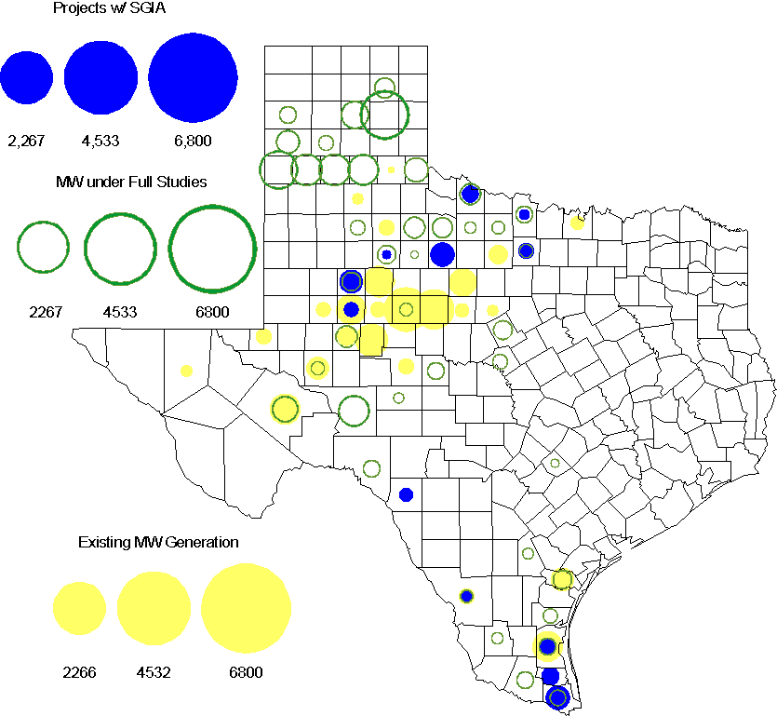

Regional Planning Group Project Reviews

- South Texas Electric Cooperative (STEC) has submitted the Karnes Electric Cooperative (KEC) load addition project to accommodate 167 MW of new load in Karnes and Atascosa Counties. This is a Tier 2 project that is estimated to cost $33.1 million. This Tier 2 project is undergoing ERCOT Independent Review.

- CenterPoint Energy has submitted the Mont Belvieu Area upgrades project. This is a Tier 3 project that is estimated to cost approximately $42 million. This project has completed the RPG review and ERCOT has sent the RPG acceptance letter.

- Texas Municipal Power agency (TMPA) has submitted the Denton 138 kV loop upgrades project. This is a Tier 3 project that is estimated to cost approximately $21.1 million. This project is currently in the study mode.

- LCRA TSC, San Bernard Electric Cooperative (SBEC), and South Texas Electric Cooperative (STEC) has jointly submitted the Glidden to Colorado to Nada 69 kV upgrade project. This is a Tier 3 project that is estimated to cost approximately $32.4 million. This project has completed the RPG review and ERCOT has sent the RPG acceptance letter.

- AEPSC has submitted the Lobo – Rio Bravo 138 kV line project. This is a Tier 3 project that is estimated to cost approximately $20 million. This project is currently in the study mode.

Congestion Costs
Dollars shown in RUC Make Whole payment graph are settlement quality.

RUC net Make Whole payment in $mm
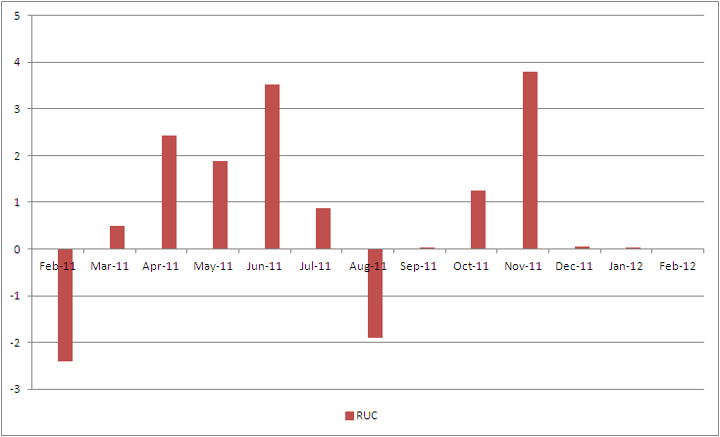

Monthly Average LMP
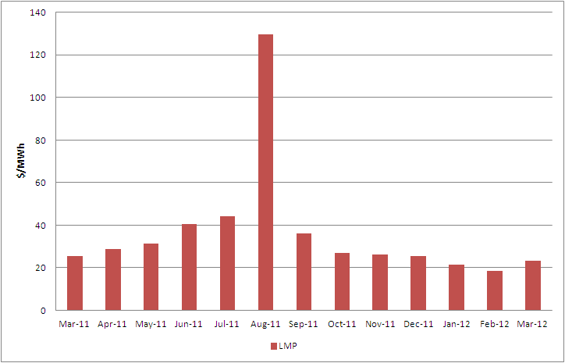

Binding Constraints – Year to Date
Contingency | Binding Element | Number of 5-min intervals | Shadow Price Range $/MWh | Estimated Congestion Rent $ (Shadow Price*Limit) | Transmission Project
BASE CASE | West to North Stability Limit | 5751 | 0 - 436 | 19,466,587 | CREZ
Lewisville Switch - Carrollton Northwest 345 kV | Lewisville Switch - Jones Street Tnp 138 kV | 2733 | 0 - 2870 | 10,801,138 | 07TPIT0042
Amoco North Cowden Tap - Moss Switch 138kV | Odessa North 138/69 kV Autotransformer | 1508 | 0 - 2800 | 7,750,232 | 5YTP [2010-R7, R8]
Midland East - Cal Energy 345 kV | China Grove - Bluff Creek 138 kV | 216 | 0 - 3500 | 6,222,628
Ajo - Rio Hondo 345 kV | North Edinburg - Lon Hill 345 kV | 54 | 0 - 4500 | 4,592,529 | 14TPIT0050
Bluff Creek Auto T2_H & T2_L & T2_T | Nicole - Oak Creek 138kV | 2629 | 0 - 132 | 3,254,766 | CREZ
Scurry Switch - Sun Switch 138 kV, Aspermont Aep - Spur 138 kV, Salt Creek Bepc - Salt Creek Reactor 138 kV | Girard Tap - Spur 69 kV | 4677 | 0 - 2800 | 3,136,124 | CREZ
Fort Stockton Plant - Barrilla 138 kV | Barrilla - Fort Stockton Switch 69 kV | 2805 | 0 - 1263 | 2,250,880 | CREZ
Aspermont - Paint Creek 138 kV, Sacroc - Sun Switch 138 kV, Scurry Switch - Sun Switch, Salt Creek - Spur 138 kV | Aspermont 138/69 kV autotransfomer T1 | 4536 | 0 - 332 | 2,038,781 | CREZ
Cal Energy - Morgan Creek 345 kV | McDonald - Forsan Tap 138 kV | 56 | 3 - 3500 | 1,456,070 | CREZ
Binding Constraints – March 2012
Contingency | Binding Element | Number of 5-min intervals | Shadow Price Range $/MWh | Estimated Congestion Rent $ (Shadow Price*Limit) | Transmission Project | Comments
Lewisville Switch - Carrollton Northwest 345 kV | Lewisville Switch - Jones Street Tnp 138 kV | 2639 | 0 - 2870 | 10,580,927 | 07TPIT0042
Midland East - Cal Energy 345 kV | China Grove - Bluff Creek 138 kV | 216 | 0 - 3500 | 6,222,628 |  | Moss Switch bus outage
BASE CASE | West to North Stability Limit | 1486 | 0 - 68 | 5,011,729 | CREZ | High west wind
Ajo - Rio Hondo 345 kV | North Edinburg - Lon Hill 345 kV | 54 | 0 - 4500 | 4,592,529 | 14TPIT0050
Amoco North Cowden Tap - Moss Switch 138kV | Odessa North 138/69 kV Autotransformer | 572 | 0 - 2800 | 3,416,891 | 5YTP [2010-R7, R8] | Moss Switch bus outage and high west wind
Cal Energy - Morgan Creek 345 kV | McDonald - Forsan Tap 138 kV | 56 | 3 - 3500 | 1,456,070 | CREZ | High west wind
Scurry Switch - Sun Switch 138 kV, Aspermont Aep - Spur 138 kV, Salt Creek Bepc - Salt Creek Reactor 138 kV | Girard Tap - Spur 69 kV | 1969 | 0 - 1329 | 1,335,166 | CREZ | High west wind and Matador -Paducah 69 kV line outage
Fort Stockton Plant - Barrilla 138 kV | Barrilla - Fort Stockton Switch 69 kV | 1097 | 0 - 1263 | 1,024,730 | CREZ | High McCamey and West wind
Odessa EHV - Crane Arco 138 kV | Woodward - 16th Street 138 kV | 958 | 0 - 173 | 665,813 | CREZ | High west wind
Morgan Creek SES - Sun Switch 138 kV | China Grove - Snyder 138 kV | 79 | 34 - 3500 | 659,512 | CREZ | High west wind

Wind Generation as a Percent of Load
One-hour average of total wind power output as a percentage of ERCOT load.
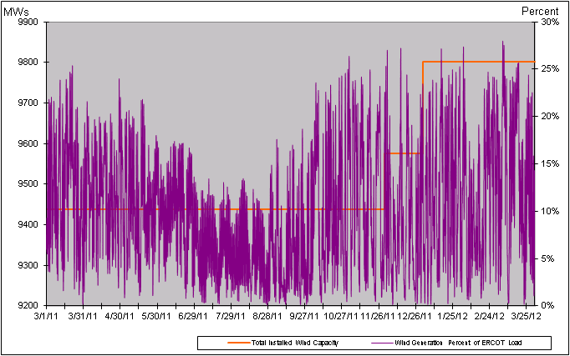

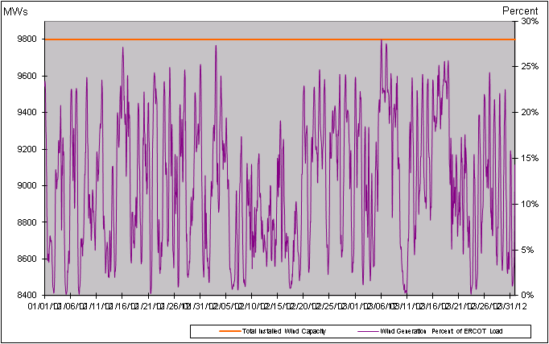

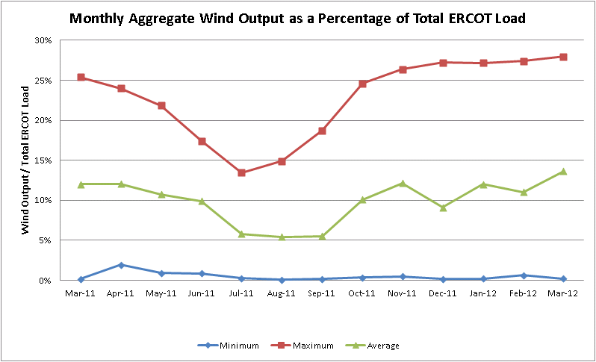

Planning Model Activities
- The March TPIT update is underway utilizing for the first time the topology from the NMMS Topology Processor (TP) in the Model on Demand (MOD) case building environment. TSP’s and ERCOT have been reviewing all PMCR’s for relevancy and updating the generation, load, and device control profiles to match the slightly different topology.
- Network Operations Model Change Requests (NOMCR’s) were submitted by TSP’s to populate data for new data types recently made available by completion of Bundle 2 of SCR760, which included sub parts 2, 4, and 9 from the table below. An incremental update to the NMMS Topology Processed base case in MOD was made to insert the data as a Planning Model Change Request (PMCR).
- The short term calendar of major events during Planning Go-Live follows:
  - Feb 27, 2012 ERCOT produces TP case with 7/1/2012 energization date and uses this output as the new base case in MOD.
  - Feb 29, 2012 Planning Go-Live initiated with creation of a MOD base case utilizing the TP case produced two days earlier.
  - Apr 30, 2012 Creation of 13DSA Pass 1 cases
  - May 11, 2012 March TPIT case posted on POI.
  - Aug 1, 2012 13DSA cases completed and posted on POI.
- Status update on SCR760, Changes Needed for Information Model Manager and Topology Processor for Planning Models, which was approved by the ERCOT Board in March 2011.
  - Bundle 1 (Items 3, 7 and 8): In Production.
  - Bundle 2 (Items 2a, 4, 9): In Production.
  - Bundle 3 (Item 5, 2b, 2c): Sample TP output produced by vendor and examined by ERCOT. TP Release expected during week of Apr 9th. Target June production date.
  - Bundle 4 (Items 1, 6): ERCOT and TSPs have identified new fields or records added between version 33 and version 30 of the PSS/E RAWD format and are decided which new fields need to be implemented. The evaluation process for Item 1 has been added to the SSWG Procedure Manual as section 5.3. Item 1 considered to be in production.
SCR Sub Part | SCR Description | Status
SCR760-1 | Upgrade to PSS/E v32 | Production
SCR760-2 | Distribution Capacitor banks | Production
SCR760-3 | Zero Impedance Line Ratings | Production
SCR760-4 | Associate Loads and Capacitor banks with the correct CNG | Production
SCR760-5 | Additional Transformer Data for Planning | Planning
SCR760-6 | FACTS Devices | Submitted
SCR760-7 | Assign valid PSSE IDs to Breakers/  Switches/ Series Devices | Production
SCR760-8 | Phase shift of Autos for short circuit studies | Production
SCR760-9 | Multisection Line Grouping | Production
Table 1: In the following table:
- Red will be used to show status of Not Submitted, meaning that the SCR sub part has not been submitted to Siemens as a Service Request.
- Yellow will indicate that the SCR sub part has been submitted. The color will remain yellow and the status will change in order to Submitted, Planning (Requirements, SOW, Code Writing), Release (Siemens produces first code to test), and Testing (code has completed internal test and is moving through release management).
- Green will indicate that the code has been tested and installed on the machines that ERCOT uses to produce Topology Processor output for Planning and CRR.

Other Notable Activities
- The System Protection Working Group 2012 Current Year (CY) case completed. An attempt was made by ERCOT and TSPs to make the SPWG 2012 CY generation include all the generation in the 2012 SUM1 SSWG case with matching bus numbers, names, and machine ID. Some changes to accomplish the matching had to be backed out due to lack of complete and detailed RARF information that resulted in fault-current differences that could not be accepted by SPWG. This could be due to required fields in the current RARF being blank and to the fact that the current RARF does not include zero sequence data place-holders for lines and transformers. This should be rectified by October 2012 as RARF 5.0 has been released that contains these fields. Resource Entities and Interconnecting Entities need to provide this data by the required date.
- The 2011 Five-Year Transmission Plan reliability analysis has been completed including both reliability and economic studies. All of the reliability and economic final cases are posted on the ERCOT Planning and Operations Information website. ERCOT has sent the 2011 Five-Year Transmission Plan draft report to the TOs and received feedback from TOs. The final report is expected to be posted before the next RPG meeting (April 13, 2012).
- ERCOT System Planning is reviewing and comparing the dynamic model data submitted through the RARF to the DWG dynamic base case. Review results are being provided to Resource Entities for updates and confirmation.
- ERCOT is spot checking governor model performance by comparing the actual measurement with dynamic model response. Review results will be provided to Resource Entities for updates and confirmation.

