- The 2012 Current Year flat start has been finalized and posted.

- The process for the next flat start build has begun and will be based on a 2017 Future Year case with the following schedule:
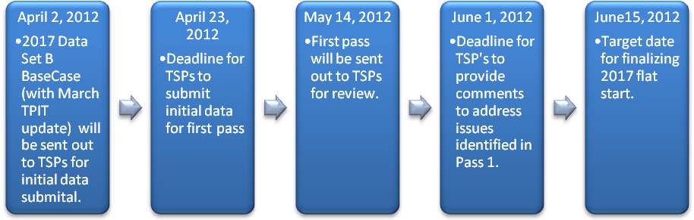
- The next DWG meeting is scheduled for June 12, 2012 to coordinate with the finalization of the 2017 flat start.

