PREAMBLE

Document Purpose
This Planning Guide, created through the collaborative efforts of representatives of all Market Segments, supplements the planning-related requirements included in the Protocols. This Planning Guide provides more detail and establishes additional planning requirements for those organizations and Entities operating in, or potentially impacting the reliability of the ERCOT System, as shown below in Figure 1, ERCOT Regional Map.
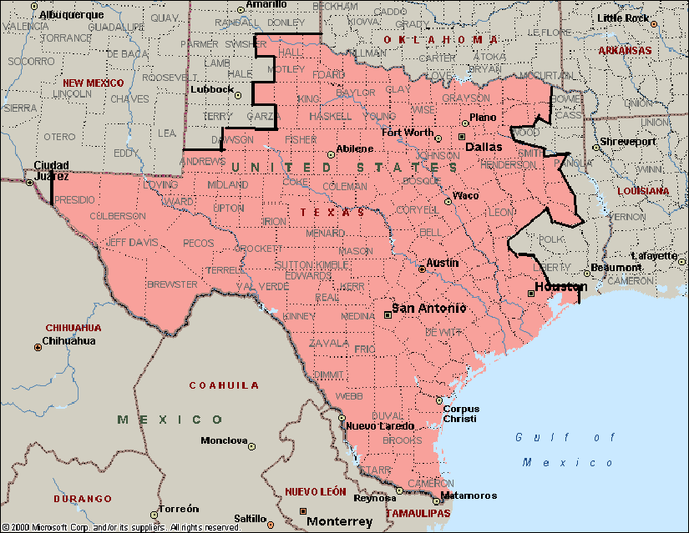
Figure 1 – ERCOT Regional Map
The title “Planning Guide” is not to be construed as presenting merely a recommendation. Organizations and Entities are obligated to comply with this Planning Guide. Specific practices described in the Planning Guide are consistent with North American Electric Reliability Corporation (NERC) Reliability Standards and the Protocols.

Document Relationship
This Planning Guide is written to be consistent with all applicable Public Utility Commission of Texas (PUCT) Substantive Rules, the Protocols, and the planning-related NERC Reliability Standards. In the event of a conflict between the Planning Guide, any PUCT Substantive Rules, and the NERC Reliability Standards, then such PUCT Substantive Rules, NERC Reliability Standards, and the Protocols shall control.
For application in the ERCOT Region, some NERC Reliability Standards must be adapted to fit the unique characteristics of ERCOT. Defined terminology for NERC Regional Variances, if any, is detailed in the NERC Reliability Standards.

