 |  |  |  | System Planning
Monthly Status Report
February 2012

 |  | Report Highlights
 | - ERCOT is currently tracking 127 active generation interconnection requests totaling almost 34,000 MW. This includes over 18,000 MW of wind generation.
- ERCOT is currently reviewing proposed transmission improvements with a total cost of $128.6 Million
- Transmission Projects endorsed in 2012 total $319.6 Million
- All projects (in engineering, routing, licensing and construction) total approximately $10.0 Billion
- Transmission Projects energized in 2011 total about $817.8 million

Table of Contents
1. Generation Interconnection 1
1.1 Signed Generation Interconnection Agreements 1
1.2 New Generation Registering for Commercial Operations 1
1.3 Summary of Generation Interconnection Requests 1
1.4 Projects with Interconnection Agreements 4
1.5 Generation Projects Undergoing Full Interconnection Studies with Confidentiality Waived by Developer 4
1.6 Generation Projects Undergoing Full Interconnection Studies 5
2. Regional Planning Group Project Reviews 7
3. Congestion Costs 8
4. Wind Generation as a Percent of Load 11
5. Planning Model Activities 12
6. Other Notable Activities 13

1. Generation Interconnection
Additional information regarding detailed generation interconnection and impact studies is contained in the “Generation Project Interconnection Information” folder in the “Operations and System Planning” area on the ERCOT website: http://planning.ercot.com/login/login.

Signed Generation Interconnection Agreements
New – 10INR0021 Panda Sherman Power – 717 MW Combined Cycle Gas in Grayson County
New – 12INR0075 Blue Summit Wind – 170 MW in Wilbarger County

New Generation Registering for Commercial Operations
Non-Modeled Harbor Wind – 9 MW in Nueces County

The total installed wind capacity is now reported as 9,838 MW by the resource owners through the registration process. Capacity by North, South and West is 232 MW, 2075 MW, and 7531 MW respectively. Included in the South zone total is 850 MW which is able to switch between the West and South zones.

Summary of Generation Interconnection Requests
GENERATION INTERCONNECTION REQUESTS CURRENTLY UNDER REVIEW
Currently tracking 167 generation interconnection or change requests
As of February 29, 2012 | North | South | West | Total
Security Screening Study | 0 | 1 | 4 | 5
SSS Completed | 4 | 5 | 8 | 17
Full Interconnect Study | 8 | 19 | 48 | 75
FIS Completed | 1 | 2 | 5 | 8
Suspended Studies | 8 | 4 | 28 | 40
Capacity of Suspended Study Projects | 6,486 | 3,338 | 11,273 | 21,097
Interconnect Agreement Completed | 8 | 10 | 4 | 22
Capacity under Interconnection Agreements | 5,294 | 4,340 | 720 | 10,354
Capacity for Grid, MW | 8,918 | 10,545 | 14,349 | 33,812
Wind Capacity, MW | 2,894 | 3,331 | 11,845 | 18,069

Fuel Type | Confidential Projects (MW) | Projects Under Full Study (MW) | Projects w/ Interconnect Agreement/Public Letter (MW) | Suspended Studies (MW) | Grand Total (MW)
Gas-AllOther |  |  |  |  | 1,014
Gas-CombinedCycle |  |  | 5,449 | 2,890 | 10,642
Total Gas | 1,843 | 1,474 | 5,449 | 2,890 | 11,656
Nuclear |  |  |  | 5,900 | 5,900
Coal |  | 850 | 2,785 |  | 3,635
Wind | 1,730 | 14,119 | 2,220 | 11,904 | 29,973
Solar | 315 | 481 | 60 | 353 | 1,209
Biomass |  |  | 100 | 50 | 150
Storage | 560 | 346 |  |  | 906
Other |  | 240 | 1,240 |  | 1,480
Grand Total | 4,448 | 17,510 | 11,854 | 21,097 | 54,909
County Location of Installed Generation and Interconnection Requests (all fuels)

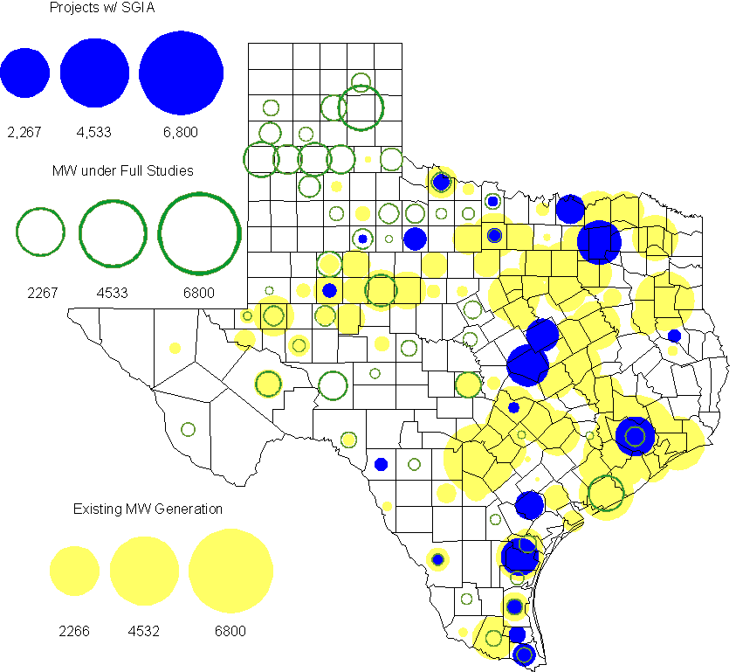

Projects with Interconnection Agreements
(Status: IA=Interconnect Agreement, XX= cancelled)
Generation Interconnections as of February 29, 2012
INR | SiteName | Status | County | Region | COD | Fuel Type |  | MW For Grid |  | Change from Last Report
09INR0007 | Nacogdoches Project | IA | Nacogdoches | North | Jun-12 |  | Biomass |  | 100
10INR0060 | Redfish Wind Project | IA | Willacy | South | Jun-12 |  | Wind |  | 206 | Name
11INR0086 | RRE Austin Solar | IA | Travis | South | Oct-12 |  | Solar |  | 60
08INR0011 | Senate Wind Project | IA | Jack | North | Nov-12 |  | Wind |  | 150
12INR0075 | Blue Summit Windfarm | IA | Wilbarger | West | Nov-12 |  | Wind |  | 170 | New
09INR0061 | WKN Mozart | IA | Kent | West | Dec-12 |  | Wind |  | 30
12INR0072 | Anacacho Windfarm | IA | Kinney | South | Dec-12 |  | Wind |  | 100
11INR0091 | Whitetail Wind Energy Project | IA | Webb | South | Dec-12 |  | Wind |  | 92
10INR0023 | Baker Ranch | IA | Haskell | West | Dec-12 |  | Wind |  | 400
11INR0033 | Los Vientos | IA | Cameron | South | Dec-12 |  | Wind |  | 400
08INR0049 | Briar Creek | IA | Clay | North | Dec-12 |  | Wind |  | 50
09INR0001 | Sandy Creek 1 | IA | McLennan | North | Mar-13 |  | Coal |  | 925
06INR0022c | Penascal Wind Farm 3 | IA | Kenedy | South | Dec-13 |  | Wind |  | 202
10INR0021 | Panda Sherman Power | IA | Grayson | North | Jul-14 |  | Gas-CC |  | 717 | New
08INR0018 | Gunsight Mountain | IA | Howard | West | Aug-14 |  | Wind |  | 120
10INR0020a | Panda Temple Power | IA | Bell | North | Jan-15 |  | Gas-CC |  | 780
06INR0006 | Cobisa-Greenville | IA | Hunt | North | May-15 |  | Gas-CC |  | 1,792
12INR0016a | Las Brisas Energy Center | IA | Nueces | South | Oct-15 |  | Other |  | 620
10INR0020b | Panda Temple Power | IA | Bell | North | Jan-16 |  | Gas-CC |  | 780
10INR0022 | Pondera King Power Project | IA | Harris | South | Jan-16 |  | Gas-CC |  | 1,380
12INR0016b | Las Brisas Energy Center | IA | Nueces | South | Oct-16 |  | Other |  | 620
14INR0002 | Coleto Creek Unit 2 | IA | Goliad | South | Jan-17 |  | Coal |  | 660
 |  |  |  |  |  |  | Total |  | 10,354
Note: Projects that do not have an interconnection agreement but have been publicly disclosed via a Public Letter to ERCOT and were previously reported on this table have been moved to section 1.5 unless Suspended or Cancelled

Generation Projects Undergoing Full Interconnection Studies with Confidentiality Waived by Developer
INR | SiteName | Status | County | Region | COD | Fuel | MW For Grid | Change from Last Report
12INR0080 | Blanco Canyon Wind | PL | Floyd | West | Dec-12 | Wind | 300
14INR0005 | White Stallion Energy Center | PL | Matagorda | South | Jul-14 | Coal | 1,200

Generation Projects Undergoing Full Interconnection Studies
INR | County | Grid | COD | Fuel |  | INR | County | Grid | COD | Fuel
10INR0016 | Childress | 150 | TBD | Wind |  | 11INR0054 | San Patricio | 161 | TBD | Wind
10INR0062a | Pecos | 80 | TBD | Wind |  | 11INR0094 | Kent | 100 | TBD | Solar
12INR0086 | Harris | 89 | Jun-12 | Gas |  | 12INR0053 | Crockett | 615 | Jun-12 | Wind
08INR0031 | Childress | 100 | Jun-12 | Wind |  | 12INR0050 | King | 332 | Jun-12 | Wind
11INR0085 | Nolan | 106 | Jul-12 | Wind |  | 12INR0079 | Kenedy | 200 | Aug-12 | Wind
12INR0076 | Winkler | 36 | Sep-12 | Other |  | 12INR0075 | Wilbarger | 170 | Nov-12 | Wind
13INR0036 | Hidalgo | 200 | Dec-12 | Wind |  | 12INR0071 | Caldwell | 30 | Dec-12 | Wind
12INR0068 | Jim Hogg | 80 | Dec-12 | Wind |  | 12INR0067 | Webb | 94 | Dec-12 | Wind
11INR0093 | San Patricio | 41 | Dec-12 | Wind |  | 11INR0091 | Webb | 92 | Dec-12 | Wind
11INR0079a | Clay | 200 | Dec-12 | Wind |  | 12INR0059 | Pecos | 50 | Dec-12 | Solar
12INR0057 | Ector | 50 | Dec-12 | Solar |  | 12INR0060 | Schleicher | 58 | Dec-12 | Wind
12INR0055 | Baylor | 80 | Dec-12 | Wind |  | 10INR0023 | Haskell | 400 | Dec-12 | Wind
09INR0048 | Jack | 113 | Dec-12 | Wind |  | 11INR0081 | Live Oak | 72 | Dec-12 | Wind
12INR0085 | Stonewall | 25 | Dec-12 | Wind |  | 12INR0081 | Upton | 113 | Dec-12 | Wind
12INR0029 | Swisher | 500 | Dec-12 | Wind |  | 13INR0040 | Harris |  | Jan-13 | Gas
13INR0010a | Parmer | 200 | Jan-13 | Wind |  | 11INR0083B | Crockett | 100 | Mar-13 | Wind
11INR0082B | Val Verde | 150 | Mar-13 | Wind |  | 11INR0050 | Crosby | 149 | Mar-13 | Wind
09INR0051 | Borden | 249 | Mar-13 | Wind |  | 12INR0018 | Gray | 500 | Apr-13 | Wind
12INR0070 | Knox | 300 | Apr-13 | Wind |  | 10INR0089 | Harris | 40 | May-13 | Other
13INR0020a | Glasscock | 200 | May-13 | Wind |  | 10INR0062b | Pecos | 220 | May-13 | Wind
10INR0085 | Ector | 40 | May-13 | Solar |  | 13INR0031 | Austin | 30 | Jun-13 | Solar
12INR0045 | Kleberg | 135 | Jun-13 | Wind |  | 13INR0032 | Andrews | 30 | Jun-13 | Solar
13INR0023 | Ector | 240 | Jul-13 | Other |  | 13INR0025 | Randall | 150 | Sep-13 | Wind
11INR0083A | Crockett | 50 | Sep-13 | Wind |  | 11INR0082A | Val Verde | 50 | Sep-13 | Wind
13INR0005 | Carson | 600 | Oct-13 | Wind |  | 13INR0028 | Hale | 392 | Nov-13 | Gas
13INR0050 | Comanche | 260 | Dec-13 | Wind |  | 13INR0038 | Swisher | 300 | Dec-13 | Wind
11INR0013 | Mills | 150 | Dec-13 | Wind |  | 13INR0044 | Wilacy | 400 | Dec-13 | Wind
13INR0039 | Castro | 500 | Dec-13 | Wind |  | 13INR0030 | Archer | 100 | Dec-13 | Wind
13INR0026 | Oldham | 201 | Dec-13 | Wind |  | 13INR0007 | Pecos | 200 | Dec-13 | Wind
12INR0002a | Briscoe | 200 | Dec-13 | Wind |  | 10INR0009 | Castro | 300 | Dec-13 | Wind
12INR0058 | San Patricio | 50 | Dec-13 | Wind |  | 11INR0057 | Cameron | 165 | Dec-13 | Wind
12INR0034 | Borden | 342 | Dec-13 | Wind |  | 14INR0014 | Val Verde | 100 | Jan-14 | Solar
13INR0006 | Gray | 750 | Jan-14 | Wind |  | 08INR0019c | Gray | 250 | Jan-14 | Wind
08INR0019b | Gray | 250 | Jan-14 | Wind |  | 08INR0019a | Gray | 250 | Jan-14 | Wind
13INR0010b | Parmer | 500 | Jan-14 | Wind |  | 10INR0080 | Presidio | 81 | Jan-14 | Solar
13INR0020b | Glasscock | 150 | May-14 | Wind |  | 14INR0016 | Harris | 190 | Jun-14 | Gas
14INR0015 | Harris | 192 | Jun-14 | Gas |  | 14INR0011 | Swisher | 270 | Jun-14 | Gas
14INR0012 | Gray | 401 | Jun-14 | Wind |  | 10INR0021 | Grayson | 717 | Jul-14 | Gas
14INR0010 | Roberts | 300 | Jul-14 | Wind |  | 12INR0042b | Deaf Smith | 135 | Sep-14 | Wind
12INR0042a | Deaf Smith | 265 | Sep-14 | Wind |  | 13INR0021 | Llano | 600 | Dec-14 | Gas
14INR0009 | Kent | 248 | Dec-14 | Wind |  | 12INR0002b | Briscoe | 200 | Dec-14 | Wind
13INR0010c | Parmer | 500 | Jan-15 | Wind |  | 12INR0002c | Briscoe | 350 | Dec-15 | Wind
16INR0003 | Brazoria | 11 | Jun-16 | Gas |  | 14INR0003 | Nolan | 850 | Jun-18 | Coal

Note: ERCOT recently requested that the Transmission Service Providers comprehensively review the status of each of their assigned Full Interconnection Studies and report the status of each study back to ERCOT. Projects that were classified as “Cancelled” or “Suspended” as a result of this review are excluded from this table.

Wind Generation Wind Capacity Installed by Year 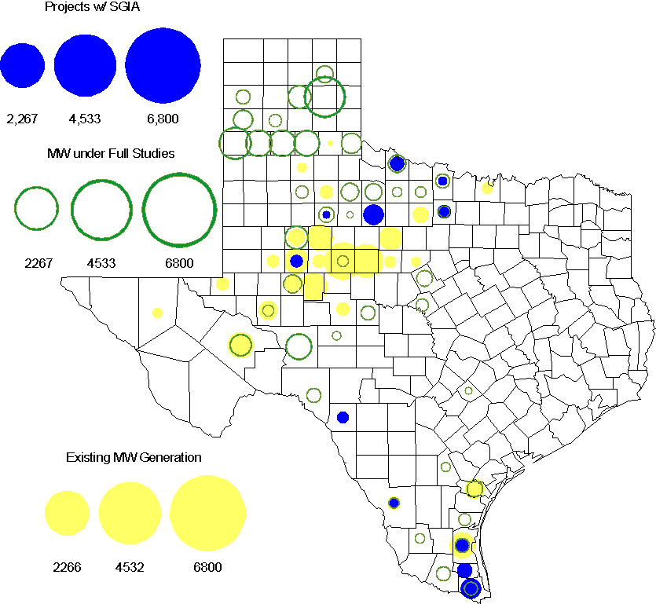
County Location of Installed Generation and Interconnection Requests (Wind Generation Projects Only)

Regional Planning Group Project Reviews

- South Texas Electric Cooperative (STEC) has submitted the El Campo to Vanderbilt rebuild project to rebuild the existing 69 kV transmission line between El Campo and Vanderbilt with a double circuit 138/69 kV line. The proposed project is to accommodate 118 MW of new load in Jackson County. This is a Tier 2 project that is estimated to cost $26.8 million. This project has completed the Independent Review and ERCOT has sent the RPG acceptance letter.

- South Texas Electric Cooperative (STEC) has submitted the Karnes Electric Cooperative (KEC) load addition project to accommodate 167 MW of new load in Karnes and Atascosa Counties. This is a Tier 2 project that is estimated to cost $33.1 million. This Tier 2 project is undergoing ERCOT Independent Review.

- CenterPoint Energy has submitted the Mont Belvieu Area upgrades project. This is a Tier 3 project that is estimated to cost approximately $42 million. This project has been submitted for RPG comments.

- Texas Municipal Power Agency (TMPA) has submitted the Denton 138 kV loop upgrades project. This is a Tier 3 project that is estimated to cost approximately $21.1 million. This project has been submitted for RPG comments.

- LCRA TSC, San Bernard Electric Cooperative (SBEC), and South Texas Electric Cooperative (STEC) have jointly submitted the Glidden to Colorado to Nada 69 kV upgrade project. This is a Tier 3 project that is estimated to cost approximately $32.4 million. This project has been submitted for RPG comments.

Congestion Costs
Dollars shown in RUC Make Whole payment graph are settlement quality.

RUC net Make Whole payment in million$

Monthly Average LMP
Binding Constraints - February 2012
Contingency | Binding Element | Number of 5-min intervals | Shadow Price Range $/MWh | Estimated Congestion Rent $ (Shadow Price*Limit) | Transmission Project | Comments
BASE CASE | West to North Stability Limit | 1763 | 0 - 136 | 6,090,505 | CREZ
Amoco North Cowden Tap - Moss Switch 138kV | Odessa North 138/69 kV Autotransformer | 700 | 0 - 2275 | 3,340,495 | 5YTP [2010-R7, R8]
Bluff Creek Auto T2_H & T2_L & T2_T | Nicole - Oak Creek 138kV | 1797 | 0 - 129 | 2,191,125 | CREZ | High west wind generation
Scurry Switch - Sun Switch 138 kV, Aspermont Aep - Spur 138 kV, Salt Creek Bepc - Salt Creek Reactor 138 kV | Girard Tap - Spur 69 kV | 2708 | 0 - 2800 | 1,800,958 |  | High west wind generation; Outage on Matador-Paducah 69 kV line
San Angelo Red Creek 345/138kV autotransformer T1 | San Angelo Red Creek 345/138 kV autotransformer T2 | 21 | 20 - 3500 | 891,664 | CREZ
Fort Stockton Plant - Barrilla 138 kV | Barrilla - Fort Stockton Switch 69 kV | 906 | 0 - 1186 | 684,921 | CREZ | High west wind generation
Graham SES - Long Creek 345 kV, Bracketville - Asphalt Mines | Hamilton Road - Maverick 138 kV | 263 | 3 - 456 | 585,740 | CREZ | High west wind generation
Orange Grove Switching Station - Lon_Hill 138 kV, Pawnee - Lon_Hill 345 kV, Whitepoint 345/138 kV autotransformer | Sinton - Skidmore 69 kV | 678 | 0 - 1646 | 394,911
Willow Creek Switch - Parker Switch 345 kV | Fort Worth Substation - West Denton 138 kV | 34 | 209 - 555 | 279,252 | 5YTP [2010-R12]
Lewisville Switch - Carrollton Northwest | Lewisville Switch - Jones Street Tnp 138 kV | 94 | 1 - 262 | 220,211 | 5YTP [2010-R21] | Outage on West Tnp - TI TNP 138 kV
Binding Constraints – January to February 2012
Contingency | Binding Element | Number of 5-min intervals | Shadow Price Range $/MWh | Estimated Congestion Rent $ (Shadow Price*Limit) | Transmission Project
BASE CASE | West to North Stability Limit | 4265 | 0 - 436 | 14,454,858 | CREZ
Amoco North Cowden Tap - Moss Switch 138kV | Odessa North 138/69 kV Autotransformer | 936 | 0 - 2275 | 4,333,342 | 5YTP [2010-R7, R8]
Bluff Creek Auto T2_H & T2_L & T2_T | Nicole - Oak Creek 138kV | 2462 | 0 - 132 | 3,023,165 | CREZ
Scurry Switch - Sun Switch 138 kV, Aspermont Aep - Spur 138 kV, Salt Creek Bepc - Salt Creek Reactor 138 kV | Girard Tap - Spur 69 kV | 2708 | 0 - 2800 | 1,800,958
Aspermont - Paint Creek 138 kV, Sacroc - Sun Switch 138 kV, Scurry Switch - Sun Switch, Salt Creek - Spur 138 kV | Aspermont 138/69 kV autotransfomer T1 | 3509 | 0 - 332 | 1,622,045 | CREZ
Fort Stockton Plant - Barrilla 138 kV, Crane Arco - Pegasus 138 kV | Barrilla - Fort Stockton Switch 69 kV | 1708 | 0 - 1186 | 1,226,150 | CREZ
Nelson Sharpe - Lon_Hill 345 kV | Kingsville - Lon_Hill 138 kV | 41 | 0 - 3500 | 1,153,541
Orange Grove Switching Station - Lon_Hill 138 kV, Pawnee - Lon_Hill 345 kV, Whitepoint 345/138 kV autotransformer | Sinton - Skidmore 69 kV | 1604 | 0 - 2800 | 1,112,259
San Angelo Red Creek 345/138kV autotransformer T1 | San Angelo Red Creek 345/138 kV autotransformer T2 | 21 | 20 - 3500 | 891,664 | CREZ
Wharton - Dyann 138 kV | Blessing - Lane City 138 kV | 349 | 0 - 3500 | 614,631

Wind Generation as a Percent of Load
One-hour average of total wind power output as a percentage of ERCOT load.

Planning Model Activities
- The December TPIT updates to the base cases were completed and the cases were posted on ERCOT MIS and POI. Work has begun to update all the base cases to use the transmission topology from the Topology Processor.
By second week of April | 13DSA Initial case build
By second week of April | 13DSA NOIE dispatch due to ERCOT
By first week of May | 12DSA/12DSB TPIT March updates are posted at the ERCOT POI site
By June 30 | SSWG meeting (at ERCOT in Taylor, TX)
By August 1st | 13DSA cases and June TPIT updates are posted at the ERCOT POI site

- Status update on SCR760, Changes Needed for Information Model Manager and Topology Processor for Planning Models, which was approved by the ERCOT Board in March 2011.
  - Bundle 1 (Items 3, 7 and 8): In Production.
  - Bundle 2 (Items 2, 4, 9): In Production.
  - Bundle 3 (Items 5, 2b, and 2c): Requirements are complete. Vendor estimate received and being negotiated. Item 5 target date for production is before the start of 2013 Data Set B in July 2012. Items 2b and 2c are extensions of Bundle 2 Item 2 to make RMPCT and Control Mode available for existing ShuntCompensator objects and may not be available prior to 2013 Data Set B.
  - Bundle 4 (Items 1 and 6):
    - For Item 1, a process to determine the new fields and records that need to be implemented in NMMS for new releases of PSS/E has been created and added to the SSWG Procedure Manual. This item will be given the status of Production. Item 6 is considered to be the first implementation of this process.
    - For Item 6, ERCOT and TSPs have identified new fields or records added between version 33 and version 30 of the PSS/E RAWD format and have decided which new fields need to be implemented. Requirements have started but are on-hold awaiting SOW for Bundle 3.
SCR Sub Part | SCR Description | Status
SCR760-1 | Upgrade to PSS/E v32 | Production
SCR760-2 | Distribution Capacitor banks | Production
SCR760-3 | Zero Impedance Line Ratings | Production
SCR760-4 | Associate Loads and Capacitor banks with the correct CNG | Production
SCR760-5 | Additional Transformer Data for Planning | Planning
SCR760-6 | FACTS Devices | Planning
SCR760-7 | Assign valid PSSE IDs to Breakers/  Switches/ Series Devices | Production
SCR760-8 | Phase shift of Autos for short circuit studies | Production
SCR760-9 | Multisection Line Grouping | Production
Table 1: In the following table:
- Red will be used to show status of Not Submitted, meaning that the SCR sub part has not been submitted to Siemens as a Service Request.
- Yellow will indicate that the SCR sub part has been submitted. The color will remain yellow and the status will change in order to Submitted, Planning (Requirements, SOW, Code Writing), Release (Siemens produces first code to test), and Testing (code has completed internal test and is moving through release management).
- Green will indicate that the code has been tested and installed on the machines that ERCOT uses to produce Topology Processor output for Planning and CRR.

Other Notable Activities
- The 2011 Five-Year Transmission Plan reliability analysis has been completed for 2012, 2014 and 2016 and all the reliability projects are posted on the ERCOT Planning and Operations Information. Work on the 2011 Five-Year Transmission Plan economic analysis is ongoing. ERCOT is also working on the 2011 Five-Year Transmission Plan draft report that is expected to be completed in March 2012.

