Framing Rolling CRR Auction Options:
Objective-
- More liquidity/ Price discovery
- Increase frequency of auctions
- Utilize horsepower/bandwidth/capability more effectively, eg- redefine TOU from 3 to 2, changed linked bids
- Find potential credit enhancements
- Maintain 2-year window of CRRs
- Build platform solution to move into future capability
- Maximize 200k limitation
- Develop transition plan that includes current inventory sold, or to be sold (keep annual auction in mind)

Option 1 ERCOT Seasonal auction between monthly/annual
Option 2 ERCOT Rolling 3-month auction
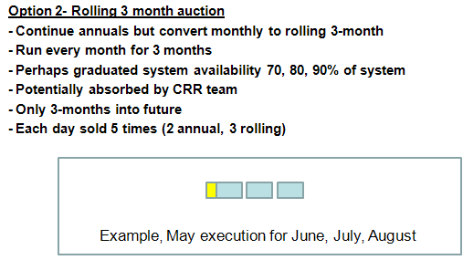
Option 3 PJM-style auction
Combination of monthlies (within each prompt quarter), with 7 quarters into future
