- DWG recently met on February 22, 2012
- 2012 Current Year flat start schedule was updated and agreed upon as follows:
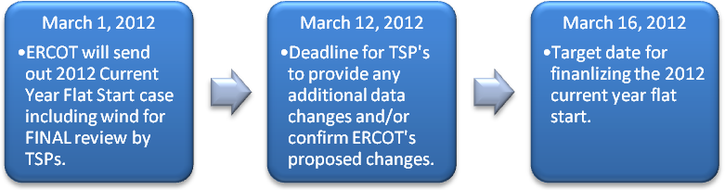
Proposed DWG 2012 Current Year flat start case building schedule

- DWG Procedure Manual was revised to better correlate with the Dynamic Guides and updated with current DWG procedures.
- The next flat start build will be based on a 2017 Future Year case with the following agreed upon schedule:
