 |  |  |  | System Planning
Monthly Status Report
January 2012

 |  | Report Highlights
 | - ERCOT is currently tracking 124 active generation interconnection requests totaling over 33,000 MW. This includes almost 18,000 MW of wind generation.
- ERCOT is currently reviewing proposed transmission improvements with a total cost of $33.1 Million
- Transmission Projects endorsed in 2012 total $319.6 Million
- All projects (in engineering, routing, licensing and construction) total approximately $10.0 Billion
- Transmission Projects energized in 2011 total about 817.8 million

Table of Contents
1. Generation Interconnection 1
1.1 New Signed Generation Interconnection Agreements 1
1.2 New Generation Registering for Commercial Operations 1
1.3 Summary of Generation Interconnection Requests 1
1.4 Projects with Interconnection Agreements 4
1.5 Generation Projects Undergoing Full Interconnection Studies 4
1.6 Wind Generation 6
2. Regional Planning Group Project Reviews 7
3. Congestion Costs 8
4. Wind Generation as a Percent of Load 11
5. Planning Model Activities 12
6. Other Notable Activities 12

1. Generation Interconnection
Additional information regarding detailed generation interconnection and impact studies is contained in the “Generation Project Interconnection Information” folder in the “Operations and System Planning” area on the ERCOT website: http://planning.ercot.com/login/login.

Signed Generation Interconnection Agreements
New – 10INR0023 Baker Ranch Wind – 400 MW in Haskell County

New Generation Registering for Commercial Operations
08INR0062 Trinity Hills Wind – 225 MW in Young County
10INR0082 FRV AE Solar – 30 MW in Travis County

The total installed wind capacity is now reported as 9,829 MW by the resource owners through the registration process. Capacity by North, South and West is 232 MW, 2066 MW, and 7531 MW respectively. 850 MW is able to switch between the West and South zones and is currently shown in the South zone.

Summary of Generation Interconnection Requests
GENERATION INTERCONNECTION REQUESTS CURRENTLY UNDER REVIEW
Currently tracking 164 generation interconnection or change requests
As of January 31, 2012 | North | South | West | Total
Security Screening Study | 1 | 1 | 3 | 5
SSS Completed | 3 | 4 | 8 | 15
Full Interconnect Study | 8 | 19 | 49 | 76
FIS Completed | 1 | 2 | 5 | 8
Suspended Studies | 8 | 4 | 28 | 40
Capacity of Suspended Study Projects | 6,486 | 3,338 | 11,273 | 21,097
Interconnect Agreement Completed | 7 | 10 | 3 | 20
Capacity under Interconnection Agreements | 4,577 | 4,336 | 550 | 9,463
Capacity for Grid, MW | 8,587 | 10,164 | 14,476 | 33,227
Wind Capacity, MW | 2,634 | 3,326 | 11,973 | 17,933

Fuel Type | Confidential Projects (MW) | Projects Under Full Study (MW) | Projects w/ Interconnect Agreement/Public Letter (MW) | Suspended Studies (MW) | Grand Total (MW)
Gas-AllOther |  |  |  |  | 547
Gas-CombinedCycle |  |  | 4,732 | 2,890 | 10,660
Total Gas | 1,465 | 2,120 | 4,732 | 2,890 | 11,207
Nuclear |  |  |  | 5,900 | 5,900
Coal |  | 850 | 2,785 |  | 3,635
Wind | 1,529 | 14,358 | 2,046 | 11,904 | 29,837
Solar | 285 | 511 | 60 | 353 | 1,209
Biomass |  |  | 100 | 50 | 150
Storage | 560 | 346 |  |  | 906
Other |  | 240 | 1,240 |  | 1,480
Grand Total | 3,839 | 18,425 | 10,963 | 21,097 | 54,324
County Location of Installed Generation and Interconnection Requests (all fuels)

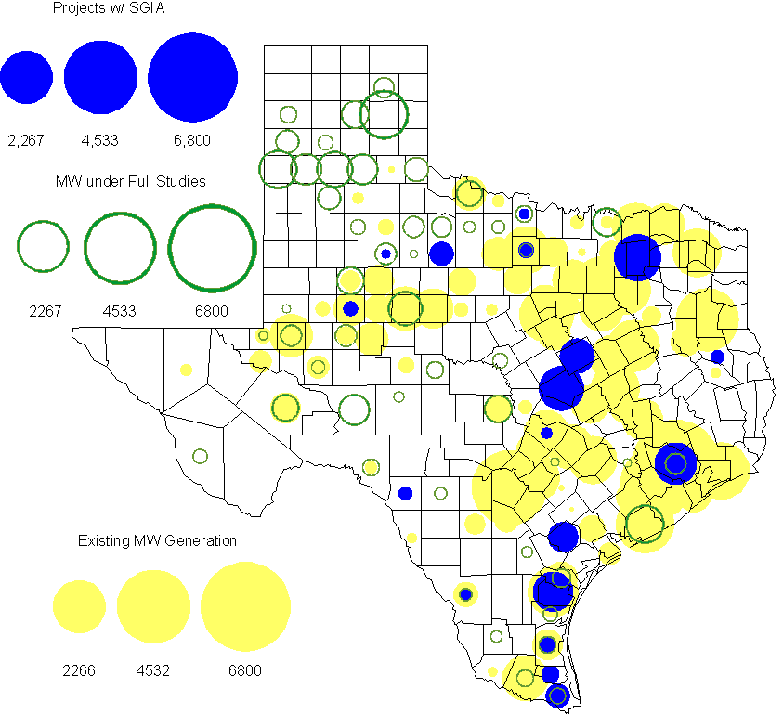

Projects with Interconnection Agreements

(Status: IA=Interconnect Agreement, XX= cancelled)
Generation Interconnections as of January 31, 2012
INR | SiteName | Status | County | Region | COD | Fuel Type |  | MW For Grid |  | Change from Last Report
09INR0007 | Nacogdoches Project | IA | Nacogdoches | North | Jun-12 |  | Biomass |  | 100
10INR0060 | Magic Valley Wind Project | IA | Willacy | South | Jun-12 |  | Wind |  | 202
11INR0086 | RRE Austin Solar | IA | Travis | South | Oct-12 |  | Solar |  | 60
08INR0011 | Senate Wind Project | IA | Jack | North | Nov-12 |  | Wind |  | 150
12INR0072 | Anacacho Windfarm | IA | Kinney | South | Dec-12 |  | Wind |  | 100
10INR0023 | Baker Ranch Windfarm | IA | Haskell | West | Dec-12 |  | Wind |  | 400 | New
11INR0091 | Whitetail Wind Energy Project | IA | Webb | South | Dec-12 |  | Wind |  | 92
09INR0061 | WKN Mozart | IA | Kent | West | Dec-12 |  | Wind |  | 30
11INR0033 | Los Vientos | IA | Cameron | South | Dec-12 |  | Wind |  | 400
08INR0049 | Briar Creek | IA | Clay | North | Dec-12 |  | Wind |  | 50
09INR0001 | Sandy Creek 1 | IA | McLennan | North | Mar-13 |  | Coal |  | 925
06INR0022c | Penascal Wind Farm 3 | IA | Kenedy | South | Dec-13 |  | Wind |  | 202
06INR0006 | Cobisa-Greenville | IA | Hunt | North | May-14 |  | Gas-CC |  | 1,792
08INR0018 | Gunsight Mountain | IA | Howard | West | Aug-14 |  | Wind |  | 120
10INR0020a | Panda Temple Power | IA | Bell | North | Jan-15 |  | Gas-CC |  | 780
12INR0016a | Las Brisas Energy Center | IA | Nueces | South | Oct-15 |  | Other |  | 620
10INR0022 | Pondera King Power Project | IA | Harris | South | Jan-16 |  | Gas-CC |  | 1,380
10INR0020b | Panda Temple Power | IA | Bell | North | Jan-16 |  | Gas-CC |  | 780
12INR0016b | Las Brisas Energy Center | IA | Nueces | South | Oct-16 |  | Other |  | 620
14INR0002 | Coleto Creek Unit 2 | IA | Goliad | South | Jan-17 |  | Coal |  | 660
 |  |  |  |  |  |  | Total |  | 9,463
Note: Projects that do not have an interconnection agreement but have been publicly disclosed via a Public Letter to ERCOT and were previously reported on this table have been moved to section 1.5 unless Suspended or Cancelled

Generation Projects Undergoing Full Interconnection Studies with Confidentiality Waived by Developer
INR | SiteName | Status | County | Region | COD | Fuel | MW For Grid | Change from Last Report
12INR0080 | Blanco Canyon Wind | PL | Floyd | West | Dec-12 | Wind | 300
14INR0005 | White Stallion Energy Center | PL | Matagorda | South | Jul-14 | Coal | 1,200

Generation Projects Undergoing Full Interconnection Studies
INR | County | Grid | COD | Fuel |  | INR | County | Grid | COD | Fuel
10INR0016 | Childress | 150 | TBD | Wind |  | 11INR0054 | San Patricio | 161 | TBD | Wind
10INR0062a | Pecos | 80 | TBD | Wind |  | 11INR0094 | Kent | 100 | TBD | Solar
12INR0075 | Wilbarger | 499 | Apr-12 | Wind |  | 12INR0086 | Harris | 89 | Jun-12 | Gas
12INR0053 | Crockett | 615 | Jun-12 | Wind |  | 08INR0031 | Childress | 100 | Jun-12 | Wind
12INR0050 | King | 332 | Jun-12 | Wind |  | 11INR0085 | Nolan | 106 | Jul-12 | Wind
12INR0079 | Kenedy | 200 | Aug-12 | Wind |  | 12INR0082 | Pecos | 30 | Aug-12 | Solar
12INR0076 | Winkler | 36 | Sep-12 | Other |  | 13INR0036 | Hidalgo | 200 | Dec-12 | Wind
12INR0071 | Caldwell | 30 | Dec-12 | Wind |  | 12INR0068 | Jim Hogg | 80 | Dec-12 | Wind
12INR0067 | Webb | 94 | Dec-12 | Wind |  | 11INR0093 | San Patricio | 41 | Dec-12 | Wind
11INR0079a | Clay | 200 | Dec-12 | Wind |  | 12INR0059 | Pecos | 50 | Dec-12 | Solar
12INR0057 | Ector | 50 | Dec-12 | Solar |  | 12INR0060 | Schleicher | 58 | Dec-12 | Wind
12INR0055 | Baylor | 80 | Dec-12 | Wind |  | 09INR0048 | Jack | 113 | Dec-12 | Wind
11INR0081 | Live Oak | 72 | Dec-12 | Wind |  | 12INR0085 | Stonewall | 25 | Dec-12 | Wind
12INR0029 | Swisher | 500 | Dec-12 | Wind |  | 12INR0081 | Upton | 113 | Dec-12 | Wind
13INR0040 | Harris | 0 | Jan-13 | Gas |  | 13INR0010a | Parmer | 200 | Jan-13 | Wind
11INR0083B | Crockett | 100 | Mar-13 | Wind |  | 11INR0082B | Val Verde | 150 | Mar-13 | Wind
11INR0050 | Crosby | 149 | Mar-13 | Wind |  | 09INR0051 | Borden | 249 | Mar-13 | Wind
12INR0018 | Gray | 500 | Apr-13 | Wind |  | 12INR0070 | Knox | 300 | Apr-13 | Wind
10INR0089 | Harris | 40 | May-13 | Other |  | 13INR0020a | Glasscock | 200 | May-13 | Wind
10INR0062b | Pecos | 220 | May-13 | Wind |  | 10INR0085 | Ector | 40 | May-13 | Solar
13INR0031 | Austin | 30 | Jun-13 | Solar |  | 12INR0045 | Kleberg | 135 | Jun-13 | Wind
13INR0032 | Andrews | 30 | Jun-13 | Solar |  | 13INR0023 | Ector | 240 | Jul-13 | Other
13INR0025 | Randall | 150 | Sep-13 | Wind |  | 11INR0083A | Crockett | 50 | Sep-13 | Wind
11INR0082A | Val Verde | 50 | Sep-13 | Wind |  | 13INR0005 | Carson | 600 | Oct-13 | Wind
13INR0028 | Hale | 392 | Nov-13 | Gas |  | 13INR0038 | Swisher | 300 | Dec-13 | Wind
11INR0013 | Mills | 150 | Dec-13 | Wind |  | 13INR0044 | Wilacy | 400 | Dec-13 | Wind
13INR0039 | Castro | 500 | Dec-13 | Wind |  | 13INR0030 | Archer | 100 | Dec-13 | Wind
13INR0026 | Oldham | 201 | Dec-13 | Wind |  | 13INR0007 | Pecos | 200 | Dec-13 | Wind
12INR0002a | Briscoe | 200 | Dec-13 | Wind |  | 10INR0009 | Castro | 300 | Dec-13 | Wind
12INR0058 | San Patricio | 50 | Dec-13 | Wind |  | 11INR0057 | Cameron | 165 | Dec-13 | Wind
12INR0034 | Borden | 342 | Dec-13 | Wind |  | 14INR0014 | Val Verde | 100 | Jan-14 | Solar
13INR0006 | Gray | 750 | Jan-14 | Wind |  | 08INR0019c | Gray | 250 | Jan-14 | Wind
08INR0019b | Gray | 250 | Jan-14 | Wind |  | 08INR0019a | Gray | 250 | Jan-14 | Wind
13INR0010b | Parmer | 500 | Jan-14 | Wind |  | 10INR0080 | Presidio | 81 | Jan-14 | Solar
13INR0020b | Glasscock | 150 | May-14 | Wind |  | 14INR0016 | Harris | 190 | Jun-14 | Gas
14INR0015 | Harris | 192 | Jun-14 | Gas |  | 14INR0011 | Swisher | 270 | Jun-14 | Gas
14INR0012 | Gray | 401 | Jun-14 | Wind |  | 10INR0021 | Grayson | 646 | Jul-14 | Gas
14INR0010 | Roberts | 300 | Jul-14 | Wind |  | 12INR0042b | Deaf Smith | 135 | Sep-14 | Wind
12INR0042a | Deaf Smith | 265 | Sep-14 | Wind |  | 13INR0021 | Llano | 600 | Dec-14 | Gas
12INR0002b | Briscoe | 200 | Dec-14 | Wind |  | 14INR0009 | Kent | 248 | Dec-14 | Wind
13INR0010c | Parmer | 500 | Jan-15 | Wind |  | 12INR0002c | Briscoe | 350 | Dec-15 | Wind
16INR0003 | Brazoria | 11 | Jun-16 | Gas |  | 14INR0003 | Nolan | 850 | Jun-18 | Coal

Note: ERCOT recently requested that the Transmission Service Providers comprehensively review the status of each of their assigned Full Interconnection Studies and report the status of each study back to ERCOT. Projects that were classified as “Cancelled” or “Suspended” as a result of this review are excluded from this table.

Wind Generation Wind Capacity Installed by Year

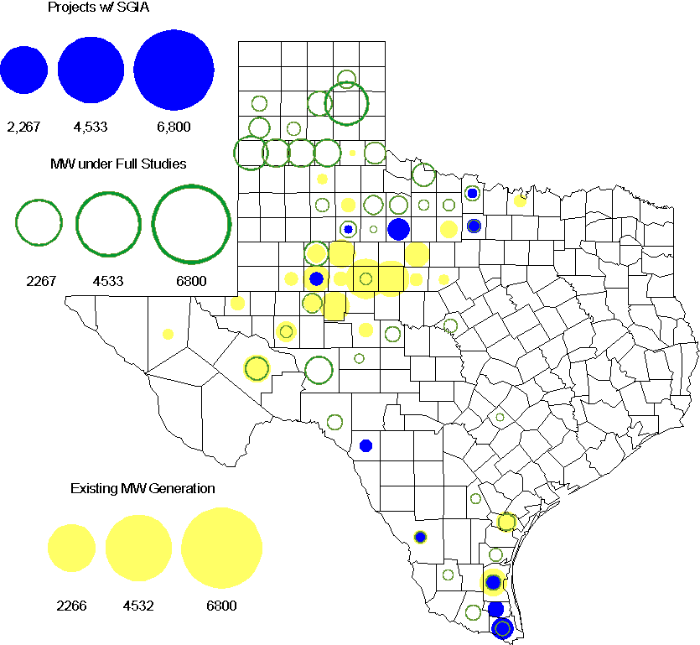

Regional Planning Group Project Reviews

- Sharyland Utilities (Sharyland) and Brownsville Public Utilities Board (BPUB) has submitted the Cross Valley Brownsville Loop project. The estimated cost for this project is $275 Million. ERCOT has completed the Independent Review for this Tier 1 project. The project was endorsed by the ERCOT BOD in January 2012. ERCOT has sent an endorsement letter.

- Brazos Electric Cooperative has submitted the Olney to Lake Kemp Switch 69kV Rebuild project. This is a Tier 3 project that is estimated to cost approximately $17.8 million. This project has completed the RPG review and ERCOT has sent the RPG acceptance letter.

- South Texas Electric Cooperative (STEC) has submitted the El Campo to Vanderbilt rebuild project to rebuild the existing 69 kV transmission line between El Campo and Vanderbilt with a double circuit 138/69 kV line. The proposed project is to accommodate 118 MW of new load in Jackson County. This is a Tier 2 project that is estimated to cost $26.8 million. ERCOT has completed the Independent Review and has sent the RPG acceptance letter.

- South Texas Electric Cooperative (STEC) has submitted the Karnes Electric Cooperative (KEC) load addition project to accommodate 167 MW of new load in Karnes and Atascosa Counties. This is a Tier 2 project that is estimated to cost $33.1 million. This Tier 2 project is undergoing ERCOT Independent Review.

Congestion Costs
Dollars shown in RUC Make Whole payment graph are settlement quality.

OOMC and RUC net Make Whole payment in million$

Monthly Average MCPE and LMP
Binding Constraints - January 2012
Contingency | Binding Element | Number of 5-min intervals | Shadow Price Range $/MWh | Estimated Congestion Rent $ (Shadow Price*Limit) | Transmission Project | Comments
BASE CASE | West to North Stability Limit | 2502 | 0-436 | 8,364,352 | CREZ
Aspermont - Paint Creek 138 kV, Sacroc - Sun Switch 138 kV, Scurry Switch - Sun Switch, Salt Creek - Spur 138 kV | Aspermont 138/69 kV autotransformer T1 | 3388 | 0-332 | 1,582,952 | CREZ | High wind generation in the West
Nelson Sharpe - Lon_Hill 345 kV | Kingsville - Lon_Hill 138 kV | 41 | 0-3500 | 1,153,541
Amoco North Cowden Tap - Moss Switch 138kV | Odessa North 138/69 kV Autotransformer | 236 | 0-1092 | 992,846 | 5YTP [2010-R7, R8]
Bluff Creek Auto T2_H & T2_L & T2_T | Nicole - Oak Creek 138kV | 665 | 4-132 | 832,040 | CREZ | High wind generation in the West
Orange Grove Switching Station - Lon_Hill 138 kV, Pawnee - Lon_Hill 345 kV, Whitepoint 345/138 kV autotransformer | Sinton - Skidmore 69 kV | 926 | 0-2800 | 717,348
Wharton - Dyann 138 kV | Blessing - Lane City 138 kV | 317 | 0-3500 | 611,039 |  | Outage on South Lane City - New Gulf 138 kV , Pledger - West Columbia 138 kV
Fort Stockton Plant - Barrilla 138 kV | Barrilla - Fort Stockton Switch 69 kV | 802 | 0-1077 | 541,229 | CREZ | High wind generation in the West
Gaf Tnp - PH Robinson 138 kV | Heights Tnp - PH Robinson 138 kV | 8 | 0-3500 | 491,271 |  | Outage on Center - PH Robinson 345 kV
Singleton - Zenith 345 kV | Betka - Hockley 138 kV | 371 | 0-436 | 429,631 |  | Outage on King - Rothwood 345 kV

Wind Generation as a Percent of Load
One-hour average of total wind power output as a percentage of ERCOT load.

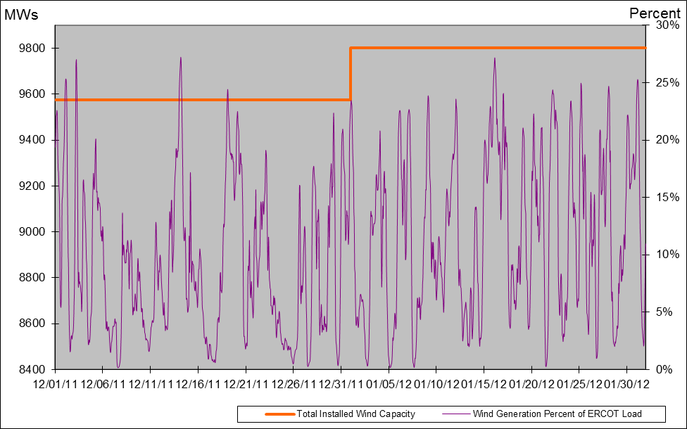

Planning Model Activities
- The Contingency List update was completed and posted on ERCOT POI. The Data Dictionary update is underway. The TPIT update to begin the week of January 9th:
  - Dec 14, 2011 ERCOT Finalized and Posted Contingency database
  - Jan 16, 2012 Data Dictionary Posted
  - Jan 9, 2012 TPIT No Cost Report posted on ERCOT POI
  - Jan 13, 2012 12DSA and 12DSB Pass0 TPIT updates begin
  - Feb 27, 2012 12DSA and 12DSB TPIT updates posted to ERCOT POI
- Status update on SCR760, Changes Needed for Information Model Manager and Topology Processor for Planning Models, which was approved by the ERCOT Board in March 2011.
  - Bundle 1 (Items 3, 7 and 8): In Production.
  - Bundle 2 (Items 2, 4, 9): Scheduled for Production on February 2012 (approx 23rd) on-cycle release.
  - Item 5: Requirements completed by ERCOT and TSPs and agreed upon with vendor. Awaiting vendor estimate on cost for implementation so that SOW can be prepared.
  - Bundle 4 (Items 1 and 6): ERCOT and TSPs have identified new fields or records added between version 33 and version 30 of the PSS/E RAWD format and are decided which new fields need to be implemented. The evaluation process for Item 1 has been added to the SSWG Procedure Manual currently being updated.
SCR Sub Part | SCR Description | Status
SCR760-1 | Upgrade to PSS/E v32 | Planning
SCR760-2 | Distribution Capacitor banks | Release
SCR760-3 | Zero Impedance Line Ratings | Production
SCR760-4 | Associate Loads and Capacitor banks with the correct CNG | Release
SCR760-5 | Additional Transformer Data for Planning | Planning
SCR760-6 | FACTS Devices | Submitted
SCR760-7 | Assign valid PSSE IDs to Breakers/  Switches/ Series Devices | Production
SCR760-8 | Phase shift of Autos for short circuit studies | Production
SCR760-9 | Multisection Line Grouping | Release
Table 1: In the following table:
- Red will be used to show status of Not Submitted, meaning that the SCR sub part has not been submitted to Siemens as a Service Request.
- Yellow will indicate that the SCR sub part has been submitted. The color will remain yellow and the status will change in order to Submitted, Planning (Requirements, SOW, Code Writing), Release (Siemens produces first code to test), and Testing (code has completed internal test and is moving through release management).
- Green will indicate that the code has been tested and installed on the machines that ERCOT uses to produce Topology Processor output for Planning and CRR.

Other Notable Activities
The 2011 Five-Year Transmission Plan reliability analysis has been completed for 2012, 2014 and 2016 and all the reliability projects are posted on the ERCOT Planning and Operations Information. Work on the 2011 Five-Year Transmission Plan economic analysis is ongoing. ERCOT is also working on the 2011 Five-Year Transmission Plan draft report that is expected to be completed in March 2012.

