 |  |  |  | System Planning
Monthly Status Report
December 2011

 |  | Report Highlights
 | - ERCOT is currently tracking 133 active generation interconnection requests totaling over 38,000 MW. This includes over 19,000 MW of wind generation.
- ERCOT is currently reviewing proposed transmission improvements with a total cost of $334.9 Million
- Transmission Projects endorsed in 2011 total $674.7 Million
- All projects (in engineering, routing, licensing and construction) total approximately $9.8 Billion
- Transmission Projects energized in 2011 total about $694.8 million

Table of Contents
1. Generation Interconnection 1
1.1 New Signed Generation Interconnection Agreements 1
1.2 New Generation Registering for Commercial Operations 1
1.3 Summary of Generation Interconnection Requests 1
1.4 Projects with Interconnection Agreements 4
1.5 Generation Projects Undergoing Full Interconnection Studies 4
1.6 Wind Generation 6
2. Regional Planning Group Project Reviews 7
3. Congestion Costs 8
4. Wind Generation as a Percent of Load 11
5. Planning Model Activities 12
6. Other Notable Activities 12

1. Generation Interconnection
Additional information regarding detailed generation interconnection and impact studies is contained in the “Generation Project Interconnection Information” folder in the “Operations and System Planning” area on the ERCOT website: http://planning.ercot.com/login/login.

Signed Generation Interconnection Agreements
Cancelled – 10INR0077 Kaiser Creek Wind - 101 MW in Callahan County
New – 11INR0091 Whitetail Wind - 92 MW in Webb County

New Generation Registering for Commercial Operations - none
The total installed wind capacity is now reported as 9,604 MW by the resource owners through the registration process. Capacity by North, South and West is 232 MW, 2066 MW, and 7306 MW respectively. 850 MW is able to switch between the West and South zones.

Summary of Generation Interconnection Requests
GENERATION INTERCONNECTION REQUESTS CURRENTLY UNDER REVIEW
Currently tracking 175 generation interconnection or change requests
As of December 31, 2011 | North | South | West | Total
Security Screening Study | 0 | 3 | 0 | 3
SSS Completed | 3 | 4 | 18 | 25
Full Interconnect Study | 9 | 16 | 52 | 77
FIS Completed | 0 | 2 | 5 | 7
Suspended Studies | 8 | 4 | 30 | 42
Capacity of Suspended Study Projects | 6,486 | 3,338 | 11,773 | 21,597
Interconnect Agreement Completed | 8 | 10 | 3 | 21
Capacity under Interconnection Agreements | 4,607 | 4,336 | 400 | 9,343
Capacity for Grid, MW | 8,597 | 10,209 | 15,980 | 34,786
Wind Capacity, MW | 2,634 | 3,236 | 13,492 | 19,362

Fuel Type | Confidential Projects (MW) | Projects Under Full Study (MW) | Projects w/ Interconnect Agreement/Public Letter (MW) | Suspended Studies (MW) | Grand Total (MW)
Gas-AllOther |  |  |  |  | 1,233
Gas-CombinedCycle |  |  | 4,732 | 2,890 | 10,850
Total Gas | 2,272 | 2,189 | 4,732 | 2,890 | 12,083
Nuclear |  |  |  | 5,900 | 5,900
Coal |  | 850 | 2,785 |  | 3,635
Wind | 2,503 | 14,963 | 1,896 | 12,404 | 31,766
Solar | 379 | 471 | 90 | 353 | 1,293
Biomass |  |  | 100 | 50 | 150
Other |  | 316 | 1,240 |  | 1,556
Grand Total | 5,154 | 18,789 | 10,843 | 21,597 | 56,383
County Location of Installed Generation and Interconncection Requests (all fuels)

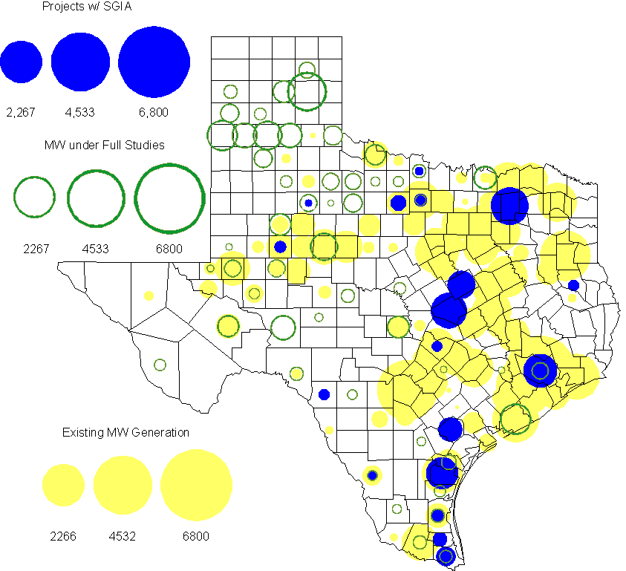

Projects with Interconnection Agreements

(Status: IA=Interconnect Agreement, XX= cancelled)
Generation Interconnections as of December 31, 2011
INR | SiteName | Status | County | Region | COD | Fuel Type |  | MW For Grid |  | Change from Last Report
10INR0082 | FRV AE Solar | IA | Travis | North | Dec-11 |  | Solar |  | 30
08INR0062 | Trinity Hills | IA | Young | West | Mar-12 |  | Wind |  | 250
09INR0007 | Nacogdoches Project | IA | Nacogdoches | North | Jun-12 |  | Biomass |  | 100
10INR0060 | Magic Valley Wind Project | IA | Willacy | South | Jun-12 |  | Wind |  | 202
11INR0086 | RRE Austin Solar | IA | Travis | South | Oct-12 |  | Solar |  | 60
08INR0011 | Senate Wind Project | IA | Jack | North | Nov-12 |  | Wind |  | 150
12INR0072 | Anacacho Windfarm | IA | Kinney | South | Dec-12 |  | Wind |  | 100
10INR0077 | Kaiser Creek Windfarm | XX | Callahan | West | Dec-12 |  | Wind |  | 101 | Cancelled
11INR0091 | Whitetail Wind Energy Project | IA | Webb | South | Dec-12 |  | Wind |  | 92 | New
09INR0061 | WKN Mozart | IA | Kent | West | Dec-12 |  | Wind |  | 30
11INR0033 | Los Vientos | IA | Cameron | South | Dec-12 |  | Wind |  | 400
08INR0049 | Briar Creek | IA | Clay | North | Dec-12 |  | Wind |  | 50
09INR0001 | Sandy Creek 1 | IA | McLennan | North | Mar-13 |  | Coal |  | 925
06INR0022c | Penascal Wind Farm 3 | IA | Kenedy | South | Dec-13 |  | Wind |  | 202
06INR0006 | Cobisa-Greenville | IA | Hunt | North | May-14 |  | Gas-CC |  | 1,792
08INR0018 | Gunsight Mountain | IA | Howard | West | Aug-14 |  | Wind |  | 120
10INR0020a | Panda Temple Power | IA | Bell | North | Jan-15 |  | Gas-CC |  | 780
12INR0016a | Las Brisas Energy Center | IA | Nueces | South | Oct-15 |  | Other |  | 620
10INR0022 | Pondera King Power Project | IA | Harris | South | Jan-16 |  | Gas-CC |  | 1,380
10INR0020b | Panda Temple Power | IA | Bell | North | Jan-16 |  | Gas-CC |  | 780
12INR0016b | Las Brisas Energy Center | IA | Nueces | South | Oct-16 |  | Other |  | 620
14INR0002 | Coleto Creek Unit 2 | IA | Goliad | South | Jan-17 |  | Coal |  | 660
 |  |  |  |  |  |  | Total |  | 9,343
Note: Projects that do not have an interconnection agreement but have been publicly disclosed via a Public Letter to ERCOT and were previously reported on this table have been moved to section 1.5 unless Suspended or Cancelled

Generation Projects Undergoing Full Interconnection Studies with Confidentiality Waived by Developer
INR | SiteName | Status | County | Region | COD | Fuel | MW For Grid | Change from Last Report
12INR0080 | Blanco Canyon Wind | PL | Floyd | West | Dec-12 | Wind | 300
14INR0005 | White Stallion Energy Center | PL | Matagorda | South | Jul-14 | Coal | 1,200

Generation Projects Undergoing Full Interconnection Studies
INR | County | Grid | COD | Fuel |  | INR | County | Grid | COD | Fuel
10INR0016 | Childress | 150 | TBD | Wind |  | 11INR0054 | San Patricio | 161 | TBD | Wind
10INR0062a | Pecos | 80 | TBD | Wind |  | 11INR0094 | Kent | 100 | TBD | Solar
12INR0075 | Wilbarger | 499 | Apr-12 | Wind |  | 12INR0086 | Harris | 89 | Jun-12 | Gas
12INR0053 | Crockett | 615 | Jun-12 | Wind |  | 08INR0031 | Childress | 100 | Jun-12 | Wind
12INR0050 | King | 332 | Jun-12 | Wind |  | 11INR0085 | Nolan | 106 | Jul-12 | Wind
12INR0079 | Kenedy | 200 | Aug-12 | Wind |  | 12INR0076 | Winkler | 36 | Sep-12 | Other
13INR0036 | Hidalgo | 200 | Dec-12 | Wind |  | 12INR0071 | Caldwell | 30 | Dec-12 | Wind
12INR0068 | Jim Hogg | 80 | Dec-12 | Wind |  | 12INR0067 | Webb | 94 | Dec-12 | Wind
12INR0060 | Schleicher | 58 | Dec-12 | Wind |  | 12INR0059 | Pecos | 50 | Dec-12 | Solar
12INR0057 | Ector | 50 | Dec-12 | Solar |  | 12INR0055 | Baylor | 80 | Dec-12 | Wind
11INR0093 | San Patricio | 41 | Dec-12 | Wind |  | 11INR0079a | Clay | 200 | Dec-12 | Wind
10INR0023 | Haskell | 405 | Dec-12 | Wind |  | 12INR0085 | Stonewall | 25 | Dec-12 | Wind
12INR0081 | Upton | 113 | Dec-12 | Wind |  | 12INR0029 | Swisher | 500 | Dec-12 | Wind
11INR0081 | Live Oak | 72 | Dec-12 | Wind |  | 09INR0048 | Jack | 113 | Dec-12 | Wind
13INR0040 | Harris |  | Jan-13 | Gas |  | 13INR0010a | Parmer | 200 | Jan-13 | Wind
11INR0083B | Crockett | 100 | Mar-13 | Wind |  | 11INR0082B | Val Verde | 150 | Mar-13 | Wind
12INR0034 | Borden | 342 | Mar-13 | Wind |  | 11INR0050 | Crosby | 149 | Mar-13 | Wind
09INR0051 | Borden | 249 | Mar-13 | Wind |  | 12INR0018 | Gray | 500 | Apr-13 | Wind
12INR0070 | Knox | 300 | Apr-13 | Wind |  | 13INR0020a | Glasscock | 200 | May-13 | Wind
10INR0089 | Harris | 40 | May-13 | Other |  | 10INR0062b | Pecos | 220 | May-13 | Wind
10INR0085 | Ector | 40 | May-13 | Solar |  | 13INR0032 | Andrews | 30 | Jun-13 | Solar
13INR0031 | Austin | 30 | Jun-13 | Solar |  | 12INR0045 | Kleberg | 135 | Jun-13 | Wind
13INR0023 | Ector | 240 | Jul-13 | Other |  | 13INR0025 | Randall | 150 | Sep-13 | Wind
11INR0083A | Crockett | 50 | Sep-13 | Wind |  | 11INR0082A | Val Verde | 50 | Sep-13 | Wind
13INR0005 | Carson | 600 | Oct-13 | Wind |  | 13INR0028 | Hale | 392 | Nov-13 | Gas
13INR0044 | Wilacy | 400 | Dec-13 | Wind |  | 13INR0039 | Castro | 500 | Dec-13 | Wind
13INR0038 | Swisher | 300 | Dec-13 | Wind |  | 13INR0030 | Archer | 100 | Dec-13 | Wind
13INR0026 | Oldham | 201 | Dec-13 | Wind |  | 13INR0017 | Childress | 200 | Dec-13 | Wind
13INR0007 | Pecos | 200 | Dec-13 | Wind |  | 12INR0002a | Briscoe | 200 | Dec-13 | Wind
11INR0013 | Mills | 150 | Dec-13 | Wind |  | 10INR0009 | Castro | 300 | Dec-13 | Wind
12INR0058 | San Patricio | 50 | Dec-13 | Wind |  | 11INR0057 | Cameron | 165 | Dec-13 | Wind
13INR0006 | Gray | 750 | Jan-14 | Wind |  | 08INR0019c | Gray | 250 | Jan-14 | Wind
08INR0019b | Gray | 250 | Jan-14 | Wind |  | 08INR0019a | Gray | 250 | Jan-14 | Wind
13INR0010b | Parmer | 500 | Jan-14 | Wind |  | 10INR0080 | Presidio | 81 | Jan-14 | Solar
12INR0063 | Uvalde | 90 | Apr-14 | Solar |  | 13INR0020b | Glasscock | 150 | May-14 | Wind
14INR0015 | Harris | 192 | Jun-14 | Gas |  | 14INR0012 | Gray | 401 | Jun-14 | Wind
14INR0011 | Swisher | 270 | Jun-14 | Gas |  | 14INR0010 | Roberts | 300 | Jul-14 | Wind
10INR0021 | Grayson | 646 | Jul-14 | Gas |  | 12INR0042b | Deaf Smith | 135 | Sep-14 | Wind
12INR0042a | Deaf Smith | 265 | Sep-14 | Wind |  | 14INR0009 | Kent | 248 | Dec-14 | Wind
13INR0021 | Llano | 600 | Dec-14 | Gas |  | 12INR0002b | Briscoe | 200 | Dec-14 | Wind
13INR0010c | Parmer | 500 | Jan-15 | Wind |  | 12INR0002c | Briscoe | 350 | Dec-15 | Wind
14INR0003 | Nolan | 850 | Jun-18 | Coal

Note: ERCOT recently requested that the Transmission Service Providers comprehensively review the status of each of their assigned Full Interconnection Studies and report the status of each study back to ERCOT. Projects that were classified as “Cancelled” or “Suspended” as a result of this review are excluded from this table.

Wind Generation
Wind Capacity Installed by Year

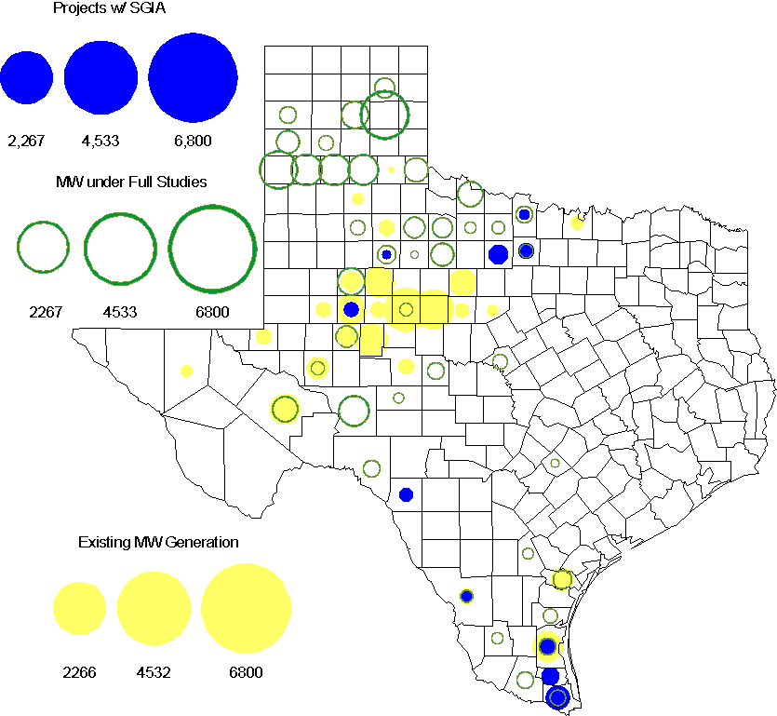

Regional Planning Group Project Reviews

- Sharyland Utilities (Sharyland) and Brownsville Public Utilities Board (BPUB) has submitted the Cross Valley Brownsville Loop project that proposes a new 345kV line from LaPalma to Loma Alta and a new 345kV line from Loma Alta to Frontera. The estimated cost for this project is $275 Million. ERCOT has completed the Independent Review for this Tier 1 project. The project will be presented to the TAC and ERCOT BOD for approval on January, 2012.

- South Texas Electric Cooperative (STEC) has submitted the El Campo to Vanderbilt rebuild project to rebuild the existing 69 kV transmission between El Campo and Vanderbilt with a double circuit 138/69 kV line. The proposed project is to accommodate 118 MW of new load in Jackson County. This is a Tier 2 project that is estimated to cost $26.8 million. This Tier 2 project is undergoing ERCOT Independent Review.

- Brazos Electric Cooperative has submitted the Olney to Lake Kemp Switch 69kV Rebuild project. This is a Tier 3 project that is estimated to cost approximately $17.8 million. This project has completed the RPG review and ERCOT will send the RPG acceptance letter.

- South Texas Electric Cooperative (STEC) has submitted the Karnes Electric Cooperative (KEC) load addition project to accommodate 167 MW of new load in Karnes and Atascosa Counties. This is a Tier 2 project that is estimated to cost $33.1 million. This Tier 2 project has been submitted for RPG comments.

Congestion Costs
Dollars shown in RUC Make Whole payment graph are settlement quality.

OOMC and RUC net Make Whole payment in million$

Monthly Average MCPE and LMP
Binding Constraints - December 2011
Contingency | Binding Element | Number of 5-min intervals | Shadow Price Range $/MWh | Estimated Congestion Rent $ (Shadow Price*Limit) | Transmission Project | Comments
Amoco North Cowden Tap - Moss Switch 138kV |  | 652 | 0-1344 | 3,998,635 | 5YTP [2010-R7, R8]
BASE CASE | West to North Stability Limit | 1086 | 0-52 | 3,884,299 | CREZ
Gila - Nueces Bay 138 kV | Gila - Hiway_9 138 kV | 1003 | 0-3500 | 3,359,282 |  | Outage on Nueces Bay - Gila 138 kV and Koch Up River 138 kV
Tri Corner - Tyler Grande and Martin Lake SES - Elkton 345 kV | Tyler Grande 345/138 Auto transformer 1H | 64 | 0-4500 | 1,674,075
Lago Vista - Marshall Ford 138 kV | Buttercup - Whitestone 138 kV | 68 | 10.4-4500 | 1,548,129 | Buttercup - Whitestone line upgrade (10TPIT0074)
Watermill Switch - Tri Corner and Trinidad SES 345 kV | Trinidad SES 345/138 kV autotransformer | 292 | 0-3500 | 1,368,252 |  | Outage on Big Brown SES - Richland Chambers 345 kV
Bell County East - Sandow Switch 345 kV | Austrop 345/138 kV Autotransformer AT1 | 16 | 0-4500 | 1,326,727 |  | Outage on Austrop 345/138 Auto transformer AT2
Monticello - Allen Switch and Sulphur Springs - Royse Switch 345 kV | Monticello SES - Farmersville Switch 345 kV | 11 | 36-4500 | 1,252,768
Whitepoint - Nueces Bay 138 kV, Pelican - Whitepoint 138 kV, Whitepoint - Lon_Hill 345 kV, Whitepoint 345/138 kV autotransformer | Pelican - Lon_Hill 345 kV | 1422 | 0-3500 | 1,048,094 |  | Pelican - Lon_Hill line has been dynamically derated
Watermill Switch -West Levee Switch and Sargen Road 345 kV, West Levee Switch - Watermill Switch 345 kV | Cedar Hill Switch - Watermill Switch 345 kV | 98 | 0-398 | 952,094 |  | Outage on the Watermill 345 kV West Bus
Binding Constraints - January to December 2011
Contingency | Binding Element | Number of 5-min intervals | Shadow Price Range $/MWh | Estimated Congestion Rent $ (Shadow Price*Limit) | Transmission Project
BASE CASE | West to North Stability Limit | 22120 | 0-3980 | 99,736,902 | CREZ
BASE CASE | Valley Import | 273 | 0-5000 | 41,457,339 | Lobo to North Edinburg 345kV project [11TPIT0002]
Nelson Sharpe - Ajo 345kV | Lon Hill - North Edinburg 345kV | 78 | 0-4500 | 31,689,757 | Lobo to North Edinburg 345kV project [11TPIT0002]
Denton - Argyle & West Denton 138kV, Fort Worth - W_Dent 138kV | West Denton - Jim Cristal 138kV | 474 | 0-3500 | 25,219,060 | 5YTP [2010-R12]
Amoco North Cowden Tap - Moss Switch 138kV | Odessa North 138/69 kV Autotransformer | 3082 | 0-2800 | 23,694,657 | 5YTP [2010-R7, R8]
Greens Bayou - Gable and Hardy - Crocket 138kV, Singleton - Tomball and Singleton - Roanes Prairie 345kV, Meadow - Oasis 345kV, Thermal Energy Coop - Blodgett 138kV, W.A. Parish - Obrien 345kV | Garrott - Midtown 138kV | 5183 | 0-3500 | 20,035,789 | Upgrade 138 kV underground Ckt. 90 Garrott to Midtown to Polk [11TPIT0072]
Lewisville Switch 345/138kV Auto, Lewisville Switch - Carrollton Northwest 345kV | Carrollton Northwest - Lakepointe 138kV | 444 | 0-3500 | 15,137,927 | Upgrade NW Carrollton - Lakepointe (TNMP) 138 kV line [14TPIT0014]
BASE CASE, Zorn - Marion and Clear Springs 345kV, Marion - Zorn and Clear Springs 345 kV, Clear Springs 345/138kV Autotransformer | Marion 345/138kV Autotransformer | 391 | 0-4500 | 13,826,062
Roans prairie - Kuykendahl - King & Singleton - Tomball 345kV, Singleton - Tomball and Roans Prairie 345 KV | Singleton - Zenith 345kV | 946 | 0-4500 | 13,261,025 | Zenith to Fayetteville 345kV project [14TPIT0002]
Abilene South - Bluff Creek 138kV, Bluff Creek Auto T2_H & T2_L & T2_T, Bluff Creek - Abilene Mulberry Creek 345 kV, San Angelo Red Creek - Bluff Creek 345 kV | Nicole - Oak Creek 138kV | 9094 | 0-3500 | 11,429,205 | CREZ

Wind Generation as a Percent of Load
One-hour average of total wind power output as a percentage of ERCOT load.

Planning Model Activities
- The Contingency List update was completed and posted on ERCOT POI. The Data Dictionary update is underway. The TPIT update to begin the week of January 9th:
  - Dec 14, 2011 ERCOT Finalized and Posted Contingency database
  - Jan 16, 2012 Data Dictionary Posted
  - Jan 9, 2012 TPIT No Cost Report posted on ERCOT POI
  - Jan 13, 2012 12DSA and 12DSB Pass0 TPIT updates begin
  - Feb 17, 2012 12DSA and 12DSB TPIT updates posted to ERCOT POI
- Status update on SCR760, Changes Needed for Information Model Manager and Topology Processor for Planning Models, which was approved by the ERCOT Board in March 2011.
  - Bundle 1 (Items 3, 7 and 8): In Production.
  - Bundle 2 (Items 2, 4, 9): SOW signed by both Vendor and ERCOT. Code release received mid- December 2011. Release testing is underway. Production date still expected to be the February 2012 on-cycle release.
  - Item 5: Requirements completed by ERCOT and TSPs and agreed upon with vendor. Awaiting vendor estimate on cost for implementation so that SOW can be prepared.
  - Bundle 3 (Items 1 and 6): ERCOT and TSPs have identified new fields or records added between version 33 and version 30 of the PSS/E RAWD format. The evaluation process for Item 1 has been added to the SSWG Procedure Manual currently being updated.
SCR Sub Part | SCR Description | Status
SCR760-1 | Upgrade to PSS/E v32 | Planning
SCR760-2 | Distribution Capacitor banks | Release
SCR760-3 | Zero Impedance Line Ratings | Production
SCR760-4 | Associate Loads and Capacitor banks with the correct CNG | Release
SCR760-5 | Additional Transformer Data for Planning | Planning
SCR760-6 | FACTS Devices | Submitted
SCR760-7 | Assign valid PSSE IDs to Breakers/  Switches/ Series Devices | Production
SCR760-8 | Phase shift of Autos for short circuit studies | Production
SCR760-9 | Multisection Line Grouping | Release
Table 1: In the following table:
- Red will be used to show status of Not Submitted, meaning that the SCR sub part has not been submitted to Siemens as a Service Request.
- Yellow will indicate that the SCR sub part has been submitted. The color will remain yellow and the status will change in order to Submitted, Planning (Requirements, SOW, Code Writing), Release (Siemens produces first code to test), and Testing (code has completed internal test and is moving through release management).
- Green will indicate that the code has been tested and installed on the machines that ERCOT uses to produce Topology Processor output for Planning and CRR.

Other Notable Activities
- The 5YTP reliability studies for n-1 have been completed for 2012, 2014 and 2016. The results and n-1 secure base cases including the set of reliability projects (for 2012, 2014 and 2016) were posted on Nov. 14, 2011. Work on the 2011 5YTP n-1 + g-1 reliability assessment and the economic analysis is ongoing.

