- Last meeting held September 20, 2011, Next Meeting December 14, 2011
- 2011 Flat Start Schedule (Remaining):
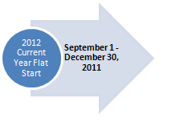
Proposed DWG Flat Start case building schedule

- Work is continuing on revisions to the DWG Procedure Manual in anticipation of approval of PGRR-012 DWG Procedures for the Planning Guide. The goal is to review the revised procedure manual at the December DWG meeting.

