 |  |  |  | System Planning
Monthly Status Report
November 2011

 |  | Report Highlights
- A comprehensive review by Transmission Service Providers of the status of each of their assigned generation interconnection studies has been completed. ERCOT has incorporated the results of this review into this month’s report.
- ERCOT is currently tracking 136 active generation interconnection requests totaling over 38,000 MW. This includes over 19,000 MW of wind generation.
- Study has been suspended on 41 projects totaling over 18,000 MW.
- ERCOT is currently reviewing proposed transmission improvements with a total cost of $162.5 Million
- Transmission Projects endorsed in 2011 total $594.9 Million
- All projects (in engineering, routing, licensing and construction) total approximately $9.8 Billion
- Transmission Projects energized in 2011 total about $694.8 million

Table of Contents
1. Generation Interconnection 1
1.1 New Signed Generation Interconnection Agreements 1
1.2 New Generation Registering for Commercial Operations 1
1.3 Summary of Generation Interconnection Requests 1
1.4 Projects with Interconnection Agreements 4
1.5 Generation Projects Undergoing Full Interconnection Studies 4
1.6 Wind Generation 6
2. Regional Planning Group Project Reviews 7
3. Congestion Costs 8
4. Wind Generation as a Percent of Load 11
5. Planning Model Activities 12
6. Other Notable Activities 12

1. Generation Interconnection
Additional information regarding detailed generation interconnection and impact studies is contained in the “Generation Project Interconnection Information” folder in the “Operations and System Planning” area on the ERCOT website: http://planning.ercot.com/login/login.

New Signed Generation Interconnection Agreements - none

New Generation Registering for Commercial Operations - none
The total installed wind capacity is now reported as 9,604 MW by the resource owners through the registration process. Capacity by North, South and West is 232 MW, 2066 MW, and 7306 MW respectively. 850 MW is able to switch between the West and South zones.

Summary of Generation Interconnection Requests
GENERATION INTERCONNECTION REQUESTS CURRENTLY UNDER REVIEW
Currently tracking 177 generation interconnection or change requests
As of November 30, 2011 | North | South | West | Total
Security Screening Study | 2 | 4 | 3 | 9
SSS Completed | 1 | 2 | 16 | 19
Full Interconnect Study | 9 | 17 | 52 | 78
FIS Completed | 1 | 2 | 6 | 9
Suspended Studies | 7 | 4 | 30 | 41
Capacity of Suspended Study Projects | 3,286 | 3,338 | 11,923 | 18,547
Interconnect Agreement Completed | 8 | 9 | 4 | 21
Capacity under Interconnection Agreements | 4,607 | 4,244 | 501 | 9,352
Capacity for Grid, MW | 11,797 | 10,200 | 16,332 | 38,329
Wind Capacity, MW | 2,634 | 3,238 | 13,794 | 19,666

Fuel Type | Confidential Projects (MW) | Projects Under Full Study (MW) | Projects w/ Interconnect Agreement/Public Letter (MW) | Suspended Studies (MW) | Grand Total (MW)
Gas-AllOther |  |  |  |  | 1,222
Gas-CombinedCycle |  |  | 4,732 | 2,890 | 10,850
Total Gas | 2,261 | 2,189 | 4,732 | 2,890 | 12,072
Nuclear |  |  | 3,200 | 2,700 | 5,900
Coal |  | 850 | 2,785 |  | 3,635
Wind | 2,907 | 14,854 | 1,905 | 12,554 | 32,220
Solar | 379 | 521 | 90 | 353 | 1,343
Biomass |  |  | 100 | 50 | 150
Other |  | 316 | 1,240 |  | 1,556
Grand Total | 5,547 | 18,730 | 14,052 | 18,547 | 56,876
County Location of Installed Generation and Interconncection Requests (all fuels)

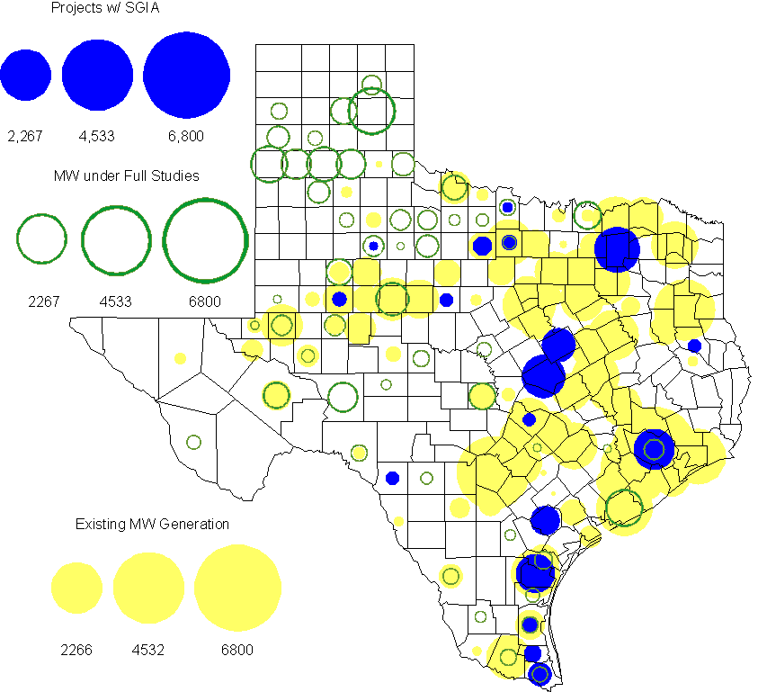

Projects with Interconnection Agreements

(Status: IA=Interconnect Agreement, XX= cancelled)
Generation Interconnections as of November 30, 2011
INR | SiteName | Status | County | Region | COD | Fuel Type |  | MW For Grid |  | Change from Last Report
10INR0082 | FRV AE Solar | IA | Travis | North | Dec-11 |  | Solar |  | 30
08INR0062 | Trinity Hills | IA | Young | West | Mar-12 |  | Wind |  | 250
09INR0007 | Nacogdoches Project | IA | Nacogdoches | North | Jun-12 |  | Biomass |  | 100
10INR0060 | Magic Valley Wind Project | IA | Willacy | South | Jun-12 |  | Wind |  | 202
11INR0086 | RRE Austin Solar | IA | Travis | South | Oct-12 |  | Solar |  | 60
08INR0011 | Senate Wind Project | IA | Jack | North | Nov-12 |  | Wind |  | 150
12INR0072 | Anacacho Windfarm | IA | Kinney | South | Dec-12 |  | Wind |  | 100
10INR0077 | Kaiser Creek Windfarm | IA | Callahan | West | Dec-12 |  | Wind |  | 101
09INR0061 | WKN Mozart | IA | Kent | West | Dec-12 |  | Wind |  | 30
11INR0033 | Los Vientos | IA | Cameron | South | Dec-12 |  | Wind |  | 400
08INR0049 | Briar Creek | IA | Clay | North | Dec-12 |  | Wind |  | 50 | Renamed
09INR0001 | Sandy Creek 1 | IA | McLennan | North | Mar-13 |  | Coal |  | 925 | Date
06INR0022c | Penascal Wind Farm 3 | IA | Kenedy | South | Dec-13 |  | Wind |  | 202
06INR0006 | Cobisa-Greenville | IA | Hunt | North | May-14 |  | Gas-CC |  | 1,792
08INR0018 | Gunsight Mountain | IA | Howard | West | Aug-14 |  | Wind |  | 120
10INR0020a | Panda Temple Power | IA | Bell | North | Jan-15 |  | Gas-CC |  | 780 | Date
12INR0016a | Las Brisas Energy Center | IA | Nueces | South | Oct-15 |  | Other |  | 620
10INR0022 | Pondera King Power Project | IA | Harris | South | Jan-16 |  | Gas-CC |  | 1,380 | Date
10INR0020b | Panda Temple Power | IA | Bell | North | Jan-16 |  | Gas-CC |  | 780 | Date
12INR0016b | Las Brisas Energy Center | IA | Nueces | South | Oct-16 |  | Other |  | 620
14INR0002 | Coleto Creek Unit 2 | IA | Goliad | South | Jan-17 |  | Coal |  | 660
 |  |  |  |  |  |  | Total |  | 9,352
Note: Projects that do not have an interconnection agreement but have been publicly disclosed via a Public Letter to ERCOT and were previously reported on this table have been moved to section 1.5 unless Suspended or Cancelled

Generation Projects Undergoing Full Interconnection Studies with Confidentiality Waived by Developer
INR | SiteName | Status | County | Region | COD | Fuel | MW For Grid | Change from Last Report
12INR0080 | Blanco Canyon Wind | PL | Floyd | West | Dec-12 | Wind | 300
14INR0005 | White Stallion Energy Center | PL | Matagorda | South | Jul-14 | Coal | 1,200
15INR0002 | Comanche Peak 3 and 4 | PL | Somervel | North | Dec-21 | Nuclear | 3,200

Generation Projects Undergoing Full Interconnection Studies

INR | County | Grid Capacity | COD | Fuel |  | INR | County | Grid Capacity | COD | Fuel
10INR0016 | Childress | 150 | TBD | Wind |  | 11INR0091 | Webb | 92 | TBD | Wind
11INR0054 | San Patricio | 161 | TBD | Wind |  | 10INR0062a | Pecos | 80 | TBD | Wind
11INR0094 | Kent | 100 | TBD | Solar |  | 12INR0075 | Wilbarger | 499 | Apr-12 | Wind
12INR0086 | Harris | 89 | Jun-12 | Gas |  | 12INR0053 | Crockett | 615 | Jun-12 | Wind
08INR0031 | Childress | 100 | Jun-12 | Wind |  | 12INR0050 | King | 332 | Jun-12 | Wind
11INR0085 | Nolan | 106 | Jul-12 | Wind |  | 12INR0079 | Kenedy | 200 | Aug-12 | Wind
12INR0076 | Winkler | 36 | Sep-12 | Other |  | 08INR0044 | Concho | 200 | Nov-12 | Wind
13INR0036 | Hidalgo | 200 | Dec-12 | Wind |  | 12INR0071 | Caldwell | 30 | Dec-12 | Wind
12INR0069 | Presidio | 50 | Dec-12 | Solar |  | 12INR0068 | Jim Hogg | 80 | Dec-12 | Wind
12INR0067 | Webb | 94 | Dec-12 | Wind |  | 12INR0060 | Schleicher | 58 | Dec-12 | Wind
12INR0059 | Pecos | 50 | Dec-12 | Solar |  | 12INR0057 | Ector | 50 | Dec-12 | Solar
12INR0055 | Baylor | 80 | Dec-12 | Wind |  | 11INR0093 | San Patricio | 41 | Dec-12 | Wind
11INR0079a | Clay | 200 | Dec-12 | Wind |  | 10INR0023 | Haskell | 405 | Dec-12 | Wind
12INR0085 | Stonewall | 25 | Dec-12 | Wind |  | 12INR0081 | Upton | 113 | Dec-12 | Wind
12INR0029 | Swisher | 500 | Dec-12 | Wind |  | 11INR0081 | Live Oak | 72 | Dec-12 | Wind
09INR0048 | Jack | 113 | Dec-12 | Wind |  | 13INR0040 | Harris | 0 | Jan-13 | Gas
13INR0010a | Parmer | 200 | Jan-13 | Wind |  | 11INR0083B | Crockett | 100 | Mar-13 | Wind
11INR0082B | Val Verde | 150 | Mar-13 | Wind |  | 09INR0051 | Borden | 249 | Mar-13 | Wind
12INR0034 | Borden | 342 | Mar-13 | Wind |  | 11INR0050 | Crosby | 149 | Mar-13 | Wind
12INR0018 | Gray | 500 | Apr-13 | Wind |  | 12INR0070 | Knox | 300 | Apr-13 | Wind
13INR0020a | Glasscock | 200 | May-13 | Wind |  | 10INR0062b | Pecos | 220 | May-13 | Wind
10INR0089 | Harris | 40 | May-13 | Other |  | 10INR0085 | Ector | 40 | May-13 | Solar
13INR0032 | Andrews | 30 | Jun-13 | Solar |  | 13INR0031 | Austin | 30 | Jun-13 | Solar
12INR0045 | Kleberg | 135 | Jun-13 | Wind |  | 13INR0023 | Ector | 240 | Jul-13 | Other
13INR0025 | Randall | 150 | Sep-13 | Wind |  | 11INR0083A | Crockett | 50 | Sep-13 | Wind
11INR0082A | Val Verde | 50 | Sep-13 | Wind |  | 13INR0005 | Carson | 600 | Oct-13 | Wind
13INR0028 | Hale | 392 | Nov-13 | Gas |  | 13INR0044 | Wilacy | 400 | Dec-13 | Wind
13INR0039 | Castro | 500 | Dec-13 | Wind |  | 13INR0038 | Swisher | 300 | Dec-13 | Wind
13INR0030 | Archer | 100 | Dec-13 | Wind |  | 13INR0026 | Oldham | 201 | Dec-13 | Wind
13INR0017 | Childress | 200 | Dec-13 | Wind |  | 13INR0007 | Pecos | 200 | Dec-13 | Wind
12INR0002a | Briscoe | 200 | Dec-13 | Wind |  | 11INR0013 | Mills | 150 | Dec-13 | Wind
10INR0009 | Castro | 300 | Dec-13 | Wind |  | 12INR0058 | San Patricio | 50 | Dec-13 | Wind
11INR0057 | Cameron | 165 | Dec-13 | Wind |  | 13INR0006 | Gray | 750 | Jan-14 | Wind
08INR0019c | Gray | 250 | Jan-14 | Wind |  | 08INR0019b | Gray | 250 | Jan-14 | Wind
08INR0019a | Gray | 250 | Jan-14 | Wind |  | 13INR0010b | Parmer | 500 | Jan-14 | Wind
10INR0080 | Presidio | 81 | Jan-14 | Solar |  | 12INR0063 | Uvalde | 90 | Apr-14 | Solar
13INR0020b | Glasscock | 150 | May-14 | Wind |  | 14INR0015 | Harris | 192 | Jun-14 | Gas
14INR0011 | Swisher | 270 | Jun-14 | Gas |  | 14INR0010 | Roberts | 300 | Jul-14 | Wind
10INR0021 | Grayson | 646 | Jul-14 | Gas |  | 14INR0005 | Matagorda | 1,200 | Jul-14 | Coal
12INR0042b | Deaf Smith | 135 | Sep-14 | Wind |  | 12INR0042a | Deaf Smith | 265 | Sep-14 | Wind
14INR0009 | Kent | 248 | Dec-14 | Wind |  | 13INR0021 | Llano | 600 | Dec-14 | Gas
12INR0002b | Briscoe | 200 | Dec-14 | Wind |  | 13INR0010c | Parmer | 500 | Jan-15 | Wind
12INR0002c | Briscoe | 350 | Dec-15 | Wind |  | 14INR0003 | Nolan | 850 | Jun-18 | Coal
15INR0002 | Somervel | 3,200 | Dec-21 | Nuclear
Note: ERCOT recently requested that the Transmission Service Providers comprehensively review the status of each of their assigned Full Interconnection Studies and report the status of each study back to ERCOT. Projects that were classified as “Cancelled” or “Suspended” as a result of this review are excluded from this table.

Wind Generation
Wind Capacity Installed by Year

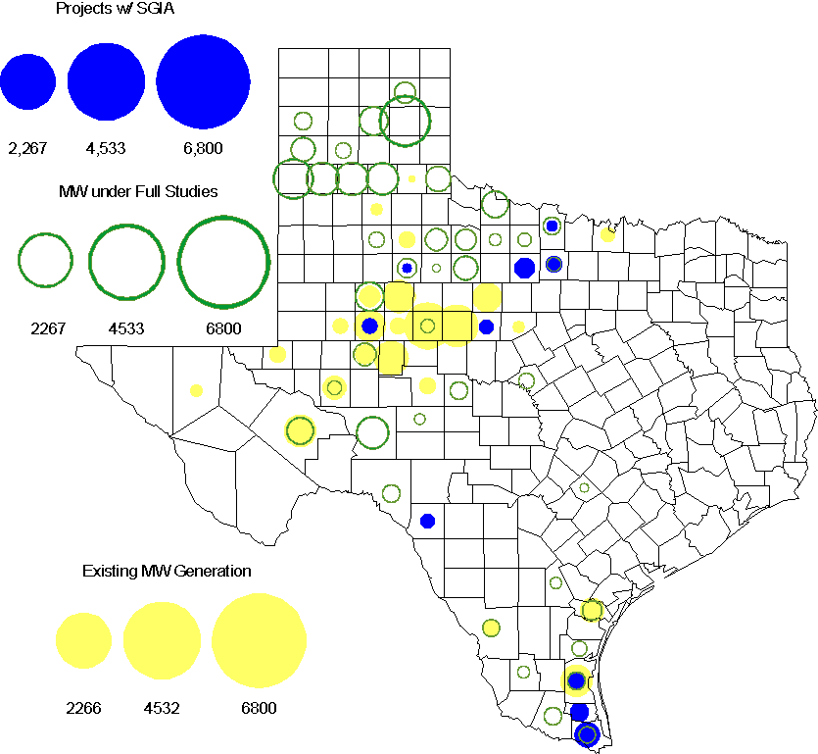

Regional Planning Group Project Reviews

- Sharyland Utilities (Sharyland) and Brownsville Public Utilities Board (BPUB) has submitted the Cross Valley Brownsville Loop project that proposes a new 345kV line from LaPalma to Loma Alta and a new 345kV line from Loma Alta to Frontera. The estimated cost for this project is $117.9 Million. This Tier 1 project is undergoing ERCOT Independent Review. Sharyland and BPUB submitted an study addendum report to the Cross valley project with additional options which is is currently undergoing ERCOT Independent Review.

- South Texas Electric Cooperative (STEC) has submitted the El Campo to Vanderbilt rebuild project to rebuild the existing 69 kV transmission between El Campo and Vanderbilt with a double circuit 138/69 kV line. The proposed project is to accommodate 118 MW of new load in Jackson County. This is a Tier 2 project that is estimated to cost $26.8 million. This Tier 2 project is undergoing ERCOT Independent Review.

- LCRA and STEC have submitted the STEC Ricebird and LCRA TSC Nada 138/69 kV auto project. This is a Tier 3 project that is estimated to cost approximately $15 million. This project has completed the RPG review and ERCOT has sent the RPG acceptance letter.

- Brazos Electric Cooperative has submitted the Olney to Lake Kemp Switch 69kV Rebuild project. This is a Tier 3 project that is estimated to cost approximately $17.8 million. This project has been submitted for RPG comments.

Congestion Costs
Dollars shown in RUC Make Whole payment graph are settlement quality.

OOMC and RUC net Make Whole payment in million$

Monthly Average MCPE and LMP

Binding Constraints - November 2011
Contingency | Binding Element | Number of 5-min intervals | Shadow Price Range $/MWh | Estimated Congestion Rent $ (Shadow Price*Limit) | Transmission Project | Comments
BASE CASE | West to North Stability Limit | 2122 | 0-3980 | 9,066,867 | CREZ
Graham SES - Long Creek 345 kV | Murray Switch - Paint Creek 138 kV | 1257 | 0-3500 | 6,409,532 | CREZ
Oklaunion - Abilene Mulberry Creek 345 kV | Lake Pauline - Vernon 138 kV | 643 | 0-3500 | 5,858,075 | CREZ | Outage on the Fisher Road Switch - Riley 345 kV
Morgan Creek SES 345/138 autotransformer 4 | Morgan Creek SES 345/138 Autotransformer 1 | 44 | 732-4500 | 5,335,575 | CREZ | Outage on the Morgan Creek SES 3B1 138kV bus
Sun Switch - Golden Switch 138 kV, Morgan Creek SES - Sun Switch 138 kV | Bluff Creek Switch - China Grove Switch 138 kV | 72 | 0-3500 | 2,771,147 | CREZ
Odessa EHV Switch - Longshore Switch and Quail Switch 345 kV | McDonald Road - Forsan Tap 138 kV | 179 | 0-3500 | 1,842,692 | CREZ | Outage on the Falcon Seaboard - Morgan Creek SES and Midland East 345 kV
Odessa EHV Switch - Longshore Switch and Quail Switch 345 kV | Forsan Tap - CRMWD 7 Tap 138 kV | 169 | 3.3-3500 | 1,626,665 | CREZ | Outage on the Falcon Seaboard - Morgan Creek SES and Midland East 345 kV
Graham SES - Long Creek 345 kV | Putnam 138/69 kV Autotransformer | 119 | 399-2800 | 1,558,817 | CREZ
Lane City Pump - El Campo 138 kV | Blessing - Lane City 138 kV | 26 | 3500-3500 | 1,380,750 |  | Outage on the South Lane City to New Gulf 138 kV line
Formosa autotransformer TR22 | Formosa autotransformer TR21 | 42 | 3500-3500 | 1,275,330
Binding Constraints - January to November 2011
Contingency | Binding Element | Number of 5-min intervals | Shadow Price Range $/MWh | Estimated Congestion Rent $ (Shadow Price*Limit) | Transmission Project
BASE CASE | West to North Stability Limit | 21034 | 0-3980 | 95,852,603 | CREZ
BASE CASE | Valley Import | 273 | 0-5000 | 41,457,339 | Lobo to North Edinburg 345kV project [11TPIT0002]
Nelson Sharpe - Ajo 345kV | Lon Hill - North Edinburg 345kV | 78 | 0-4500 | 31,689,757 | Lobo to North Edinburg 345kV project [11TPIT0002]
Denton - Argyle & West Denton 138kV, Fort Worth - W_Dent 138kV | West Denton - Jim Cristal 138kV | 474 | 0-3500 | 25,219,060 | 5YTP [2010-R12]
Greens Bayou - Gable and Hardy - Crocket 138kV, Singleton - Tomball and Singleton - Roanes Prairie 345kV, Meadow - Oasis 345kV, Thermal Energy Coop - Blodgett 138kV, W.A. Parish - Obrien 345kV | Garrott - Midtown 138kV | 5183 | 0-3500 | 20,035,789 | Upgrade 138 kV underground Ckt. 90 Garrott to Midtown to Polk [11TPIT0072]
Amoco North Cowden Tap - Moss Switch 138kV | Amoco North Cowden Tap - Moss Switch 138kV | 2430 | 0-2800 | 19,696,022 | 5YTP [2010-R7, R8]
Lewisville Switch 345/138kV Auto, Lewisville Switch - Carrollton Northwest 345kV | Carrollton Northwest - Lakepointe 138kV | 444 | 0-3500 | 15,137,927 | Upgrade NW Carrollton - Lakepointe (TNMP) 138 kV line [14TPIT0014]
BASE CASE, Zorn - Marion and Clear Springs 345kV, Clear Springs 345/138kV Autotransformer | Marion 345/138kV Autotransformer | 391 | 0-4500 | 13,826,062
Roans prairie - Kuykendahl - King & Singleton - Tomball 345kV | Singleton - Zenith 345kV | 946 | 0-4500 | 13,261,025 | Zenith to Fayetteville 345kV project [14TPIT0002]
Abilene South - Bluff Creek 138kV, Bluff Creek Auto T2_H & T2_L & T2_T, Bluff Creek - Abilene Mulberry Creek 345 kV | Nicole - Oak Creek 138kV | 9019 | 0-3500 | 11,284,508 | CREZ

Wind Generation as a Percent of Load
One-hour average of total wind power output as a percentage of ERCOT load.

Planning Model Activities
- Work on Data Set B has been completed. An update of the Contingency List and calculation of the Transmission Loss Factors are underway. The remaining schedule is as follows:
  - Nov 22, 2011 ERCOT sends out request to update Data Dictionary
  - Dec 1, 2011 DSB Consistency Validation spreadsheet posted
  - Dec 2, 2011 Transmission Loss Factors Approved
  - Nov 29, 2011 ERCOT sends out Pass 1 Contingency Updates
  - Dec 9, 2011 Data Dictionary Pass 0 Updates due to ERCOT
  - Dec 14, 2011 ERCOT Finalizes Contingency database
  - Dec 22, 2011 ERCOT sends out Pass 1 Data Dictionary Updates
- Status update on SCR760, Changes Needed for Information Model Manager and Topology Processor for Planning Models, which was approved by the ERCOT Board in March 2011.
  - Bundle 1 (Items 3, 7 and 8): In Production.
  - Bundle 2 (Items 2, 4, 9): SOW signed by both Vendor and ERCOT. Code release delayed until December 2011 due to Item 2 Change Request. Production date still expected to the February 2012 on-cycle release. Example Topology Processor output for Items 4 (Associate Load with Correct CNG) and 9 (Multi-section Line Grouping) created by vendor and reviewed by ERCOT with positive results. Note: The other part of Item 4, Associate Capacitor banks with correct CNG, is now part of the change request for Item 2, Distribution Capacitor banks.
  - Item 5: Requirements completed by ERCOT and TSPs. Requirements are still being vetted by ERCOT and vendor.
  - Bundle 3 (Items 1 and 6): ERCOT and TSPs have identified new fields or records added between version 33 and version 30 of the PSS/E RAWD format. Began creating the envaluation process for Item 1 that would be added to SSWG Procedure Manual.
SCR Sub Part | SCR Description | Status
SCR760-1 | Upgrade to PSS/E v32 | Planning
SCR760-2 | Distribution Capacitor banks | Planning
SCR760-3 | Zero Impedance Line Ratings | Production
SCR760-4 | Associate Loads and Capacitor banks with the correct CNG | Planning
SCR760-5 | Additional Transformer Data for Planning | Planning
SCR760-6 | FACTS Devices | Submitted
SCR760-7 | Assign valid PSSE IDs to Breakers/  Switches/ Series Devices | Production
SCR760-8 | Phase shift of Autos for short circuit studies | Production
SCR760-9 | Multisection Line Grouping | Planning
Table 1: In the following table:
- Red will be used to show status of Not Submitted, meaning that the SCR sub part has not been submitted to Siemens as a Service Request.
- Yellow will indicate that the SCR sub part has been submitted. The color will remain yellow and the status will change in order to Submitted, Planning (Requirements, SOW, Code Writing), Release (Siemens produces first code to test), and Testing (code has completed internal test and is moving through release management).
- Green will indicate that the code has been tested and installed on the machines that ERCOT uses to produce Topology Processor output for Planning and CRR.

Other Notable Activities
- UFLS Assessment Study as required by NERC PRC-006 is in progress.
- DFW Dynamic Reactive Reserve Study is in progress.
- Dynamic data set preparation for year 2015 network conditions – As part of year 2011 DWG activities, ERCOT is preparing a future year 2015 no-disturbance data set for dynamic studies.
- The 5YTP reliability studies for n-1 have been completed for 2012, 2014 and 2016. The results and n-1 secure base cases including the set of reliability projects (for 2012, 2014 and 2016) were posted on Nov. 14, 2011. Work on the 2011 5YTP n-1 & g-1 reliability assessment is ongoing.

