- Last meeting held September 20, 2011
- 2011 Flat Start Schedule (Remaining):
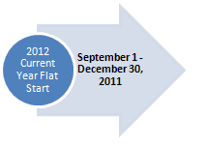
Proposed DWG Flat Start case building schedule

- 2011 Future Year Flat Start– The final 2015 Flat Start Case was posted on November 8, 2011.
- 2012 Current Year Flat Start Case development has begun.
- Work is beginning on revisions to the DWG Procedure Manual in anticipation of approval of PGRR-012 DWG Procedures for the Planning Guide. The goal is to review the revised procedure manual at the December DWG meeting.

