Commercial Operations Market Guide
Section 8: ERCOT Settlement and Invoice Process

October 25, 2011
_______________________________________________

8 ERCOT SETTLEMENT AND INVOICE PROCESS 8-1
8.1 Invoice Process 1
8.1.1 Overview 1
8.1.2 Types of Ad Hoc Invoices 3
8.1.3 Method of Communication 3
8.1.4 Timing of Communication 4
8.1.5 Content of Communication 4
8.1.6 Market Participants 4
8.2 Settlement Statements and Invoices 5
8.2.1 Congestion Revenue Rights (CRR) Settlement Invoices 7
8.2.1.1 CRR Auction Award Invoices 7
8.2.1.2 CRR Auction Revenue Distribution (CARD) Invoice 10
8.2.1.3 CRR Balancing Account (CRRBA) Invoice 11
8.2.2 Day-Ahead Market Statements 12
8.2.2.1 DAM Statement 12
Error! Bookmark not defined.
Error! Bookmark not defined.
8.2.3 Real-Time Market Statements and Invoices 14
8.2.3.1 Real-Time Market Statements 14
8.2.3.1.1 RTM Initial Statement 15
8.2.3.1.2 RTM Final Statement 16
8.2.3.1.3 RTM True-Up Statement 17
8.2.3.1.4 RTM Resettlement Statement 18
Error! Bookmark not defined.
8.2.3.2 Default Uplift Invoice 18
Error! Bookmark not defined.
8.2.3.3 Miscellaneous Invoice 19

8.2.4 Combined Invoices 20
8.2.4.1 Settlement Invoices 20
8.2.4.2 Late Fee Invoices 21

ERCOT SETTLEMENT AND INVOICE PROCESS

8.1 Invoice Process
The process for receiving the ERCOT weekly Invoice based on Settlement Statements are documented in Protocol Section 9.6, Settlement Invoices for the Day-Ahead Market and Real-Time Market. This Section explains the process for Invoices that are not settled according to the Protocol timeline.

8.1.1 Overview
The following figure illustrates the process flow of ERCOT’s Invoice process, including the ad hoc Invoice process.

8.1.2 Types of Ad Hoc Invoices
The following are types of Settlements that will be invoiced on an ad hoc basis:
(a) Contract Period
These are Settlements based on a contract period instead of an operating date.
(i) Schedule Control Error (SCE); and
(ii) Emergency Interruptible Load Service (EILS).
(b) Recurring Non-Settlement Related Charges
These are routine, non-standard Settlements.
(i) Wide Area Network (WAN) fee;
(ii) Electric Reliability Organization (ERO) fee;
(iii) Transmission Congestion Right (TCR) auction Invoice; and
(iv) TCR auction revenue.
(c) Ad Hoc Settlement
These are Settlements that occur infrequently and are not a part of standard operations.
(i) Uplift of short pays; and
(ii) Litigation.
(d) Undefined Scenarios
These are Settlements for any scenario that is not defined as a typical Settlement that usually originates from the following groups:
(i) ERCOT Legal;
(ii) ERCOT Wholesale Client Services (WCS); and
(iii) ERCOT Finance.

8.1.3 Method of Communication
The method of communication varies depending on the type of ad hoc Invoice. Although ERCOT WCS will send out Market Notices for ad hoc Invoice circumstances, whenever possible, they are unable to commit to providing Notice in every circumstance. In all scenarios, the following Authorized Representatives registered with ERCOT will receive an email regarding the Invoice. These Authorized Representatives will receive an email from CientServices@ercot.com.
(a) Primary Authorized Representative;
(b) Backup Authorized Representative;
(c) Accounts payable; and
(d) Accounts payable backup.

8.1.4 Timing of Communication
ERCOT WCS will send the Market Notice in advance of the Invoice, as many days as possible. However, there could be potential situations when ERCOT WCS is unable to provide a sufficient Market Notice.

8.1.5 Content of Communication
If there is sufficient time, the communication from ERCOT will contain as much detail as possible. In circumstances where an extremely quick turn-around-time is required, there may be a need to send a Notice that is light on content but provides an advanced warning of the ad hoc Settlement.
(a) The subject line of the Market Notice will indicate the appropriate urgency and action.
(b) If the ad hoc Invoice does not impact all Qualified Scheduling Entities (QSEs), the Market Notice will define the parameters by which a QSE can determine whether or not they should receive an Invoice (e.g., “all QSEs with Load in February 2005 will receive this Invoice, adjustments made to reflect QSEs with Load who have exited the market” or “all QSEs who were short-paid in March 2003 will receive payment”).
(c) The signature within the Market Notice will include the standard ERCOT signature/contact information.
(d) The Market Notice will indicate when the Invoice will be posted and where the Invoice will be posted. Normally, the Invoice will be posted in the “Miscellaneous” folder on the Market Information System (MIS).

8.1.6 Market Participants
Each Market Participant should ensure that the accounting contacts registered with ERCOT are current to ensure that the Invoices are received and paid in a timely manner.

8.2 Settlement Statements and Invoices
(1) The Real-Time Market (RTM), the Day-Ahead Market (DAM), and the Congestion Revenue Right (CRR) Auction are settled separately. Each type of Settlement has a unique set of statements and/or Invoices and settles according to a different timeline. Settlement Statements and Invoices can apply to a registered CRR Account Holder (CRRAH), a registered Qualified Scheduling Entity (QSE), or both. The table below provides details regarding the various statements and Invoices.
Type | Invoice or Statement | Recipient | Frequency | Post Timing | Payment Due
CRR | CRR Auction Invoice | - CRRAHs | Monthly | 1st Business Day after completion of a CRR Auction (Monthly and Annual CRR Auctions will be invoiced separately) | 3rd Bank Business Day after Invoice posts (or next day that is both Business Day and Bank Business Day)
CRR | CRR Auction Revenue Distribution Invoice | - QSEs (with Load) | Monthly | 1st Business Day after RTM Initial Statement posts for the last day of the relevant month  and  1st Business Day after RTM Final Statement posts for the last day of the relevant month | 5th Bank Business Day after Invoice posts (or next day that is both Business Day and Bank Business Day)
CRR | CRR Balancing Account Invoice | - CRRAH (due a shortfall refund)  - QSEs (with load) | Monthly | 1st Business Day after RTM Initial Statement posts for the last day of the relevant month | 1st Bank Business Day after the due date of the RTM Invoice that includes the RTM Initial Settlement statement for the last day of the month (or next day that is both Business Day and Bank Business Day)  *Note: Payout to market only
DAM | DAM Statement | - QSEs  - CRRAHs | Daily | 2nd Business after the Operating Day | n/a
DAM | DAM Resettlement Statement | - QSEs  - CRRAHs | Ad hoc | Ad hoc (on Business Day)  *Note: Notice posted on MIS Public Area | n/a
RTM | RTM Initial Settlement Statement | - QSEs  - CRRAHs | Daily | Operating Day + 9 (or next day Business Day) | n/a
RTM | RTM Final Settlement Statement | - QSEs  - CRRAHs | Daily | Operating Day + 59 (or next day Business Day) | n/a
RTM | RTM True-Up Settlement Statement | - QSEs  CRRAHs | Daily | Operating Day + 180 (or next day Business Day) | n/a
RTM | RTM Resettlement Settlement Statement | - QSEs  CRRAHs | Ad hoc | Ad hoc (on Business Day)  *Note: Notice posted on MIS Public Area | n/a
RTM | Default Uplift Invoice | - QSEs  - CRRAHs | Ad hoc | Ad hoc (on Business Day)  *Market Notice required | 5th Bank Business Day after the Invoice posts, (or next day that is both Business Day and Bank Business Day)
RTM | Miscellaneous Invoice | - QSEs  - CRRAHs | Ad hoc | Ad hoc (on Business Day)  *Market Notice required | Specified in the Market Notice
Combined DAM and RTM | Settlement Invoice | - QSEs  - CRRAHs | Daily | Same Business Day as the day that the DAM and RTM Statements are posted  *Note: See above for specific statement post timing | 2rd Bank Business Day after Invoice posts (or next day that is both Business Day and Bank Business Day)
Combined DAM and RTM | Late Fee Invoice  Charge  Credit | - QSEs  - CRRAHs | Monthly | 10th calendar day after the end of the relevant month (or next Business Day) | 4th Business Day after Invoice posts (or next day that is both Business Day and Bank Business Day)
(2) Upon approval and posting of Settlement Statements and Invoices, the associated data is sent to the Credit Monitoring & Management (CMM) system for use in credit calculations. Similarly, when payment is made to or from the QSE/CRRAH, the payment data is subsequently sent to the CMM system.
(3) The QSE Settlement Statements and Invoices and the CRR Account Holder Statements and Invoices are available on the Market Information System (MIS) Certified Area. Statements and Invoices are ‘MIS Certified’ meaning they are Market Participant specific and have data proprietary to individual Entities. Therefore, these files are only available to those Entities owning the data and having a matching DUNS number.
(4) Market Participants must have access to the ERCOT MIS and a Digital Certificate with appropriate roles in order to retrieve data via the MIS and/or Application Programmatic Interface (API). This Digital Certificate must be obtained from your Entity’s User Security Administrator (USA) and must contain the role of QSE Extracts (for QSEs) or CRR_Extracts (for CRRs) in order to view and download statements, Invoices and/or related Settlement extracts.
(5) Invoices, statements and extracts are also available via the API. To download the information from the API, utilize the report type IDs as described in the Nodal Settlement and extract user guides, along with the GetReport functionality on the API. For details regarding this option, refer to the External Web Services information posted to the ERCOT website.
(6) In addition to statements and Invoices, the Settlements Calendar which provides statement, Invoice and dispute posting information details, is provided as an extract and can be found on both the MIS Public Area and on the ERCOT website. Supporting information for the Settlements Calendar can be found in the Settlements Calendar User Guide and in the Data Definition Language (DDL) and XML Schema Definition (XSD).
(7) Settlement details, including the supporting input, intermediate, and output Settlement billing determinants and other data associated with Settlement Statements and Invoices are found in the appropriate Settlements extracts and reports. When viewing QSE/CRRAH Settlement Statements, a negative amount represents a payment due to the QSE/CRRAH and a positive amount represents a payment due to ERCOT. More information about the available extracts and reports, as well as example statements and Invoices, are available on the MIS Public Area and on the ERCOT website. Descriptions and definitions for the billing determinants can be found on the ERCOT website in the Settlement Charge Matrix and in the relevant Protocol sections. (Also see Section 10, Extracts and Reports).
(8) Information about the Settlements Calendar, statements, and Invoices may be found in Protocol Section 9, Settlement and Billing.

8.2.1 Congestion Revenue Right (CRR) Settlement Invoices

8.2.1.1 CRR Auction Award Invoices
Refer to Protocol Sections 9.8, CRR Auction Award Invoices, and 9.9, Payment Process for CRR Auction Invoices, for details regarding CRR Auction invoicing. Monthly and Annual CRR Auctions are invoiced separately. Additionally, each year of the two year annual auction will be invoiced separately.
CRR Auction Invoice Timeline

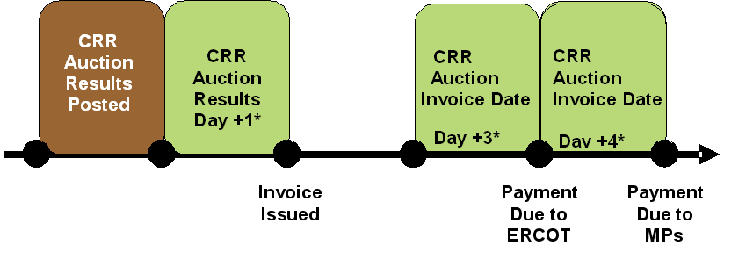
*Must be a Business Day or move to next Business Day.
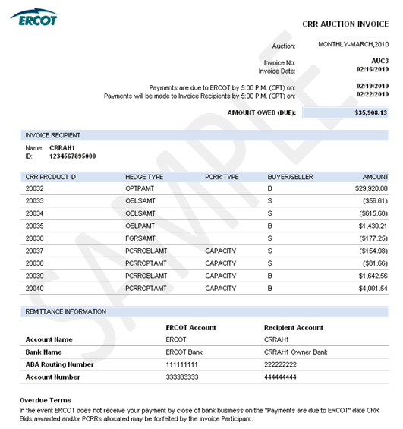

8.2.1.2 CRR Auction Revenue Distribution (CARD) Invoice
Refer to Protocol Sections 9.10, CRR Auction Revenue Distribution Invoices, and 9.11, Payment Process for CRR Auction Revenue Distribution, for details regarding CRR Auction Revenue Distribution (CARD) invoicing. The ‘Time Period’ label on the Invoice indicates the month relevant to the CRR Auction revenue being paid out to QSEs.
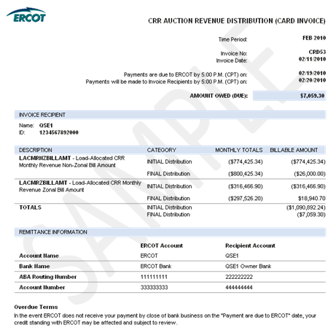

8.2.1.3 CRR Balancing Account (CRRBA) Invoice
Refer to Protocol Sections 9.12, CRR Balancing Account Invoices, and 9.13, Payment Process for CRR Balancing Account, for details regarding CCR Balancing Account (CRRBA) invoicing. The “Time Period” label on the Invoice indicates the month relevant to the balancing account funds being paid out to CRRAHs and/or QSEs.
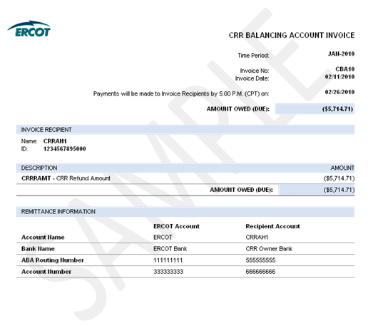

8.2.2 Day-Ahead Market Statements
The DAM statements for CRR Account Holders and QSEs are issued two days after the Operating Day.
Refer to Protocol Section 9.2, Settlement Statements for the Day-Ahead Market, for details regarding DAM Settlement Statements.

DAM Statement Timeline
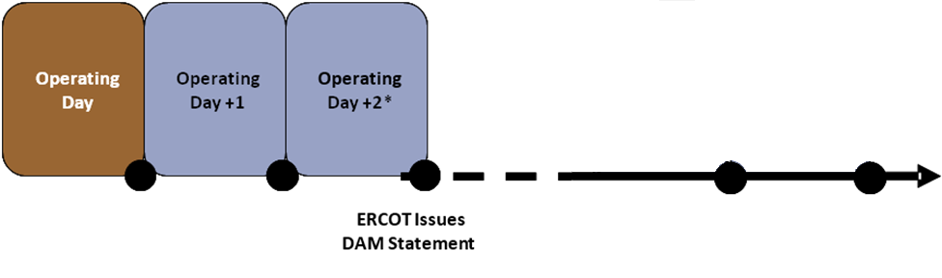
*Must be a Business Day or move to next Business Day.

8.2.2.1 DAM Statement
Refer to Protocol Section 9.2 for details regarding DAM Settlement Statements. In the case of a “No DAM” scenario, where DAM is not successfully executed for an Operating Day, DAM statements will not be generated or posted for that Operating Day.
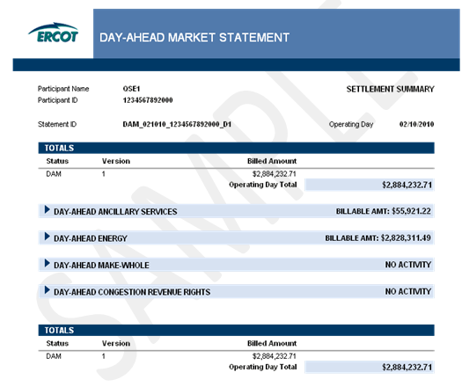

8.2.3 Real-Time Market Statements and Invoices

8.2.3.1 Real-Time Market Statements
(1) Refer to Protocol Section 9.5, Settlement Statements for Real-Time Market, for details regarding RTM Settlement Statements.
(2) There are four types of RTM Settlement Statements: Initial, Final, True-Up and Resettlement.
(3) The figure below illustrates the timing of each statement. Resettlements can occur at any point in accordance with Protocol Section 9.5.6, RTM Resettlement Statement.
RTM Statement Timeline

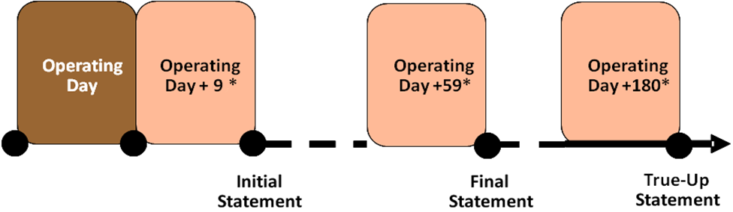
*Must be a Business Day or move to next Business Day.

8.2.3.1.1 RTM Initial Statement

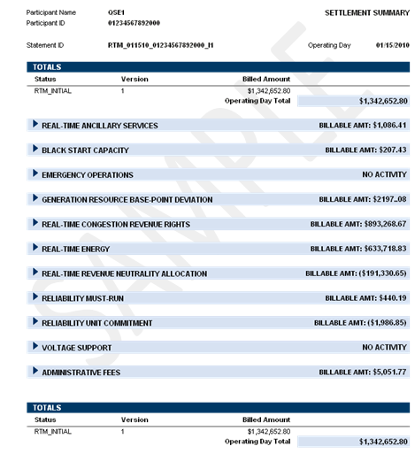

8.2.3.1.2 RTM Final Statement
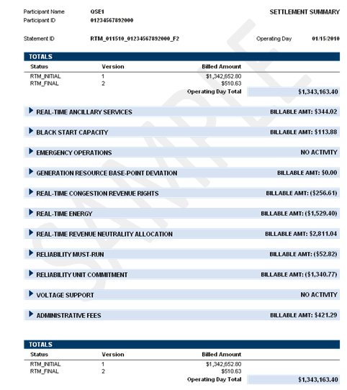

8.2.3.1.3 RTM True-Up Statement
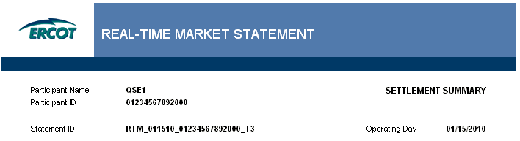
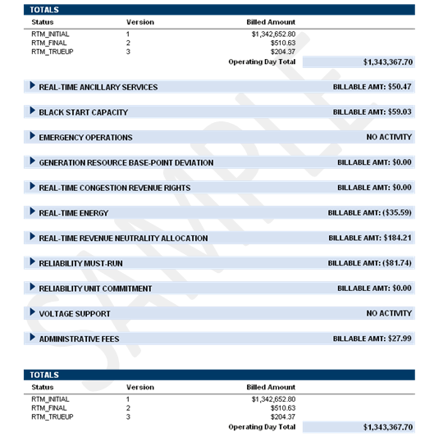

8.2.3.1.4 RTM Resettlement Statement
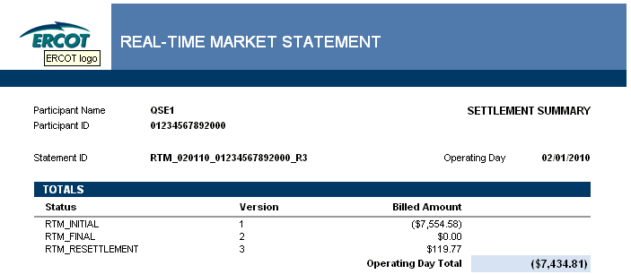
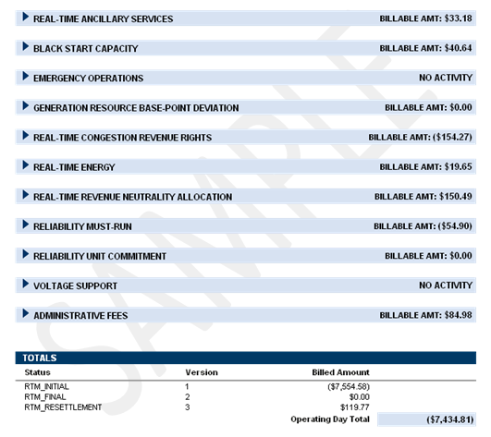

8.2.3.2 Default Uplift Invoice
(1) Refer to Protocol Sections 9.19.1, Default Uplift Invoices, and 9.19.2, Payment Process for Default Uplift Invoices, for details regarding the Default Uplift Invoicing Process. The Default Uplift Invoicing process allocates DAM and/or RTM losses to QSEs and CRR Account Holders.

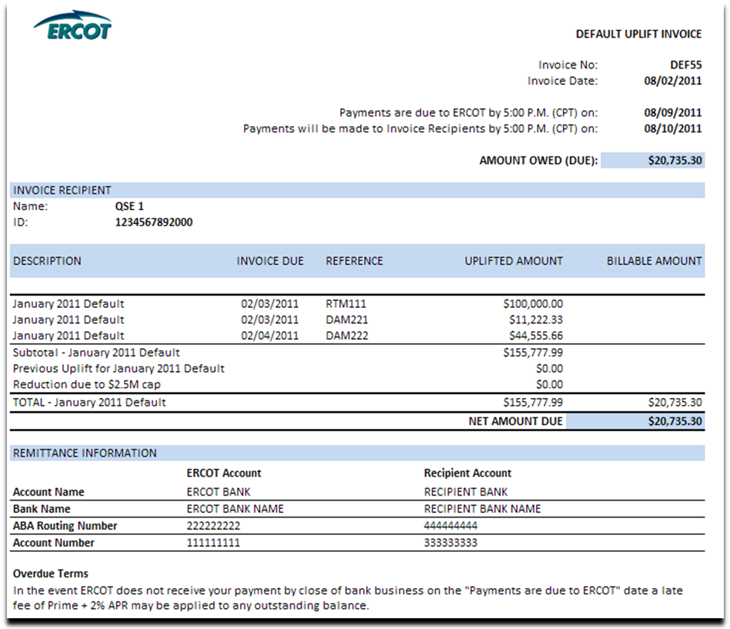

8.2.3.3 Miscellaneous Invoice
In the event that ERCOT cannot reasonably Invoice Market Participants via one of the other Protocol-defined Invoices, ERCOT may utilize the Miscellaneous Invoice. Use of the Miscellaneous Invoice would be noticed to the market and could be in support of any invoicing activity described as “ad hoc” in Section 8.1, Invoice Process, of this document. The Miscellaneous Invoice posts to the same location on MIS as other QSE/CRRAH Invoices. This Invoice is generated out of the Settlements and Billing System using data which is derived and input by analysts. The Invoice format allows for flexibility to communicate descriptive information which varies depending on the nature of the ad hoc Invoice.
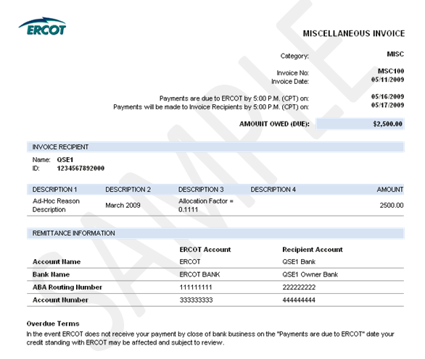

8.2.4 Combined Day-Ahead Market and Real-Time Market Invoices

8.2.4.1 Settlement Invoices
Refer to Protocol Section 9.6, Settlement Invoices for the Day-Ahead Market and Real-Time Market and Protocol Section 9.7, Payment Process for Settlement Invoices, for details regarding the DAM and RTM invoicing process. The Settlement Invoice posting on a Business Day includes Operating Days for which a DAM Statement or RTM Statement is posting on the same Business Day.
[INSERT EXAMPLE WHEN AVAILABLE]

8.2.4.2 Late Fee Invoices
Refer to Protocol Section 9.7.4, Late Fees and Late Fee Invoices for the Settlement Invoices, for details regarding the RTM late fee invoicing process. To better facilitate verification of relatively small late fee charges and credits, the late fee charge line items have greater precision than the total amount on the Late Fee Invoice.
[INSERT EXAMPLE WHEN AVAILABLE]

