SCED Up Down Availability - SAMPLE / DEMO – Data not representative.
Business Owner Suggested Name change: Capacity Available to SCED
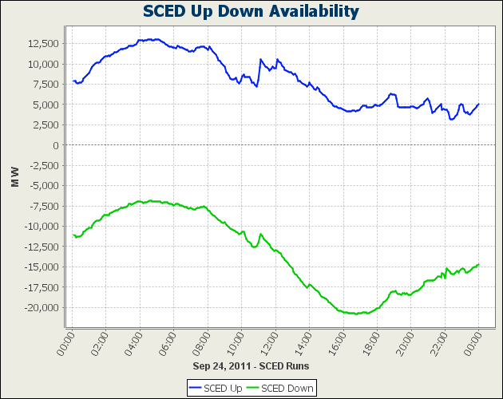

LMP Contour Map - SAMPLE / DEMO – Data not representative.
Hover over a point to see: LMP Description
Price
Other ?
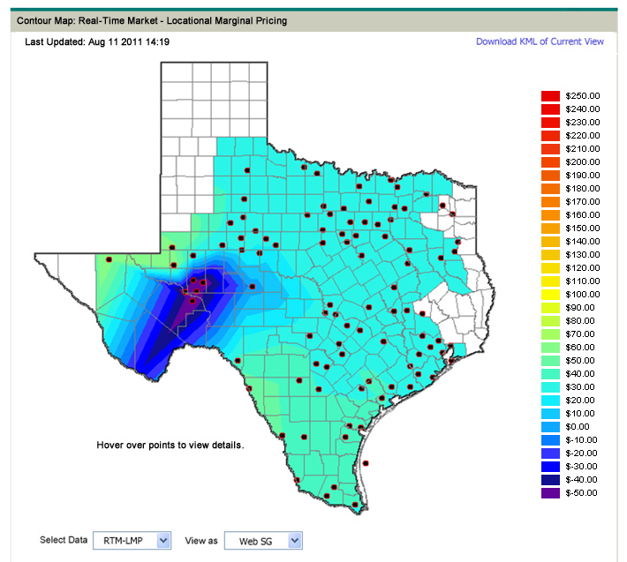

LMP Ticker - SAMPLE / DEMO – Data not representative.
Mockup of how we might update the existing Real-Time LMPs for Latest SCED Run Display and Real-Time LMPs for Load Zones and Trading Hubs Display (ERCOT.com) to provide indications of price changes in latest data in lieu of producing a ticker tape showing the same data.
(You can’t see in the screen shot below, but imagine that your cursor is pointing at the green arrow immediately above the “LZ_AEN was …” popup.)

