 |  |  |  | System Planning
Monthly Status Report
September 2011

 |  | Report Highlights
 | - ERCOT is currently tracking 185 generation interconnection requests totaling over 59,000 MW. This includes almost 34,000 MW of wind generation.
- ERCOT is currently reviewing proposed transmission improvements with a total cost of $117.9 Million
- Transmission Projects endorsed in 2011 total $579.9 Million
- All projects (in engineering, routing, licensing and construction) total approximately $9.8 Billion
- Transmission Projects energized in 2011 total about $694.8 million

Table of Contents
1. Generation Interconnection 1
1.1 New Generation Registering for Commercial Operations 1
1.2 Publicly Disclosed Generation Interconnection Projects 4
1.3 Generation Projects Undergoing Full Interconnection Studies (not otherwise public) 6
1.4 Wind Generation 8
2. Regional Planning Group Project Reviews 10
3. Congestion Costs 11
4. Wind Generation as a Percent of Load 13
5. Planning Model Activities 14
6. Other Notable Activities 15

1. Generation Interconnection
Additional information regarding detailed generation interconnection and impact studies is contained in the “Generation Project Interconnection Information” folder in the “Operations and System Planning” area on the ERCOT website: http://planning.ercot.com/login/login.

New Signed Generation Interconnection Agreements - none

New Generation Registering for Commercial Operations
11INR0075 – WA Parish Upgrade – 15 MW Coal – Fort Bend County

The total installed wind capacity is now reported as 9,452 MW by the resource owners through the registration process. Capacity by North, South and West is 292 MW, 1216 MW, and 7943 MW respectively. 850 MW is able to switch between the West and South zones.

Summary of Active Generation Interconnection Requests

GENERATION INTERCONNECTION REQUESTS CURRENTLY BEING PROCESSED
Currently tracking 185 generation interconnection or change requests
As of September 30, 2011 | North | South | West | Total
Security Screening Study | 0 | 2 | 1 | 3
SSS Completed | 2 | 7 | 21 | 30
Full Interconnect Study | 18 | 18 | 87 | 123
FIS Completed | 2 | 2 | 5 | 9
Interconnect Agreement Completed | 7 | 8 | 5 | 20
Capacity under Interconnection Agreements | 4,557 | 4,144 | 651 | 9,352
Capacity for Grid, MW | 16,671 | 11,837 | 30,935 | 59,443
Wind Capacity, MW | 3,184 | 3,098 | 27,639 | 33,921

Fuel Type | Confidential Projects (MW) | Projects Under Full Study (MW) | Projects w/ Interconnect Agreement/Public Letter (MW) | Grand Total (MW)
Gas-AllOther |  |  |  | 708
Gas-CombinedCycle |  |  | 4,732 | 11,379
Total Gas | 888 | 6,467 | 4,732 | 12,087
Nuclear |  | 5,900 |  | 5,900
Coal |  | 2,050 | 1,585 | 3,635
Wind | 3,078 | 29,238 | 1,605 | 33,921
Solar | 530 | 874 | 90 | 1,494
Biomass |  | 50 | 100 | 150
Other |  | 1,016 | 1,240 | 2,256
Grand Total | 4,496 | 45,595 | 9,352 | 59,443

Publicly Disclosed Generation Interconnection Projects
The table below summarizes the publicly disclosed generation projects for the ERCOT region.
(Status: IA=Interconnect Agreement, PL=Public Letter, XX= cancelled)
Generation Interconnections as of September 30, 2011
INR | SiteName | Status | County | Region | COD | Fuel Type |  | MW For Grid |  | Change from Last Report
06INR0012b | Sherbino Mesa Wind Farm 2 | IA | Pecos | West | Oct-11 |  | Wind |  | 150
09INR0034 | Gatesville Wind Farm | PL | Coryell | North | Dec-11 |  | Wind |  | 200
08INR0038 | M Bar Wind | PL | Andrews | West | Dec-11 |  | Wind |  | 194
10INR0082 | FRV AE Solar | IA | Travis | North | Dec-11 |  | Solar |  | 30
08INR0025 | Pistol Hill Energy Center | PL | Ector | West | Dec-11 |  | Wind |  | 300
09INR0001 | Sandy Creek 1 | IA | McLennan | North | Feb-12 |  | Coal |  | 925
11INR0084 | 2W Whatley Phase 1 | PL | Ector | West | Mar-12 |  | Wind |  | 45
08INR0062 | Trinity Hills | IA | Young | West | Mar-12 |  | Wind |  | 250
09INR0037 | Scurry County Wind III | PL | Scurry | West | Jun-12 |  | Wind |  | 350
09INR0024 | B&B Panhandle Wind | PL | Carson | West | Jun-12 |  | Wind |  | 1,001
09INR0007 | Nacogdoches Project | IA | Nacogdoches | North | Jun-12 |  | Biomass |  | 100
10INR0060 | Magic Valley Wind Project | IA | Willacy | South | Jun-12 |  | Wind |  | 202
12INR0043 | 2W Whatley Phase 2 | PL | Ector | West | Aug-12 |  | Wind |  | 290
11INR0086 | RRE Austin Solar | IA | Travis | South | Oct-12 |  | Solar |  | 60
12INR0080 | Blanco Canyon Wind | PL | Taylor | West | Dec-12 |  | Wind |  | 300
10INR0077 | Kaiser Creek Windfarm | IA | Callahan | West | Dec-12 |  | Wind |  | 101
09INR0061 | WKN Mozart | IA | Kent | West | Dec-12 |  | Wind |  | 30
08INR0011 | Senate Wind Project | IA | Jack | North | Dec-12 |  | Wind |  | 150
08INR0018 | Gunsight Mountain | IA | Howard | West | Dec-12 |  | Wind |  | 120
11INR0033 | Los Vientos | IA | Cameron | South | Dec-12 |  | Wind |  | 400
06INR0022c | Penascal Wind Farm 3 | IA | Kenedy | South | Dec-13 |  | Wind |  | 202
10INR0020a | Panda Temple Power | IA | Bell | North | May-14 |  | Gas-CC |  | 780
06INR0006 | Cobisa-Greenville | IA | Hunt | North | May-14 |  | Gas-CC |  | 1,792
14INR0005 | White Stallion Energy Center | PL | Matagorda | South | Jul-14 |  | Coal |  | 1,200
10INR0020b | Panda Temple Power | IA | Bell | North | May-15 |  | Gas-CC |  | 780
10INR0022 | Pondera King Power Project | IA | Harris | South | Jun-15 |  | Gas-CC |  | 1,380
12INR0016a | Las Brisas Energy Center | IA | Nueces | South | Oct-15 |  | Other |  | 620
15INR0008 | STP 3 and 4 | PL | Matagorda | South | Jun-16 |  | Nuclear |  | 2,700
12INR0016b | Las Brisas Energy Center | IA | Nueces | South | Oct-16 |  | Other |  | 620
14INR0002 | Coleto Creek Unit 2 | IA | Goliad | South | Jan-17 |  | Coal |  | 660
15INR0002 | Comanche Peak 3 and 4 | PL | Somervel | North | Dec-21 |  | Nuclear |  | 3,200
 |  |  |  |  | TOTAL |  |  |  | 19,132

County Location of Installed Generation and Interconnection Requests (all fuels)

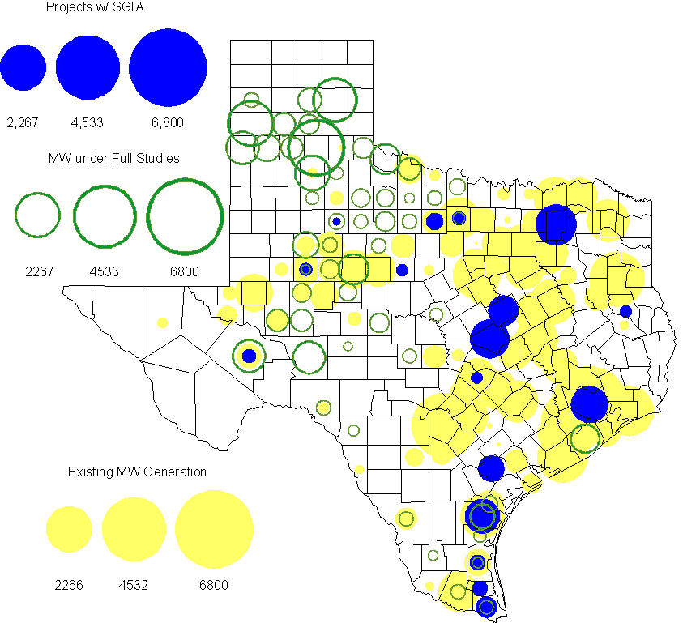

Generation Projects Undergoing Full Interconnection Studies (not otherwise public)

INR | County | Capacity | COD | Fuel |  | INR | County | Capacity | COD | Fuel
09INR0054 | Stonewall | 149 | TBD | Wind |  | 10INR0048 | Hardeman | 1,000 | TBD | Wind
10INR0079 | Nolan | 60 | TBD | Wind |  | 10INR0016 | Childress | 150 | TBD | Wind
10INR0029 | Hood | 810 | TBD | Gas |  | 10INR0013 | Upton | 400 | TBD | Wind
10INR0041 | Floyd | 135 | TBD | Wind |  | 11INR0029 | Throckmorton | 200 | TBD | Wind
10INR0051 | Brazoria | 200 | TBD | Wind |  | 10INR0042 | Mason | 170 | TBD | Wind
10INR0033 | Armstrong | 399 | TBD | Wind |  | 10INR0032 | Navarro | 775 | TBD | Gas
10INR0019 | Deaf Smith | 609 | TBD | Wind |  | 11INR0076 | Archer | 94 | TBD | Wind
11INR0085 | Nolan | 106 | TBD | Wind |  | 11INR0062 | Nueces | 149 | TBD | Wind
11INR0061 | Presidio | 90 | TBD | Solar |  | 11INR0060 | Tom Green | 90 | TBD | Solar
11INR0058 | Pecos | 135 | TBD | Solar |  | 11INR0037 | Smith | 50 | TBD | Biomass
11INR0091 | Webb | 92 | TBD | Wind |  | 11INR0065 | Nueces | 240 | TBD | Wind
11INR0054 | San Patricio | 161 | TBD | Wind |  | 10INR0023 | Haskell | 386 | TBD | Wind
09INR0050 | Fannin | 1,200 | TBD | Gas |  | 11INR0006 | Lamar | 579 | TBD | Gas
11INR0040 | freestone | 640 | TBD | Gas |  | 11INR0079a | Clay | 200 | TBD | Wind
11INR0047 | Deaf Smith | 600 | TBD | Wind |  | 10INR0062a | Pecos | 80 | TBD | Wind
11INR0094 | Kent | 100 | Nov-11 | Solar |  | 11INR0090 | Howard | 60 | Nov-11 | Solar
10INR0021 | Grayson | 646 | Nov-11 | Gas |  | 11INR0043 | Coke | 300 | Dec-11 | Wind
11INR0025 | Crockett | 400 | Dec-11 | Wind |  | 12INR0081 | Upton | 113 | Dec-11 | Wind
12INR0033 | Motley | 150 | Jan-12 | Wind |  | 10INR0085 | Ector | 40 | Jan-12 | Solar
10INR0080 | Presidio | 81 | Jan-12 | Solar |  | 12INR0054 | Jones | 200 | Feb-12 | Wind
10INR0018 | Madison | 550 | Mar-12 | Gas |  | 12INR0075 | Wilbarger | 499 | Apr-12 | Wind
09INR0031 | Ector | 275 | May-12 | Gas |  | 12INR0053 | Crockett | 615 | Jun-12 | Wind
08INR0031 | Childress | 100 | Jun-12 | Wind |  | 12INR0050 | King | 332 | Jun-12 | Wind
12INR0079 | Kenedy | 94 | Aug-12 | Wind |  | 12INR0076 | Winkler | 36 | Sep-12 | Other
12INR0026 | Randall | 400 | Oct-12 | Wind |  | 12INR0035 | Nueces | 249 | Nov-12 | Wind
08INR0044 | Concho | 200 | Nov-12 | Wind |  | 13INR0036 | Hidalgo | 200 | Dec-12 | Wind
12INR0072 | Kinney | 100 | Dec-12 | Wind |  | 12INR0069 | Presidio | 50 | Dec-12 | Solar
12INR0068 | Jim Hogg | 80 | Dec-12 | Wind |  | 12INR0067 | Webb | 94 | Dec-12 | Wind
12INR0060 | Schleicher | 58 | Dec-12 | Wind |  | 12INR0059 | Pecos | 50 | Dec-12 | Solar
12INR0057 | Ector | 50 | Dec-12 | Solar |  | 12INR0055 | Baylor | 80 | Dec-12 | Wind
12INR0005 | Floyd | 1,100 | Dec-12 | Wind |  | 11INR0093 | San Patricio | 34 | Dec-12 | Wind
09INR0025 | Concho | 180 | Dec-12 | Wind |  | 12INR0029 | Swisher | 500 | Dec-12 | Wind
09INR0048 | Jack | 113 | Dec-12 | Wind |  | 08INR0049 | Clay | 50 | Dec-12 | Wind
13INR0040 | Harris | 0 | Jan-13 | Gas |  | 12INR0027 | Gray | 200 | Jan-13 | Wind
10INR0024 | Briscoe | 2,940 | Jan-13 | Wind |  | 13INR0010a | Parmer | 200 | Jan-13 | Wind
12INR0034 | Borden | 342 | Mar-13 | Wind |  | 11INR0083B | Crockett | 100 | Mar-13 | Wind
11INR0082B | Val Verde | 150 | Mar-13 | Wind |  | 11INR0050 | Crosby | 149 | Mar-13 | Wind
12INR0018 | Gray | 500 | Apr-13 | Wind |  | 12INR0070 | Knox | 300 | Apr-13 | Wind
13INR0020a | Glasscock | 200 | May-13 | Wind |  | 10INR0089 | Harris | 40 | May-13 | Other
10INR0062b | Pecos | 220 | May-13 | Wind |  | 12INR0045 | Kleberg | 135 | Jun-13 | Wind
09INR0051 | Borden | 249 | Jun-13 | Wind |  | 13INR0023 | Ector | 240 | Jul-13 | Other
13INR0016 | Deaf Smith | 251 | Aug-13 | Wind |  | 13INR0025 | Randall | 150 | Sep-13 | Wind
11INR0083A | Crockett | 50 | Sep-13 | Wind |  | 11INR0082A | Val Verde | 50 | Sep-13 | Wind
13INR0005 | Carson | 600 | Oct-13 | Wind |  | 13INR0004 | Deaf Smith | 500 | Oct-13 | Wind
13INR0028 | Hale | 392 | Nov-13 | Gas |  | 13INR0039 | Castro | 500 | Dec-13 | Wind
13INR0030 | Archer | 100 | Dec-13 | Wind |  | 13INR0026 | Oldham | 201 | Dec-13 | Wind
13INR0017 | Childress | 200 | Dec-13 | Wind |  | 13INR0007 | Pecos | 200 | Dec-13 | Wind
12INR0002a | Briscoe | 200 | Dec-13 | Wind |  | 11INR0013 | Mills | 150 | Dec-13 | Wind
10INR0009 | Castro | 300 | Dec-13 | Wind |  | 09INR0077 | Reagan | 500 | Dec-13 | Wind
12INR0058 | San Patricio | 50 | Dec-13 | Wind |  | 11INR0057 | Cameron | 165 | Dec-13 | Wind
09INR0073 | Scurry | 200 | Dec-13 | Wind |  | 12INR0085 | Stonewall | 25 | Dec-13 | Wind
13INR0006 | Gray | 750 | Jan-14 | Wind |  | 08INR0019c | Gray | 250 | Jan-14 | Wind
08INR0019b | Gray | 250 | Jan-14 | Wind |  | 08INR0019a | Gray | 250 | Jan-14 | Wind
13INR0010b | Parmer | 500 | Jan-14 | Wind |  | 12INR0063 | Uvalde | 90 | Apr-14 | Solar
13INR0020b | Glasscock | 150 | May-14 | Wind |  | 10INR0015 | Mitchell | 350 | May-14 | Wind
14INR0003 | Nolan | 850 | Jun-14 | Coal |  | 12INR0042 | Deaf Smith | 400 | Sep-14 | Wind
14INR0006 | Floyd | 151 | Oct-14 | Wind |  | 14INR0009 | Kent | 248 | Dec-14 | Wind
14INR0001 | Pecos | 500 | Dec-14 | Wind |  | 13INR0021 | Llano | 600 | Dec-14 | Gas
12INR0002b | Briscoe | 200 | Dec-14 | Wind |  | 13INR0010c | Parmer | 500 | Jan-15 | Wind
15INR0011b | Borden | 38 | Dec-15 | Solar |  | 15INR0011a | Borden | 112 | Dec-15 | Wind
12INR0002c | Briscoe | 350 | Dec-15 | Wind |  | 16INR0002 | Brazoria | 700 | Jun-17 | Other

Wind Generation
Wind Capacity Installed by Year

County Location of Installed Capacity and Interconnection Requests (Wind only)

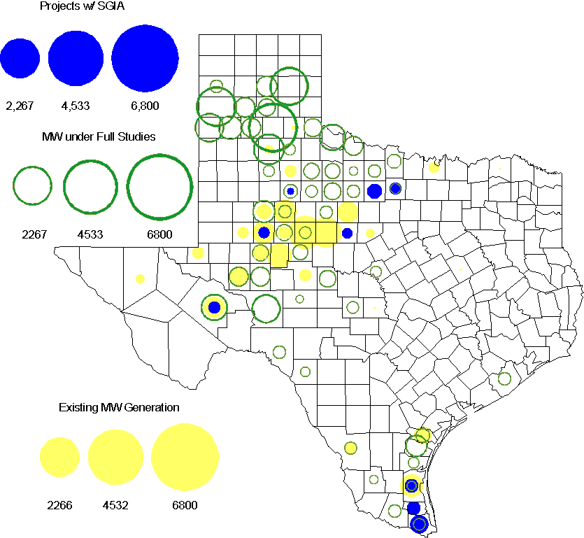

Regional Planning Group Project Reviews

- CenterPoint Energy submitted the 2014 Houston Area Dynamic Reactive Project to address the need for additional dynamic reactive compensation in the Houston area. This project calls for dynamic reactive devices at two locations (on the CenterPoint’s transmission system), with the compensation devices to be in service before summer peak 2014. The approximate cost for this project is $125 Million, depending on the selected dynamic reactive device technology. This Tier 1 project has completed the ERCOT Independent Review. Through the course of the review the project scope was changed and the revised project capital cost estimate has been reduced to $11 million. Accordingly, ERCOT has reclassified it as a Tier 2 project and accepted the revised project.

- American Electric Power Service Corporation has submitted the Laredo to the lower Rio Grande Valley 345 kV Project to improve reliability of the lower Rio Grande Valley transmission system. This project proposes a new 345kV transmission line to be constructed from Laredo to the lower Rio Grande Valley to provide a third 345kV source to the area with an in-service date of 2016. The estimated cost for this project is $525 Million. This Tier 1 project has completed the ERCOT Independent Review. The project was approved and endorsed by the ERCOT BOD on September 20, 2011.

- Sharyland Utilities (Sharyland) and Brownsville Public Utilities Board (BPUB) has submitted the Cross Valley Brownsville Loop project that proposes a new 345kV line from LaPalma to Loma Alta and a new 345kV line from Loma Alta to Frontera. The estimated cost for this project is $117.9 Million. This Tier 1 project is undergoing ERCOT Independent Review. Sharyland and BPUB submitted an study addendum report to the Cross valley project with additional options which is is currently undergoing ERCOT Independent Review.

Congestion Costs
Dollars shown in RUC Make Whole payment graph are settlement quality.

OOMC and RUC net Make Whole payment in million$

Monthly Average MCPE and LMP
Binding Constraints - September 2011
Contingency | Binding Element | Number of 5-min intervals | Shadow Price Range $/MWh | Estimated Congestion Cost $ (Shadow Price*Limit) | Transmission Project | Comments
Roans prairie - Kuykendahl - King & Singleton - Tomball 345kV | Singleton - Zenith 345kV | 486 | 0 - 4500 | 18,214,350 | Zenith to Fayetteville 345kV project [14TPIT0002] | Outage on Singleton - Zenith 345kV
Fayette - Lytton Springs and Fayette - Holman 345kV | Fayetteville 345/138kV Auto 2 | 1371 | 0 - 4500 | 7,105,005 | Zenith to Fayetteville 345kV project [14TPIT0002] | Outage on FPP Plant 1 – Lost Pines 345kV and 15 other lines due to Bastrop fires.
Austrop - Lost Pines 345kV | Fayette 1 - Fayette 2 345kV | 58 | 0 - 4500 | 4,083,734 | Zenith to Fayetteville 345kV project [14TPIT0002] | Outage on FPP Plant 1 – Lost Pines 345kV and 15 other lines due to Bastrop fires.
Amoco North Cowden Tap - North Cowden Amoco 138kV | Odessa North 138/69kV Auto | 375 | 0 - 2800 | 2,958,621 | 5YTP [2010-R7, R8]
Rodd Field - Barney Davis 138kV | Airline - Cabaniss 138kV | 100 | 0 - 3500 | 1,925,897 |  | Barney Davis – Alazan – Nelson sharpe 138kV outage caused the deactivation of B_Davis SPS.
BASE CASE | West to North Stability Limit | 459 | 1 - 81 | 1,817,331 | CREZ
Fayette - Lytton Springs and Fayette - Holman 345kV | Bellville South - Peters Reit 138kV | 294 | 0 - 3500 | 1,755,580 |  | Outage on FPP Plant 1 – Lost Pines 345kV and 15 other lines due to Bastrop fires.
Formosa - Lolita 138 kV | Victoria - Victoria Dupont Switch 138kV | 37 | 0 - 3500 | 1,694,161 |  | Generation unit outage
Greens Bayou - Gable and Hardy - Crocket 138kV, Singleton - Tomball and Singleton - Roanes Prairie 345kV | Garrott - Midtown 138kV | 289 | 0 - 3500 | 1,557,670 | Upgrade 138 kV underground Ckt. 90 Garrott to Midtown to Polk [11TPIT0072]
Dyann - Caney Creek138kV | Lane City - Blessing 138kV | 173 | 0 - 3500 | 1,492,532 |  | Outage on Pledger - New Gulf 138 kV line
Binding Constraints - January to September 2011
Contingency | Binding Element | Number of 5-min intervals | Shadow Price Range $/MWh | Estimated Congestion Cost $ (Shadow Price*Limit) | Transmission Project
BASE CASE | West to North Stability Limit | 17059 | 0 - 3910 | 76,993,957 | CREZ
BASE CASE | Valley Import | 273 | 0 - 5000 | 41,457,339
Nelson Sharpe - Ajo 345kV | Lon Hill - North Edinburg 345kV | 78 | 0 - 4500 | 31,689,757
Denton - Argyle & West Denton 138kV,  Fort Worth - W_Dent 138kV | West Denton - Jim Cristal 138kV | 474 | 0 - 3500 | 25,219,060 | 5YTP [2010-R12]
Roans prairie - Kuykendahl - King & Singleton - Tomball 345kV | Singleton - Zenith 345kV | 1186 | 0 - 4500 | 20,173,205 | Zenith to Fayetteville 345kV project [14TPIT0002]
Amoco North Cowden Tap - North Cowden Amoco 138kV | Odessa North 138/69kV Autotransformer | 1901 | 0 - 2800 | 15,248,987 | 5YTP [2010-R7, R8]
Lewisville Switch 345/138kV Auto,  Lewisville Switch - Carrollton Northwest 345kV | Carrollton Northwest - Lakepointe 138kV | 444 | 0 - 3500 | 15,137,927 | Upgrade NW Carrollton - Lakepointe (TNMP) 138 kV line [14TPIT0014]
BASE CASE,  Zorn - Marion and Clear Springs 345kV,  Clear Springs 345/138kV Autotransformer | Marion 345/138kV Autotransformer | 391 | 0 - 4500 | 13,826,062
Greens Bayou - Gable and Hardy - Crocket 138kV,  Singleton - Tomball and Singleton - Roanes Prairie 345kV,  Meadow - Oasis 345kV,  Thermal Energy Coop - Blodgett 138kV,  W.A. Parish - Obrien 345kV | Garrott - Midtown 138kV | 4391 | 0 - 3500 | 13,255,718 | Upgrade 138 kV underground Ckt. 90 Garrott to Midtown to Polk [11TPIT0072]
Abilene South - Bluff Creek 138kV,  Bluff Creek Auto T2_H & T2_L & T2_T | Nicole - Oak Creek 138kV | 8881 | 0 - 3500 | 11,113,649 | CREZ

Wind Generation as a Percent of Load
One-hour average of total wind power output as a percentage of ERCOT load.
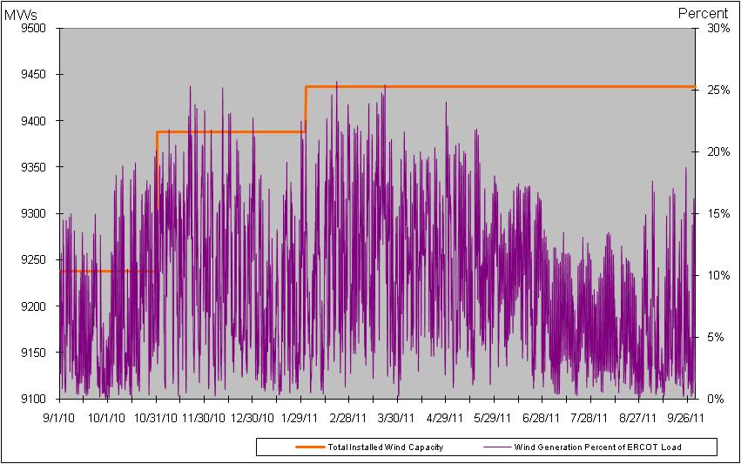

Planning Model Activities
- Work on Data Set A has been completed. Data Set B work has begun and has started one week late. The remaining schedule is as follows:
  - Aug 4, 2011 DSA cases finalized and posted (delayed from July 15)
  - Aug 26, 2011 DSA Final Comparison posted (delayed from Aug 1)
  - Aug 8, 2011 DSB Case Build started (delayed from Aug 1)
  - Oct 14, 2011 DSB cases finalized and posted (delayed from Oct 7)
  - Oct 28, 2011 DSB Final Comparison posted (projected on-time)
- Status update on SCR760, Changes Needed for Information Model Manager and Topology Processor for Planning Models, which was approved by the ERCOT Board in March 2011.
  - Bundle 1 (Items 3, 7 and 8): Release received and tested. Defect fixes underway. Also received updated TP Enhancement and PSSE/IMM Mapping documents. Anticipate production date of October 17th.
  - Bundle 2 (Items 2, 4, 9): SOW signed by both Vendor and ERCOT. Expected code release in late November 2011 with production date of February 2012 on-cycle release. A Project Change Request is underway for Item 2 to allow additional functionality requested by TSPs. Requirements complete and sent to Vendor for review.
  - Item 5: Requirements completed by ERCOT and TSPs. Sent to Vendor for estimate.
  - Bundle 3 (Items 1 and 6): ERCOT and TSPs are updating document to identify new fields or records added between version 33 and version 30 of the PSS/E RAWD format. Began creating the envaluation process for Item 1 that would be added to SSWG Procedure Manual.
SCR Sub Part | SCR Description | Status
SCR760-1 | Upgrade to PSS/E v32 | Planning
SCR760-2 | Distribution Capacitor banks | Planning
SCR760-3 | Zero Impedance Line Ratings | Release
SCR760-4 | Associate Loads and Capacitor banks with the correct CNG | Planning
SCR760-5 | Additional Transformer Data for Planning | Planning
SCR760-6 | FACTS Devices | Submitted
SCR760-7 | Assign valid PSSE IDs to Breakers/  Switches/ Series Devices | Release
SCR760-8 | Phase shift of Autos for short circuit studies | Release
SCR760-9 | Multisection Line Grouping | Planning
Table 1: In the following table:
- Red will be used to show status of Not Submitted, meaning that the SCR sub part has not been submitted to Siemens as a Service Request.
- Yellow will indicate that the SCR sub part has been submitted. The color will remain yellow and the status will change in order to Submitted, Planning (Requirements, SOW, Code Writing), Release (Siemens produces first code to test), and Testing (code has completed internal test and is moving through release management).
- Green will indicate that the code has been tested and installed on the machines that ERCOT uses to produce Topology Processor output for Planning and CRR.

Other Notable Activities
- UFLS Assessment Study as required by NERC PRC-006 is in progress.
- DFW Dynamic Reactive Reserve Study is in progress.
- A LAARs Assessment study has started, looking into potential increase in LAARs percentage of total responsive reserve.
- Work on the 2011 Five-Year Transmission Plan is underway. The 5YTP start cases (condition the SSWG base cases) are completed for 2012, 2014 and 2016 and posted. The results and base cases for the reliability assessement with initial set of projects (for 2012, 2014 and 2016) was posted on September 23, 2011.
- A Resource Integration, Registration and Modeling Workshop was held on September 27, 2011 at ERCOT Met Center location. The workshop was intended for Resource Entities, Transmission Service Providers, and ERCOT to discuss resource data received through the Resource Asset Registration Form (RARF). ERCOT presented an introduction to the modeling process, the RARF Process, and possible new Fields and Tabs that will be added to the RARF. Transmission Service Providers from the SSWG, DWG, SPWG, and NDSWG presented information relative to their specific use of RARF data in their respective study cases and the importance of accurate information. It is anticipated that much of the information provided will be added to the Resource Registration Guide to help RE’s provide the data needed for the various ERCOT models.

