NPRR Number | 351 | NPRR Title | Calculate and Post Projected Non-Binding LMPs for the Next 15 Minutes
Date |  | September 21, 2011
Submitter’s Information
Name |  | John Dumas
E-mail Address |  | jdumas@ercot.com
Company |  | ERCOT
Phone Number |  | 512.248.3195
Market Segment |  | Not applicable

Comments

As ERCOT has worked to assess the costs, benefits, and risks to develop a future-looking market and pricing analysis as proposed in Nodal Protocol Revision Request (NPRR) 351 (Option 1), ERCOT has evaluated an alternative as “Option 2” which is explained and compared below to Option 1. ERCOT also offers initial draft language that aligns Option 2 with the Protocols if considered by PRS.

OPTION 1

ERCOT recognizes the benefits of Option 1 and has completed the Impact Analysis reflecting implementation of an enhanced Security-Constrained Economic Dispatch (SCED) that re-runs after each production SCED and publishes a snapshot of prices to reflect 15-minute future Locational Marginal Prices (LMPs) based on the Load forecast and Resource ramping extended over a 15-minute period. These indicative prices may encourage passive Load response and/or encourage Quick Start Generation Resources (QSGRs) to come On-Line.

This implementation would utilize EMS/MMS resources for development and the work cannot be leveraged for the longer-term Look-Ahead SCED effort.

Inputs and calculations:
Current On-Line Resources, offer curves, telemetered ramp rates
Calculate Load forecast 15-minutes in the future
Extend telemetered ramp rate across 15-minutes into the future while respecting HASL/HSL/LASL/LSL

RTM Execution:
Create current/binding SCED prices and Dispatch (as done today)
Execute second SCED iteration to calculate and post 15-minute future LMPs using 15-minute forecast and 15-minute ramps.
Post single report of LMPs for SCEDTimeStamp=currentSCED+15 minutes

See graphic for overview of Option 1:

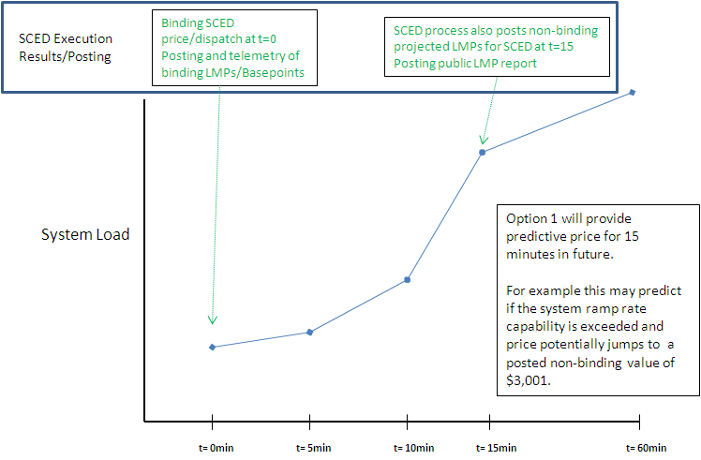

OPTION 2

Alternatively ERCOT has evaluated Option 2 for implementing a “Phase1” Look-Ahead SCED in 2012 with baseline functionality for optimizing prices and Dispatch of Resources across an evaluation period of one hour. Although the total scope of Look-Ahead SCED is broad, this proposal would be to implement only Phase 1 scope as a production stepping-stone towards the longer-term improvements (such as short-term Resource commitment, Real-Time Ancillary Service co-optimization, etc). With a focused effort ERCOT believes that a one-hour optimization of prices and Dispatch could be implemented in 2012 and open the door to potentially incorporating Load participation as a pilot.

Using inputs and calculations:
Current On-Line Resources, offer curves, telemetered ramp rates
Calculate Load forecast for every five minutes for one hour into future
Extend telemetered ramp rate across hour into future while respecting current HASL/HSL/LASL/LSL

RTM Execution:
New Phase 1 Look-Ahead SCED would optimize On-Line Resources, offers, and consider ramp rates to create optimal energy Dispatch solution to meet the Load forecast for all five minute intervals of the next sixty minutes. The solution for the first interval would be binding, and all remaining future intervals would be indicative of where prices and Dispatch are headed at that point in time.
Not included in this optimization for future intervals:
- Changes in outages/topology
- Quick Start commitment
- A/S co-optimization
- Temporal constraints for Load Resources/Demand Response (minimum deploy time)
- Detailed modeling of changes in ramp rates with the movement of the Resource to different operating levels
- These could be added in a later phases, but scope is streamlined to simplify initial implementation
Posting and telemetry of prices and Base Points for current binding SCED interval (as currently done)
Post public report of all LMPs for all intervals in future hour.
Post on MIS Certified the Base Points for all intervals in the future for the Qualified Scheduling Entity’s (QSE’s) Resource(s).

See graphic for overview of Option 2:

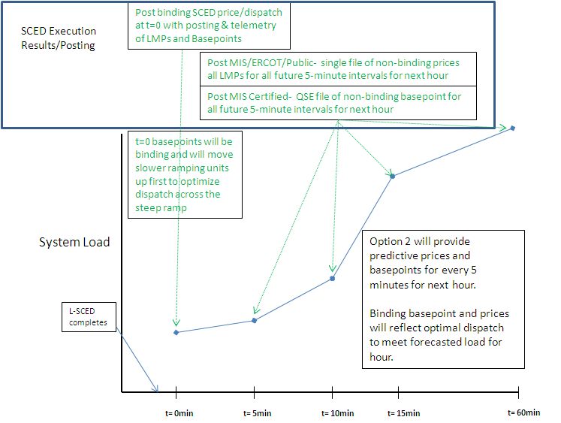

Using the language from the August 18, 2011 PRS Report, ERCOT offers revisions reflecting the expansion of the Option 2 capabilities.

Revised Proposed Protocol Language
6.3.2 Activities for Real-Time Operations
(1) Activities for Real-Time operations begin at the end of the Adjustment Period and conclude at the close of the Operating Hour.
(2) The following table summarizes the timeline for the Operating Period and the activities of QSEs and ERCOT during Real-Time operations where “T” represents any instant within the Operating Hour. The table is intended to be only a general guide and not controlling language, and any conflict between this table and another section of the Protocols is controlled by the other section:
Operating Period | QSE Activities | ERCOT Activities
During the first hour of the Operating Period |  | Execute the Hour-Ahead Sequence, including HRUC, beginning with the second hour of the Operating Period  Review and communicate HRUC commitments  Snapshot the Scheduled Power Consumption for Controllable Load Resources
Before the start of each SCED run | Update Output Schedules for DSRs | Validate Output Schedules for DSRs  Execute Real-Time Sequence
SCED run |  | Execute SCED
During the Operating Hour | Telemeter the Ancillary Service Resource Responsibility for each Resource  Acknowledge receipt of Dispatch Instructions  Comply with Dispatch Instruction  Review Resource Status to assure current state of the Resources is properly telemetered  Update COP with actual Resource Status and limits and Ancillary Service Schedules  Communicate Resource Forced Outages to ERCOT  Communicate to ERCOT Resource changes to Ancillary Service Resource Responsibility via telemetry in the time window beginning 30 seconds prior to the five-minute clock interval and ending ten seconds prior to that five-minute clock interval | Communicate all binding Base Points, Dispatch Instructions and LMPs for energy and Ancillary Services using Inter-Control Center Communications Protocol (ICCP) or Verbal Dispatch Instructions (VDIs)  Monitor Resource Status and identify discrepancies between COP and telemetered Resource Status  Restart Real-Time Sequence on major change of Resource or Transmission Element Status  Monitor ERCOT total system capacity providing Ancillary Services  Validate COP information  Monitor ERCOT control performance  Distribute by ICCP, and post on the MIS Public Area, the LMPs created by each binding SCED process for each Resource Node. These prices shall be posted immediately subsequent to deployment of Base Points from SCED with the time stamp the prices are effective  Post Hub LMP, Load Zone LMP, and LMPs for each Electrical Bus on the MIS Public Area. These prices shall be posted immediately subsequent to deployment of Base Points from each binding SCED with the time stamp the prices are effective  Post on the MIS Public Area the projected non-binding LMPs created by each SCED process for each Resource Node, the projected Hub LMPs and Load Zone LMPs. These projected prices shall be posted immediately subsequent to deployment of binding Base Points from SCED with the time stamp of the SCED process that produced the projections  Post on the MIS Certified Area the projected non-binding Base Points for each Resource created by each SCED process. These projected non-binding Base Points shall be posted immediately subsequent to deployment of binding Base Points from SCED with the time stamp of the SCED process that produced the projections  Post each hour on the MIS Public Area binding SCED Shadow Prices and active binding transmission constraints by Transmission Element name (contingency /overloaded element pairs)  Post the Settlement Point Prices for each Settlement Point immediately following the end of each Settlement Interval  Post parameters as required by Section 6.4.8, Ancillary Services Capacity During the Adjustment Period and in Real-Time, on the MIS Secure Area

(3) At the beginning of each hour, ERCOT shall post on the MIS Public Area the following information:
(a) Changes in ERCOT System conditions that could affect the security and dynamic transmission limits of the ERCOT System, including:
(i) Changes or expected changes, in the status of Transmission Facilities as recorded in the Outage Scheduler for the remaining hours of the current Operating Day and all hours of the next Operating Day; and
(ii) Any conditions such as adverse weather conditions as determined from the ERCOT-designated weather service;
(b) Updated system-wide Load forecasts;
(c) The quantities of Reliability Must-Run (RMR) Services deployed by ERCOT for each previous hour of the current Operating Day;
(d) Total ERCOT System Demand, from Real-Time operations, integrated over each Settlement Interval; and
(e) Updated Electrical Bus Load distribution factors and other information necessary to forecast Electrical Bus Loads for each hour of the current Operating Day and all hours of the next Operating Day.
6.5.7.3 Security Constrained Economic Dispatch
(1) The SCED process is designed to simultaneously manage energy, the system power balance and network congestion through Resource Base Points and calculation of LMPs every five minutes. The SCED process uses a two-step methodology that applies mitigation prospectively to resolve network Non-Competitive Constraints for the current Operating Hour. The SCED process evaluates Energy Offer Curves and Output Schedules to produce a least cost dispatch of On-Line Generation Resources to the total current generation requirement determined by LFC, subject to power balance and network constraints. The SCED process uses the Resource Status provided by SCADA telemetry under Section 6.5.5.2, Operational Data Requirements, and validated by the Real-Time Sequence, instead of the Resource Status provided by the COP.
[NPRR257: Replace paragraph (1) above with the following upon system implementation:]
(1) The SCED process is designed to simultaneously manage energy, the system power balance and network congestion through Resource Base Points and calculation of LMPs every five minutes. The SCED process uses a two-step methodology that applies mitigation prospectively to resolve Non-Competitive Constraints for the current Operating Hour. The SCED process evaluates Energy Offer Curves and Output Schedules to produce a least cost dispatch of On-Line Generation Resources to the total current generation requirement determined by LFC, subject to power balance and network constraints. The SCED process uses the Resource Status provided by SCADA telemetry under Section 6.5.5.2, Operational Data Requirements, and validated by the Real-Time Sequence, instead of the Resource Status provided by the COP.

(2) The SCED solution must monitor cumulative deployment of Regulation Services and ensure that Regulation Services deployment is minimized over time.
(3) For use as SCED inputs, ERCOT shall use the available capacity of all committed Generation Resources by creating proxy Energy Offer Curves for certain Resources as follows:
(a) Non-WGRs and Dynamically Scheduled Resources (DSRs) without Energy Offer Curves
ERCOT shall create a monotonically increasing proxy Energy Offer Curve as described below for:
(i) Each non-WGR for which its QSE has submitted an Output Schedule instead of an Energy Offer Curve; and
(ii) Each DSR that has not submitted Incremental and Decremental Energy Offer Curves.
MW | Price (per MWh)
HSL | System-Wide Offer Cap (SWCAP)
Output Schedule MW plus 1 MW | SWCAP minus $0.01
Output Schedule MW | -$249.99
LSL | -$250.00

(b) DSRs with Energy Offer Curves
For each DSR that has submitted incremental and decremental Energy Offer Curves, ERCOT shall create a monotonically increasing proxy Energy Offer Curve. That curve must consist of the incremental Energy Offer Curve that reflects the available capacity above the Resource’s Output Schedule to its HSL and the decremental Energy Offer Curve that reflects the available capacity below the Resource’s Output Schedule to the LSL. The curve must be created as described below:
MW | Price (per MWh)
Output Schedule MW plus 1 MW to HSL | Incremental Energy Offer Curve
LSL to Output Schedule MW | Decremental Energy Offer Curve

(c) Non-WGRs without full-range Energy Offer Curves
For each non-WGR for which its QSE has submitted an Energy Offer Curve that does not cover the full range of the Resource’s available capacity, ERCOT shall create a proxy Energy Offer Curve that extends the submitted Energy Offer Curve to use the entire available capacity of the Resource using the SWCAP above the highest point on the Energy Offer Curve to the Resource’s HSL and the offer floor from the lowest point on the Energy Offer Curve to its LSL, using these points:
MW | Price (per MWh)
HSL (if more than highest MW in Energy Offer Curve) | SWCAP
1 MW above highest MW in Energy Offer Curve (if less than HSL) | SWCAP minus $0.01
Energy Offer Curve | Energy Offer Curve
1 MW below lowest MW in Energy Offer Curve (if more than LSL) | -$249.99
LSL (if less than lowest MW in Energy Offer Curve) | -$250.00

(d) WGRs
(i) For each WGR that has not submitted an Energy Offer Curve, ERCOT shall create a monotonically increasing proxy Energy Offer Curve as described below:
MW | Price (per MWh)
HSL | SWCAP
HSL minus 1 MW | -$249.99
LSL | -$250.00

(ii) For each WGR for which its QSE has submitted an Energy Offer Curve, ERCOT shall create a monotonically increasing proxy Energy Offer Curve as described below:
MW | Price (per MWh)
HSL (if more than highest MW in Energy Offer Curve) | SWCAP
1 MW above highest MW in Energy Offer Curve (if less than HSL) | SWCAP minus $0.01
Energy Offer Curve | Energy Offer Curve
1 MW below lowest MW in Energy Offer Curve (if more than LSL) | -$249.99
LSL (if less than lowest MW in Energy Offer Curve) | -$250.00

(4) The Entity with decision making authority, as more fully described in Section 3.19.1, Annual Competitiveness Test, over how a Resource or Split Generation Resource is offered or scheduled, shall be responsible for all offers associated with each Resource, including offers represented by a proxy Energy Offer Curve.
[NPRR240: Insert paragraph (5) and renumber accordingly upon system implementation:]
(5) Energy Offer Curves that were constructed in whole or in part with proxy Energy Offer Curves shall be so marked in all ERCOT postings or references to the energy offer.
(5) The two-step SCED methodology referenced in paragraph (1) above is:
(a) The first step is to execute the SCED process to determine Reference LMPs. In this step, ERCOT executes SCED using the full Network Operations Model while only observing limits of Competitive Constraints. Energy Offer Curves for all On-Line Generation Resources, whether submitted by QSEs or created by ERCOT under this Section, are used in the SCED to determine “Reference LMPs.”
(b) The second step is to execute the SCED process to produce Base Points, Shadow Prices, and LMPs, subject to security constraints (including Competitive and Non-Competitive Constraints) and other Resource constraints. The second step must:
(i) Use Energy Offer Curves for all On-Line Generation Resources, whether submitted by QSEs or created by ERCOT. Each Energy Offer Curve must be capped at the greater of the Reference LMP (from Step 1) at the Resource Node or the appropriate Mitigated Offer Cap and bounded at the lesser of the Reference LMP (from Step 1) at the Resource Node or the appropriate Mitigated Offer Floor; and
(ii) Observe all Competitive and Non-Competitive Constraints.
(c) ERCOT shall archive information and provide monthly summaries of security violations and any binding transmission constraints identified in Step 2 of the SCED process. The summary must describe the limiting element (or identified operator-entered constraint with operator’s comments describing the reason and the Resource-specific impacts for any manual overrides). ERCOT shall provide the summary to Market Participants on the MIS Secure Area and to the Independent Market Monitor (IMM).
(6) For each SCED process, in addition to the binding Base Points and LMPs, ERCOT shall calculate a rolling 60-minute non-binding projection of the Base Points and Resource Node LMPs, Hub LMPs and Load Zone LMPs for each five-minute interval within the next hour based on the same inputs to the SCED process as described in this Section, except that the Resource’s HDL and LDL and the total generation requirement will be as estimated at five-minute intervals within the next hour. The Resource’s HDL and LDL will be calculated for each five-minute interval of the projection based on the current telemetered ramp rate capability over the hour-long study period. ERCOT shall estimate the projected total generation requirement by calculating a Load forecast for every five-minute interval within the next hour. ERCOT shall post the projected non-binding Base Points for each Resource for each five-minute interval of the next hour on the MIS Certified Area and the projected non-binding five-minute LMPs for Resource Nodes, Hub LMPs and Load Zone LMPs on the MIS Public Area pursuant to Section 6.3.2, Activities for Real-Time Operations.

