- 2011 Stability Book
  - Non-Wind Flat Start – Draft Posted.
  - Wind Flat Start – Draft Posted.
- 2011 Flat Start Schedule (Remaining):
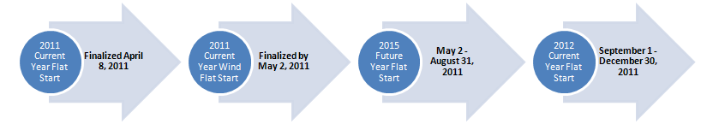
Proposed DWG Flat Start case building schedule

- 2011 Future Year Flat Start Update –
  - Pass 1 has been posted to DWG members for review.
  - Final Review scheduled for DWG meeting in September.
- Draft PGRR submitted to RPS for formal submission to PLWG.
- Preparing presentation on impact of Resource Data on Dynamics analysis for September 27 meeting being coordinated by ERCOT.

