

EEA Events Report
August 23 - August 24, 2011

Table of Contents
Executive Summary 3
PRC, Wind Generation, and Non-Spin from August 23 through 24, 2011 5
System Demand 6
Mid-Term Load Forecast (MTLF) 7
ERCOT System Frequency 8
Area Control Error (ACE) and ERCOT System Frequency 9
Direct Current Ties (DC Ties) “importing power” during the EEA events 10
ERCOT Outaged Capacity Summary 11
The Role of Wind Generation 12

Executive Summary

The ERCOT Region continued to experience unusually high temperatures and high electricity usage throughout the state on August 23 and 24, 2011. Texas heat has reached record temperatures this summer which has stressed the system and depleted committed-generation capacity.
ERCOT ISO issued a media appeal for consumers and businesses to reduce their electricity use. This request was specifically for the peak electricity hours from 3 to 7 PM. This appeal was made in an attempt to avoid requiring rotating outages. Conservation of energy is still encouraged due to the continued high temperatures.
As a result of record loads and unplanned outages, ERCOT ISO initiated emergency procedures including a series of progressive steps to ensure grid reliability on the following days:
On August 23rd, 2011 at 15:43, ERCOT ISO implemented Level 1 of the Energy Emergency Alert (EEA) procedure when the Physical Responsive Capability (PRC) dropped below 2,300 MW. ERCOT ISO cancelled the EEA Level 1 at 17:17. ERCOT was in EEA Level 1 for approximately 1 hour and 34 minutes.
On August 24th, 2011 at 14:18, ERCOT ISO implemented Level 1 of the EEA procedure when the PRC fell below 2,300 MW. Then at 15:08 with the PRC dropping below 1,750 MW, ERCOT ISO declared EEA Level 2A. The ERCOT ISO Operators deployed Group 1 (QSE Responsibility of 618 MW) of Load Resources (LR) providing Responsive Reserve Service (RRS). Ten minutes after the VDI had been issued, the QSEs and their Load Resources had dropped 634 MW of Load. At 17:26, with the PRC increasing ERCOT ISO moved to EEA Level 1 from Level 2A and all deployed Load Resources were recalled. After 3 hours and 50 minutes, at 18:08, ERCOT ISO cancelled EEA Level 1.
The following Event Analysis Report discusses factors leading up to the event, system performance during the event, and actions taken by ERCOT ISO in response to the event.

The following table shows the summary for the events which occurred on August 23 and 24, 2011.

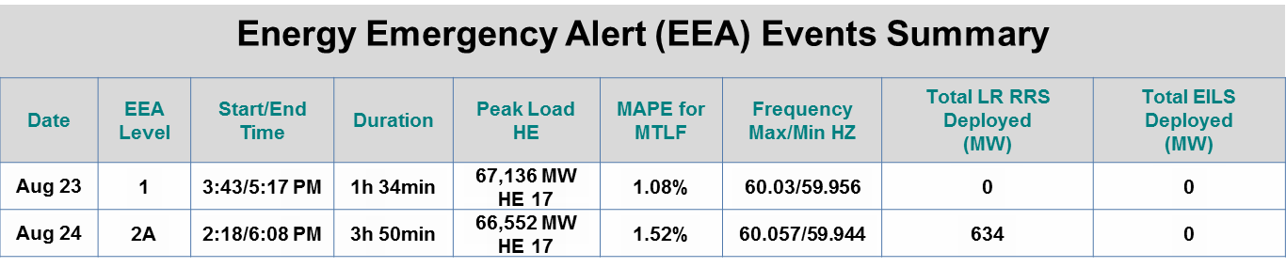
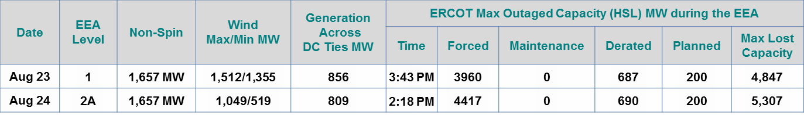

PRC, Wind Generation, and Non-Spin from August 23 through 24, 2011
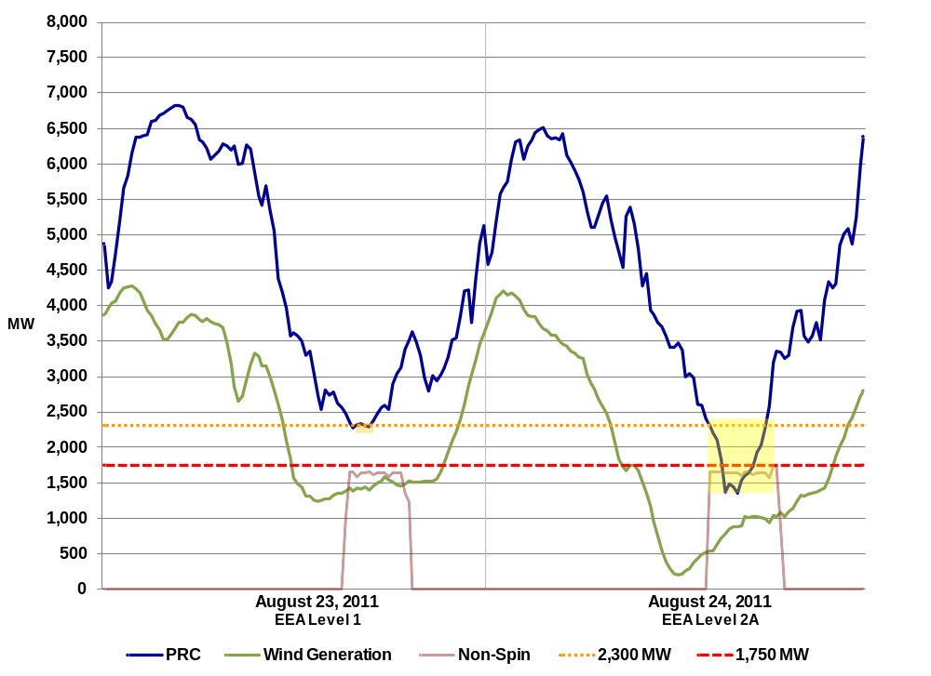
Figure 1: PRC, Wind Generation, and Non-Spin Performance on August 23-24, 2011
August 23, 2011
ERCOT ISO issues an Advisory for PRC falling below 3,000 MW at 13:25. At 15:15 ERCOT ISO deployed 1,657 MW of Non-Spin. At 15:17 a Watch was issued due to PRC falling below 2,500 MW. ERCOT ISO implemented Level 1 of its EEA procedure at 15:43 as PRC fell below 2,300 MW. PRC dropped below 2,300 MW at 15:38 and returned above 2,300 MW in 20 minutes at 15:58. At 17:17 EEA Level 1 was cancelled.
August 24, 2011
ERCOT ISO issues an Advisory for PRC falling below 3,000 MW at 12:51. At 14:03 ERCOT ISO issued a Watch due to PRC falling below 2,500 MW. At 14:08 1,657 MW of Non-Spin was deployed. PRC fell below 2,300 MW at 14:15 causing ERCOT ISO to implement Level 1 of its EEA procedure at 14:18. At 15:03 PRC fell below 1,750 MW and ERCOT ISO moved into EEA Level 2A at 15:08. At 15:10 PRC reached the lowest value of 1,188 MW. Note that the PRC dropped as a result of the Load Resource deployment. PRC recovered to above 1,750 MW at 17:00 and ERCOT ISO moved to EEA Level 1 at 17:26. At 17:45 the PRC increased above 2,300 MW and ERCOT ISO cancelled EEA Level 1 at 18:08.

System Demand

Below is an illustration of ERCOT Load, Online Capacity, and Offline Non-Spin used to meet load. On August 23rd and 24th, ERCOT had instantaneous peak loads of 67,243 MW and 66,682 MW respectively.
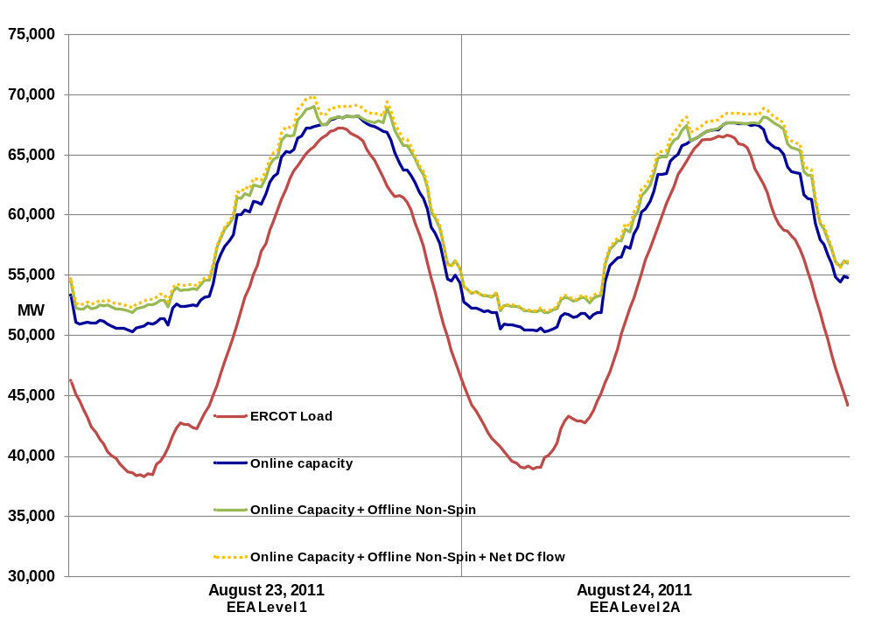
Figure 2: ERCOT Load, Online Capacity, Offline Non-Spin, and Net DC Flows on August 23-24, 2011.

Mid-Term Load Forecast (MTLF)

The table below shows the Mean Absolute Percent Error (MAPE) for the days during the EEA events. Figure 3 compares the actual integrated load versus the day-ahead load forecast. Hours in which the EEAs were active are highlighted yellow.
Table 1: MAPE Summary August 23 - 24, 2011
MAPE for ERCOT MTLF
Run at 14:00 Day-Ahead
Forecast | ERCOT Active  Daily | ERCOT Active  Monthly
Aug. 23 | 1.08% | 2.03%
Aug. 24 | 1.52% | 2.01%

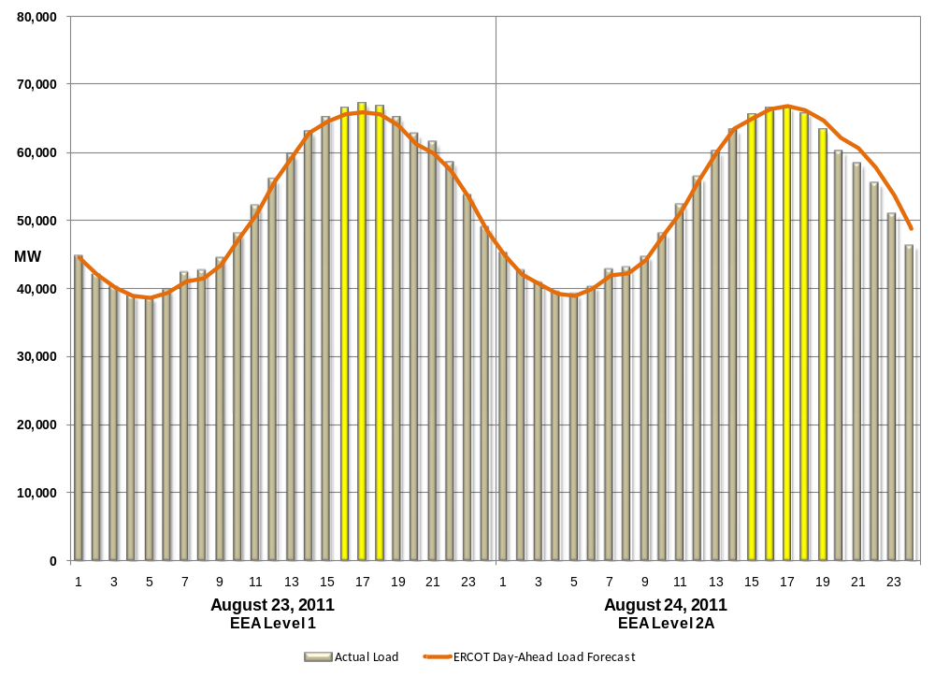
Figure 3: ERCOT Actual Load and ERCOT Load Forecast on August 23 - 24, 2011

ERCOT System Frequency

The graph below depicts the frequency throughout the EEA events (August 23 – 24, 2011).

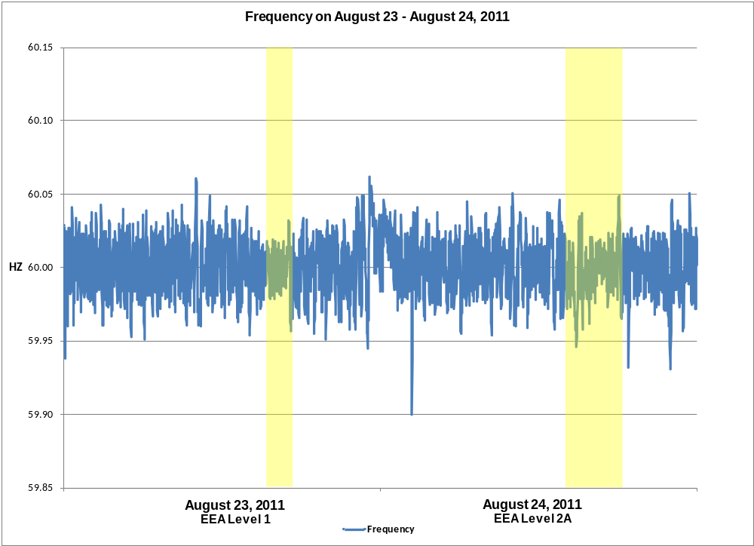
(Note: Frequency drop in the morning of 8/24 was due to a large Resource trip)
Figure 4: ERCOT System Frequency on August 23-24, 2011

Area Control Error (ACE) and ERCOT System Frequency

The figure below shows the system frequency vs ACE. The table below shows the lowest point ACE during the EEA events.

Table 2: Lowest ACE August 23 - 24, 2011
ACE Values During EEA Events
Date | Lowest ACE Value
Aug. 23 | -483 MW
Aug. 24 | -666 MW

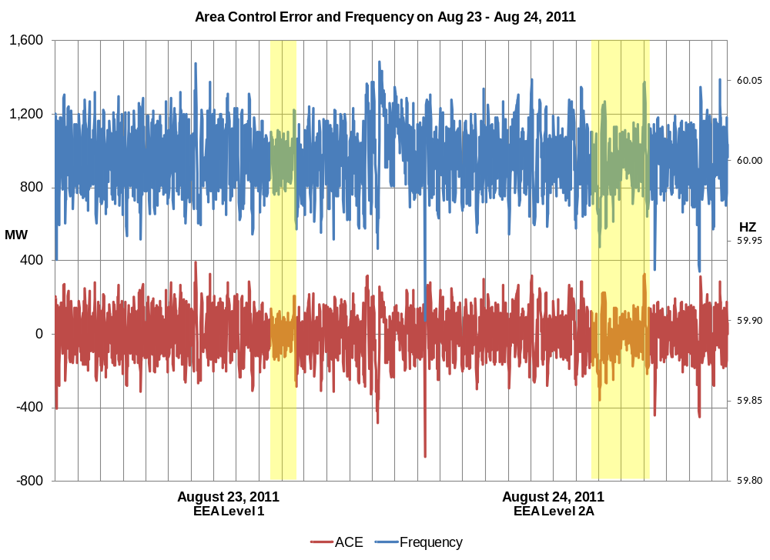
Figure 5: ACE and ERCOT Frequency

Direct Current Ties (DC Ties) “importing power” during the EEA events

The figure below shows the maximum generation from other grids across DC Ties during the EEA events.

Table 3: Maximum Import across DC Ties on August 23 - 24, 2011
Generation Across DC Ties
Date | Maximum Transfer Across DC Ties
Aug. 23 | 932 MW
Aug. 24 | 807 MW

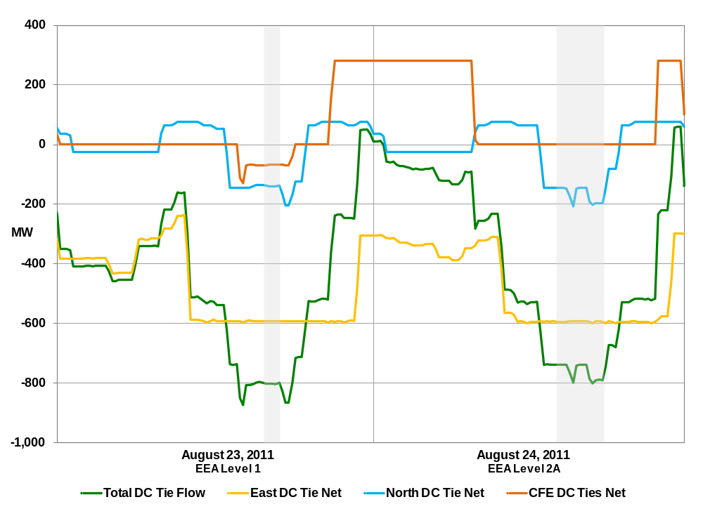
Figure 6: Flows across DC Ties on August 23-24, 2011.

ERCOT Outaged Capacity Summary

Below is an illustration of Outaged Capacity during the EEA events. Table 5 provides the summary of the forced, maintenance, derated, and planned capacity on outage for August 23 and August 24, 2011.

Table 4: Maximum Outaged Capacity during EEA Events
ERCOT Max Outaged Capacity (MW) During the EEA Events
Time | Forced | Maintenance | Derated | Planned | Lost Capacity
8/23 15:43 | 3960 | 0 | 687 | 200 | 4,847
8/24 14:18 | 4417 | 0 | 690 | 200 | 5,307

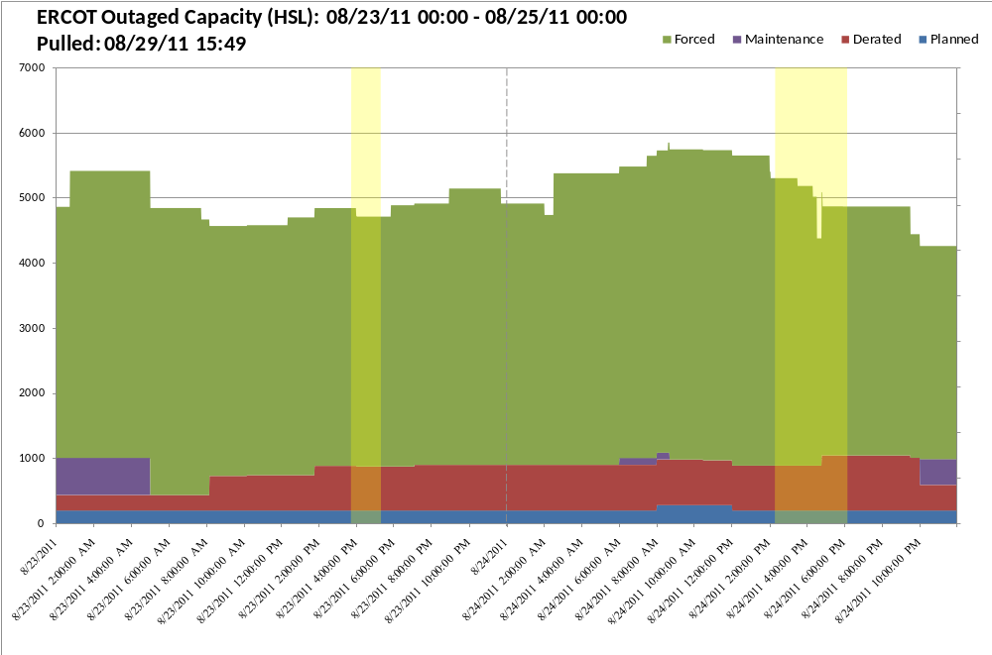
Figure 7: ERCOT Outaged Capacity Summary for 8/23-8/24, 2011.

The Role of Wind Generation

Figure 11 show the hourly averages of actual wind output, the wind hour-ahead Current Operating Plan (COP) High Sustainable Limit (HSL) and the wind day-ahead COP HSL data during the EEA events on August 23-24, 2011. Hours in which the EEAs were active are highlighted yellow.

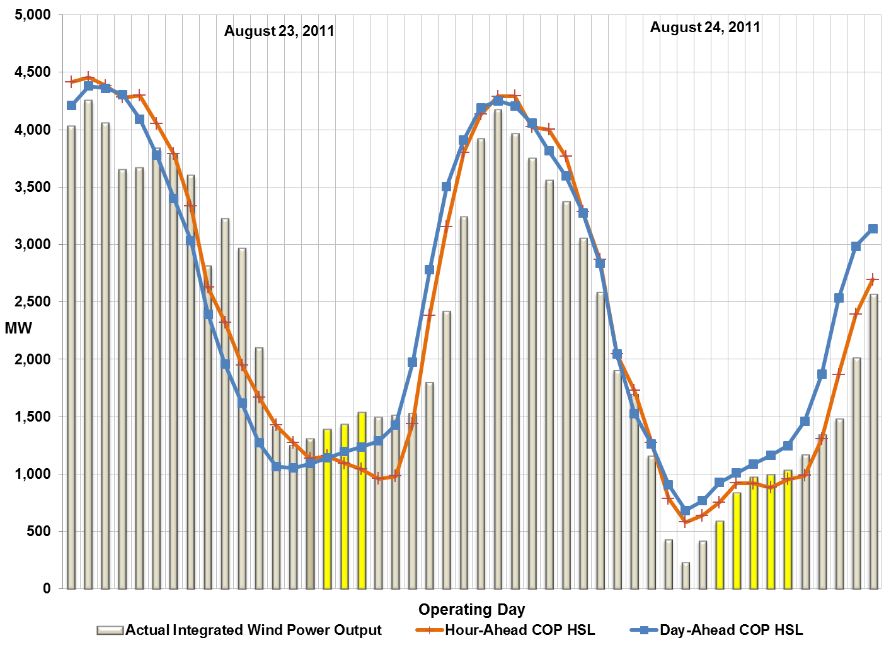
Figure 8: Actual Aggregated Wind Data for August 23 - 24, 2011

EEA Level 1 Report
August 23, 2011

August 23, 2011 EEA Level 1
- 02:26 - ERCOT ISO issues an Operating Condition Notice (OCN) for a Projected Reserve Capacity shortage for hours 15:00 through 19:00.
- 10:48 – ERCOT ISO issues a Watch for Projected Reserve Capacity shortage with no Market solution available. RMR Resources are committed.
- 13:25 - ERCOT ISO issues an Advisory for PRC below 3,000 MW.
- 15:15 - 1,657 MW of Non-Spin deployed.
- 15:17 - ERCOT ISO issues a Watch for PRC below 2,500 MW.
- 15:43 - EROCT declares EEA Level 1 due to PRC dropping below 2,300 MW. ERCOT receives 856 MW across the DC Ties.
- 17:17 - EEA Level 1 is cancelled. The duration of the EEA was 1 hour and 34 minutes.
- 20:03 - Watch is cancelled.
- 22:21 - Advisory is cancelled.
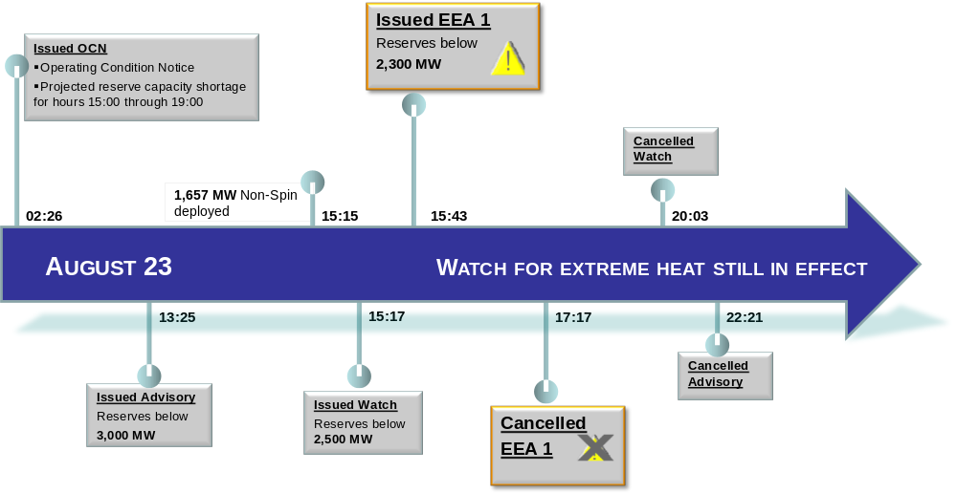
Figure 9: Event Timeline on August 23, 2011

PRC and Non-Spin Performance on August 23, 2011
At 15:15 ERCOT ISO deployed 1,657 MW of Non-Spin. At 15:17 a Watch was issued due to PRC falling below 2,500 MW. ERCOT ISO implemented Level 1 of its EEA procedure at 15:43 as PRC fell below 2,300 MW. PRC dropped below 2,300 MW at 15:38 and returned above 2,300 MW in 20 minutes at 15:58. At 17:17 EEA Level 1 was cancelled.
Below is a graph of ERCOT PRC, Non-Spin deployed, and System Frequency during the event.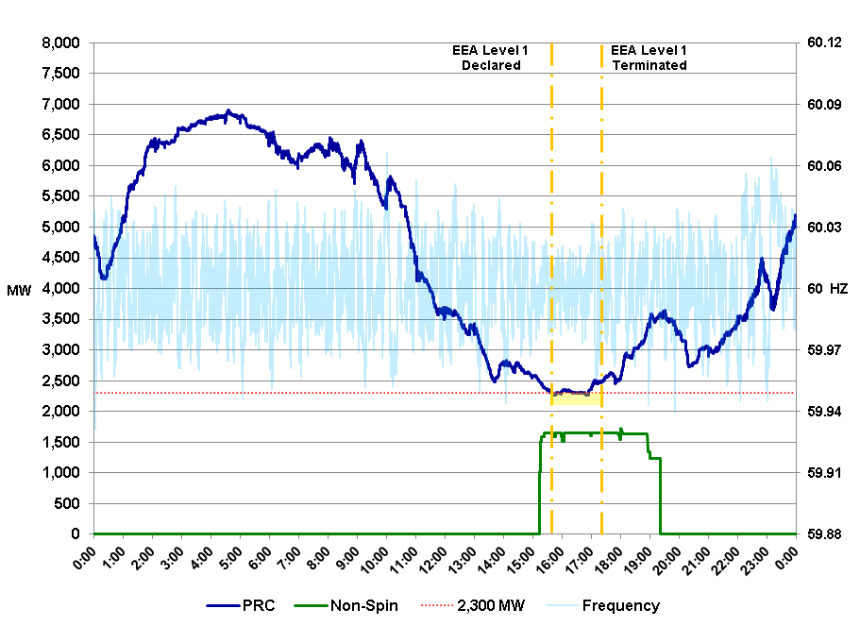
Figure 10: PRC and Non-Spin Performance on August 23, 2011

DC Ties “Importing Power” During the EEA Level 1 Event on August 23, 2011
The figure below shows the maximum generation from other grids across DC Ties during the EEA Level 1 event. ERCOT received 55 MWh of Emergency Energy from the North DC Tie on 8/23.
Table 5: Maximum Import across DC Ties on August 23, 2011
Generation Across DC Ties
DC Tie Name | Maximum Transfer Across DC Ties
East DC Tie | 591 MW
North DC Tie | 135 MW
CFE DC Ties | 130 MW
Total | 856 MW

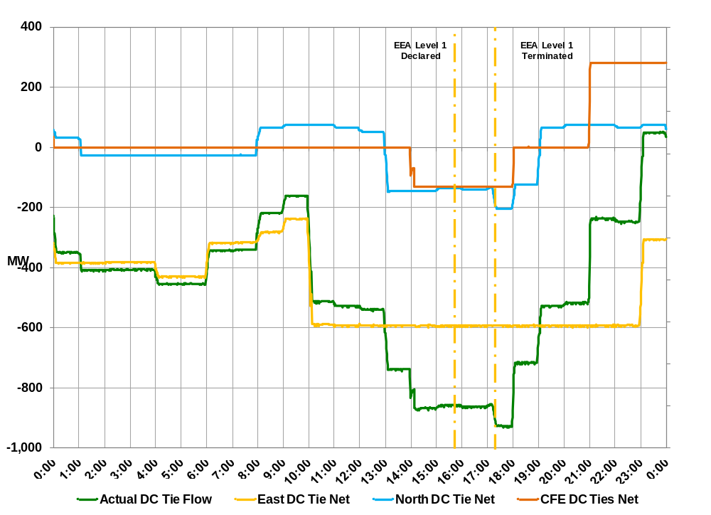
Figure 11: Flows across DC Ties on August 23, 2011

ERCOT Outaged Capacity on August 23, 2011
Below is an illustration of Outaged Capacity during the EEA Level 1 event. Table 6: Maximum Outaged Capacity during August 23, 2011 provides the summary of the forced, maintenance, derated, and planned outage capacity on August 23, 2011.
Table 6: Maximum Outaged Capacity during August 23, 2011
ERCOT Max Outaged Capacity (MW) During EEA Level 1
Time | Forced | Maintenance | Derated | Planned | Lost Capacity
8/23 15:43 | 3960 | 0 | 687 | 200 | 4,847

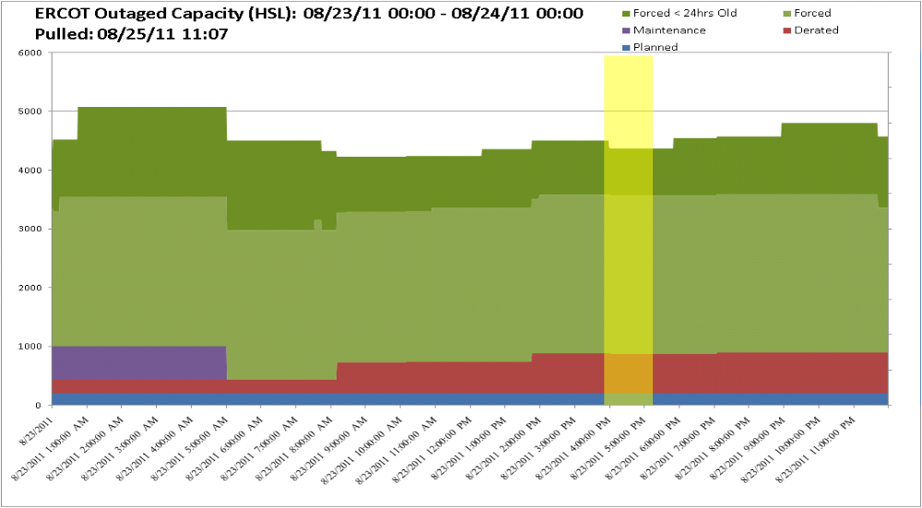
Figure 12: Outaged Capacity during August 23, 2011

The Role of wind Generation on August 23, 2011
At 04:30, PRC began to fall while Wind Generation decreased and load increased. At the start of this PRC decline, wind generation output was 3,675 MW and reached a minimum of 1,200 MW at 13:25. Wind Generation slowly increased over the next 4 hours. During the EEA event Wind Generation was increasing by approximately 75 MW per hour and reached a maximum of 1,512 MW.
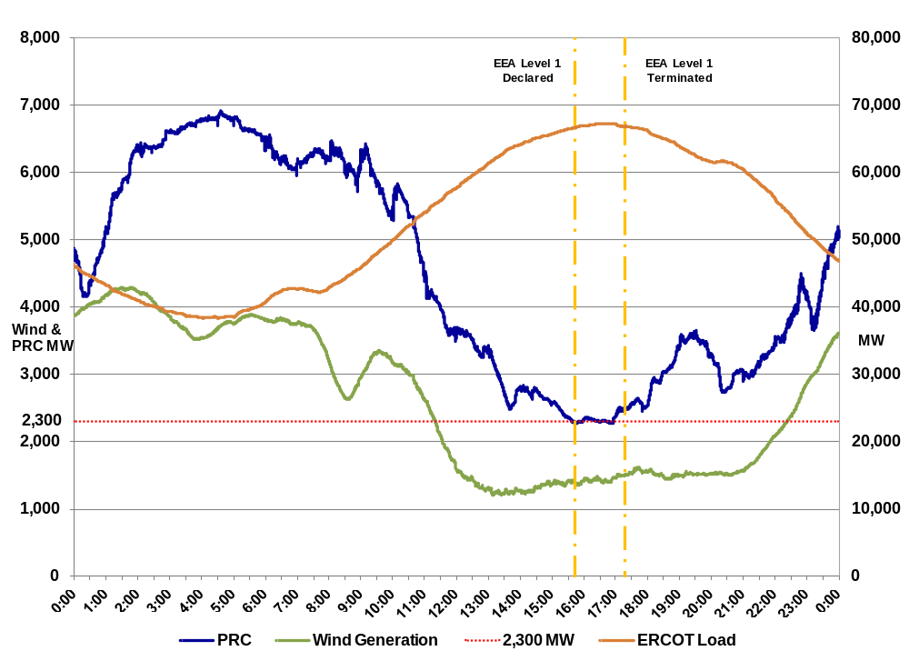Figure 13: ERCOT Load, PRC, and Wind Generation on August 23, 2011

The figure below shows the hourly averages of actual wind, wind hour-ahead COP HSL, and wind day-ahead COP HSL data on August 23, 2011.

Table 7: Wind Output, Hour-Ahead and Day-Ahead COP HSL Values on August 23, 2011
Operating Day | Operating Hour | WGRs Aggregated Power Output | Hour-Ahead COP HSL [MW] | Day-Ahead COP HSL [MW]
8/23/2011 | 16 | 1,388 | 1,158 | 1,141
8/23/2011 | 17 | 1,430 | 1,094 | 1,195
8/23/2011 | 18 | 1,536 | 1,267 | 1,237

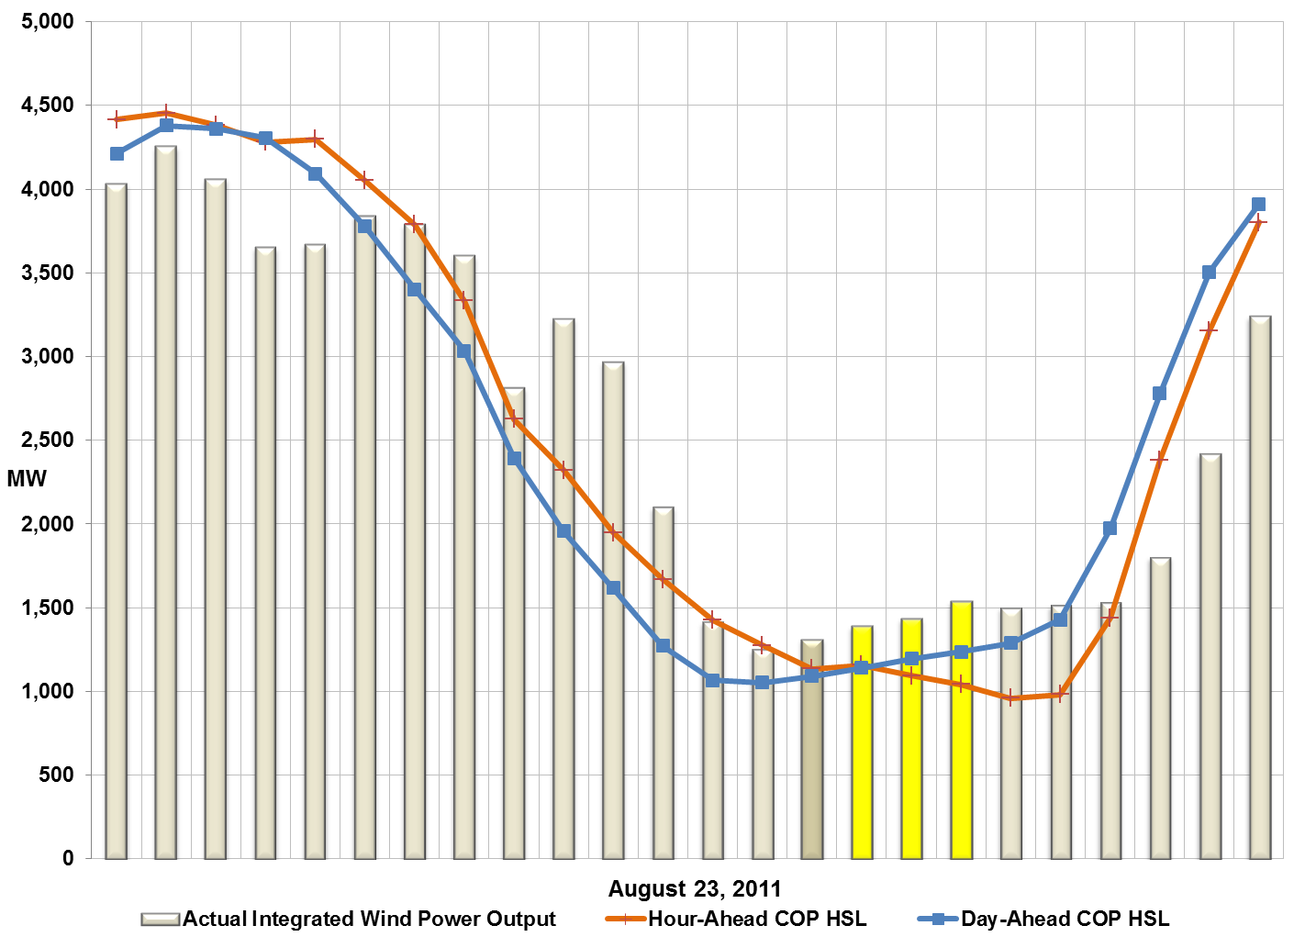
Figure 14 Actual Aggregated Wind Data for August 23, 2011

EEA Level 2A Report
August 24, 2011

August 24, 2011 EEA Level 2A
- 02:57 - ERCOT ISO issues an OCN for a Projected Reserve Capacity shortage for hours 15:00 through 20:00.
- 08:45 – ERCOT ISO issues a Watch for Projected Reserve Capacity shortage with no Market solution available. RMR Resources are committed.
- 12:51 - ERCOT ISO issues an Advisory for PRC below 3,000 MW.
- 14:03 - ERCOT ISO issues a Watch for PRC below 2,500 MW.
- 14:08 - 1,657 MW of Non-Spin is deployed.
- 14:18 - ERCOT ISO declares EEA Level 1 due to PRC falling below 2,300 MW.
- 15:08 - ERCOT ISO declares EEA Level 2A due to PRC falling below 1,750 MW.
- 15:10:43 - ERCOT ISO System Operators complete deployment instructions for Load Resources assigned to Group 1. Group 1 Load Resources responsible for 617.7 MW.
- 17:23:15 - ERCOT ISO System Operators recall all Load Resources.
- 17:26 - ERCOT ISO moves to EEA Level 1 from EEA Level 2A.
- 18:08 - ERCOT ISO cancels EEA Level 1.
- 18:56 - Watch cancelled.
- 19:37 - Advisory cancelled.
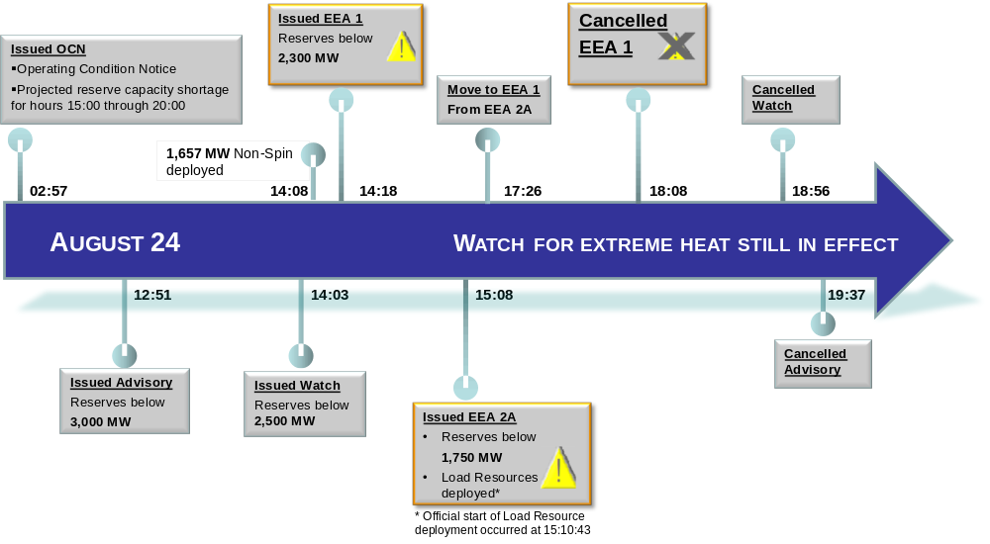
Figure 15: Event Timeline on August 24, 2011

PRC and Non-Spin Performance on August 24, 2011
At 14:03 ERCOT ISO issued a Watch due to PRC falling below 2,500 MW. At 14:08 1,657 MW of Non-Spin was deployed. PRC fell below 2,300 MW at 14:15 causing ERCOT ISO to implement Level 1 of its EEA procedure at 14:18. PRC returned to 2,300 MW at 17:46.
Between 15:03 and 17:00, PRC dropped below 1,750 MW and, at 15:08, ERCOT ISO declared EEA Level 2A. Load Resources providing RRS were deployed.
PRC reached its lowest value during the event of 1,188 MW at 15:10.
Below is a graph of ERCOT PRC and Non-Spin during the event.
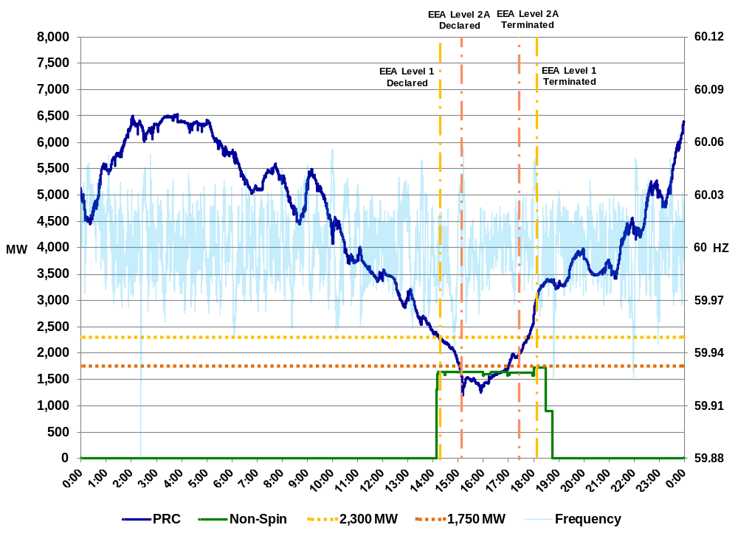
Figure 16: PRC, Non-Spin Performance and ERCOT Frequency on August 24, 2011

DC Ties “Importing Power” During the EEA Level 1 Event on August 24, 2011
The figure below shows the maximum generation from other grids across DC Ties during the EEA Level 1 event. ERCOT received 97 MWh of Emergency Energy on 8/24.
Table 8: Maximum Import across DC Ties on August 24, 2011
Generation Across DC Ties
DC Tie Name | Maximum Transfer Across DC Ties
East DC Tie | 601 MW
North DC Tie | 208 MW
CFE DC Ties | 0 MW
Total | 809 MW

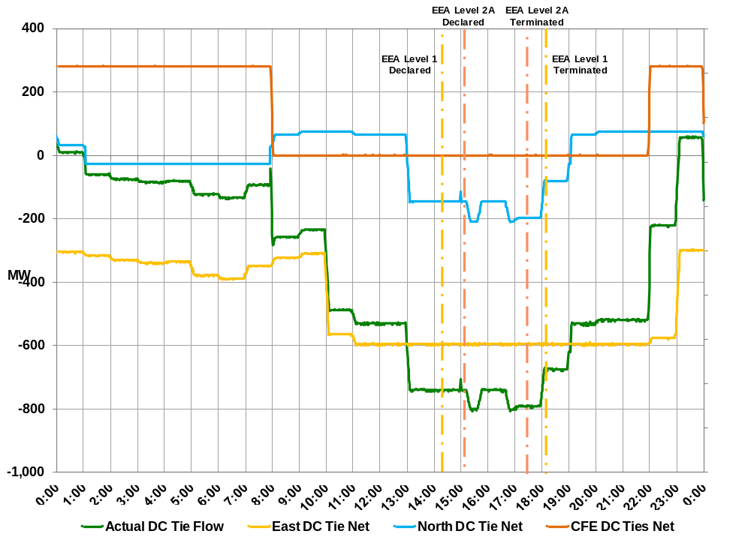South
Figure 17: Flows across DC Ties on August 24, 2011

ERCOT Outaged Capacity on August 23, 2011
Below is an illustration of Outaged Capacity during the EEA Level 1 event. Table 9 provides the summary of the forced, maintenance, derated, and planned outage capacity on August 24, 2011.
Table 9: Maximum Outaged Capacity during August 24, 2011
ERCOT Max Outaged Capacity (MW) During EEA Event
Time | Forced | Maintenance | Derated | Planned | Lost Capacity
8/24 14:18 | 4,417 | 0 | 690 | 200 | 5,307

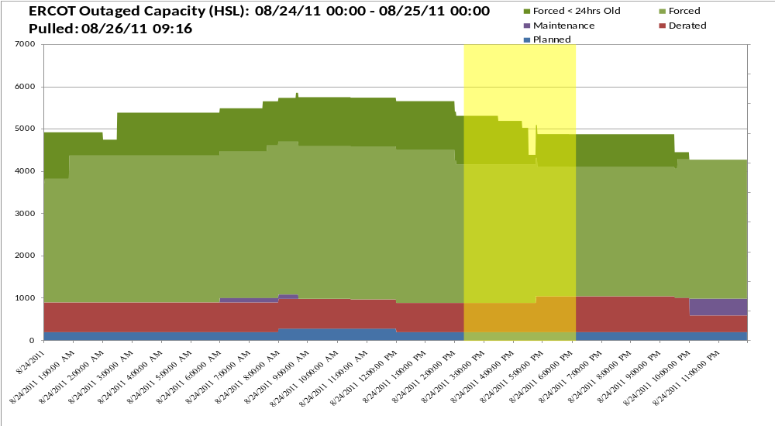
Figure 18: Outaged Capacity during August 24, 2011

The Role of wind Generation on August 24, 2011
At 01:15 on August 24, 2011 wind was at its maximum output of 4,228 MW. Over the next 12 hours wind generation output fell and reached its minimum value of 197 MW at 12:18. At the start of EEA Level 1 wind output had increased to 519 MW. During the EEA wind reached a maximum of 1,049 MW.
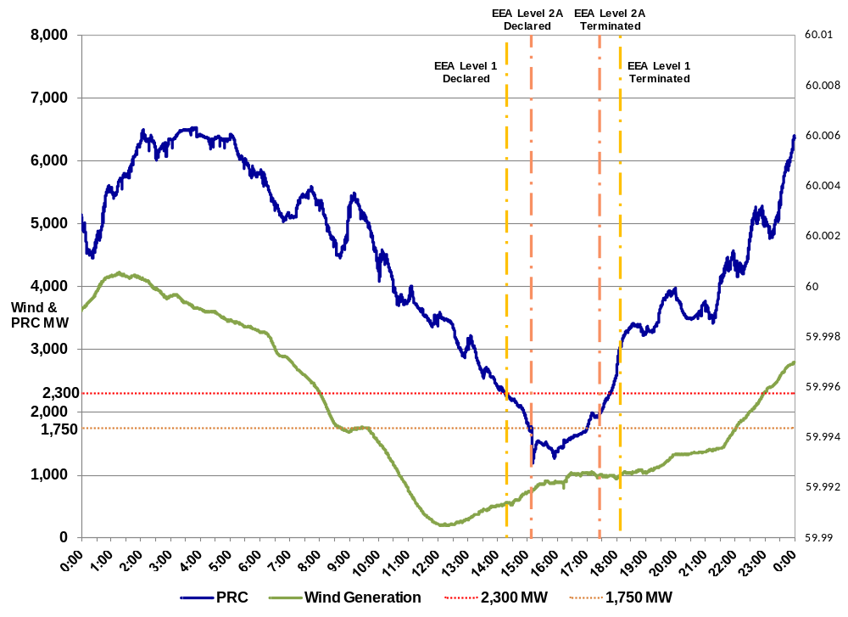
Figure 19: ERCOT PRC and Wind Generation on August 24, 2011

The figure below shows the hourly averages of actual wind, wind hour-ahead COP HSL, and wind day-ahead COP HSL data on August 24, 2011.

Table 10: Wind Output, Hour-Ahead and Day-Ahead COP HSL Values on August 24, 2011
Operating Day | Operating Hour | WGRs Aggregated Power Output | Hour-Ahead COP HSL [MW] | Day-Ahead COP HSL [MW]
8/24/2011 | 15 | 587 | 753 | 925
8/24/2011 | 16 | 834 | 922 | 1,001
8/24/2011 | 17 | 971 | 918 | 1,089
8/24/2011 | 18 | 993 | 882 | 1,163
8/24/2011 | 19 | 1,034 | 953 | 1,248

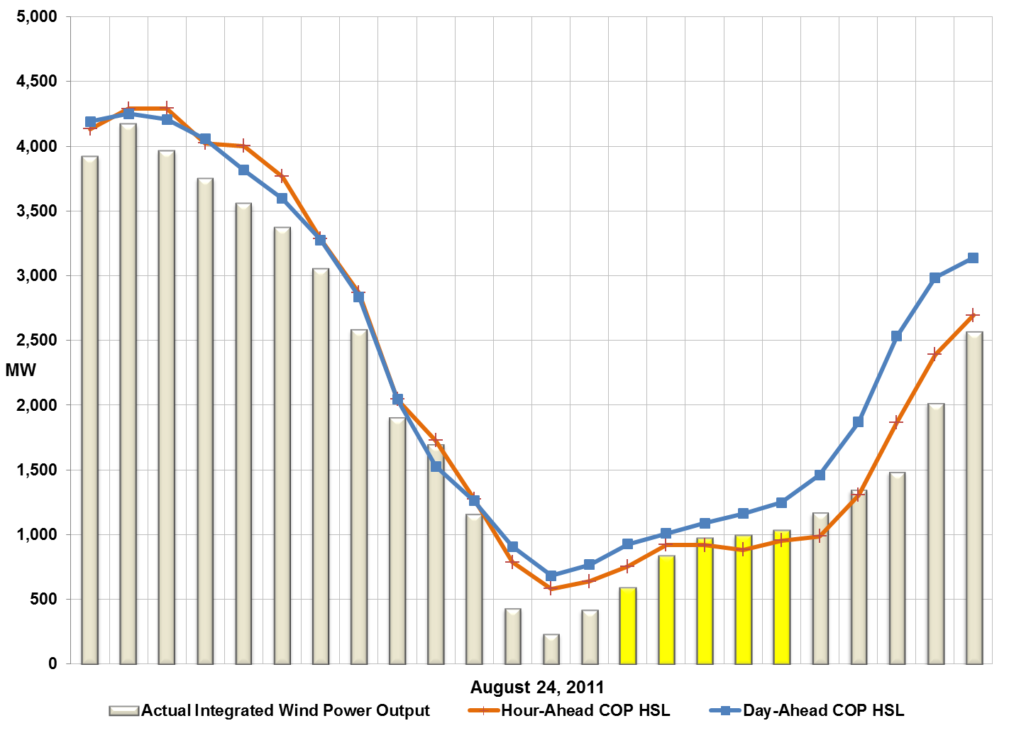
Figure 20: Actual Aggregated Wind on August 24, 2011

Load Resources on August 24, 2011
- 15:08 – ERCOT ISO initiates EEA Level 2A.
- 15:10:43 – ERCOT ISO completes VDI to deploy Group 1 Load Resources. Group 2 Load Resources not deployed.
- 15:20:43 – 102.7% (634.2 MW) of deployed Load Resource capacity has responded.
- 17:23:15 – ERCOT ISO recalls Load Resources.
- 17:26 – ERCOT ISO moves to EEA Level 1 from EEA Level 2A.

Table 11: Load Resources Deployment on August 24, 2011
 | Total LR RRS Responsibility [MW] | LR Response [MW] at 10 Minutes
Total | 617.7 | 634.2

Technical Opinion
ERCOT ISO System Operators declared Level 1 of its Energy Emergency Alert (EEA) as required by the ERCOT Protocols due to Physical Responsive Capability (PRC) dropping below 2,300 MW on August 23, 2011. On August 24 ERCOT ISO went beyond Level 1 and declared EEA Level 2A.

The event on the 24th progressed further into the EEA procedure due to increased Resource outages and derates, and decreased wind generation. Due to this reduction in effective capacity, the PRC reached the 2,300 MW trigger sooner than on the 23rd.

Performed By: Joel Koepke, P.E., Operations Support Engineering
Department: System Operations Support

Based on telemetry at time of VDI.
Using 15:10:43 as official deployment time.

