Currently available on ERCOT.com (Grid Information/Current System Conditions):

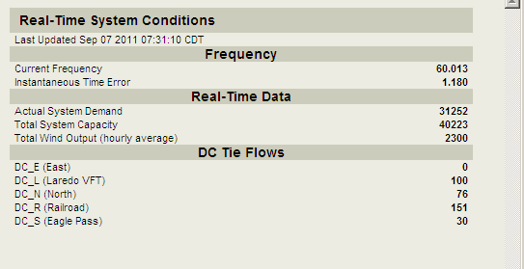
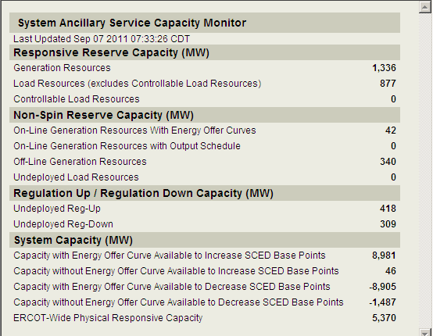
Load Forecast vs. Actual SAMPLE / DEMO – Data not representative.
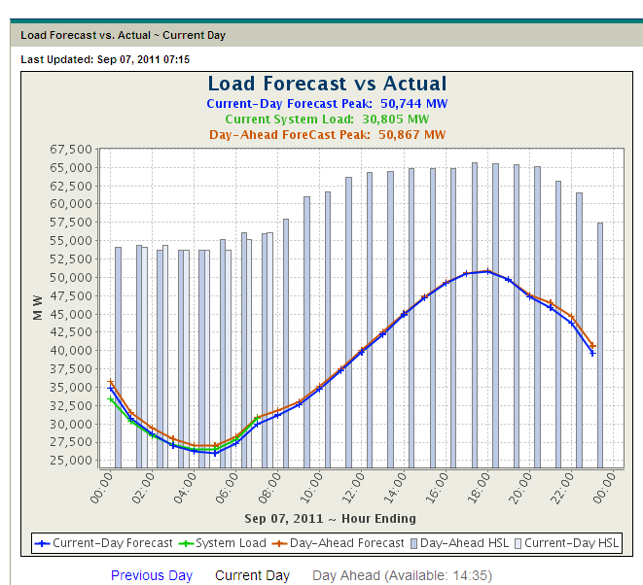

LMP Contour SAMPLE / DEMO – Data not representative.
