NPRR Number | 365 | NPRR Title | Change in Resource Outage Approvals from Eight to 90 Days
Date |  | August 26, 2011
Submitter’s Information
Name |  | Woody Rickerson
E-mail Address |  | wrickerson@ercot.com
Company |  | ERCOT
Phone Number |  | 512.248.6501
Cell Number
Market Segment |  | N/A

Comments

ERCOT submits these comments in response to the 8/18/11 PRS recommendation on NPRR365 which revised the ERCOT proposed 90-day acceptance rule to 45-days. In addition, PRS included a 3-day response provision for Planned Resource Outages received with 45-days or less notice, as well as a 5-day conflict notice for all Resource Outages submitted with more than 45-days notice. While the recommendation is an improvement over the existing Protocol, it decreases the coordination benefits found in the original NPRR language. ERCOT supports the original NPRR language for the following reasons:
- North American Electric Reliability Corporation (NERC) and Federal Energy Regulatory Commission (FERC) February 2nd Report - In August of 2011, the staffs of NERC and FERC released the NERC/FERC Report on “Outages and Curtailments During the Southwest Cold Weather Event of February 1-5, 2011. In the report, NERC and FERC staff recommended that ERCOT consider revising the Protocols to provide ERCOT ability to withdraw previous approval or acceptance of Resource Outages, expand its Resource Outage evaluation criteria, and lengthen the period for which ERCOT may deny a Planned Resource Outage request (p.53, pp. 198-199). The report referenced the ERCOT proposal in NPRR365 and stated “ERCOT is presently considering a Protocol revision to give itself the authority to deny an outage request that is not scheduled more than 90 days prior to the outage date, a revision which the task force supports.”

- Congestion Revenue Rights (CRR) Model Fidelity - Resource Outages, while not directly included in the CRR model, have an effect on the transmission Outages that are included in the CRR model. The 90-day acceptance rule, as proposed by ERCOT, provides more surety that the transmission Outages included in the CRR model, captured roughly 70 days before the beginning of the CRR Auction, are not displaced or modified by late arriving resource Outages. A 45-day notice requirement does not offer the same benefit, and would potentially allow late arriving Resource Outages to change transmission Outages and introduce more inaccuracies in the CRR Auction.

- Increased System Cost, Staff Impact, and Implementation Time – The 8/18/11 PRS recommendation would create significant impacts to ERCOT systems and staffing. ERCOT estimates that the PRS recommended language will require 6 to 9 months to implement and require additional FTEs. There would be no increased Outage coordination during the Fall 2011 and Spring 2012 Outage seasons when a larger than usual number of Outages are expected due to Competitive Renewable Energy Zone (CREZ) construction and possible Resource modifications due to new EPA Cross State Air Pollutants Rule (CSAPR) rules. The ERCOT proposal could be in place in time for the Fall 2011 Outage season.

- Transmission and Resource Outage Coordination - A move from the 90-day notice requirement to 45-days will negate the benefits of ERCOT coordinating both Resource and transmission Outages submitted specifically within the 45 - 90-day time period. Three examples of the coordination benefits lost in this time period are:

  - EPA-mandated Emission Work - Due to the potential CSAPR changes, some coal units may desire to shut down for extended periods during shoulder months (generally, March-May and October-November) in order to preserve their ability to operate during peak periods. Without the ability to coordinate Resource Outages on a seasonal basis, it is likely that there will be periods during these shoulder months in which insufficient generation capacity is available to serve system Load because of simultaneous CSAPR and normal planned Maintenance Outages even if sufficient capacity is available during the summer peak period. Tight reserve margins will exacerbate this problem.

  - CREZ Construction - The Public Utility Commission of Texas (PUCT) published a schedule of expected CREZ construction projects and illustrates that CREZ construction will peak in the fall of 2012.

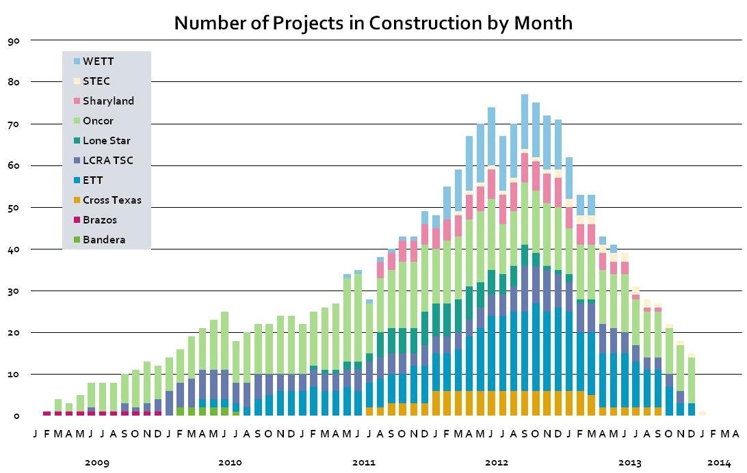
The unprecedented amount of CREZ-related construction will be a scheduling and coordination challenge for ERCOT. To ensure timely completion of these projects, it is critical that ERCOT not only coordinate the CREZ construction Outages, but that it also has the ability to coordinate the Resource Outages that will impact construction. Due to both stability and thermal limitations in the West Load Zone, Resource Outages in that area play an integral role in determining reliability limitations for importing power into the rest of ERCOT. It is critical that ERCOT have the ability to coordinate West Load Zone Resource Outages with CREZ construction work well in advance of the starting dates. The PRS recommendation will limit ERCOT’s ability to coordinate CREZ construction and Resource maintenance to no more than 45-days in advance.

  - Seasonal Planning - The 90-day notification requirement will give ERCOT adequate time to proactively consider Forced Outage rates and seasonal peaks in its Outage Coordination. This relates directly back to the Recommendation 6B found in the Report of Rotating Blackout Operations Task Force of the ERCOT Board – March 2011 which states, “Reconsider having ERCOT coordinate generator scheduled maintenance.” In order to do this on a seasonal basis, the approval timeline needs to be set at 90-days.

ERCOT continues to support a 90-day notice for ERCOT approval of Resource Outages and recommends approval of NPRR365 as originally submitted on 5/5/11.

Revised Proposed Protocol Language

None at this time.

