 |  |  |  | System Planning Division
Monthly Status Report
to
Reliability and Operations Subcommittee
for
February 2011

 |  | Report Highlights
Item
1. | - ERCOT is currently tracking 192 active generation interconnection requests totaling over 63,000 MW. This includes over 36,000 MW of wind generation.
2. | - ERCOT is currently reviewing proposed transmission improvements with a total cost of $176.1 Million  - Transmission Projects endorsed in 2011 total $23.6 Million  - All projects (in engineering, routing, licensing and construction) total approximately $9.3 Billion  - Transmission Projects energized in 2010 total about $857.1 million

Table of Contents
1. Generation Interconnection 1
1.1 New Generation Registering for Commercial Operations 1
1.2 Publicly Disclosed Generation Interconnection Projects 4
1.3 Generation Projects Undergoing Full Interconnection Studies (not otherwise public) 6
1.4 Wind Generation 8
2. Regional Planning Group Project Reviews 10
3. Congestion Costs 11
4. Wind Generation as a Percent of Load 13
5. Planning Model Activities 14
6. Other Notable Activities 15

1. Generation Interconnection
Additional information regarding detailed generation interconnection and impact studies is contained in the “Generation Project Interconnection Information” folder in the “Operations and System Planning” area on the ERCOT website: http://planning.ercot.com/login/login.

New Generation Registering for Commercial Operations

The total installed wind capacity is reported as 9,400 MW by the resource owners through the registration process.

Summary of Active Generation Interconnection Requests

GENERATION INTERCONNECTION REQUESTS CURRENTLY BEING PROCESSED
Currently tracking 191 active generation interconnection or change requests
As of February 28, 2011 | North | South | West | Total
Security Screening Study | 2 | 6 | 8 | 16
SSS Completed | 1 | 2 | 15 | 18
Full Interconnect Study | 18 | 14 | 87 | 119
FIS Completed | 5 | 13 | 5 | 23
Interconnect Agreement Completed | 7 | 6 | 3 | 16
Capacity under Interconnection Agreements | 5,092 | 3,742 | 520 | 9,354
Capacity for Grid, MW | 18,690 | 12,845 | 31,809 | 63,344
Wind Capacity, MW | 3,457 | 4,067 | 28,839 | 36,363

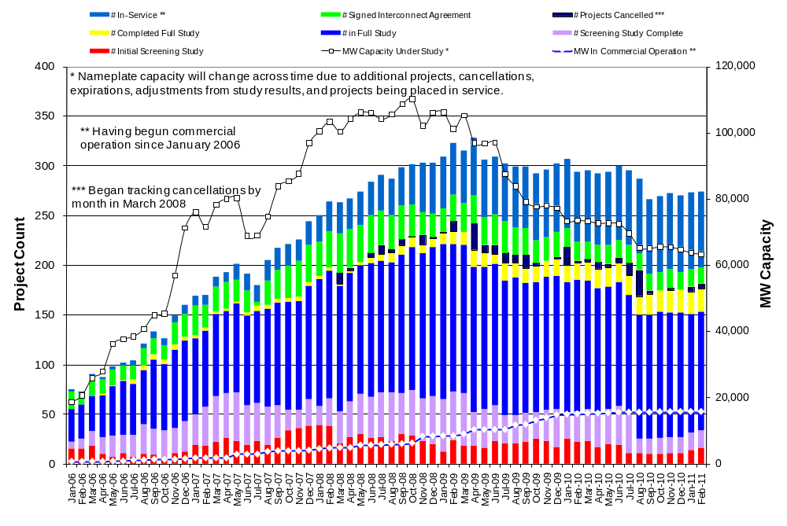

Fuel Type | Confidential Projects (MW) | Projects Under Full Study (MW) | Projects w/ Interconnect Agreement/Public Letter (MW) | Grand Total (MW)
Gas-CombinedCycle |  |  | 5,297 | 11,988
Gas-All Other |  |  |  | 650
Total Gas | 11 | 7,330 | 5,297 | 12,638
Nuclear |  |  | 5,900 | 5,900
Coal |  | 1,740 | 3,210 | 4,950
Wind | 2,870 | 28,176 | 5,317 | 36,363
Solar | 544 | 819 |  | 1,363
Biomass |  | 50 | 100 | 150
Other |  | 740 | 1,240 | 1,980
Grand Total | 3,425 | 38,855 | 21,064 | 63,344

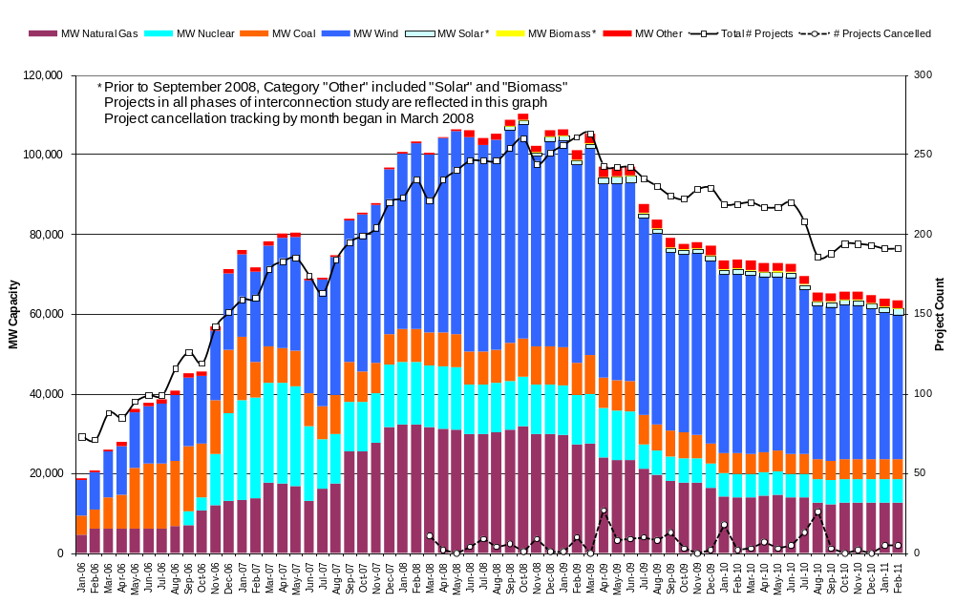

Publicly Disclosed Generation Interconnection Projects
The table below summarizes the publicly disclosed generation projects for the ERCOT region.
(Status: IA=Interconnect Agreement, PL=Public Letter, XX= cancelled)
Generation Interconnections as of February 28, 2011
INR | SiteName | Status | County | Region | COD | Fuel Type |  | MW For Grid | Change from Last Report
09INR0029 | CFB Power Plant Units 11&12 | IA | Calhoun | South | Mar-11 |  | Coal | 260
08INR0065 | Buffalo Gap 4 and 5 | PL | Nolan | West | Mar-11 |  | Wind | 465
10INR0010 | Jack County 2 | IA | Jack | North | Jun-11 |  | Gas | 565 | Capacity
12INR0003 | Throckmorton Wind Farm | PL | Throckmorton | West | Dec-11 |  | Wind | 400
09INR0034 | Gatesville Wind Farm | PL | Coryell | North | Dec-11 |  | Wind | 200
08INR0038 | M Bar Wind | PL | Andrews | West | Dec-11 |  | Wind | 194
08INR0025 | Pistol Hill Energy Center | PL | Ector | West | Dec-11 |  | Wind | 300
06INR0012b | Sherbino Mesa Wind Farm 2 | IA | Pecos | West | Jan-12 |  | Wind | 150
09INR0001 | Sandy Creek 1 | IA | McLennan | North | Feb-12 |  | Coal | 925
08INR0062 | Archer-Young | IA | Young | West | Mar-12 |  | Wind | 250
11INR0084 | 2W Whatley Phase 1 | PL | Ector | West | Mar-12 |  | Wind | 45
09INR0007 | Nacogdoches Project | IA | Nacogdoches | North | Apr-12 |  | Biomass | 100
07INR0004 | Pampa Energy Center | PL | Gray | West | May-12 |  | Coal | 165
09INR0024 | B&B Panhandle Wind | PL | Carson | West | Jun-12 |  | Wind | 1,001
09INR0037 | Scurry County Wind III | PL | Scurry | West | Jun-12 |  | Wind | 350
05INR0015b | Gulf Wind 2 | PL | Kenedy | South | Jul-12 |  | Wind | 400
12INR0004 | Fort Concho Wind Farm | PL | Tom Green | West | Jul-12 |  | Wind | 400
12INR0043 | 2W Whatley Phase 2 | PL | Ector | West | Aug-12 |  | Wind | 290
08INR0011 | Senate Wind Project | IA | Jack | North | Sep-12 |  | Wind | 150
08INR0018 | Gunsight Mountain | IA | Howard | West | Dec-12 |  | Wind | 120
06INR0022c | Penascal Wind Farm 3 | IA | Kenedy | South | Dec-12 |  | Wind | 202
05INR0015c | Gulf Wind 3 | PL | Kenedy | South | Dec-13 |  | Wind | 400
10INR0020a | Panda Temple Power | IA | Bell | North | Feb-14 |  | Gas | 780
06INR0006 | Cobisa-Greenville | IA | Hunt | North | May-14 |  | Gas | 1,792
10INR0022 | Pondera King Power Project | IA | Harris | South | Jun-14 |  | Gas | 1,380
14INR0005 | White Stallion Energy Center | PL | Matagorda | South | Jul-14 |  | Coal | 1,200
10INR0020b | Panda Temple Power | IA | Bell | North | May-15 |  | Gas | 780
12INR0016a | Las Brisas Energy Center | IA | Nueces | South | Jul-15 |  | Other | 620 | Date
14INR0002 | Coleto Creek Unit 2 | IA | Goliad | South | Jan-16 |  | Coal | 660
15INR0008 | STP 3 and 4 | PL | Matagorda | South | Jun-16 |  | Nuclear | 2,700
12INR0016b | Las Brisas Energy Center | IA | Nueces | South | Jul-16 |  | Other | 620 | Date
15INR0002 | Comanche Peak 3 and 4 | PL | Somervel | North | Dec-18 |  | Nuclear | 3,200
04INR0011b | Cedar Elm | XX | Shackelford | West | 6/2/2014 |  | Wind | 136 | Cancel
04INR0011c | Cottonwood Wind | XX | Shackelford | West | 6/2/2014 |  | Wind | 100 | Cancel
 |  |  |  |  |  |  | TOTAL | 21,064

County Location of Installed Generation and Interconnection Requests (all fuels)

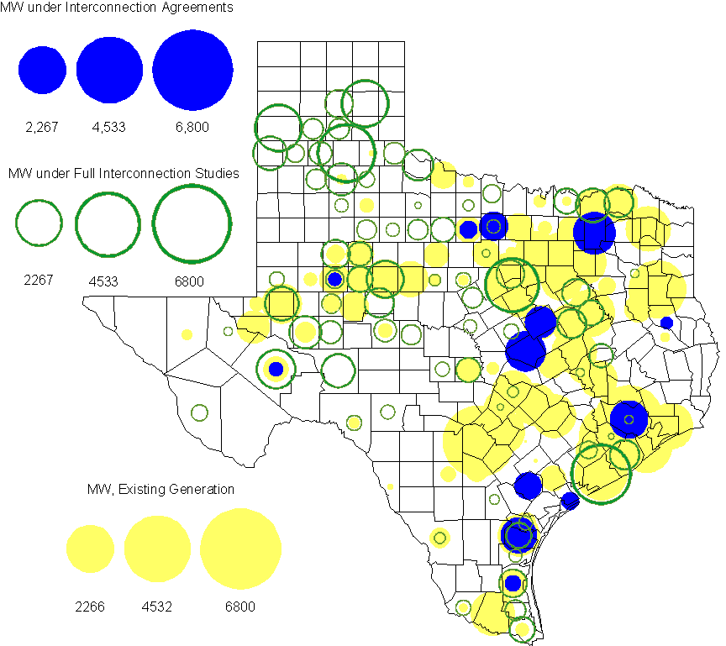

Generation Projects Undergoing Full Interconnection Studies (not otherwise public)

INR | County | Capacity | COD | Fuel |  | INR | County | Capacity | COD | Fuel
09INR0054 | Stonewall | 149 | TBD | Wind |  | 09INR0061 | Kent | 258 | TBD | Wind
10INR0048 | Hardeman | 1,000 | TBD | Wind |  | 10INR0016 | Childress | 150 | TBD | Wind
10INR0054 | Palo Pinto | 36 | TBD | Wind |  | 10INR0079 | Nolan | 60 | TBD | Wind
10INR0029 | Hood | 810 | TBD | Gas |  | 10INR0052a | Knox | 21 | TBD | Wind
10INR0013 | Upton | 400 | TBD | Wind |  | 10INR0041 | Floyd | 135 | TBD | Wind
09INR0074 | Motley | 70 | TBD | Wind |  | 11INR0029 | Throckmorton | 200 | TBD | Wind
10INR0019 | Deaf Smith | 609 | TBD | Wind |  | 10INR0033 | Armstrong | 399 | TBD | Wind
10INR0032 | Navarro | 775 | TBD | Gas |  | 10INR0080 | Presidio | 144 | TBD | Solar
10INR0042 | Mason | 170 | TBD | Wind |  | 10INR0051 | Brazoria | 200 | TBD | Wind
10INR0060 | Willacy | 401 | TBD | Wind |  | 07INR0013 | Coke | 200 | TBD | Wind
10INR0008 | Pecos | 500 | TBD | Wind |  | 10INR0077 | Callahan | 101 | TBD | Wind
11INR0076 | Archer | 94 | TBD | Wind |  | 11INR0088 | Brazos | 45 | Mar-11 | Gas
11INR0050 | Crosby | 149 | Mar-11 | Wind |  | 11INR0085 | Nolan | 106 | Mar-11 | Wind
11INR0075 | Fort Bend | 15 | Apr-11 | Coal |  | 11INR0071 | Harris | 7 | Apr-11 | Gas
11INR0086 | Travis | 60 | Apr-11 | Solar |  | 11INR0037 | Smith | 50 | May-11 | Biomass
11INR0058 | Pecos | 135 | May-11 | Solar |  | 11INR0060 | Tom Green | 90 | May-11 | Solar
11INR0061 | Presidio | 90 | May-11 | Solar |  | 11INR0062 | Nueces | 149 | May-11 | Wind
11INR0033a | Cameron | 200 | May-11 | Wind |  | 11INR0033b | Cameron | 200 | May-11 | Wind
10INR0023 | Haskell | 386 | Jun-11 | Wind |  | 09INR0050 | Fannin | 1,200 | Jun-11 | Gas
10INR0089 | Harris | 40 | Jun-11 | Other |  | 11INR0054 | San Patricio | 161 | Jun-11 | Wind
11INR0057 | Cameron | 165 | Jun-11 | Wind |  | 11INR0065 | Nueces | 240 | Jun-11 | Wind
11INR0091 | Webb | 92 | Jun-11 | Wind |  | 08INR0020 | Eastland | 200 | Jun-11 | Wind
11INR0019 | Upton | 200 | Jun-11 | Wind |  | 11INR0006 | Lamar | 579 | Jul-11 | Gas
11INR0040 | freestone | 640 | Aug-11 | Gas |  | 11INR0039 | Starr | 201 | Sep-11 | Wind
11INR0079a | Clay | 200 | Sep-11 | Wind |  | 11INR0047 | Deaf Smith | 600 | Sep-11 | Wind
10INR0062a | Pecos | 80 | Oct-11 | Wind |  | 10INR0081b | Clay | 19 | Oct-11 | Wind
10INR0021 | Grayson | 646 | Nov-11 | Gas |  | 11INR0090 | Howard | 60 | Nov-11 | Solar
11INR0094 | Kent | 100 | Nov-11 | Solar |  | 11INR0089 | Hays | 20 | Dec-11 | Solar
11INR0070 | Reeves | 50 | Dec-11 | Solar |  | 08INR0049 | Clay | 50 | Dec-11 | Wind
11INR0067 | Cameron | 78 | Dec-11 | Wind |  | 11INR0005 | Upton | 500 | Dec-11 | Wind
11INR0025 | Crockett | 400 | Dec-11 | Wind |  | 11INR0043 | Coke | 300 | Dec-11 | Wind
10INR0082 | Travis | 30 | Dec-11 | Solar |  | 09INR0048 | Jack | 100 | Dec-11 | Wind
10INR0085 | Ector | 40 | Jan-12 | Solar |  | 12INR0021 | Edwards | 165 | Jan-12 | Wind
12INR0033 | Motley | 150 | Jan-12 | Wind |  | 10INR0018 | Madison | 550 | Mar-12 | Gas
12INR0042 | Deaf Smith | 400 | Mar-12 | Wind |  | 12INR0045 | Kleberg | 135 | Mar-12 | Wind
12INR0007 | Lamar | 296 | May-12 | Gas |  | 11INR0049 | Wharton | 275 | May-12 | Gas
09INR0031 | Ector | 275 | May-12 | Gas |  | 10INR0081a | Clay | 30 | May-12 | Wind
12INR0006 | Limestone | 875 | Jun-12 | Coal |  | 08INR0031 | Childress | 100 | Jun-12 | Wind
12INR0053 | Crockett | 615 | Jun-12 | Wind |  | 08INR0041 | Coke | 200 | Oct-12 | Wind
12INR0026 | Randall | 400 | Oct-12 | Wind |  | 12INR0035 | Nueces | 249 | Nov-12 | Wind
08INR0044 | Concho | 200 | Nov-12 | Wind |  | 08INR0054 | Comanche | 401 | Dec-12 | Wind
11INR0081 | Live Oak | 72 | Dec-12 | Wind |  | 08INR0042 | Coke | 200 | Dec-12 | Wind
09INR0025 | Concho | 180 | Dec-12 | Wind |  | 12INR0005 | Floyd | 1,100 | Dec-12 | Wind
12INR0029 | Swisher | 500 | Dec-12 | Wind |  | 10INR0024 | Briscoe | 2,940 | Jan-13 | Wind
12INR0027 | Gray | 200 | Jan-13 | Wind |  | 09INR0058 | Howard | 250 | Mar-13 | Wind
10INR0056 | Borden | 249 | Mar-13 | Wind |  | 11INR0082B | Val Verde | 150 | Mar-13 | Wind
11INR0083B | Crockett | 100 | Mar-13 | Wind |  | 12INR0034 | Borden | 342 | Mar-13 | Wind
12INR0018 | Gray | 500 | Apr-13 | Wind |  | 10INR0062b | Pecos | 220 | May-13 | Wind
13INR0020a | Glasscock | 200 | May-13 | Wind |  | 09INR0041 | Mitchell | 300 | Jun-13 | Wind
09INR0051 | Borden | 249 | Jun-13 | Wind |  | 13INR0023 | Ector | 240 | Jul-13 | Gas
13INR0016 | Deaf Smith | 251 | Aug-13 | Wind |  | 11INR0082A | Val Verde | 50 | Sep-13 | Wind
11INR0083A | Crockett | 50 | Sep-13 | Wind |  | 13INR0005 | Carson | 600 | Oct-13 | Wind
13INR0004 | Deaf Smith | 500 | Oct-13 | Wind |  | 13INR0028 | Hale | 392 | Nov-13 | Gas

Wind Generation
Wind Capacity Installed by Year

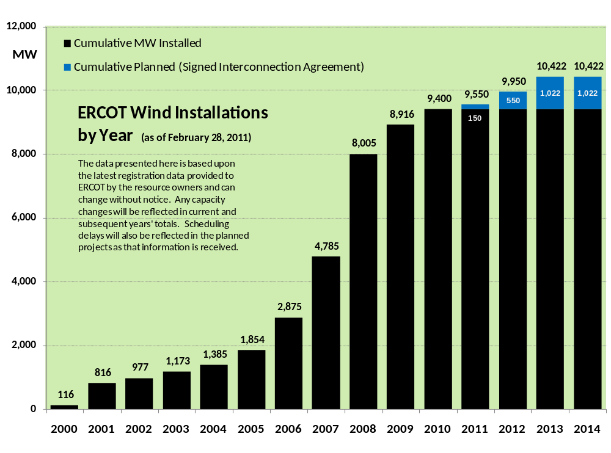

County Location of Installed Capacity and Interconnection Requests (Wind only)

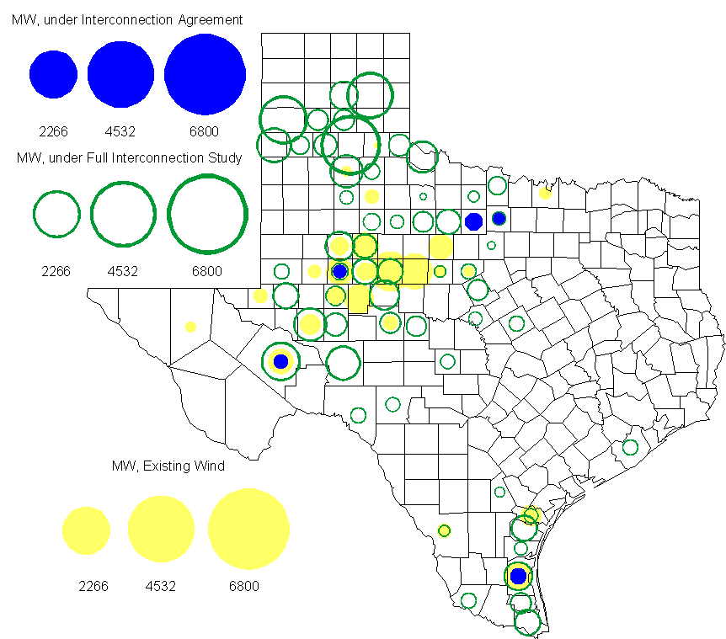

Regional Planning Group Project Reviews

- Brazos Electric Cooperative has submitted a project to move some load that is currently being served by the Entergy Texas system into the ERCOT system. The project would involve disconnecting the subject load from the Entergy Texas system, constructing a new 345/ 138 kV substation in ERCOT, upgrading an existing 69 kV line in the ERCOT system and constructing two new 138 kV lines to serve the load from the ERCOT system. The estimated cost of this project is $51.1 M. This Tier 1 project is currently undergoing ERCOT Independent Review.

- CenterPoint Energy has submitted the South Lane City to West Columbia 138 kV upgrade project. This is a Tier 3 project that is estimated to cost $ 23.6 million. The Regional Planning Group (RPG) has reviewed and accepted this Tier 3 transmission project.

- CenterPoint Energy has submitted the 2014 Houston Area Dynamic Reactive Project to to address the need for additional dynamic reactive compensation in the Houston area. This project calls for dynamic reactive devices at two locations (on the CenterPoint’s transmission system), with the compensation devices to be in service before summer peak 2014. The approximate cost for this project is $125 Million, depending on the selected dynamic reactive device technology. This Tier 1 project is currently undergoing ERCOT Independent Review.

Congestion Costs
Dollars shown in graphs are settlement quality.

OOMC and RUC net Make Whole payment in million$
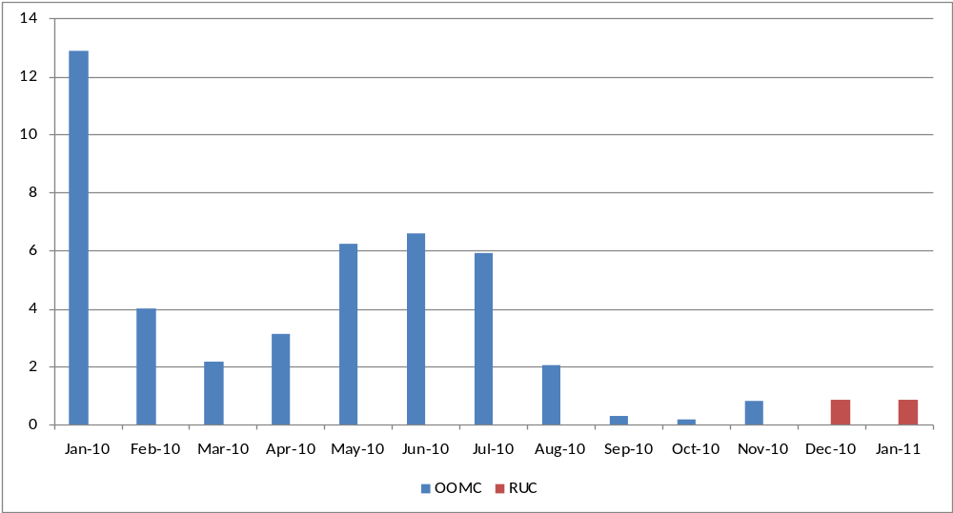

Monthly Average MCPE and LMP
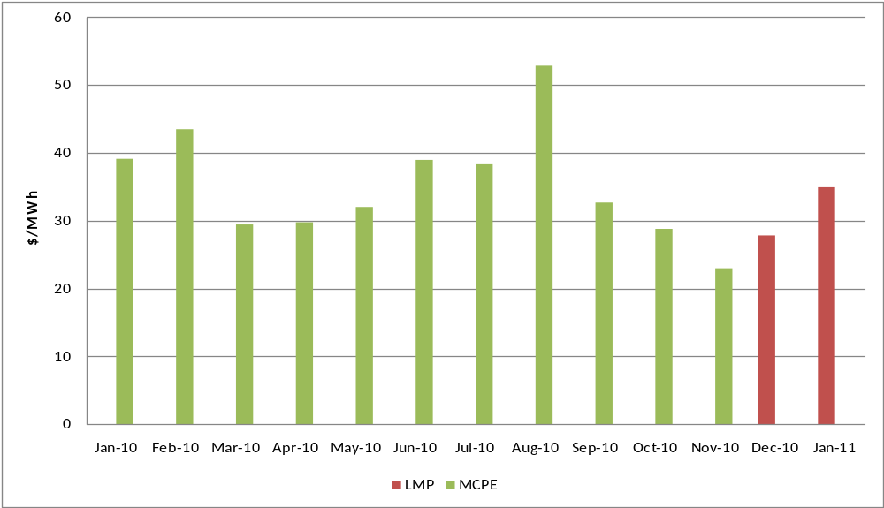
Binding Constraints - January 2011
Contingency | Binding Element | Number of 5-min intervals | Shadow Price Range $/MWh | Estimated Congestion Cost $ (Shadow Price*Limit) | Transmission Project | Clearance
BASE CASE | Valley Import | 259 | 0 - 5000 | 11,349,558
BASE CASE | West to North Stability Limit | 1840 | 0 - 2833 | 6,613,340 | CREZ
Lon Hill - North Edinburg 345kV | Rio Hondo 345kV Series Capacitor 1 | 15 | 460 - 4500 | 3,251,815
Watermill - Desoto Switch & Cedar Hill 345kV | West Levee 345/138kV autotransformer | 11 | 4500 - 4500 | 2,813,100 | 5YTP [2009-R21]
Denton - Argyle & West Denton 138kV,  Fort Worth - W_Dent 138kV | West Denton - Jim Cristal 138kV | 61 | 0 - 3500 | 2,091,723 | 5YTP [2009-R11]
Lewisville Switch 345/138kV AT1,  Parker Switch - Eagle Mountain - Roanoke 345kV,  Lewisville Switch - Carrollton Northwest 345kV | Lewisville Jones Street - Lewisville Switch 138kV | 318 | 0 - 3500 | 2,027,937 |  | Outage on Lewisville - Roanoke Switch 345kV, Lewisville - Argyle 138kV
Braunig - Toyota & Valley 138kV,  Fern Street - Ball Park 138kV,  Streich - Braunig 138kV,  Calavers -Streich 138kV | Five Points - Westside CPS 138kV | 975 | 0 - 3500 | 1,447,941 | Westside substation equipment upgrade [12TPIT0054] | Outage on Cagnon - Marbach 138kV, Marbach - Valley 138kV
Moss Switch - Holt Switch 138kV | Odessa North 138/69kV autotransformer | 79 | 0 - 2800 | 663,020 | 5YTP [2009-R4]
Gail - Keysb 138kV | Ackerly Vealmoor Switch - Ackerly 69kV | 134 | 0 - 2800 | 576,371 | Rebuild existing 69kV line [11TPIT0060]
Farmersville - Monticello 345kV | Monticello SES - Sulpher Springs Switch 345kV | 25 | 0 - 4500 | 460,973

Wind Generation as a Percent of Load
One-hour average Settlement quality data shown.

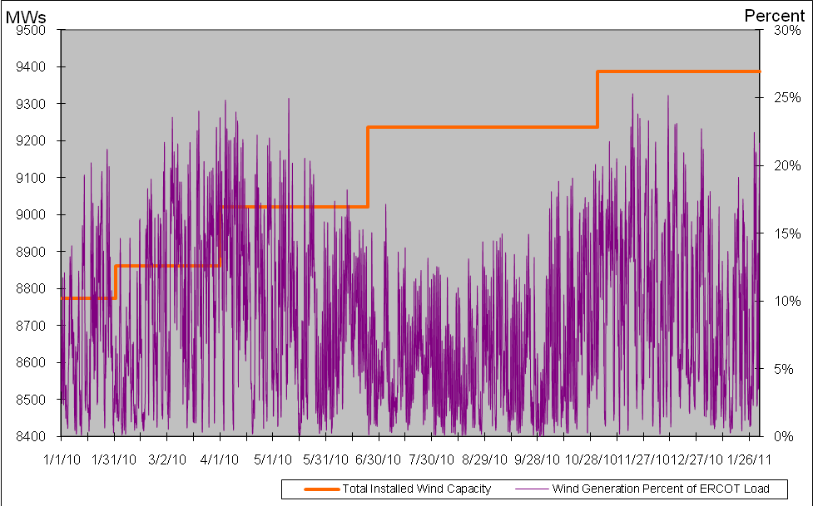

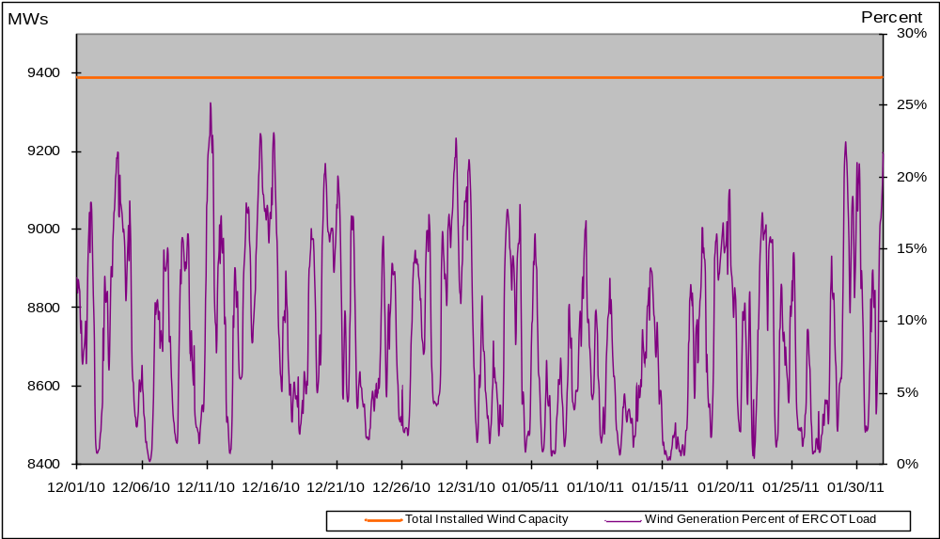
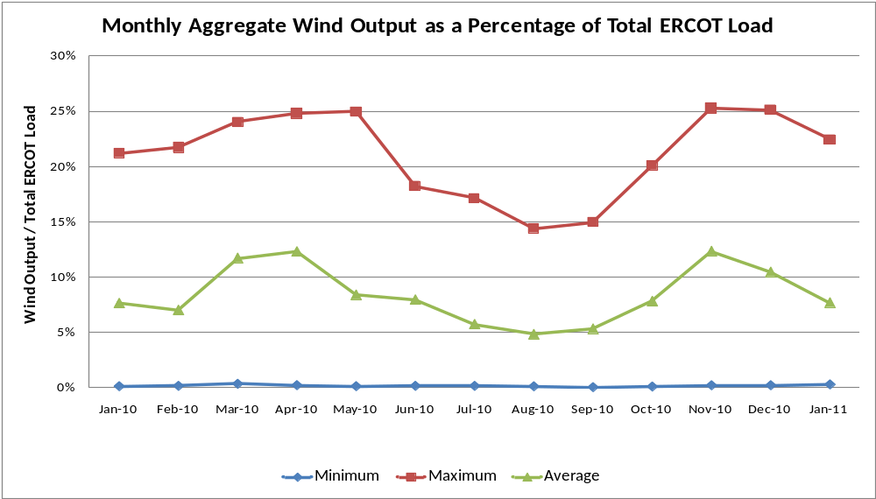

Planning Model Activities
- ERCOT and SSWG agreed to use ROS Option 2 to build the 2011 Data Set A and B cases transitioning to using ROS Option 1 starting with Data Set A in April 2012.
- ERCOT and the TSP are working to complete Cost Benefit Analysis for SCR760 based on the ROS approved comments from the January meeting and readied the CBA for presentation to TAC on March 3, 2011.
- ERCOT is working on several defects with Siemens regarding the Topology Processor and will receive a new release in early March 2011.
- ERCOT is working on creating a new MOD environment to use for the 2011 Case Building efforts. This will allow ERCOT to continue testing on the first MOD environment with the Topology Processor output.

Other Notable Activities
- Work on the 2010 Five-Year Transmission Plan (5YTP) is wrapping up. The studies & report have been completed for the 2010 5YTP. The report is currently going through ERCOT internal review.

- Transient Stability Study for 2011 Winter off-peak conditions: As part of the annual reliability assessment of the network, a transient stability study study is being performed on an ERCOT 2011 Winter off-peak case.

