ERCOT Operations Report
Jul 2011 ROS & OWG

Frequency Control
Time | Freq(Hz) | Duration (s)
7/1/2011 21:58 | 59.897 | 8 | Gen Deviation -800 MW in 2 min; Out of URS
7/7/2011 21:59 | 59.895 | 8 | Gen Deviation -1200 MW in 2 min; Out of URS
7/17/2011 0:11 | 59.899 | 60 | Gen Deviation -1300 in 2 min; Out of URS
7/17/2011 10:18 | 59.879 | 88 | Unit trip with 550 MW online; Out of URS
7/18/2011 0:10 | 59.884 | 188 | Gen Deviation -1500 MW in 5 min; Out of URS
7/18/2011 9:13 | 59.859 | 133 | Unit Trip with 452 MW online; Out of URS
7/18/2011 20:50 | 59.867 | 80 | Unit Trip with 585 MW online
7/19/2011 16:29 | 59.887 | 40 | Unit trip with 776 MW
7/20/2011 19:17 | 59.796 | 211 | Unit trip with 795 MW
7/24/2011 11:59 | 59.848 | 208 | Unit trip with 833 MW
Note: Time of frequency excursions outside the range of +/- 0.1 Hz.

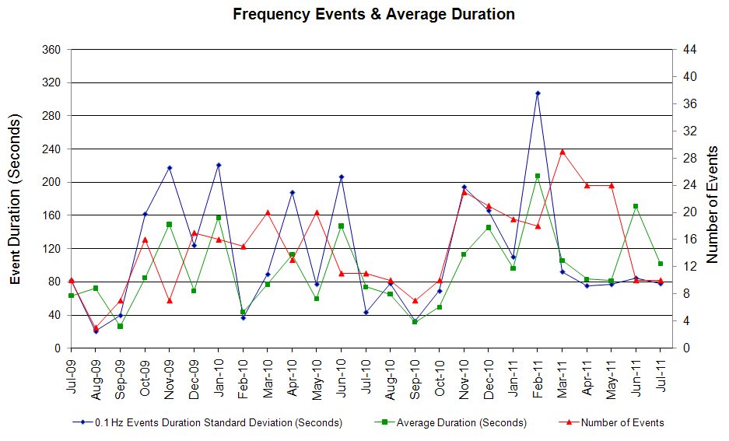

Deployed Responsive (Reported Above)
None

RUC Capacity Purchases
Weather Zone | Unit Days
COAST | 47
EAST | 3
NORTH CENTRAL | 19
SOUTH | 5
SOUTH CENTRAL | 12
Grand Total | 86

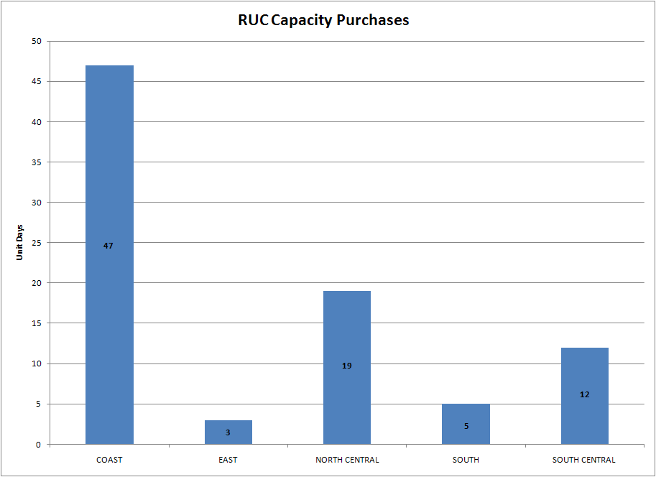

SCED Congestion Management Activity Congestion affected by outages
Remedial action plan has been developed for the element
Contingency | Overloaded Element | Days
Amoco North Cowden Tap - Moss Switch 138 kV | Odessa North Transformer 138/69 kV | 15
DCKT Greens Bayou - Gable & Hardy - Crocket 138 kV | Garrott - Midtown 138 kV | 14
Trinidad SES - Watermill & Tricorner 345kV | Trinidad SES 345/138kV AT6 | 11
Orange Grove Switching Station - Lon Hill 138 kV | Sinton - Skidmore 69 kV | 11
Lewisville Switch FMR1 345/138 kV | Lakepointe TNP - Carrollton Northwest 138 kV | 11
Venus Switch 3 - Big Brown SES 345 kV | Trinidad SES - Richland Chambers 345 kV | 7
Temple Switch - Salado Switch 345 kV | Bell County East Switch - Temple Switch 345 kV | 7
Meadow Sub - Oasis 345 kV | Midtown - Garrott 138 kV | 7
Bell County East Switch - Temple Switch 345 kV (425) | Bell County East Switch - Temple Switch 345 kV (435) | 7
Amoco North Cowden Tap - Moss Switch 138 kV | Odessa North - North Cowden 69 kV | 6
Gail Sub - Key Sub 138 kV | Ackerly Lyntegar - Sparenburg 69 kV | 5
Gail Sub - Key Sub 138 kV | Sparenburg - Lamesa 69 kV | 5
Basecase | Bell County East Switch - Temple Switch 345 kV (435) | 5
San Angelo Red Creek - Comanche Switch 345 kV | Flat Creek - Leon Switch 138 kV | 5
Temple Pecan Creek - Temple SW & Tradinghouse SES 345 kV | Troy Sub - Eddy Substation 69 kV | 5
Norwood Switch - Empire Central Tap 2 138 kV | Lombardy Lane - Lakemont Tap1 138 kV | 5
Royse Switch - Allen Switch 345 kV | Apollo - Richardson east 138 kV | 4
Moss Switch - Odessa EHV Switch 345 kV | Odessa - Odessa North 138 kV | 3
China Grove Switch - Morgan Creek SES 138 kV | China Grove Switch - Morgan SES 138kV | 3
Fort Stockton - Barilla 138 kV | Fort Stockton Switch - Barilla 69 kV | 3
Bluff Creek Switch - Exxon Sharon Ridge 138 kV | Ackerly Lyntegar - Sparenburg 69 kV | 3
Bluff Creek 345/138 kV Transformer 2 | Oak Creek CSW - Nicole 138 kV | 3
Paloduro Sub - Pearsall Switching Station 138 kV | Pearsall Switching Station 138/69 kV XFMER | 3
Venus Switch 3 - Big Brown SES 345 kV | Trinidad SES - Tri Corner 345 kV | 2
Lewisville Switch - Carrolton Northwest 345kV | Lakepointe TNP - Carrollton Northwest 138 kV | 2
Meadow Sub - Ph Robinson 345 kV | Friendswood TNP - Hastings TNP 138 kV | 2
Jeanetta - W.A. Parish 345 kV | Bellaire - Smithers 345 kV | 2
Sigmor - Three Rivers 138 kV | Sinton - Skidmore 68 kV | 2
Bell County Switch - Temple Switch 345 kV (435) | Bell County Switch - Temple Switch 345 kV (425) | 2
Watermill Switch - Tri Corner & Trinidad SES 345 kV | Seagoville Switch - Tri Corner 345 kV | 2
Olinger - Ben Davis & Elm grove 138 kV | Firewheel - Olinger 138 kV | 2
Permian Basin SES to Wind Sub 138 kV | Permian Basin SES axfmr2 69/138 kV | 2
Transformer 1 Atkins 138/69 kV | Nall Lane – Briarcrest 69 kV | 2
Caney Creek - Dyann 138 kV | South Lane City - New Gulf 138 kV | 2
Amoco North Cowden Tap - Moss Switch 138 kV | Odessa North - Odessa Basin Switch 69 kV | 1
Trinidad SES - Watermill & Tricorner 345kV | Forest Grove Switch - Mabank Tap 138 kV | 1
Venus Switch 3 - Big Brown SES 345 kV | Trinidad SES - Watermill Switch 345 kV | 1
Royse Switch - Allen Switch 345 kV | Ben Davis - Pkrmx 138 kV | 1
Moss Switch - Odessa EHV Switch 345 kV | Odessa EHV Switch - Big Three Odessa Tap 138 kV | 1
Lewisville Switch - Carrolton Northwest 345kV | Collin SES - Frisco A 138kV | 1
Meadow Sub - Ph Robinson 345 kV | North Alvin TNP - Hastings TNP 138 kV | 1
Watermill Switch - Limestone Plant 345 kV | Jewett - Big Brown SES 345 kV | 1
Watermill Switch - Limestone Plant 345 kV | Jewett - Rattlesnake Rd Switch 345 kV | 1
Rodd Field - Holly 138 kV | Cabaniss - Airline CSW 138 kV | 1
Liggett Switch 345/138 kV | Mayfield Tap North - Cedar Hill Switch 138 kV | 1
Trinidad SES - Richland Chambers 345 kV | Big Brown SES - Venus Switch 345 kV | 1
Watermill Switch -West Levee Switch & Sargent Road 345 kV | Duncanville South - Cedar Hill Tu 138 kV | 1
Cagnon 345/138 kV XFMR1 | Cagnon 345/138 kV XFM4H | 1
Moss Switch - Westover 138 kV | Moss Switch - Amoco North Cowden Tap 138 kV | 1
Lon Hill - Nelson Sharpe 345kV | Barney Davis - Alazan 138 kV | 1
Cabaniss - Airline CSW 138 kV | Barney Davis - Alazan 138 kV | 1
Moore Switching Station - Downie Switching Station 138 kV | Uvalde CSW - West Batesville 138 kV | 1
Bell County East - Temple Switch 138kV | Seaton - Poage 69 kV | 1
Abilene South - Bluff Creek 138 kV | Oak Creek CSW - Nicole 138 kV | 1
Transformer Hiway 9 69a2 138/69 kV | Koch Up River 138/69 kV Transformer | 1
Lobo - San Miguel 345 kV | Laquinta - Lobo 138 kV | 1
Air Liquid AEP - Valero East 69 kV | Koch Up River 138_69A1 XFMR | 1
Collin SES - Collin Switch 138 kV | Allen Switch - Plano Custer Road 138 kV | 1
Chambers - King & Northbelt - Cedar Bayou Plant 345 kV | Exxon - Lynchberg 138 kV | 1

Generic Transmission Limits (GTL’s)
GTL | Days
West – North | 4

New RAP, PCAP (Date indicates last update of RAP, PCAP not implementation date.)
None

SPS (RAS) (New, Modified, Removed)
None

New Procedures/Forms/Operations Bulletins
Date | Subject | Bulletin No.
07/20/2011 | Transmission and Security Desk V1 Rev 8 | 547
07/20/2011 | Shift Supervisor Desk V1 Rev 6 | 546
07/20/2011 | Resource Desk V1 Rev 8 | 545
07/20/2011 | Reliability Unit Commitment V1 Rev 7 | 544
07/20/2011 | Real Time Desk V1 Rev 8 | 543
07/20/2011 | DC Tie Desk V1 Rev 7 | 542

Load Shed Incidences
None

EEA
None

System Voltage Problems
None

Application Issues

07/23 11:05 ERCOT issued an Emergency notice due to SCED failure.

Communication Issues
None

ERCOT peak (Unofficial)
07/27 17:00 65,317 MW

Yearly MTLF Error Comparison
Yearly Mid-Term (Hourly) Load Forecast Error Comparison for the ERCOT Forecast
Month | MAPE for MTLF at 16:00 Day-Ahead
Month | 2008 | 2009 | 2010 | 2011
January | 3.30 | 4.11 | 3.78 | 2.91
February | 3.59 | 3.49 | 3.79 | 3.46
March | 3.29 | 3.24 | 2.24 | 2.02
April | 2.45 | 2.66 | 2.47 | 3.55
May | 3.01 | 2.90 | 2.63 | 3.27
June | 2.81 | 2.89 | 2.84 | 2.28
July | 2.55 | 2.83 | 2.39 | 1.63
August | 3.66 | 3.07 | 2.29 | NA
September | 4.99 | 3.68 | 3.14 | NA
October | 2.79 | 2.92 | 2.37 | NA
November | 2.60 | 1.93 | 3.46 | NA
December | 4.54 | 3.70 | 2.60 | NA
Annual Average | 3.29 | 3.11 | 2.83 | 2.73

OCN, Advisory, Watch & Emergency Notices
Capacity
Date | Start | Event
7/2/2011 | 12:34 | ERCOT issued an OCN for a Projected Reserve Capacity Shortage for HE 1600 – 1900
7/3/2011 | 11:25 | ERCOT issued an OCN for a Projected Reserve Capacity Shortage for HE 1600 – 2400
7/3/2011 | 14:31 | ERCOT issued an OCN for a Projected Reserve Capacity Shortage for HE 1600 – 2400
7/4/2011 | 14:25 | ERCOT issued an OCN for a Projected Reserve Capacity Shortage for HE 1700 – 1900
7/4/2011 | 18:05 | ERCOT issued an Advisory due to Physical Responsive Capability (PRC) below 3000 MW.
7/5/2011 | 01:00 | ERCOT issued an OCN for a Projected Reserve Capacity Shortage for HE 1600 – 2100
7/5/2011 | 14:23 | ERCOT issued an OCN for a Projected Reserve Capacity Shortage for HE 1700 – 1800
7/6/2011 | 11:39 | ERCOT issued an OCN for a Projected Reserve Capacity Shortage for HE 1600 – 2100
7/7/2011 | 02:09 | ERCOT issued an OCN for a Projected Reserve Capacity Shortage for HE 1600 – 2100
7/8/2011 | 00:55 | ERCOT issued an OCN for a Projected Reserve Capacity Shortage for HE 1500 – 2000
7/11/2011 | 10:00 | ERCOT issued an Advisory due to Physical Responsive Capability (PRC) below 3000 MW.
7/12/2011 | 02:30 | ERCOT issued an OCN for a Projected Reserve Capacity Shortage for HE 1600 – 2000
7/12/2011 | 16:50 | ERCOT issued an Advisory due to Physical Responsive Capability (PRC) below 3000 MW.
7/13/2011 | 02:10 | ERCOT issued an OCN for a Projected Reserve Capacity Shortage for HE 1500 – 1900
7/13/2011 | 13:50 | ERCOT issued an Advisory due to Physical Responsive Capability (PRC) below 3000 MW.
7/13/2011 | 14:12 | ERCOT issued an Advisory due to Physical Responsive Capability (PRC) below 3000 MW.
7/13/2011 | 17:30 | ERCOT issued an OCN for a Projected Reserve Capacity Shortage for HE 2000 – 2400
7/14/2011 | 01:30 | ERCOT issued an OCN for a Projected Reserve Capacity Shortage for HE 1500 – 2400
7/14/2011 | 14:25 | ERCOT issued an Advisory due to Physical Responsive Capability (PRC) below 3000 MW.
7/15/2011 | 00:30 | ERCOT issued an OCN for a Projected Reserve Capacity Shortage for HE 1500 – 1900
7/15/2011 | 01:35 | ERCOT issued an OCN for a Projected Reserve Capacity Shortage for HE 1500 – 1900
7/15/2011 | 14:25 | ERCOT issued an Advisory due to Physical Responsive Capability (PRC) below 3000 MW.
7/17/2011 | 16:30 | ERCOT issued an Advisory due to Physical Responsive Capability (PRC) below 3000 MW.
7/18/2011 | 03:43 | ERCOT issued an OCN for a Projected Reserve Capacity Shortage for HE 1500 – 2000
7/18/2011 | 13:23 | ERCOT issued an Advisory due to Physical Responsive Capability (PRC) below 3000 MW.
7/19/2011 | 02:28 | ERCOT issued an OCN for a Projected Reserve Capacity Shortage for HE 1600 – 2200
7/20/2011 | 11:18 | ERCOT issued an OCN for a Projected Reserve Capacity Shortage for HE 1500 – 2200
7/20/2011 | 15:28 | ERCOT issued an Advisory due to Physical Responsive Capability (PRC) below 3000 MW.
7/20/2011 | 22:48 | ERCOT issued an OCN for a Projected Reserve Capacity Shortage for HE 1500 – 2000
7/21/2011 | 01:11 | ERCOT issued an OCN for a Projected Reserve Capacity Shortage for HE 1500 – 2000
7/21/2011 | 14:22 | ERCOT issued an Advisory due to Physical Responsive Capability (PRC) below 3000 MW.
7/23/2011 | 15:52 | ERCOT issued an Advisory due to Physical Responsive Capability (PRC) below 3000 MW.
7/24/2011 | 15:11 | ERCOT issued an Advisory due to Physical Responsive Capability (PRC) below 3000 MW.
7/24/2011 | 20:30 | ERCOT issued an OCN for a Projected Reserve Capacity Shortage for HE 1500 – 2100
7/25/2011 | 13:35 | ERCOT issued an Advisory due to Physical Responsive Capability (PRC) below 3000 MW.
7/25/2011 | 20:52 | ERCOT issued an OCN for a Projected Reserve Capacity Shortage for HE 1600 – 1900
7/26/2011 | 16:05 | ERCOT issued an Advisory due to Physical Responsive Capability (PRC) below 3000 MW.
7/27/2011 | 03:45 | ERCOT issued an OCN for a Projected Reserve Capacity Shortage for HE 1700 – 1800
7/27/2011 | 13:23 | ERCOT issued an OCN for a Projected Reserve Capacity Shortage for HE 1600 – 1800
7/27/2011 | 15:10 | ERCOT issued an Advisory due to Physical Responsive Capability (PRC) below 3000 MW.
7/28/2011 | 11:30 | ERCOT issued an OCN for a Projected Reserve Capacity Shortage for HE 1500 – 1800
7/29/2011 | 12:39 | ERCOT issued an OCN for a Projected Reserve Capacity Shortage for HE 1500 – 1700
7/30/2011 | 06:10 | ERCOT issued an OCN for a Projected Reserve Capacity Shortage for HE 1500 – 1800
7/30/2011 | 15:25 | ERCOT issued an OCN for a Projected Reserve Capacity Shortage for HE 1500 – 2300 07/31/11
7/31/2011 | 00:50 | ERCOT issued an OCN for a Projected Reserve Capacity Shortage for HE 1500 – 2300 07/31/11
7/31/2011 | 02:39 | ERCOT issued an OCN for a Projected Reserve Capacity Shortage for HE 1500-2300
7/31/2011 | 06:36 | ERCOT issued an OCN for a Projected Reserve Capacity Shortage for HE 15:00 23:00 07/31/11
7/31/2011 | 14:46 | ERCOT issued an Advisory due to Physical Responsive Capability (PRC) below 3000 MW.
7/31/2011 | 15:23 | ERCOT issued an OCN for a Projected Reserve Capacity Shortage for HE 1400 – 2100 08/01/11

Weather
07/28 06:00 ERCOT issued an advisory for Tropical Storm Don.

07/29 09:00 ERCOT issued a Watch for Tropical Storm Don.

Emergency Notice
None

Texas RE Event Analysis
07/12 20:40 ERCOT experienced the simultaneous loss of three 345 KV lines as a result of the large fire burning directly beneath the energized 345 KV lines, each circuit flashed causing phase to phase faults. At the same time, two wind generators tripped with approximately 15 MW each.

07/24 03:16 ERCOT experienced the simultaneous loss of one 345 KV line and three generating units (resulting in the loss of approximately 131 MW within the first minute of the event) due to issue with the overvoltage settings on the differential relay scheme for the 345 KV line.

07/30 08:31 ERCOT experienced the simultaneous loss of one 138 KV bus and two 138 KV lines. Preliminary investigation reported the cause was a snake getting into the bus. Investigation is ongoing.

