 |  |  |  | System Planning
Monthly Status Report
July 2011

 |  | Report Highlights
 | - ERCOT is currently tracking 206 active generation interconnection requests totaling over 63,000 MW. This includes over 37,000 MW of wind generation.
- ERCOT is currently reviewing proposed transmission improvements with a total cost of $642.7 Million
- Transmission Projects endorsed in 2011 total $23.6 Million
- All projects (in engineering, routing, licensing and construction) total approximately $10.0 Billion
- Transmission Projects energized in 2011 total about $401.8 million

Table of Contents
1. Generation Interconnection 1
1.1 New Generation Registering for Commercial Operations 1
1.2 Publicly Disclosed Generation Interconnection Projects 4
1.3 Generation Projects Undergoing Full Interconnection Studies (not otherwise public) 6
1.4 Wind Generation 8
2. Regional Planning Group Project Reviews 10
3. Congestion Costs 11
4. Wind Generation as a Percent of Load 13
5. Planning Model Activities 14
6. Other Notable Activities 15

1. Generation Interconnection
Additional information regarding detailed generation interconnection and impact studies is contained in the “Generation Project Interconnection Information” folder in the “Operations and System Planning” area on the ERCOT website: http://planning.ercot.com/login/login.

New Signed Generation Interconnection Agreements
10INR0077 - Kaiser Creek – Calahan County – 101 MW - Wind
11INR0071 – Air Liquide – Harris County – 20 MW - Gas

New Generation Registering for Commercial Operations
The total installed wind capacity is now reported as 9,452 MW by the resource owners through the registration process. Capacity by North, South and West is 292 MW, 1216 MW, and 7943 MW respectively. 850 MW is able to switch between the West and South zones.

Summary of Active Generation Interconnection Requests

GENERATION INTERCONNECTION REQUESTS CURRENTLY BEING PROCESSED
Currently tracking 206 active generation interconnection or change requests
As of July 31, 2011 | North | South | West | Total
Security Screening Study | 2 | 2 | 8 | 12
SSS Completed | 2 | 6 | 20 | 28
Full Interconnect Study | 20 | 20 | 94 | 134
FIS Completed | 1 | 2 | 6 | 9
Interconnect Agreement Completed | 8 | 10 | 5 | 23
Capacity under Interconnection Agreements | 5,122 | 4,411 | 651 | 10,184
Capacity for Grid, MW | 17,312 | 12,086 | 34,160 | 63,558
Wind Capacity, MW | 3,220 | 3,170 | 30,814 | 37,204

Fuel Type | Confidential Projects (MW) | Projects Under Full Study (MW) | Projects w/ Interconnect Agreement/Public Letter (MW) | Grand Total (MW)
Gas-CombinedCycle |  |  | 5,297 | 11,839
Gas-All Other |  |  | 7 | 715
Total Gas | 508 | 6,742 | 5,304 | 12,554
Nuclear |  |  | 5,900 | 5,900
Coal |  | 865 | 3,045 | 3,910
Wind | 3,684 | 27,970 | 5,550 | 37,204
Solar | 760 | 734 | 90 | 1,584
Biomass |  | 50 | 100 | 150
Other |  | 1,016 | 1,240 | 2,256
Grand Total | 4,952 | 37,377 | 21,229 | 63,558

Publicly Disclosed Generation Interconnection Projects
The table below summarizes the publicly disclosed generation projects for the ERCOT region.
(Status: IA=Interconnect Agreement, PL=Public Letter, XX= cancelled)
Generation Interconnections as of July 31, 2011
INR | SiteName | Status | County | Region | COD | Fuel Type |  | MW For Grid |  | Change from Last Report
08INR0065 | Buffalo Gap 4 and 5 | PL | Nolan | West | TBD |  | Wind |  | 465
09INR0029 | CFB Power Plant Units 11&12 | IA | Calhoun | South | TBD |  | Coal |  | 260
10INR0010 | Jack County 2 | IA | Jack | North | Sep-11 |  | Gas |  | 565
06INR0012b | Sherbino Mesa Wind Farm 2 | IA | Pecos | West | Oct-11 |  | Wind |  | 150
12INR0003 | Throckmorton Wind Farm | PL | Throckmorton | West | Dec-11 |  | Wind |  | 400
11INR0071 | Air Liquide Gulf Coast H2 Plant | IA | Harris | South | Dec-11 |  | Gas |  | 7 | NEW
09INR0034 | Gatesville Wind Farm | PL | Coryell | North | Dec-11 |  | Wind |  | 200
08INR0038 | M Bar Wind | PL | Andrews | West | Dec-11 |  | Wind |  | 194
10INR0082 | FRV AE Solar | IA | Travis | North | Dec-11 |  | Solar |  | 30
08INR0025 | Pistol Hill Energy Center | PL | Ector | West | Dec-11 |  | Wind |  | 300
09INR0001 | Sandy Creek 1 | IA | McLennan | North | Feb-12 |  | Coal |  | 925
11INR0084 | 2W Whatley Phase 1 | PL | Ector | West | Mar-12 |  | Wind |  | 45
08INR0062 | Trinity Hills | IA | Young | West | Mar-12 |  | Wind |  | 250
09INR0037 | Scurry County Wind III | PL | Scurry | West | Jun-12 |  | Wind |  | 350
09INR0024 | B&B Panhandle Wind | PL | Carson | West | Jun-12 |  | Wind |  | 1,001
09INR0007 | Nacogdoches Project | IA | Nacogdoches | North | Jun-12 |  | Biomass |  | 100
11INR0086 | RRE Austin Solar | IA | Travis | South | Jun-12 |  | Solar |  | 60
10INR0060 | Magic Valley Wind Project | IA | Willacy | South | Jun-12 |  | Wind |  | 202
12INR0004 | Fort Concho Wind Farm | PL | Tom Green | West | Jul-12 |  | Wind |  | 400
12INR0043 | 2W Whatley Phase 2 | PL | Ector | West | Aug-12 |  | Wind |  | 290
08INR0011 | Senate Wind Project | IA | Jack | North | Sep-12 |  | Wind |  | 150
12INR0080 | Blanco Canyon Wind | PL | Taylor | West | Dec-12 |  | Wind |  | 300 | NEW
10INR0077 | Kaiser Creek Windfarm | IA | Callahan | West | Dec-12 |  | Wind |  | 101 | NEW
09INR0061 | WKN Mozart | IA | Kent | West | Dec-12 |  | Wind |  | 30
08INR0018 | Gunsight Mountain | IA | Howard | West | Dec-12 |  | Wind |  | 120
11INR0033 | Los Vientos | IA | Cameron | South | Dec-12 |  | Wind |  | 400
06INR0022c | Penascal Wind Farm 3 | IA | Kenedy | South | Dec-13 |  | Wind |  | 202
10INR0020a | Panda Temple Power | IA | Bell | North | May-14 |  | Gas |  | 780
06INR0006 | Cobisa-Greenville | IA | Hunt | North | May-14 |  | Gas |  | 1,792
14INR0005 | White Stallion Energy Center | PL | Matagorda | South | Jul-14 |  | Coal |  | 1,200
10INR0020b | Panda Temple Power | IA | Bell | North | May-15 |  | Gas |  | 780
10INR0022 | Pondera King Power Project | IA | Harris | South | Jun-15 |  | Gas |  | 1,380
12INR0016a | Las Brisas Energy Center | IA | Nueces | South | Oct-15 |  | Other |  | 620
15INR0008 | STP 3 and 4 | PL | Matagorda | South | Jun-16 |  | Nuclear |  | 2,700
12INR0016b | Las Brisas Energy Center | IA | Nueces | South | Oct-16 |  | Other |  | 620
 |  |  |  |  | TOTAL |  |  |  | 21,229

County Location of Installed Generation and Interconnection Requests (all fuels)

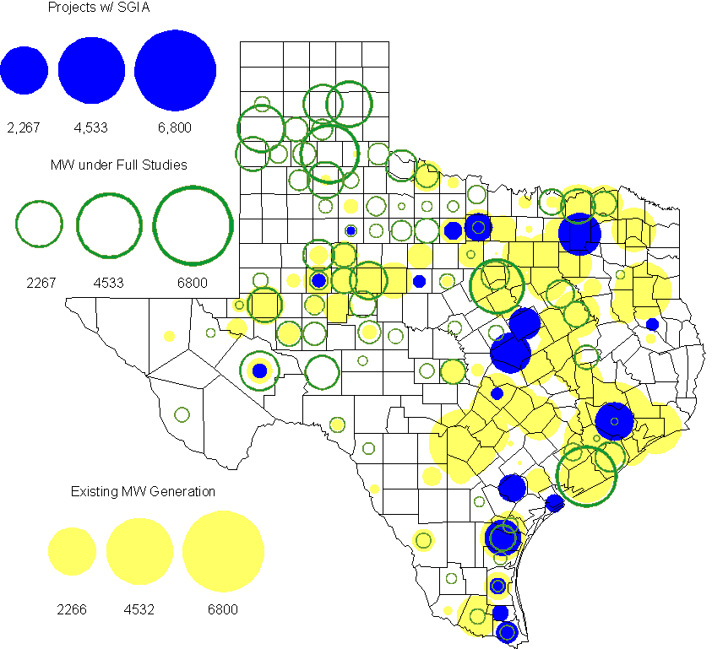

Generation Projects Undergoing Full Interconnection Studies (not otherwise public)

INR | County | Capacity | COD | Fuel |  | INR | County | Capacity | COD | Fuel
09INR0054 | Stonewall | 149 | Dec-09 | Wind |  | 10INR0048 | Hardeman | 1,000 | Jan-10 | Wind
10INR0079 | Nolan | 60 | May-10 | Wind |  | 10INR0054 | Palo Pinto | 36 | May-10 | Wind
10INR0016 | Childress | 150 | May-10 | Wind |  | 10INR0029 | Hood | 810 | Jun-10 | Gas
10INR0052a | Knox | 21 | Jul-10 | Wind |  | 10INR0013 | Upton | 400 | Jul-10 | Wind
10INR0041 | Floyd | 135 | Oct-10 | Wind |  | 09INR0074 | Motley | 70 | Oct-10 | Wind
11INR0029 | Throckmorton | 200 | Nov-10 | Wind |  | 10INR0051 | Brazoria | 200 | Dec-10 | Wind
10INR0042 | Mason | 170 | Dec-10 | Wind |  | 10INR0033 | Armstrong | 399 | Dec-10 | Wind
10INR0032 | Navarro | 775 | Dec-10 | Gas |  | 10INR0019 | Deaf Smith | 609 | Dec-10 | Wind
10INR0008 | Pecos | 500 | Dec-10 | Wind |  | 07INR0013 | Coke | 200 | Dec-10 | Wind
11INR0076 | Archer | 94 | Jan-11 | Wind |  | 11INR0093 | San Patricio | 34 | Mar-11 | Wind
11INR0085 | Nolan | 106 | Mar-11 | Wind |  | 11INR0075 | Fort Bend | 15 | Apr-11 | Coal
11INR0062 | Nueces | 149 | May-11 | Wind |  | 11INR0061 | Presidio | 90 | May-11 | Solar
11INR0060 | Tom Green | 90 | May-11 | Solar |  | 11INR0058 | Pecos | 135 | May-11 | Solar
11INR0037 | Smith | 50 | May-11 | Biomass |  | 11INR0091 | Webb | 92 | Jun-11 | Wind
11INR0065 | Nueces | 240 | Jun-11 | Wind |  | 11INR0057 | Cameron | 165 | Jun-11 | Wind
11INR0054 | San Patricio | 161 | Jun-11 | Wind |  | 11INR0019 | Upton | 200 | Jun-11 | Wind
10INR0089 | Harris | 40 | Jun-11 | Other |  | 10INR0023 | Haskell | 386 | Jun-11 | Wind
09INR0050 | Fannin | 1,200 | Jun-11 | Gas |  | 08INR0020 | Eastland | 200 | Jun-11 | Wind
11INR0006 | Lamar | 579 | Jul-11 | Gas |  | 11INR0040 | freestone | 640 | Aug-11 | Gas
11INR0079a | Clay | 200 | Sep-11 | Wind |  | 11INR0047 | Deaf Smith | 600 | Sep-11 | Wind
10INR0081b | Clay | 19 | Oct-11 | Wind |  | 10INR0062a | Pecos | 80 | Oct-11 | Wind
11INR0094 | Kent | 100 | Nov-11 | Solar |  | 11INR0090 | Howard | 60 | Nov-11 | Solar
10INR0021 | Grayson | 646 | Nov-11 | Gas |  | 11INR0070 | Reeves | 50 | Dec-11 | Solar
11INR0043 | Coke | 300 | Dec-11 | Wind |  | 11INR0025 | Crockett | 400 | Dec-11 | Wind
12INR0081 | Upton | 100 | Dec-11 | Wind |  | 12INR0033 | Motley | 150 | Jan-12 | Wind
10INR0085 | Ector | 40 | Jan-12 | Solar |  | 10INR0080 | Presidio | 81 | Jan-12 | Solar
12INR0054 | Jones | 200 | Feb-12 | Wind |  | 10INR0018 | Madison | 550 | Mar-12 | Gas
12INR0045 | Kleberg | 135 | Mar-12 | Wind |  | 12INR0075 | Wilbarger | 499 | Apr-12 | Wind
11INR0049 | Wharton | 275 | May-12 | gas |  | 10INR0081a | Clay | 30 | May-12 | Wind
09INR0031 | Ector | 275 | May-12 | Gas |  | 12INR0053 | Crockett | 615 | Jun-12 | Wind
08INR0031 | Childress | 100 | Jun-12 | Wind |  | 12INR0050 | King | 332 | Jun-12 | Wind
12INR0079 | Kenedy | 94 | Aug-12 | Wind |  | 12INR0076 | Winkler | 36 | Sep-12 | Other
12INR0026 | Randall | 400 | Oct-12 | Wind |  | 12INR0035 | Nueces | 249 | Nov-12 | Wind
08INR0044 | Concho | 200 | Nov-12 | Wind |  | 13INR0036 | Hidalgo | 200 | Dec-12 | Wind
12INR0072 | Kinney | 100 | Dec-12 | Wind |  | 12INR0068 | Jim Hogg | 80 | Dec-12 | Wind
12INR0067 | Webb | 94 | Dec-12 | Wind |  | 12INR0060 | Schleicher | 58 | Dec-12 | Wind
12INR0057 | Ector | 50 | Dec-12 | Solar |  | 12INR0055 | Baylor | 80 | Dec-12 | Wind
12INR0005 | Floyd | 1,100 | Dec-12 | Wind |  | 11INR0081 | Live Oak | 72 | Dec-12 | Wind
09INR0025 | Concho | 180 | Dec-12 | Wind |  | 08INR0042 | Coke | 200 | Dec-12 | Wind
12INR0029 | Swisher | 500 | Dec-12 | Wind |  | 09INR0048 | Jack | 113 | Dec-12 | Wind
08INR0049 | Clay | 50 | Dec-12 | Wind |  | 13INR0040 | Harris | 0 | Jan-13 | Gas
12INR0027 | Gray | 200 | Jan-13 | Wind |  | 10INR0024 | Briscoe | 2,940 | Jan-13 | Wind
13INR0010a | Parmer | 200 | Jan-13 | Wind |  | 12INR0034 | Borden | 342 | Mar-13 | Wind
11INR0083B | Crockett | 100 | Mar-13 | Wind |  | 11INR0082B | Val Verde | 150 | Mar-13 | Wind
11INR0050 | Crosby | 149 | Mar-13 | Wind |  | 10INR0056 | Borden | 249 | Mar-13 | Wind
09INR0058 | Howard | 250 | Mar-13 | Wind |  | 12INR0018 | Gray | 500 | Apr-13 | Wind
13INR0020a | Glasscock | 200 | May-13 | Wind |  | 10INR0062b | Pecos | 220 | May-13 | Wind
09INR0051 | Borden | 249 | Jun-13 | Wind |  | 09INR0041 | Mitchell | 300 | Jun-13 | Wind
13INR0023 | Ector | 240 | Jul-13 | Other |  | 13INR0016 | Deaf Smith | 251 | Aug-13 | Wind
13INR0025 | Randall | 150 | Sep-13 | Wind |  | 11INR0083A | Crockett | 50 | Sep-13 | Wind
11INR0082A | Val Verde | 50 | Sep-13 | Wind |  | 13INR0005 | Carson | 600 | Oct-13 | Wind
13INR0004 | Deaf Smith | 500 | Oct-13 | Wind |  | 13INR0028 | Hale | 392 | Nov-13 | Gas
13INR0026 | Oldham | 201 | Dec-13 | Wind |  | 13INR0017 | Childress | 200 | Dec-13 | Wind
13INR0007 | Pecos | 200 | Dec-13 | Wind |  | 12INR0002a | Briscoe | 200 | Dec-13 | Wind
11INR0013 | Mills | 150 | Dec-13 | Wind |  | 10INR0009 | Castro | 300 | Dec-13 | Wind
09INR0077 | Reagan | 500 | Dec-13 | Wind |  | 09INR0073 | Scurry | 200 | Dec-13 | Wind
13INR0006 | Gray | 750 | Jan-14 | Wind |  | 08INR0019c | Gray | 250 | Jan-14 | Wind
08INR0019b | Gray | 250 | Jan-14 | Wind |  | 08INR0019a | Gray | 250 | Jan-14 | Wind
13INR0010b | Parmer | 500 | Jan-14 | Wind |  | 13INR0020b | Glasscock | 150 | May-14 | Wind
10INR0015 | Mitchell | 350 | May-14 | Wind |  | 14INR0003 | Nolan | 850 | Jun-14 | Coal
12INR0042 | Deaf Smith | 400 | Sep-14 | Wind |  | 14INR0006 | Floyd | 151 | Oct-14 | Wind
14INR0001 | Pecos | 500 | Dec-14 | Wind |  | 13INR0021 | Llano | 600 | Dec-14 | Gas
12INR0002b | Briscoe | 200 | Dec-14 | Wind |  | 13INR0010c | Parmer | 500 | Jan-15 | Wind
15INR0011b | Borden | 38 | Dec-15 | Solar |  | 15INR0011a | Borden | 112 | Dec-15 | Wind
12INR0002c | Briscoe | 350 | Dec-15 | Wind |  | 16INR0002 | Brazoria | 700 | Jun-17 | Other

Wind Generation
Wind Capacity Installed by Year

County Location of Installed Capacity and Interconnection Requests (Wind only)

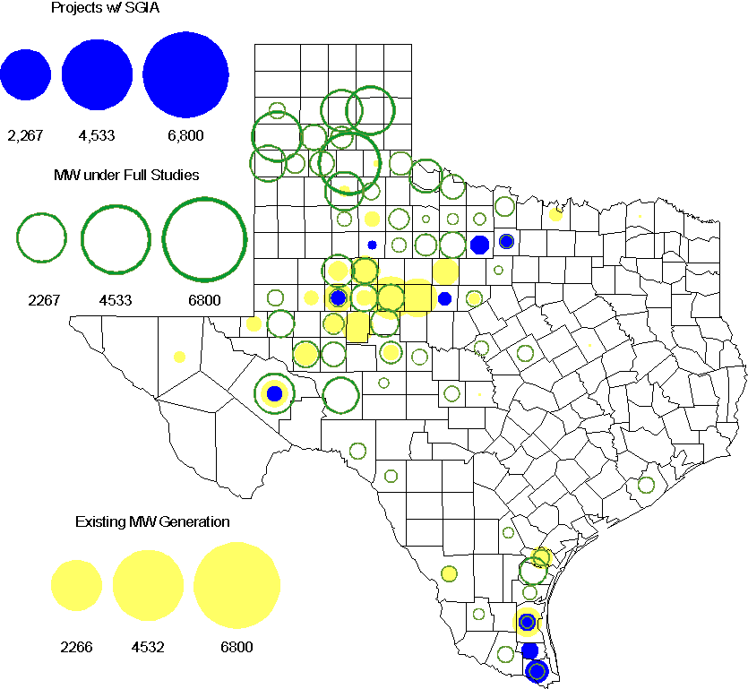

Regional Planning Group Project Reviews

- CenterPoint Energy has submitted the 2014 Houston Area Dynamic Reactive Project to address the need for additional dynamic reactive compensation in the Houston area. This project calls for dynamic reactive devices at two locations (on the CenterPoint’s transmission system), with the compensation devices to be in service before summer peak 2014. The approximate cost for this project is $125 Million, depending on the selected dynamic reactive device technology. This Tier 1 project is currently undergoing ERCOT Independent Review.

- American Electric Power Service Corporation has submitted the Laredo to the lower Rio Grande Valley 345 kV Project to improve reliability of the lower Rio Grande Valley transmission system. This project proposes a new 345kV transmission line to be constructed from Laredo to the lower Rio Grande Valley to provide a third 345kV source to the area with an in-service date in the 2016/2017 timeframe. The estimated cost for this project is $379.5 Million. This Tier 1 project is currently undergoing ERCOT Independent Review.

- Sharyland Utilities (Sharyland) and Brownsville Public Utilities Board (BPUB) has submitted the Cross Valley Brownsville Loop project that proposes a new 345kV line from LaPalma to Loma Alta and a new 345kV line from Loma Alta to Frontera. The estimated cost for this project is $117.9 Million. This Tier 1 project is undergoing ERCOT Independent Review. Sharyland and BPUB submitted an study addendum report to the Cross valley project with additional options which is is currently undergoing ERCOT Independent Review.

- TNMP has submitted the Wink-Cochise-Pecos 69 kV line rebuild project to solve the existing and forecasted West Texas North (WTN) voltage problems. The estimated cost for this project is $20.3 Million. This Tier 3 project is currently in the RPG study mode.

Congestion Costs
Dollars shown in RUC Make Whole payment graph are settlement quality.

OOMC and RUC net Make Whole payment in million$

Monthly Average MCPE and LMP

Binding Constraints - July 2011
Contingency | Binding Element | Number of 5-min intervals | Shadow Price Range $/MWh | Estimated Congestion Cost $ (Shadow Price*Limit) | Transmission Project | Clearance
Lewisville Switch 345/138kV Auto, Lewisville Switch - Carrollton Northwest 345kV | Carrollton Northwest - Lakepointe 138kV | 429 | 0 - 3500 | 14,243,808 | Upgrade NW Carrollton - Lakepointe (TNMP) 138 kV line [14TPIT0014]
W.A. Parish - Jeanetta 345kV | Smithers - Bellaire 345kV | 64 | 0 - 4500 | 6,919,506 |  | Outage on  W.A. Parish – Jeanetta 345kV
Sandow Switch – Temple Switch 345kV, Salado – Temple Switch 345kV | Bell County East – Temple Switch 345kV | 788 | 0 – 4500 | 6,835,405 |  | High South – North flows
China Grove Switch – Morgan Creek SES 138kV | Morgan Creek SES – China Grove Switch 138kV | 104 | 0 – 3500 | 4,960,187 |  | Low west wind
Trinidad-Watermill and Tricorner 345kV | Trinidad SES 345/138kV Autotransformer | 275 | 0 – 3500 | 4,613,796 |  | High South – North flows
Amoco North Cowden Tap - North Cowden Amoco 138kV | Odessa North 138/69kV Autotransformer | 333 | 0 - 2800 | 3,289,684 | 5YTP [2010-R7, R8]
Norwood Switch - Empire Central Tap 2 138kV | Lakemont 1 Tap - Lombardy Lane 138kV | 97 | 0 - 3500 | 3,189,081
Big Brown Ses - Venus Switch 345kV | Richland Chambers - Trinidad SES 345kV | 193 | 0 - 4500 | 2,513,968 |  | High South – North flows
Orange Grove Switching Station - Lon Hill 138 kV,  Sigmor - Three Rivers 138kV | Sinton - Skidmore 69kV | 805 | 0 - 2800 | 2,155,104 | Lon Hill to Sinton 69 kV Line Modifications [11TPIT0103]
Amoco North Cowden Tap - North Cowden Amoco 138kV | Odessa North - North Cowden 69kV | 369 | 0 - 2800 | 2,013,074 | Odessa North - North Cowden 69 kV line upgrade [14TPIT0009]
Binding Constraints - January to July 2011
Contingency | Binding Element | Number of 5-min intervals | Shadow Price Range $/MWh | Estimated Congestion Cost $ (Shadow Price*Limit) | Transmission Project
BASE CASE | West to North Stability Limit | 16394 | 0 - 3910 | 74,382,777 | CREZ
BASE CASE | Valley Import | 273 | 0 - 5000 | 41,457,339
Nelson Sharpe - Ajo 345kV | Lon Hill - North Edinburg 345kV | 78 | 0 - 4500 | 31,689,757
Denton - Argyle & West Denton 138kV,  Fort Worth - W_Dent 138kV | West Denton - Jim Cristal 138kV | 383 | 40 - 3500 | 22,404,765 | 5YTP [2010-R12]
Lewisville Switch 345/138kV Auto,  Lewisville Switch - Carrollton Northwest 345kV | Carrollton Northwest - Lakepointe 138kV | 429 | 0 - 3500 | 14,243,808 | Upgrade NW Carrollton - Lakepointe (TNMP) 138 kV line [14TPIT0014]
BASE CASE,  Zorn - Marion and Clear Springs 345kV,  Clear Springs 345/138kV Autotransformer | Marion 345/138kV Autotransformer | 391 | 0 - 4500 | 13,826,062
Abilene South - Bluff Creek 138kV,  Bluff Creek Auto T2_H & T2_L & T2_T | Nicole - Oak Creek 138kV | 8584 | 0 - 3500 | 10,705,811 | CREZ
Greens Bayou - Gable and Hardy - Crocket 138kV,  Singleton - Tomball and Singleton - Roanes Prairie 345kV,  Meadow - Oasis 345kV,  Thermal Energy Coop - Blodgett 138kV | Garrott - Midtown 138kV | 3768 | 0 - 3500 | 10,158,439 | Upgrade 138 kV underground Ckt. 90 Garrott to Midtown to Polk [11TPIT0072]
Gails To Keysb 138kV,  Willow Valley Switching Station - Sharon Ridge Exxon 138kV | Ackerly Lyntegar - Sparenburg 69kV | 3170 | 0 - 2800 | 10,092,284 | Lamesa - Ackerly Vealmoor 69 kV line rebuild  [ 11TPIT0060]
West Levee Switch 345/138kV AT1 | West Levee Switch 345/138kV AT2 | 98 | 0 - 3500 | 9,073,730 | 5YTP [2009-R21]

Wind Generation as a Percent of Load
One-hour average of total wind power output as a percentage of ERCOT load.
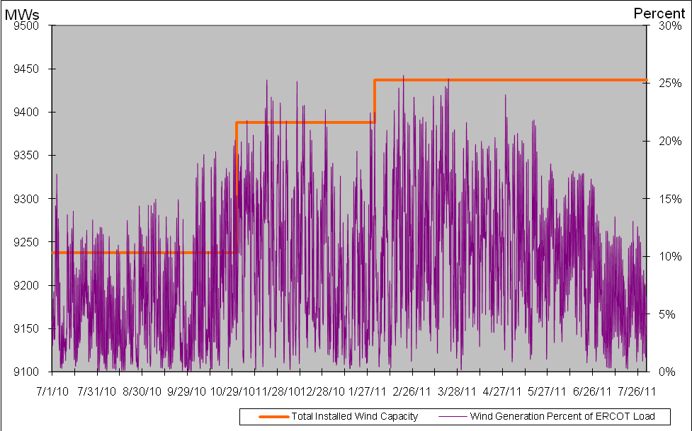

Planning Model Activities
- Work on Data Set A has been completed. Data Set B work has begun and has started one week late. The detailed case building schedule has been posted on MIS under Grid/Long-term Planning. The remaining schedule is as follows:
  - July 8, 2011 DSA Pass 6 Projects and Profiles due from all (on-time)
  - July 7 – Aug 3, 2011, Additional unplanned passes 7 to 11 completed with 2 day meeting on August 2 and 3rd in Taylor to finalize Data Set A cases.
  - Aug 4, 2011 DSA cases finalized and posted (delayed from July 15)
  - Aug 8, 2011 DSA Final Comparison Spreadsheet Template built (delayed from July 18)
  - August 8, 2011 DSB Start (delayed from August 1)
  - Aug 12, 2011 DSA Final Comparison Spreadsheet TSP Comments due (delayed from July 29)
  - Aug 17, 2011 DSA Final Comparison comments due for posting (delayed from Aug 1)
- Status update on SCR760, Changes Needed for Information Model Manager and Topology Processor for Planning Models, which was approved by the ERCOT Board in March 2011.
  - Bundle 1 (Items 3, 7 and 8): Statement of Work (SOW) completed. Sample output for all three items approved by ERCOT. Initial release and updated documentation due August 15.
  - Bundle 2 (Items 2, 4, 9): Item 5 removed from Bundle 2 to continue requirements definition without delaying remaining items 2, 4, and 9. ERCOT completed requirements with TSP review and is waiting on Siemens to update cost estimates due week of August 1.
  - Item 5: Additional requirements review completed by ERCOT and sent to Siemens to verify implementation. Will send to TSPs for review upon completion. Item 5 may rejoin Bundle 2 at code release, otherwise will continue separately.
  - Bundle 3 (Items 1 and 6): Asked Siemens to update document previously sent in December 2010 to determine differences between version 32 and version 30 of RAWD format. Update will determine differences through version 33 of RAWD.
SCR Sub Part | SCR Description | Status
SCR760-1 | Upgrade to PSS/E v32 | Submitted
SCR760-2 | Distribution Capacitor banks | Planning
SCR760-3 | Zero Impedance Line Ratings | Planning
SCR760-4 | Associate Loads and Capacitor banks with the correct CNG | Planning
SCR760-5 | Additional Transformer Data for Planning | Planning
SCR760-6 | FACTS Devices | Submitted
SCR760-7 | Assign valid PSSE IDs to Breakers/  Switches/ Series Devices | Planning
SCR760-8 | Phase shift of Autos for short circuit studies | Planning
SCR760-9 | Multisection Line Grouping | Planning
Table 1: In the following table:
- Red will be used to show status of Not Submitted, meaning that the SCR sub part has not been submitted to Siemens as a Service Request.
- Yellow will indicate that the SCR sub part has been submitted. The color will remain yellow and the status will change in order to Submitted, Planning (Requirements, SOW, Code Writing), Release (Siemens produces first code to test), and Testing (code has completed internal test and is moving through release management).
- Green will indicate that the code has been tested and installed on the machines that ERCOT uses to produce Topology Processor output for Planning and CRR.

Other Notable Activities
- West-to-North stability limits calculation completed for the current year 2011. ERCOT Operations is working on implementation.
- Cascade Analysis completed to satisfy NERC Standard PRC-023-1. System Planning will share results with appropriate TO’s.
- UFLS Assessment Study as required by NERC PRC-006 has been started.
- Transient Stability Study for 2011: As part of the annual reliability assessment of the network, a transient stability study is being performed on an ERCOT 2011 summer on-peak case.
- DFW Dynamic Reactive Reserve Study is in progress, looking into the minimum amount of generation to be online in or around the DFW region to minimize voltage collapse scenarios.
- Work on the 2011 Five-Year Transmission Plan is underway. The work is currently focused on preparing the 5YTP start cases (condition the SSWG base cases).

