

ERCOT Operations Report on the
Energy Emergency Alert (EEA) Level 1 Event
June 27, 2011

Executive Summary

An Energy Emergency Alert (EEA) Level 1 was declared at 15:25 on June 27, 2011 due to Physical Reserve Capability (PRC) being below 2,300MW. Low reserves appear to be caused by three separate large unit trips totaling 1,765 MW from about 12:54 to 14:38, just prior to peak demand.

At 12:54 one generator tripped with 679 MW. 13 minutes later at 13:07, the second resource tripped off with an additional 576 MW. Then at 14:38, a third resource tripped, which removed 510 MW from the system.

To worsen the situation, the wind generation began declining approximately 4,200 MW from 11:00 to 15:00, which was a contributor to some degree in the Reserves being depleted more quickly. In addition, load also increased approximately 4,020 MW during the hours of 13:00 – 15:00 window. Efforts stemmed the decline of reserves at around 15:25 and by 16:50 the system had demonstrated improved and improving conditions and EEA Level 1 was cancelled.

Time Line and Description of Significant Events

June 27, 2011

- 12:54:05 ERCOT system frequency prior to disturbance was 59.978 Hz.

- 12:54:15 First unit tripped with approximately 679 MW of generation.

- 12:54:15 ERCOT system frequency dropped to approximately 59.825 Hz immediately after the trip.

- 13:01:55 ERCOT system frequency recovered to 60 Hz.

- 13:07:55 Second unit tripped with approximately 576 MW.

- 13:07:55 ERCOT system frequency dropped to approximately 59.873 Hz after the trip, and reached the lowest value of 59.869 at 13:09:25.

- 13:14:50 ERCOT system frequency recovered to 60 Hz.

- 13:34 ERCOT issued an Advisory due to Physical Responsive Capability (PRC) dropped below 3,000 MW.

- 13:40 1,909 MW Non-Spinning Reserve (Non-Spin) was requested.

- 14:38:50 Third unit tripped causing the loss of approximately 510 MW of generation.

- 14:38:50 ERCOT system frequency dropped to approximately 59.849 Hz immediately after the trip.

- 14:45:05 ERCOT system frequency recovered to 60 Hz.

- 14:55 ERCOT issued Watch for PRC below 2,500 MW.

- 15:00 Media Appeal issued.

- 15:25 ERCOT declared EEA Level 1. PRC dropped below 2,300 MW.

- 16:50 EEA Level 1 was cancelled.

- 19:00 Media Appeal cancelled.

- 19:17 Watch cancelled.

- 19:50 Advisory cancelled.

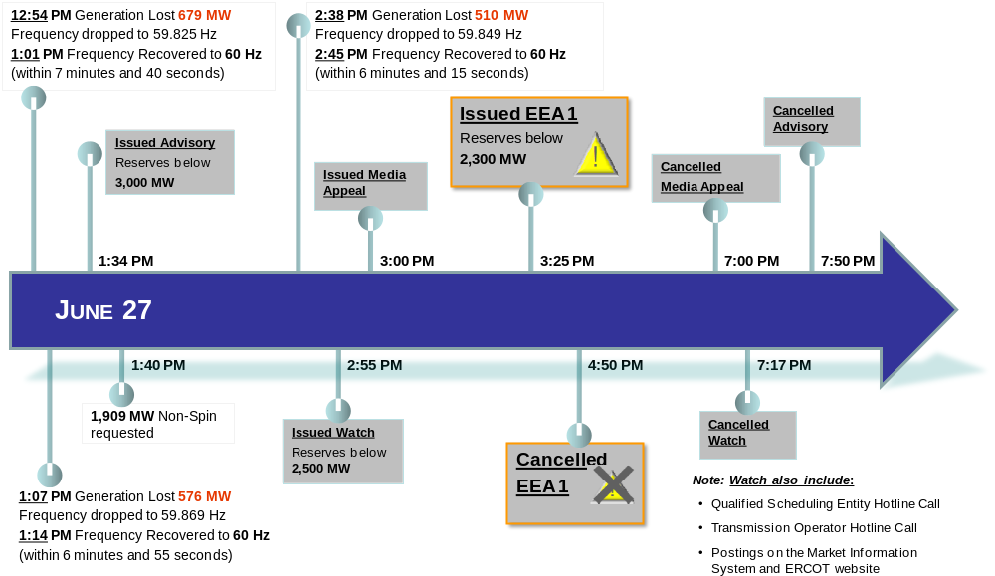
Figure 1 Event Timeline on June 27, 2011

Observations/Data Review

An Energy Emergency Alert (EEA) Level 1 was declared at 15:25 on June 27, 2011 due to Physical Reserve Capability (PRC) falling below 2,300 MW.

Initially at 13:34 ERCOT issued an Advisory when, following the two unit trips, PRC dipped below 3,000 MW. First unit was tripped by the generator operator to comply with main steam temperature limits, removing 679 MW at approximately 12:54. ERCOT load was approximately 56,966 MW and frequency dipped to 59.825 Hz; using on-line reserves ERCOT recovered to 60 Hz in about 7 minutes 40 seconds (~13:01:55).

Then the second unit tripped with 576 MW approximately 13 minutes after the first unit due to the loss of both feedwater pumps on low feedwater tank level. ERCOT load had climbed to 57,605 MW. Frequency immediately dropped to 59.873 Hz and continued to decline to 59.869 Hz where deployment of additional reserves allowed system frequency to recover to 60 Hz in about 6 minutes 55 seconds (~13:14:50). These two unit trips pushed PRC below 3,000MW prompting the Advisory at 13:34 and a request for 1,909 MW of Non-Spinning Reserves (Non-Spin) at 13:40.

By 14:00 PRC was looking better, but with load increasing, wind tailing off, and tripping 1,255 MW from the first and second unit trips, PRC again began to decline. By 14:24 PRC was again below 3,000MW. Then at 14:38 the third unit experienced a fuel control valve disruption that shut off fuel supply to the plant, taking another 510 MW off line. ERCOT load was now at 60,992 MW and frequency dipped to 59.849 Hz. Again the system responded with reserves to restore system frequency to 60 Hz in about 6 minutes 15 seconds (~14:45:05). However, that dropped PRC below 2,500 MW (Figure 2). Thus, at 14:55 ERCOT issued a Watch for Reserves falling below 2,500 MW, and issued a media appeal for energy conservation across the ERCOT area. This initiated the filings of the appropriate DOE reporting forms.

With increasing load, falling wind, and the loss of 3 large units, the trend for reserves continued to decline. At 15:25 an emergency notice was sent out declaring ERCOT was in EEA Level 1.

Although PRC was below 2,300 MW for only a minute, the EEA level 1 was continued for an hour and 25 minutes until actions taken put reserves on a sustained upward trend. After climbing above 2,700 the EEA Level 1 was cancelled at 16:50.
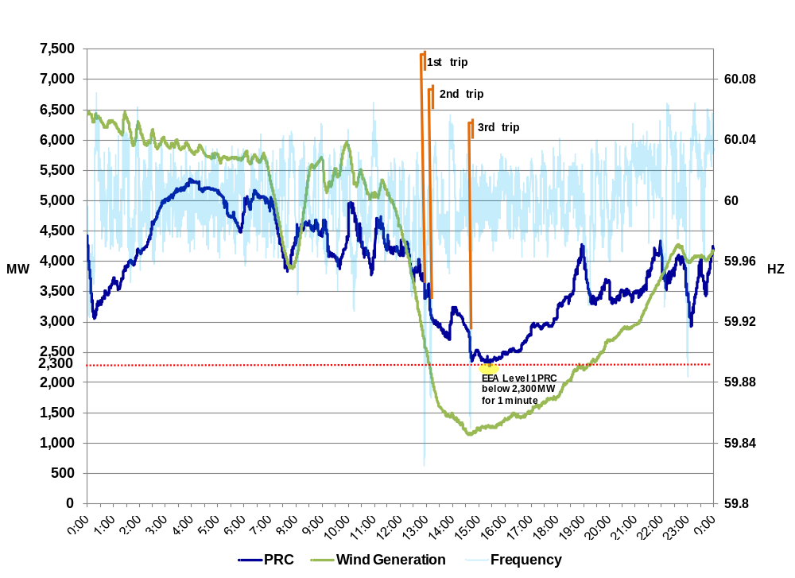
Figure 2 PRC, Wind Generation and Frequency on June 27, 2011

ERCOT Load, Online Capacity, Offline Non-Spin and Net DC flow

Below is an illustration of ERCOT Load, Online Capacity, Non-Spinning Reserve (Non-Spin), Net DC tie flow and Frequency during the event.

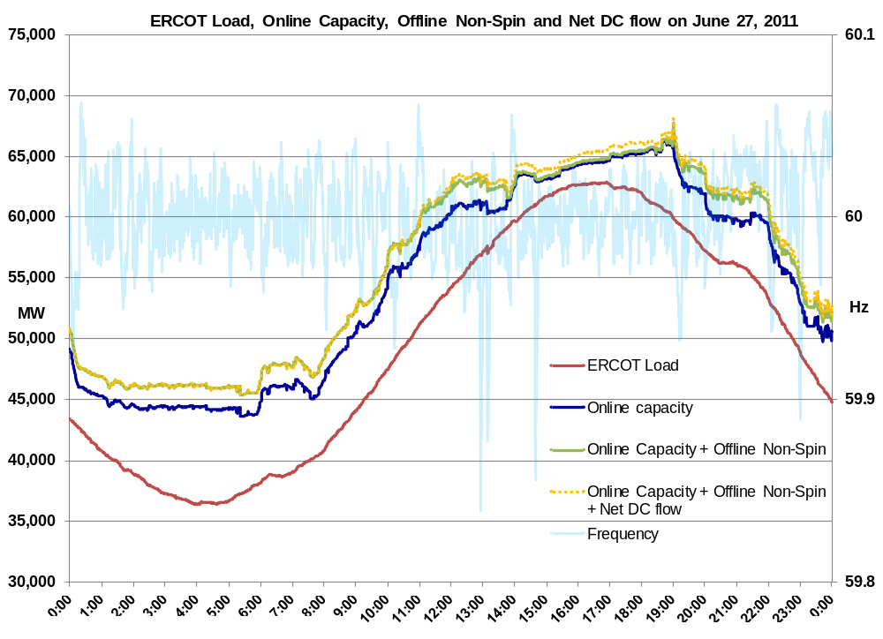

Figure 3 ERCOT Load, Online Capacity, Offline Non-Spin and Net DC flow on June 27, 2011

Load Forecast Error

The Mean Absolute Percent Error (MAPE) for the day was ~1 %; ~ 2% for the month to date.

MAPE
FORECAST | DAILY | MONTHLY
ERCOT Active | 1.15% | 2.35%
AREVA 2003 | 1.40% | 2.50%
AREVA 2006 | 1.61% | 2.60%
PRT Total | 0.74% | 2.24%
Sum of Zones | 1.40% | 2.33%

Table 1 MAPE for Mid-Term Load Forecast Error on June 27, 2011

Actual Load was ~800 MW above the ERCOT Active Forecast for HE 1200

Actual Load was ~830 MW above the ERCOT Active Forecast for HE 1300

Actual Load was ~740 MW above the ERCOT Active Forecast for HE 1400

Actual Load was ~440 MW above the ERCOT Active Forecast for HE 1500

Actual Load was ~120 MW below the ERCOT Active Forecast for HE 1600

Actual Load was ~990 MW below the ERCOT Active Forecast for HE 1700

Actual Load was ~1300 MW below the ERCOT Active Forecast for HE 1800

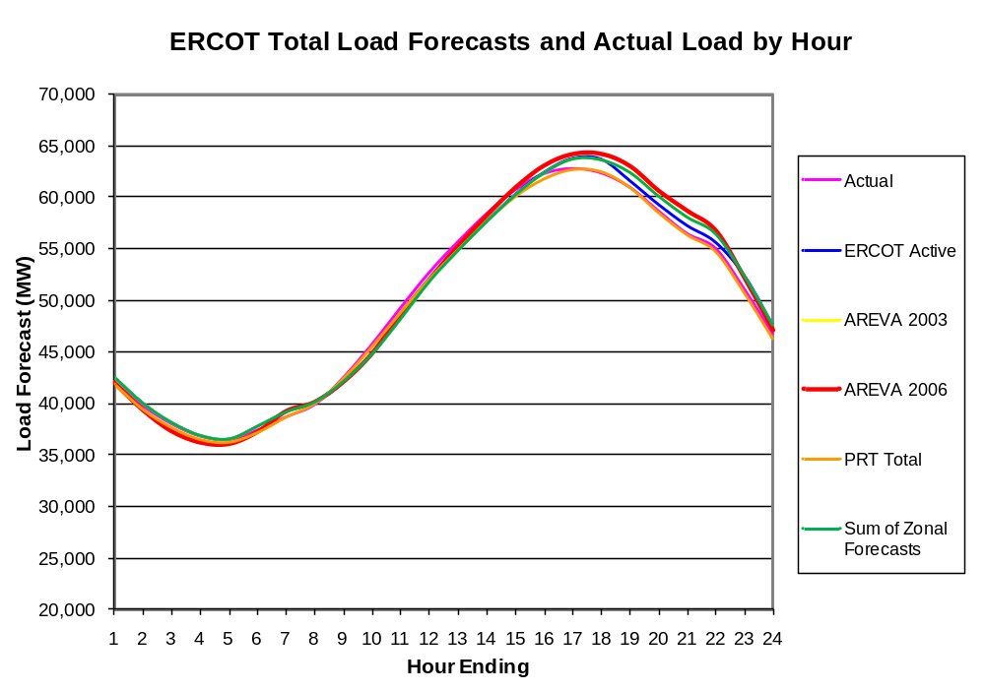

Figure 4 ERCOT Actual Load and ERCOT Total Load Forecast on June 27, 2011

ERCOT System Frequency

The graph below depicts the frequency throughout the EEA event. ERCOT ISO historical (PI) data indicates that frequency dropped to approximately 59.825 Hz immediately after the first trip. The system frequency recovered to 60 Hz in approximately 7 minutes and 40 seconds (~13:01:55).

After the second trip the frequency dropped to approximately 59.869 Hz. The system frequency recovered to 60 Hz in approximately 6 minutes and 55 seconds (~13:14:50).

At 14:38 Frequency dropped to approximately 59.849 Hz immediately after the third trip. The system frequency recovered to 60 Hz in approximately 6 minutes and 15 seconds (~14:45:05).

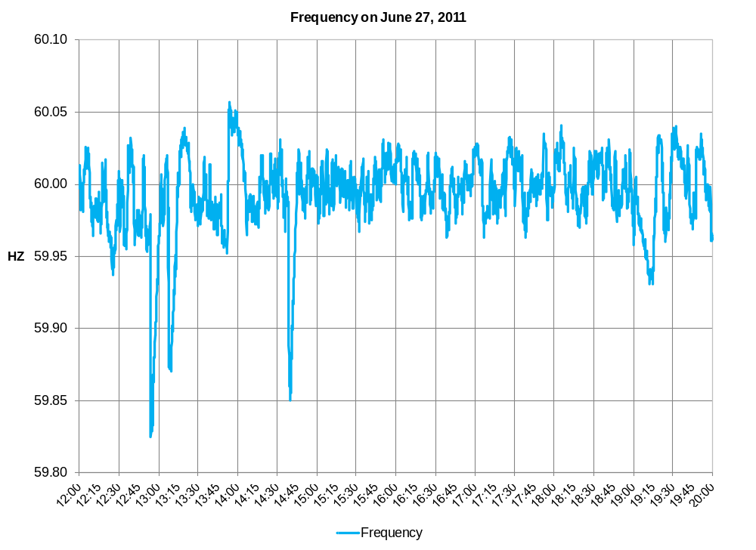
Figure 5 ERCOT System Frequency on June 27, 2011.

Physical Responsive Capability (PRC), Non-Spinning Reserve (Non-Spin) deployed and ERCOT Frequency.

Below is a graph of ERCOT PRC, Non-Spin deployed and Frequency during the event. At 13:40 1,909 MW of Non-Spin was requested, however the ERCOT meter data showed that only 1,606 MW of Non-Spin was deployed. ERCOT is currently investigating the discrepancy between the requested and deployed Non-Spin MW values.

ERCOT deployed Non-Spin but due to the earlier units tripping a good amount was replacing the capacity that was lost when the units tripped from near full load.

PRC increased around 14:00 due to the Non-Spin being deployed but the reserves had already dropped considerably due to the units trips.

At 14:55 ERCOT issued Watch for PRC below 2,500 MW. ERCOT ISO implemented Level 1 of its Energy Emergency Alert (EEA) at 15:25 as PRC dropped below 2,300 MW. PRC dropped below 2,300 MW at 15:24:10 and return above 2,300 MW in one minute at 15:25:10.

By 16:50 the EEA Level 1 was cancelled and the Advisory was lifted due to PRC above 3,000 MW at 19:50.
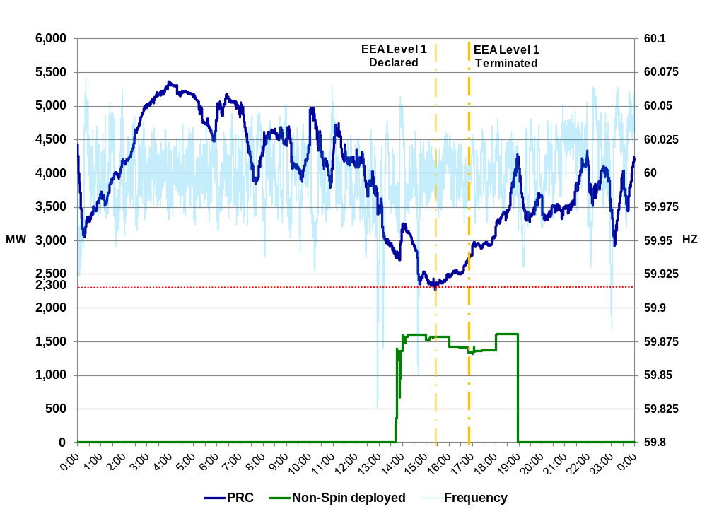
Figure 6 PRC and ERCOT Taylor Frequency on June 27, 2011.

Area Control Error (ACE) and ERCOT System Frequency

Below shows the system frequency vs ACE. At the lowest point ACE dropped to about -1,143 MW.

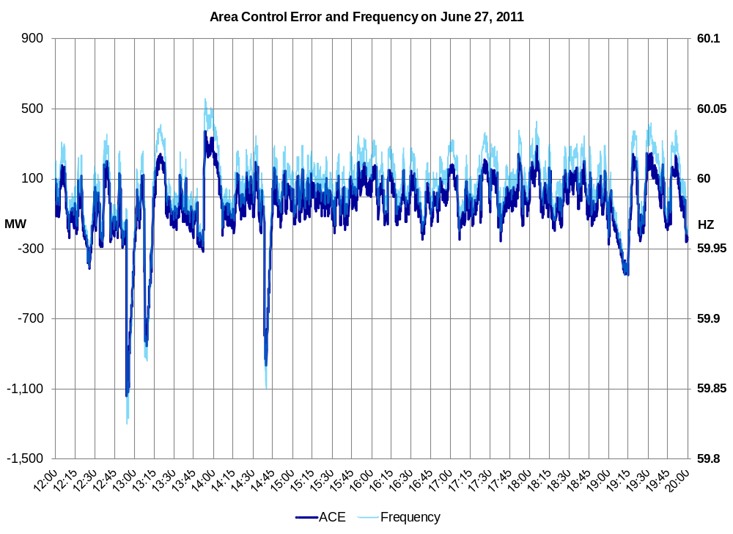
Figure 7 ACE and ERCOT System Frequency.

The role of Wind Generation

During the EEA Level 1 event the wind generation dropping which was a contributor to some degree in the Reserves being depleted more quickly.

At 11:18 the instantaneous wind generation output was 5,351MW, the Physical Responsive Capability (PRC) continued to fall as wind generation dropped off and load increased. The wind generation continued to drop approximately 4,216 MW reaching the lowest point of 1,135 MW at 14:42. The wind generation began to increase after 14:43 and was no longer falling off.

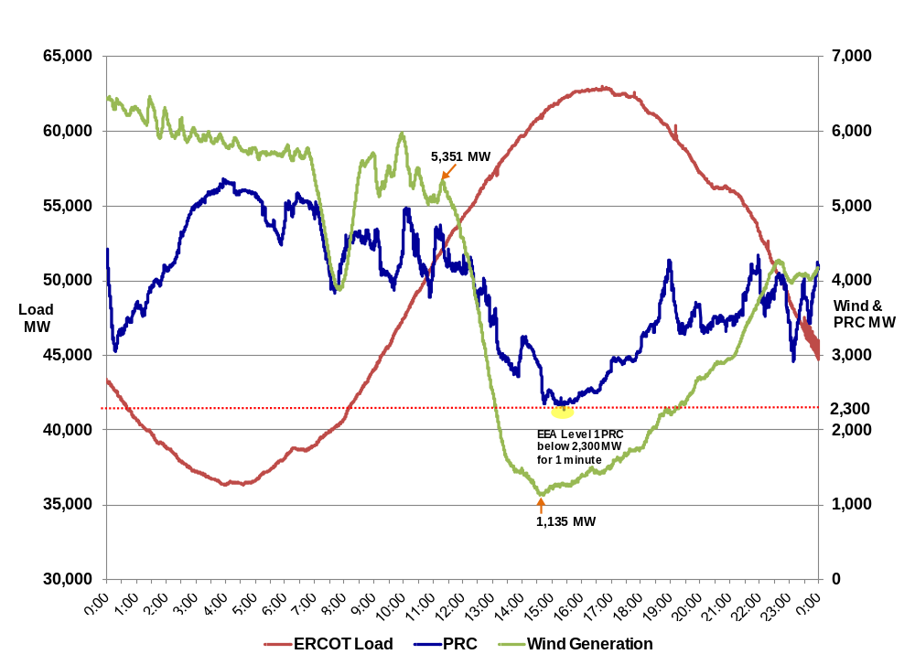
Figure 8 ERCOT Load, PRC and Wind Generation on June 27, 2011.

Figure 9 show the hourly averages of actual wind, the wind hour-ahead Current Operating Plan (COP) High Sustained Limit (HSL) and the wind day-ahead COP HSL data.

Operating Day | Operating Hour | WGRs Aggregated Power Output [MW] | Amount Decreased [MW] | Hour-Ahead COP HSL [MW] | Day-Ahead COP HSL [MW]
06/27/11 | 11 | 5,337
06/27/11 | 12 | 5,032 | 305 | 3,736 | 3,367
06/27/11 | 13 | 3,590 | 1,443 | 3,226 | 2,902
06/27/11 | 14 | 1,747 | 1,842 | 2,583 | 2,670
06/27/11 | 15 | 1,260 | 487 | 2,305 | 2,570

Table 2 Wind Output, Hour-Ahead and Day-Ahead COP HSL values on June 27, 2011

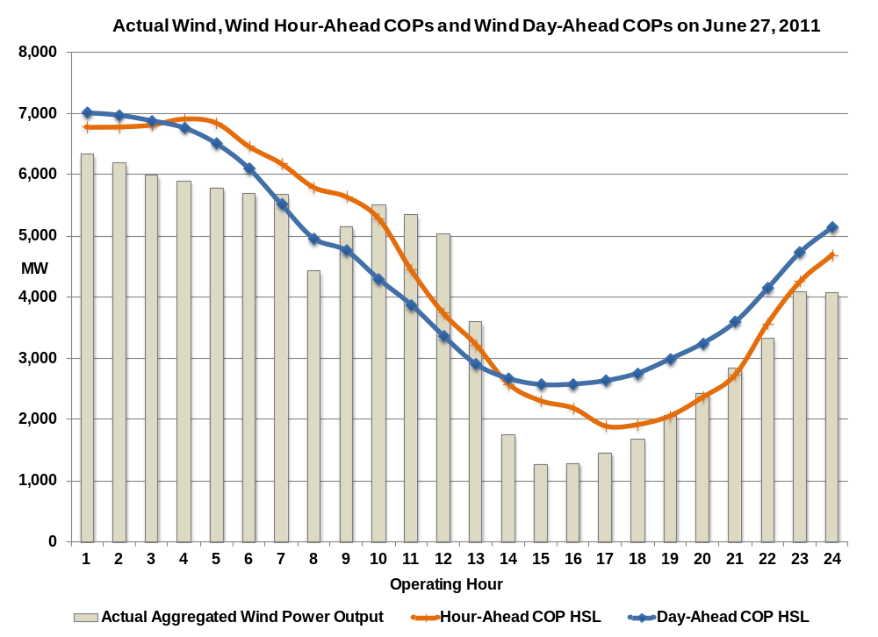
Note: Hour-Ahead (Hour retrieved an hour prior to the Operating Hour)
Day-Ahead (Data retrieved at 16:00 on previous day)

Figure 9 Actual Aggregated Wind on June 27, 2011.

Load Resources (LR) and Emergency Interruptible Load Service (EILS)

- LR
  - 1,150 MW of Load Resources providing Responsive Reserve Service were available for deployment throughout the event.
Note: That capacity would have been deployed if ERCOT went to EEA Level 2A per ERCOT Protocols Section Adjustment Period and Real-Time Operations Section 6.5.9.4.2 (2) (ii).
- EILS
  - EEA event occurred during the Business Hours 2 (1300-1400) commitment period and ERCOT had 434 MW of capacity available to respond.
  - At 16:00 hours, the EILS commitment dropped slightly to 420 MW, that would have been available for Emergency Deployments under EEA Level 2B
Note: Per ERCOT Protocols Section Adjustment Period and Real-Time Operations Section 6.5.9.4.2 (3) and Real Time Desk Operating Procedure Manual, EILS is deployed during an Energy Emergency Alert, either at Level 2B (prior to firm load shedding) or Level 3 (concurrent with or immediately following firm load shedding).

ERCOT did not deploy either set of Demand Response Resources at any time during the event.

Technical Opinion

ERCOT ISO System Operations declared Level 1 of its Energy Emergency Alert as required by regional Protocols due to Physical Reserve Capability (PRC) dropping below 2,300 MW. Operator’s procedures in effect to respond to such a loss were applied and effectively recovered frequency and reserves in a timely manner.

Investigations currently underway
- ERCOT is currently investigating the difference between the requested and deployed Non-Spinning Reserve (Non-Spin) MW values.

ERCOT’s next steps
- ERCOT will develop a tool to trouble shoot discrepancies of Generation status and High Sustained Limit (HSL) between other data sources.

- ERCOT will pursue a dash board to highlight available capacity.

