Task ISS-001 We need to set the expectations regarding the LSE file (SMT and ERCOT).

Completeness

All TDSPs shall submit 15 minute Settlement Quality Meter Data to ERCOT and Smart Meter Texas daily for all provisioned Smart Meters. One data record is for one ESI ID for one operating day containing 96 intervals on most days with 92 and 100 intervals on the 2 days a year where time changes to or from Daylight Savings Time.

If a premise has distributed generation the TDSP will send a separate interval data record with all intervals of generation for the premise.

ERCOT

Each LodeStar Enhanced (LSE) file shall contain up to, but not to exceed, 50,000 data records. For optimum processing at ERCOT, it is suggested that the file contain a minimum of 10,000 data records. Files shall be zipped prior to Pretty Good Privacy (PGP) encryption and compression.

ERCOT will inform the submitting TDSP of the success or failure of its file via the Interval Data LSE Activity Report.

Smart Meter Texas

The TDSPs will send .LSE files to Smart Meter Texas separated by REP DUNs #. The filenames will contain the REP DUNS #. Each file shall contain up to, but not to exceed, 50,000 data records. Files shall be zipped prior to Pretty Good Privacy (PGP) encryption and compression. Smart Meter Texas will post the .LSE files to the individual REP FTPS folders so REPs may pick-up.

Accuracy (eg –re-bills, cancels, replacements, percentage of estimated intervals)

- The TDSP shall ensure that the Validation Editing and Estimation (VEE) has been properly performed on such data.

- ERCOT and Smart Meter Texas will process AMS data whether the data is provided with either an A = Actual or E = Estimated status code at the interval level. Both go through the same loading routine.

- ERCOT does not differentiate whether the data from the TDSP was estimate or actual. If ERCOT does not have data for a particular period of time ERCOT will settle as defined in protocol.

- As part of the process to provide the market with accurate AMS data to both ERCOT and Smart Meter Texas, if the TDSP sends another version of the data record that passes the business validations, ERCOT’s and Smart Meter Texas Portal process will “push down” the existing record into a historical database and insert the new version to make it available in ERCOT’s and Smart Meter Texas systems for their settlement batch run, also these corrections would be visible to the their REP through the Smart Meter Texas Portal.

TDSP Processing of Actual vs. Estimates for LSE Files
- If an interval is Missing, Estimate is calculated by MDM.
- Based on historical like day
- Based on Class Load Profile
  - • If indication of a power outage to the meter is successfully flagged Zero Usage should be presented for the corresponding intervals. Intervals missed during the periodic data transmission from the meters may result in consumption on the meter getting spread across the intervals not sent to the Meter Data Management System (MDMS).

  - Day 0-1
    - A Thunder storm knocks out power.
    - Meters lose communication and interval data is not retrieved.
    - MDMs will estimate based on like days, etc.
    - Interval data will be sent with estimated readings to ERCOT and REPs
  - Day 2
    - Power is restored and actual readings are obtained
    - Interval data will be sent with actual readings of ‘0’ for times during the outage and the estimated readings will be “pushed down”.

    - There is another option at Oncor. If a register read is estimated or a particular day, when an actual register read is received a day or days after, the MDM will revisit all the estimated register reads and readjust, if necessary, and re-estimate previously estimated intervals. Oncor will resend these to the Market

- Register Read is missing .LSE may not contain the TDSPs estimated midnight read
  - For CenterPoint if the actual register read is not obtained the MDM does not estimate the register read. The field will be left as ‘Null’. Also CenterPoint cannot go back and try to retrieve the register read for a point in time in the past. The MDM at Oncor will estimate the register read.

Timeframes:

TDSPs will provide the Smart Meter Texas the LSE files by REP for SMT to place on the FTP site no later than 2300 of the next day. The TDSPs will provide the data as soon as it is available. The LSE files will be available on the FTP site for ten (10) consecutive days after delivery to SMT. Competitive Retailers (CRs) may access the Smart Meter Texas FTP site to retrieve the daily 15 minute interval data associated with a provisioned Smart Meter for the CRs’ ESI IDs. CRs may also use graphic user interface functionality to retrieve individual or groups of ESIID AMS data from SMT.
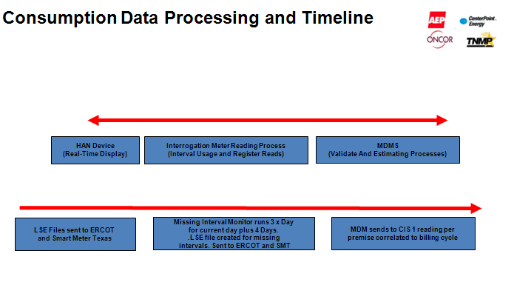

Original Purpose of LSE
    - Give residential and commercial consumers insight into 15 minute usage data on the Smart Meter Texas portal
    - Interval usage data used for ERCOT Settlement
    - Individual REP intent Ex. (billing, load forecasting, Etc)

