 |  |  |  | System Planning
Monthly Status Report
June 2011

 |  | Report Highlights
 | - ERCOT is currently tracking 205 active generation interconnection requests totaling over 63,000 MW. This includes over 37,000 MW of wind generation.
- ERCOT is currently reviewing proposed transmission improvements with a total cost of $622.4 Million
- Transmission Projects endorsed in 2011 total $23.6 Million
- All projects (in engineering, routing, licensing and construction) total approximately $10.0 Billion
- Transmission Projects energized in 2011 total about $401.8 million

Table of Contents
1. Generation Interconnection 1
1.1 New Generation Registering for Commercial Operations 1
1.2 Publicly Disclosed Generation Interconnection Projects 4
1.3 Generation Projects Undergoing Full Interconnection Studies (not otherwise public) 6
1.4 Wind Generation 8
2. Regional Planning Group Project Reviews 10
3. Congestion Costs 11
4. Wind Generation as a Percent of Load 13
5. Planning Model Activities 14
6. Other Notable Activities 15

1. Generation Interconnection
Additional information regarding detailed generation interconnection and impact studies is contained in the “Generation Project Interconnection Information” folder in the “Operations and System Planning” area on the ERCOT website: http://planning.ercot.com/login/login.

New Signed Generation Interconnection Agreements – none this period

New Generation Registering for Commercial Operations
The total installed wind capacity is now reported as 9,452 MW by the resource owners through the registration process. Capacity by North, South and West is 292 MW, 1216 MW, and 7943 MW respectively. 850 MW is able to switch between the West and South zones.

Summary of Active Generation Interconnection Requests

GENERATION INTERCONNECTION REQUESTS CURRENTLY BEING PROCESSED
Currently tracking 205 active generation interconnection or change requests
As of June 30, 2011 | North | South | West | Total
Security Screening Study | 1 | 2 | 5 | 8
SSS Completed | 3 | 7 | 23 | 33
Full Interconnect Study | 20 | 19 | 94 | 133
FIS Completed | 1 | 3 | 6 | 10
Interconnect Agreement Completed | 8 | 9 | 4 | 21
Capacity under Interconnection Agreements | 5,122 | 4,404 | 550 | 10,076
Capacity for Grid, MW | 17,431 | 12,043 | 34,080 | 63,554
Wind Capacity, MW | 3,369 | 3,319 | 30,724 | 37,412

Fuel Type | Confidential Projects (MW) | Projects Under Full Study (MW) | Projects w/ Interconnect Agreement/Public Letter (MW) | Grand Total (MW)
Gas-CombinedCycle |  |  | 5,297 | 11,647
Gas-All Other |  |  |  | 715
Total Gas | 316 | 6,749 | 5,297 | 12,362
Nuclear |  |  | 5,900 | 5,900
Coal |  | 865 | 3,045 | 3,910
Wind | 4,292 | 27,971 | 5,149 | 37,412
Solar | 740 | 734 | 90 | 1,564
Biomass |  | 50 | 100 | 150
Other |  | 1,016 | 1,240 | 2,256
Grand Total | 5,348 | 37,385 | 20,821 | 63,554

Publicly Disclosed Generation Interconnection Projects
The table below summarizes the publicly disclosed generation projects for the ERCOT region.
(Status: IA=Interconnect Agreement, PL=Public Letter, XX= cancelled)
Generation Interconnections as of June 30, 2011
INR | SiteName | Status | County | Region | COD | Fuel Type |  | MW For Grid |  | Change from Last Report
08INR0065 | Buffalo Gap 4 and 5 | PL | Nolan | West | TBD |  | Wind |  | 465
09INR0029 | CFB Power Plant Units 11&12 | IA | Calhoun | South | Jul-11 |  | Coal |  | 260
10INR0010 | Jack County 2 | IA | Jack | North | Sep-11 |  | Gas |  | 565
06INR0012b | Sherbino Mesa Wind Farm 2 | IA | Pecos | West | Oct-11 |  | Wind |  | 150
12INR0003 | Throckmorton Wind Farm | PL | Throckmorton | West | Dec-11 |  | Wind |  | 400
09INR0034 | Gatesville Wind Farm | PL | Coryell | North | Dec-11 |  | Wind |  | 200
08INR0038 | M Bar Wind | PL | Andrews | West | Dec-11 |  | Wind |  | 194
10INR0082 | FRV AE Solar | IA | Travis | North | Dec-11 |  | Solar |  | 30
08INR0025 | Pistol Hill Energy Center | PL | Ector | West | Dec-11 |  | Wind |  | 300
09INR0001 | Sandy Creek 1 | IA | McLennan | North | Feb-12 |  | Coal |  | 925
11INR0084 | 2W Whatley Phase 1 | PL | Ector | West | Mar-12 |  | Wind |  | 45
08INR0062 | Trinity Hills | IA | Young | West | Mar-12 |  | Wind |  | 250
09INR0037 | Scurry County Wind III | PL | Scurry | West | Jun-12 |  | Wind |  | 350
09INR0024 | B&B Panhandle Wind | PL | Carson | West | Jun-12 |  | Wind |  | 1001
09INR0007 | Nacogdoches Project | IA | Nacogdoches | North | Jun-12 |  | Biomass |  | 100
11INR0086 | RRE Austin Solar | IA | Travis | South | Jun-12 |  | Solar |  | 60
10INR0060 | Magic Valley Wind Project | IA | Willacy | South | Jun-12 |  | Wind |  | 202
12INR0004 | Fort Concho Wind Farm | PL | Tom Green | West | Jul-12 |  | Wind |  | 400
12INR0043 | 2W Whatley Phase 2 | PL | Ector | West | Aug-12 |  | Wind |  | 290
08INR0011 | Senate Wind Project | IA | Jack | North | Sep-12 |  | Wind |  | 150
09INR0061 | WKN Mozart | IA | Kent | West | Dec-12 |  | Wind |  | 30
08INR0018 | Gunsight Mountain | IA | Howard | West | Dec-12 |  | Wind |  | 120
11INR0033 | Los Vientos | IA | Cameron | South | Dec-12 |  | Wind |  | 400
06INR0022c | Penascal Wind Farm 3 | IA | Kenedy | South | Dec-13 |  | Wind |  | 202
10INR0020a | Panda Temple Power | IA | Bell | North | May-14 |  | Gas |  | 780
06INR0006 | Cobisa-Greenville | IA | Hunt | North | May-14 |  | Gas |  | 1792
14INR0005 | White Stallion Energy Center | PL | Matagorda | South | Jul-14 |  | Coal |  | 1200
10INR0020b | Panda Temple Power | IA | Bell | North | May-15 |  | Gas |  | 780
10INR0022 | Pondera King Power Project | IA | Harris | South | Jun-15 |  | Gas |  | 1380
12INR0016a | Las Brisas Energy Center | IA | Nueces | South | Oct-15 |  | Other |  | 620
15INR0008 | STP 3 and 4 | PL | Matagorda | South | Jun-16 |  | Nuclear |  | 2700
12INR0016b | Las Brisas Energy Center | IA | Nueces | South | Oct-16 |  | Other |  | 620
14INR0002 | Coleto Creek Unit 2 | IA | Goliad | South | Jan-17 |  | Coal |  | 660
15INR0002 | Comanche Peak 3 and 4 | PL | Somervel | North | Dec-21 |  | Nuclear |  | 3200 | Date
 |  |  |  |  |  |  | Total |  | 20,821

County Location of Installed Generation and Interconnection Requests (all fuels)

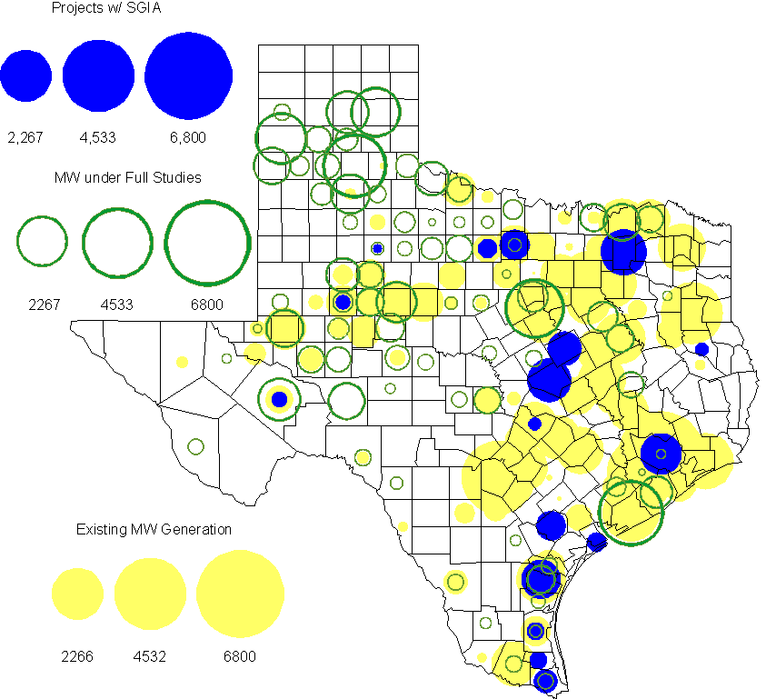

Generation Projects Undergoing Full Interconnection Studies (not otherwise public)

INR | County | Capacity | COD | Fuel |  | INR | County | Capacity | COD | Fuel
09INR0054 | Stonewall | 149 | TBD | Wind |  | 10INR0048 | Hardeman | 1,000 | TBD | Wind
10INR0079 | Nolan | 60 | TBD | Wind |  | 10INR0054 | Palo Pinto | 36 | TBD | Wind
10INR0016 | Childress | 150 | TBD | Wind |  | 10INR0029 | Hood | 810 | TBD | Gas
10INR0052a | Knox | 21 | TBD | Wind |  | 10INR0013 | Upton | 400 | TBD | Wind
10INR0041 | Floyd | 135 | TBD | Wind |  | 09INR0074 | Motley | 70 | TBD | Wind
11INR0029 | Throckmorton | 200 | TBD | Wind |  | 10INR0051 | Brazoria | 200 | TBD | Wind
10INR0042 | Mason | 170 | TBD | Wind |  | 10INR0033 | Armstrong | 399 | TBD | Wind
10INR0032 | Navarro | 775 | TBD | Gas |  | 10INR0019 | Deaf Smith | 609 | TBD | Wind
10INR0008 | Pecos | 500 | TBD | Wind |  | 07INR0013 | Coke | 200 | TBD | Wind
11INR0076 | Archer | 94 | TBD | Wind |  | 11INR0093 | San Patricio | 34 | TBD | Wind
11INR0085 | Nolan | 106 | TBD | Wind |  | 11INR0075 | Fort Bend | 15 | TBD | Coal
11INR0062 | Nueces | 149 | TBD | Wind |  | 11INR0061 | Presidio | 90 | TBD | Solar
11INR0060 | Tom Green | 90 | TBD | Solar |  | 11INR0058 | Pecos | 135 | TBD | Solar
11INR0037 | Smith | 50 | TBD | Biomass |  | 11INR0091 | Webb | 92 | TBD | Wind
11INR0065 | Nueces | 240 | TBD | Wind |  | 11INR0057 | Cameron | 165 | TBD | Wind
11INR0054 | San Patricio | 161 | TBD | Wind |  | 11INR0019 | Upton | 200 | TBD | Wind
10INR0089 | Harris | 40 | TBD | Other |  | 10INR0023 | Haskell | 386 | TBD | Wind
09INR0050 | Fannin | 1,200 | TBD | Gas |  | 08INR0020 | Eastland | 200 | TBD | Wind
11INR0006 | Lamar | 579 | TBD | Gas |  | 11INR0040 | freestone | 640 | Aug-11 | Gas
11INR0079a | Clay | 200 | Sep-11 | Wind |  | 11INR0047 | Deaf Smith | 600 | Sep-11 | Wind
10INR0081b | Clay | 19 | Oct-11 | Wind |  | 10INR0062a | Pecos | 80 | Oct-11 | Wind
11INR0094 | Kent | 100 | Nov-11 | Solar |  | 11INR0090 | Howard | 60 | Nov-11 | Solar
10INR0021 | Grayson | 646 | Nov-11 | Gas |  | 11INR0071 | Harris | 7 | Dec-11 | Gas
11INR0070 | Reeves | 50 | Dec-11 | Solar |  | 11INR0043 | Coke | 300 | Dec-11 | Wind
11INR0025 | Crockett | 400 | Dec-11 | Wind |  | 12INR0033 | Motley | 150 | Jan-12 | Wind
10INR0085 | Ector | 40 | Jan-12 | Solar |  | 10INR0080 | Presidio | 81 | Jan-12 | Solar
12INR0054 | Jones | 200 | Feb-12 | Wind |  | 10INR0018 | Madison | 550 | Mar-12 | Gas
12INR0045 | Kleberg | 135 | Mar-12 | Wind |  | 12INR0075 | Wilbarger | 499 | Apr-12 | Wind
11INR0049 | Wharton | 275 | May-12 | gas |  | 10INR0081a | Clay | 30 | May-12 | Wind
09INR0031 | Ector | 275 | May-12 | Gas |  | 12INR0053 | Crockett | 615 | Jun-12 | Wind
08INR0031 | Childress | 100 | Jun-12 | Wind |  | 12INR0050 | King | 332 | Jun-12 | Wind
12INR0079 | Kenedy | 94 | Aug-12 | Wind |  | 12INR0076 | Winkler | 36 | Sep-12 | Other
12INR0026 | Randall | 400 | Oct-12 | Wind |  | 12INR0035 | Nueces | 249 | Nov-12 | Wind
08INR0044 | Concho | 200 | Nov-12 | Wind |  | 13INR0036 | Hidalgo | 200 | Dec-12 | Wind
12INR0072 | Kinney | 100 | Dec-12 | Wind |  | 12INR0068 | Jim Hogg | 80 | Dec-12 | Wind
12INR0067 | Webb | 94 | Dec-12 | Wind |  | 12INR0060 | Schleicher | 58 | Dec-12 | Wind
12INR0057 | Ector | 50 | Dec-12 | Solar |  | 12INR0055 | Baylor | 80 | Dec-12 | Wind
12INR0005 | Floyd | 1,100 | Dec-12 | Wind |  | 11INR0081 | Live Oak | 72 | Dec-12 | Wind
10INR0077 | Callahan | 101 | Dec-12 | Wind |  | 09INR0025 | Concho | 180 | Dec-12 | Wind
08INR0042 | Coke | 200 | Dec-12 | Wind |  | 12INR0029 | Swisher | 500 | Dec-12 | Wind
09INR0048 | Jack | 113 | Dec-12 | Wind |  | 08INR0049 | Clay | 50 | Dec-12 | Wind
12INR0027 | Gray | 200 | Jan-13 | Wind |  | 10INR0024 | Briscoe | 2,940 | Jan-13 | Wind
13INR0010a | Parmer | 200 | Jan-13 | Wind |  | 12INR0034 | Borden | 342 | Mar-13 | Wind
11INR0083B | Crockett | 100 | Mar-13 | Wind |  | 11INR0082B | Val Verde | 150 | Mar-13 | Wind
11INR0050 | Crosby | 149 | Mar-13 | Wind |  | 10INR0056 | Borden | 249 | Mar-13 | Wind
09INR0058 | Howard | 250 | Mar-13 | Wind |  | 12INR0018 | Gray | 500 | Apr-13 | Wind
13INR0020a | Glasscock | 200 | May-13 | Wind |  | 10INR0062b | Pecos | 220 | May-13 | Wind
09INR0051 | Borden | 249 | Jun-13 | Wind |  | 09INR0041 | Mitchell | 300 | Jun-13 | Wind
13INR0023 | Ector | 240 | Jul-13 | Other |  | 13INR0016 | Deaf Smith | 251 | Aug-13 | Wind
13INR0025 | Randall | 150 | Sep-13 | Wind |  | 11INR0083A | Crockett | 50 | Sep-13 | Wind
11INR0082A | Val Verde | 50 | Sep-13 | Wind |  | 13INR0005 | Carson | 600 | Oct-13 | Wind
13INR0004 | Deaf Smith | 500 | Oct-13 | Wind |  | 13INR0028 | Hale | 392 | Nov-13 | Gas
13INR0026 | Oldham | 201 | Dec-13 | Wind |  | 13INR0017 | Childress | 200 | Dec-13 | Wind
13INR0007 | Pecos | 200 | Dec-13 | Wind |  | 12INR0002a | Briscoe | 200 | Dec-13 | Wind
11INR0013 | Mills | 150 | Dec-13 | Wind |  | 10INR0009 | Castro | 300 | Dec-13 | Wind
09INR0077 | Reagan | 500 | Dec-13 | Wind |  | 09INR0073 | Scurry | 200 | Dec-13 | Wind
13INR0006 | Gray | 750 | Jan-14 | Wind |  | 08INR0019c | Gray | 250 | Jan-14 | Wind
08INR0019b | Gray | 250 | Jan-14 | Wind |  | 08INR0019a | Gray | 250 | Jan-14 | Wind
13INR0010b | Parmer | 500 | Jan-14 | Wind |  | 13INR0020b | Glasscock | 150 | May-14 | Wind
10INR0015 | Mitchell | 350 | May-14 | Wind |  | 14INR0003 | Nolan | 850 | Jun-14 | Coal
12INR0042 | Deaf Smith | 400 | Sep-14 | Wind |  | 14INR0006 | Floyd | 151 | Oct-14 | Wind
14INR0001 | Pecos | 500 | Dec-14 | Wind |  | 13INR0021 | Llano | 600 | Dec-14 | Gas
12INR0002b | Briscoe | 200 | Dec-14 | Wind |  | 13INR0010c | Parmer | 500 | Jan-15 | Wind
15INR0011b | Borden | 38 | Dec-15 | Solar |  | 15INR0011a | Borden | 112 | Dec-15 | Wind
12INR0002c | Briscoe | 350 | Dec-15 | Wind |  | 16INR0002 | Brazoria | 700 | Jun-17 | Other

Wind Generation
Wind Capacity Installed by Year

County Location of Installed Capacity and Interconnection Requests (Wind only)

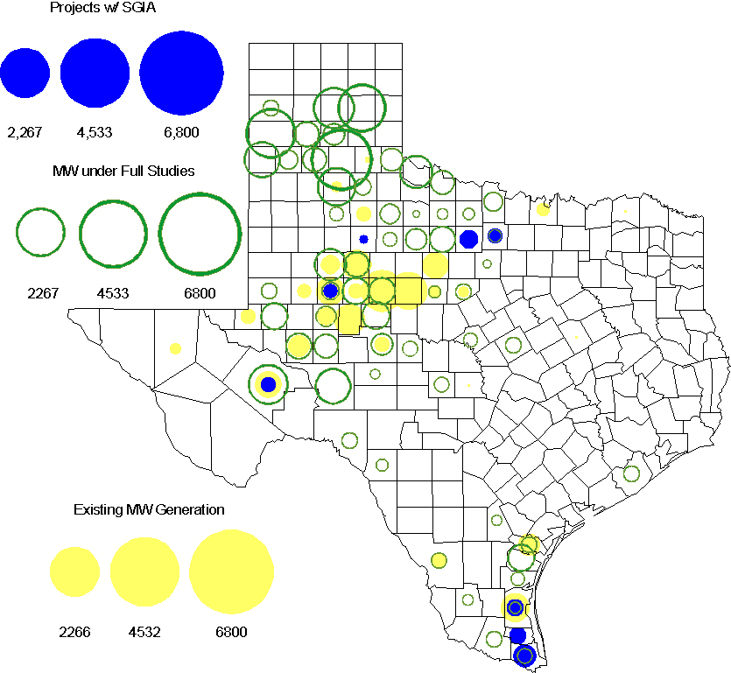

Regional Planning Group Project Reviews

- CenterPoint Energy has submitted the 2014 Houston Area Dynamic Reactive Project to address the need for additional dynamic reactive compensation in the Houston area. This project calls for dynamic reactive devices at two locations (on the CenterPoint’s transmission system), with the compensation devices to be in service before summer peak 2014. The approximate cost for this project is $125 Million, depending on the selected dynamic reactive device technology. This Tier 1 project is currently undergoing ERCOT Independent Review.

- American Electric Power Service Corporation has submitted the Laredo to the lower Rio Grande Valley 345 kV Project to improve reliability of the lower Rio Grande Valley transmission system. This project proposes a new 345kV transmission line to be constructed from Laredo to the lower Rio Grande Valley to provide a third 345kV source to the area with an in-service date in the 2016/2017 timeframe. The estimated cost for this project is $379.5 Million. This Tier 1 project is currently undergoing ERCOT Independent Review.

- Sharyland Utilities (Sharyland) and Brownsville Public Utilities Board (BPUB) has submitted the Cross Valley Brownsville Loop project that proposes a new 345kV line from LaPalma to Loma Alta and a new 345kV line from Loma Alta to Frontera. The estimated cost for this project is $117.9 Million. This Tier 1 project is currently in the RPG study mode. Sharyland and BPUB submitted an study addendum report to the Cross valley project with additional options which is currently in the RPG study mode.

Congestion Costs
Dollars shown in RUC Make Whole payment graph are settlement quality.

OOMC and RUC net Make Whole payment in million$

Monthly Average MCPE and LMP

Binding Constraints - June 2011
Contingency | Binding Element | Number of 5-min intervals | Shadow Price Range $/MWh | Estimated Congestion Cost $ (Shadow Price*Limit) | Transmission Project | Clearance
BASE CASE | West to North Stability Limit | 3703 | 0 - 3910 | 20,058,229 | CREZ
BASE CASE,  Zorn - Marion and Clear Springs 345kV, Clear Springs 345/138kV AT | Marion 345/138kV Autotransformer | 391 | 0 - 4500 | 13,826,062 |  | Outage on Zorn - Hutto 345kV and Clear Springs - Gilleland Creek 345kV
Gails To Keysb 138kV, Willow Valley - Sharon Ridge Exxon 138kV | Ackerly Lyntegar - Sparenburg 69kV | 2910 | 0 - 2800 | 8,674,241 | Lamesa - Ackerly Vealmoor 69 kV line rebuild  [11TPIT0060]
Abilene South - Bluff Creek 138kV,  Bluff Creek Auto T2_H & T2_L & T2_T | Nicole - Oak Creek 138kV | 3565 | 0 - 3500 | 5,895,745 | CREZ | Outage on Bluff Creek - Abilene Mulberry Creek 345kV and Bluff Creek - San Angelo Red Creek 345kV
Holt Switch 138/69kV AT1,  Amoco North Cowden Tap - North Cowden Amoco 138kV | Odessa North - Odessa Basin Switch 69KV | 811 | 0 - 2800 | 4,935,892 | Odessa North - North Cowden 69 kV line upgrade [14TPIT0009]
Meadow - PH Robinson 345kV,  PH Robinson 345/138kV AT1 | North Alvin Station - Hastings Sub 138kV | 538 | 0 - 3500 | 4,925,632 | Upgrade North Alvin-Hastings [14TPIT0018]
Liggett Switch 345/138kV Autotransformer | Cedar Hill Switch - Mayfield North Tap 138kV | 95 | 0 - 3500 | 4,403,431 | Cedar Hill Switch 138 kV terminal equipment upgrade [11TPIT0122]
Austrop- Daffin and Austrop - Decker 138kV | Decker - Sprinkle 138kV | 193 | 0 - 3500 | 4,174,760 |  | Outage on Kingsbery - Wheless Lane 138kV
Hackberry - Valley Ranch and Hackberry - Carrollton NW 345kV | DFW D1 - DFW C East 138kV | 151 | 0 - 3500 | 3,452,614
Greens Bayou - Gable and Hardy - Crocket 138kV | Garrott - Midtown 138kV | 1270 | 0 - 3500 | 2,876,092 | Garrott to Midtown to Polk 138 kV upgrade [11TPIT0072]
Binding Constraints - January to June 2011
Contingency | Binding Element | Number of 5-min intervals | Shadow Price Range $/MWh | Estimated Congestion Cost $ (Shadow Price*Limit) | Transmission Project
BASE CASE | West to North Stability Limit | 16322 | 0 - 3910 | 74,186,928 | CREZ
BASE CASE | Valley Import | 273 | 0 - 5000 | 41,457,339
Nelson Sharpe - Ajo 345kV | Lon Hill - North Edinburg 345kV | 78 | 0 - 4500 | 31,689,757
Denton - Argyle & West Denton 138kV,  Fort Worth - W_Dent 138kV | West Denton - Jim Cristal 138kV | 383 | 40 - 3500 | 22,404,765 | 5YTP [2010-R12]
BASE CASE,  Zorn - Marion and Clear Springs 345kV,  Clear Springs 345/138kV Autotransformer | Marion 345/138kV Autotransformer | 391 | 0 - 4500 | 13,826,062
Abilene South - Bluff Creek 138kV,  Bluff Creek Auto T2_H & T2_L & T2_T | Nicole - Oak Creek 138kV | 8558 | 0 - 3500 | 10,646,043 | CREZ
Greens Bayou - Gable and Hardy - Crocket 138kV,  Singleton - Tomball and Singleton - Roanes Prairie 345kV,  Meadow - Oasis 345kV,  Thermal Energy Coop - Blodgett 138kV | Garrott - Midtown 138kV | 3006 | 0 - 3500 | 9,576,167 | Upgrade 138 kV underground Ckt. 90 Garrott to Midtown to Polk [11TPIT0072]
West Levee Switch 345/138kV AT1 | West Levee Switch 345/138kV AT2 | 98 | 0 - 3500 | 9,073,730 | 5YTP [2009-R21]
Long Creek - Sweetwater - Abilene Mulberry 345kV, Graham SES - Long Creek Switching Station 345kV | Paint Creek - Murray TU 138KV | 1508 | 0 - 3500 | 8,839,628 | CREZ
Gails To Keysb 138kV,  Willow Valley Switching Station - Sharon Ridge Exxon 138kV | Ackerly Lyntegar - Sparenburg 69kV | 2910 | 0 - 2800 | 8,674,241 | Lamesa - Ackerly Vealmoor 69 kV line rebuild  [11TPIT0060]

Wind Generation as a Percent of Load
One-hour average of total wind power output as a percentage of ERCOT load.
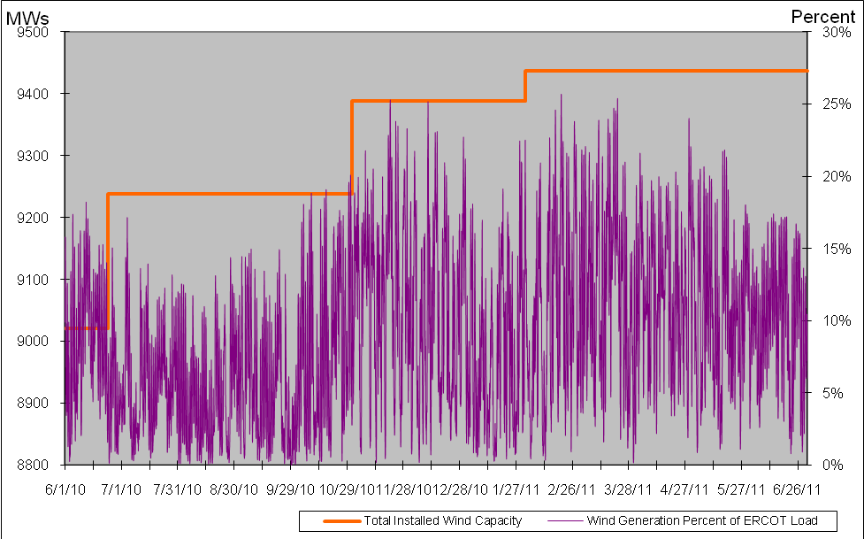

Planning Model Activities
- Work continues on Data Set A. The remaining schedule is as follows:
  - May 13, 2011 DSA Pass 0 Projects and Profiles from all (on-time)
  - June 3, 2011 DSA Pass 1 Projects and Profiles due from all (on-time)
  - June 17, 2011 DSA Pass 2 Projects and Profiles due from all (on-time)
  - June 27, 2011 DSA Pass 3 Comparison Spreadsheet Template built (on-time)
  - June 28 – 30 DSA Meeting in Taylor, complete Passes 3, 4, 5 (on-time)
  - July 8, 2011 DSA Pass 6 Projects and Profiles due from all (projected on-time)
  - July 15, 2011 DSA cases finalized and posted
  - July 18, 2011 DSA Final Comparison Spreadsheet Template built
  - July 29, 2011 DSA Final Comparison comments due for posting
  - August 1, 2011 DSB Start
- ERCOT has submitted all nine parts of SCR760 as enhancements to Siemens Topology Processor following ERCOT Board approval in March 2011. The first three parts submitted were items 3, 7 and 8 and a Statement of Work (SOW) has been completed. Siemens has completed the initial coding for items 3 and 8 on their internal systems and sent ERCOT a Topology Processor output file to check and approve. ERCOT is working with Siemens and the TSPs to complete the requirements for items 2, 4, 5, and 9.
SCR Sub Part | SCR Description | Status
SCR760-1 | Upgrade to PSS/E v32 | Submitted
SCR760-2 | Distribution Capacitor banks | Planning
SCR760-3 | Zero Impedance Line Ratings | Planning
SCR760-4 | Associate Loads and Capacitor banks with the correct CNG | Planning
SCR760-5 | Additional Transformer Data for Planning | Planning
SCR760-6 | FACTS Devices | Submitted
SCR760-7 | Assign valid PSSE IDs to Breakers/  Switches/ Series Devices | Planning
SCR760-8 | Phase shift of Autos for short circuit studies | Planning
SCR760-9 | Multisection Line Grouping | Planning
Table 1: In the following table:
- Red will be used to show status of Not Submitted, meaning that the SCR sub part has not been submitted to Siemens as a Service Request.
- Yellow will indicate that the SCR sub part has been submitted. The color will remain yellow and the status will change in order to Submitted, Planning (Requirements, SOW, Code Writing), Release (Siemens produces first code to test), and Testing (code has completed internal test and is moving through release management).
- Green will indicate that the code has been tested and installed on the machines that ERCOT uses to produce Topology Processor output for Planning and CRR.

Other Notable Activities

- An update to the West-to-North stability limits is in progress for the current year 2011.

- Work on the 2010 Five-Year Transmission Plan is underway. The work is currently focused on preparing the 5YTP start cases (condition the SSWG base cases).

