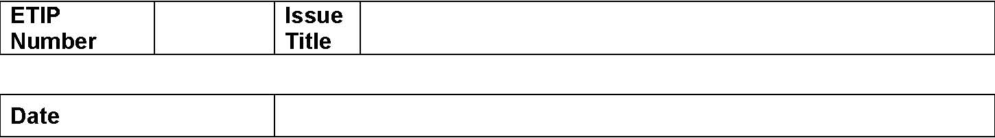
Emerging Technologies Integration Plan November 4, 2010
Appendix 6.2. Emerging Technologies Issue Comment Form
Submitter’s Information
Name
E-mail Address
Company
Phone Number
Cell Number
Market Segment

Comments
Insert comments here.
157

