- 2011 Stability Book
  - Non-Wind Flat Start – Draft Posted.
  - Wind Flat Start – Draft Posted.
- 2011 Flat Start Schedule (Remaining):
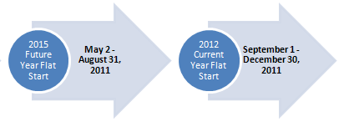
Proposed DWG Flat Start case building schedule

- 2011 Future Year Flat Start Update –
  - This Flat Start case will be based on the most recent 2015 Summer On-Peak case posted by SSWG.
  - Will be produced in v. 32.
  - Updated case data being provided by TSPs. This includes dynamic data and verification that TPIT updates are properly represented in the case.
- Prepared a draft PGRR for consideration by PLWG. The PGRR introduces selected elements from the existing DWG Procedures to the Planning Guide.
- Resource Entities can expect to hear from ERCOT or their TSP to resolve data inconsistencies between the seed cases being used to develop the SSWG cases and existing DWG cases. The data inconsistencies involve values for QMAX, MBASE and Zsource which are important for DWG cases. These inconsistencies are being found as a result of changing the case building process in which generator data for the seed case will be populated from RARF data. The seed cases feed the development of the SSWG cases which are the basis for the DWG cases. DWG members and ERCOT staff will be working with Resource Entities to resolve the data inconsistencies and ensure that RARF and seed case data is correctly populated.
- Several DWG members have expressed an interest in participating in an informal group to gather information about developing load models for use in dynamic simulations. David Mercado with CenterPoint will lead the effort.

