ERCOT Operations Report
Jun 2011 ROS & OWG

Frequency Control
Time | Freq(Hz) | Duration (s)
6/5/2011 22:01 | 59.891 | 98 | Gen Deviation -2000 MW in 5 min; Out of URS
6/10/2011 22:06 | 59.881 | 127 | Gen Deviation -800 MW in 30 sec; Out of URS
6/13/2011 22:05 | 59.885 | 52 | Gen Deviation -800 MW in 2 min; Out of URS
6/16/2011 0:08 | 59.864 | 271 | Gen Deviation -1100 MW in 2 min; Out of URS
6/17/2011 21:58 | 59.857 | 224 | Gen Deviation -900 MW in 3 min; Out of URS
6/22/2011 15:26 | 59.883 | 153 | Unit Trip with 496 MW; Out of URS
6/27/2011 12:54 | 59.823 | 223 | Unit Trip with 662 MW
6/27/2011 13:07 | 59.870 | 164 | Unit Trip with 609 MW
6/27/2011 14:29 | 59.849 | 312 | Unit Trip with 516 MW
6/27/2011 22:59 | 59.884 | 86 | Gen Deviation -700 MW in 3 min; Out of URS
Note: Time of frequency excursions outside the range of +/- 0.1 Hz.

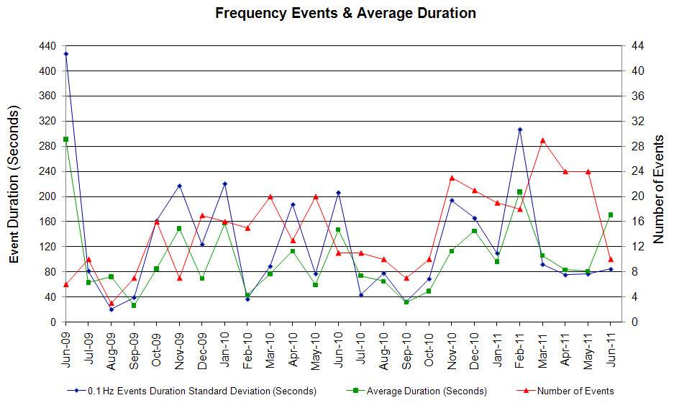

Deployed Responsive (Reported Above)
Time deployed | Stop Time | Duration | Max | Details
6/27/11 14:39:02 | 6/27/11 14:43:56 | 0:04:54 | 220 | Out of URS
6/27/11 23:00:20 | 6/27/11 23:05:30 | 0:05:10 | 400

RUC Capacity/Congestion Purchases
Weather Zone | Unit Days
COAST | 45
EAST | 6
FAR WEST | 55
NORTH CENTRAL | 47
SOUTH | 6
SOUTH CENTRAL | 26
WEST | 1
Grand Total | 186

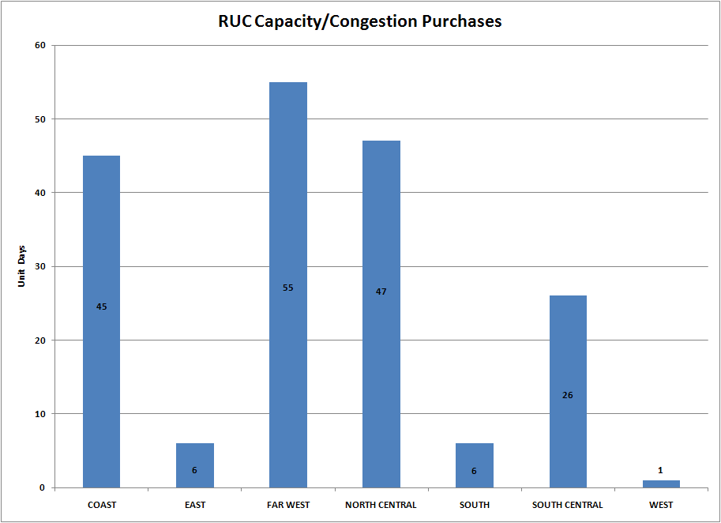

SCED Congestion Management Activity
Congestion affected by outages Remedial action plan has been developed for the element
Contingency | Overloaded Element | Days
BASE CASE | Bowie - Johnson Switch 69 kV | 26
BASE CASE | Cauthorn - Sonora 138 kV | 22
BASE CASE | South Lane City - New Gulf 138 kV | 18
BASE CASE | Marion 345/138 kV Auto #2 | 17
Bluff Creek 345/138 kV Transformer 2 | Nicole - Oak Creek CSW 138 kV | 15
Bluff Creek 345/138 kV Transformer 3 | Nicole - Orient 138 kV | 11
Gail Sub - Key Sub 138 kV | Ackerly Lyntegar - Sparenburg 69 kV | 11
Gail Sub - Key Sub 138 kV | Sparenburg - Lamesa 69 kV | 9
DCKT Greens Bayou - Gable & Hardy - Crocket 138 kV | Garrott - Midtown 138 kV | 9
Ph Robinson - Meadow 345 kV | North Alvin - Hastings TNP 138 kV | 7
Ph Robinson - Meadow 345 kV | TNN Alvin - Alvin 138 kV | 7
Ph Robinson - Meadow 345 kV | Hastings - Friendswood 138 kV | 7
Fort Stockton - Barilla 138 kV | Fort Stockton Switch - Barilla 69 kV | 6
Willow Valley Switch - Exxon Sharon Ridge 138 kV | Ackerly Lyntegar - Sparenburg 69 kV | 6
Willow Valley Switch - Exxon Sharon Ridge 138 kV | Sparenburg - Lamesa 69 kV | 5
Cagnon 345/138 kV XFMR1 | Cagnon 345/138 kV XFMR2 | 5
Holt Switch - Odessa North 69 kV | Odessa - Odessa Basin Switch 69 kV | 4
Clearsprings 345/138 kV Auto #1 | Marion 345/138 kV Auto #2 | 4
Graham SES To Long Creek 345 kV | Seymour - Bomarton 69 kV | 4
Graham SES To Long Creek 345 kV | Leon Switch - Putnam 138 kV | 4
DCKT Roans prairie-Kuykendahl-King& Singleton -Tomball 345 kV | Singleton - Zenith 345 kV | 3
Amoco North Cowden Tap - Moss Switch 138 kV | Odessa North - Odessa Basin Switch 69 kV | 3
Amoco North Cowden Tap - Moss Switch 138 kV | Odessa North Transformer 138/69 kV | 3
Aspermont - Spur 138kV | Spur 138/69kV AXFMR1 | 3
Centerville Road Switch - Lake Hubbard 138 kV | Lake Hubbard - Prairie Creek Switch 138 kV | 2
DCKT Marion-Zorn & Clear Springs 345 kV | Seguin-Seguin West 138 kV | 2
DCKT Marion-Zorn & Clear Springs 345 kV | Marion 345/138 kV Auto #2 | 2
DCKT Lytton Spring-Zorn & Austro 345 kV | Buda - Lehigh 138 kV | 2
DCKT Lytton Spring-Zorn & Austro 345 kV | MCCALA - REDWOO | 2
DCKT Lytton Spring-Zorn & Austro 345 kV | Lockhart - Luling 138 kV | 2
DCKT Lytton Spring-Zorn & Austro 345 kV | Zorn - Poolro 138 kV | 2
Hicross AEN - Garfield AEN 138 kV & Onion Creek - Pilot Knob 138 kV | Burleson AEN to Advanced Micro Devices AEN 138 kV | 2
Austrop - Daffin Gin 138 kV & Austrop - Decker Power Plant 138 kV | Decker Power Plant - Sprinkle 138 kV | 2
Lobo - San Miguel 345 kV | La Quinta - Lobo 138 kV | 2
Bosque Switch To Elmott 345 kV | Rogers Hill - Elm Mott 138 kV | 2
Batesville Switching Station - Pearsall Switching Station 138 kV | Pearsall Switching Station 138/69 kV XFMER | 2
Mc Donald To Big Spring Switch 138 kV | Forsan Tap - Crmwd 7 Tap 138 kV | 2
Liggett Switch Transformer Winding 345/138 kV | Cedar Hill Switch – Mayfield Tap North 138 kV | 2
Cagnon 345/138 kV XFMR2 | Cagnon 345/138 kV XFMR1 | 2
DCKT Zorn - Marion & Clear springs 345 kV | Marion 345/138 kV Auto #2 | 2
Odessa Basin Switch -Odessa North 69KV | Holt Switch - Ector Shell Tap 69 kV | 2
Elm Mott - Tradinghouse SES 345 kV | Rogers Hill - Elm Mott 138 kV | 2
Pecos - Wink TNP 69 kV | Wink - Cochise TNP 69 kV | 2
Orange Grove - Lon Hill 138 kV | Sinton - Skidmore 138 kV | 2
Chamber-King And Cedar Bayou-North B | Exxon - Lynchberg 138 kV | 1
Fisher Road Switch - Bowman Switch 345 kV | Vernon - Grayback 69 kV | 1
Sun switch To Scurry switch 138 kV | Matador - Paducah 69 kV | 1
Tyler Kelly Tire - Tyler West 138 kV | Tyler Northwest Auto #1 | 1
Abilene South - Bluff Creek 138 kV | Nicole - Oak Creek CSW 138 kV | 1
Sterrett - Waxahachie Pump 138 kV | Trumbull 138/69 kV Auto #1 | 1
DCKT Odessa High Voltage - Morgan Creek SES &Quail Switch 345 kV | Mc Donald Road - Forsan Tap 138 kV | 1
Gasconades Creek To Morgan Creek SES 345 kV | Twinbute low side T1L | 1
DCKT Hackberry-Valley Ranch And-Carrollton Northwest | DFWD1 - DFWCE 138 kV | 1
DCKT Trinidad SES-Stryker Creek And -Mt. Enterprise | Berea - Lufkin Chipper Mill 138 kV | 1
DCKT Cagnon- Calavers & Braunig 345 kV | Calavers - Skyline 345 kV | 1
DCKT Garfield - Lytton Springs & Austrop 345 kV | Austro 345/138 kV XFMR | 1
Lon Hill 138/69 kV transformer A1 | Koch Up 138/69 kV XFMR | 1
CITGO North - Hiway 9 138 kV | Nueces Bay - Hiway 9 138 kV | 1
DCKT Enterprise-Trinidad SES & Martin Lake - Stryker Creek 345 kV | Nacogdoches - Herty North Switch | 1
Moss Switch 345/138 Auto | Odessa High Voltage - Big Three Odessa Tap 138 kV | 1
Batesville 138/69 kV AT3 | Moore - Downies 138 kV | 1
Koch Up River 138/69 kV XFMR | Lon Hill 138/69 kV XFMR2 | 1
China Grove Switch - Morgan Creek SES 138 kV | MGSES - CGRSW 138 kV | 1
DCKT Jewet-Singleton 345KV | Tonkawa Switch - Jack Creek 345 kV | 1
Odessa North Auto 138/69 kV | Holt Switch - Ector Shell Tap 69 kV | 1
DCKT Salado - Killeen Switch 345 kV | Killeen Taft Street – Killeen Elm 138 kV | 1
San Angelo Red Creek – Comanche Switch 345 kV | Flat Creek – Leon Switch 138 kV | 1
Austrop 345/138 kV Auto #1 | Austrop 345/138 kV Auto #2 | 1
Lewisville Switch Transformer 345/138 kV | Carrollton Northwest – South TNP 138 kV | 1
Plano West - Richardson east 138 kV | Plano West – Richardson Alcatel Tap 138 kV | 1
PH Robinson 345/138 kV | North Alvin - Hastings TNP 138 kV | 1
Moss Switch - Wover 138 kV | Holt Switch - Ector Shell Tap 69 kV | 1
DCKT Garfield - Onion Creek & Hicross 138 kV | Austrop Auto #1 | 1
Sun Switch - Golden Switch 138 kV | China Grove Switch - Bluff Creek Switch | 1
Asherton 138/69 kV Auto #1 | Turtle Creek - Crystal 69 kV | 1
Odessa EHV Switch -Midland East 345 kV | Odessa - Odessa North 138 kV | 1
Lake Creek SES - Waco West 138 kV | Elm Mott - North crest Tap 138 kV. | 1
Holt Switch 138/69 kV AT1 | Odessa North - Odessa Basin Switch 138 kV | 1
DCKT Tricorner - Tyler Grand & Martin Lake SES - Elkton 345 kV | Tyler Bullard Road - Elkton 138 kV | 1
Coppell - Lewisville Switch 138 kV | Roanoke West - Roanoke Switch 138 kV | 1

Generic Transmission Limits (GTL’s)
GTL | Days
West – North | 29

New RAP, PCAP (Date indicates last update of RAP, PCAP not implementation date.)
6/15/2011 Olney – Westover 69 kV

SPS (RAS) (New, Modified, Removed)
None

New Procedures/Forms/Operations Bulletins
Date | Subject | Bulletin No.
06/17/2011 | DC Tie Desk V1 Rev6 | 541
06/15/2011 | Transmission and Security Desk V1 Rev7 | 540
06/07/2011 | Shift Supervisor Desk V1 Rev5 | 539
06/07/2011 | Resource Desk V1 Rev7 | 538
06/07/2011 | Reliability Unit Commitment Desk V1 Rev6 | 537
06/07/2011 | Real Time Desk V1 Rev7 | 536
06/07/2011 | DC Tie Desk V1 Rev 5 | 535

Load Shed Incidences
None

EEA
06/27 15:25 ERCOT issued an EEA Level 1.

System Voltage Problems
None

Application Issues

06/08 20:06 ERCOT issued an Emergency notice due to HRUC taking longer to complete.

Communication Issues
None

ERCOT peak (Unofficial)
06/15 17:00 62,967 MW

Yearly MTLF Error Comparison
Yearly Mid-Term (Hourly) Load Forecast Error Comparison for the ERCOT Forecast
Month | MAPE for MTLF at 16:00 Day-Ahead
Month | 2008 | 2009 | 2010 | 2011
January | 3.30 | 4.11 | 3.78 | 2.91
February | 3.59 | 3.49 | 3.79 | 3.46
March | 3.29 | 3.24 | 2.24 | 2.02
April | 2.45 | 2.66 | 2.47 | 3.55
May | 3.01 | 2.90 | 2.63 | 3.27
June | 2.81 | 2.89 | 2.84 | 2.28
July | 2.55 | 2.83 | 2.39 | NA
August | 3.66 | 3.07 | 2.29 | NA
September | 4.99 | 3.68 | 3.14 | NA
October | 2.79 | 2.92 | 2.37 | NA
November | 2.60 | 1.93 | 3.46 | NA
December | 4.54 | 3.70 | 2.60 | NA
Annual Average | 3.29 | 3.11 | 2.83 | 2.91

OCN, Advisory, Watch & Emergency Notices
Capacity
Date | Start | Event
6/5/2011 | 20:23 | ERCOT issued an OCN for a Projected Reserve Capacity Shortage for HE 1400-2000
6/11/2011 | 00:40 | ERCOT issued an Advisory due to Physical Responsive Capability (PRC) below 3000 MW.
6/12/2011 | 16:32 | ERCOT issued an OCN for a Projected Reserve Capacity Shortage for HE 18:00
6/13/2011 | 14:10 | ERCOT issued an OCN for a Projected Reserve Capacity Shortage for HE 1700-1800
6/17/2011 | 14:37 | ERCOT issued an OCN for a Projected Reserve Capacity Shortage for HE 1600-1700
6/17/2011 | 15:21 | ERCOT issued an Advisory due to Physical Responsive Capability (PRC) below 3000 MW.
6/21/2011 | 14:40 | ERCOT issued an Advisory due to Physical Responsive Capability (PRC) below 3000 MW.
6/21/2011 | 19:54 | ERCOT issued an OCN for a Projected Reserve Capacity Shortage for HE 23-24 & 01-02 06/22/11
6/23/2011 | 10:00 | ERCOT issued an OCN for a Projected Reserve Capacity Shortage for HE 1600-1900
6/24/2011 | 03:23 | ERCOT issued an OCN for a Projected Reserve Capacity Shortage for HE 1600-1800
6/26/2011 | 04:00 | ERCOT issued an OCN for a Projected Reserve Capacity Shortage for HE 1700-1800
6/26/2011 | 13:10 | ERCOT issued an OCN for a Projected Reserve Capacity Shortage for HE 1700-1800
6/27/2011 | 01:04 | ERCOT issued an OCN for a Projected Reserve Capacity Shortage for HE 1600-2400
6/27/2011 | 13:30 | ERCOT issued an Advisory due to Physical Responsive Capability (PRC) below 3000 MW.
6/27/2011 | 14:46 | ERCOT issued a Watch for PRC below 2500 MW.
6/28/2011 | 01:58 | ERCOT issued an OCN for a Projected Reserve Capacity Shortage for HE 16-18

Transmission Watch
06/09 15:22 ERCOT issued a Transmission Watch due to unsolved contingency (SLOBSAN5).

Emergency Notice

06/22 13:40 ERCOT issued an Emergency Notice for Rio Grande Valley area due to forced outage at Rio Hondo (Bus Outage).

Texas RE Event Analysis

06/22 13:23 From 13:23 to 14:00, ERCOT experienced multiple forced transmission outages (one 345KV Bus, two 345/138KV Autotransformers, three 345KV lines, and three 138KV lines) due to severe thunderstorms in the area combined with insulator flashover likely due to contamination or lightning. Approximately 20.2 MW of firm load was shed by Transmission Operator. All shed load was restored by 14:25.

06/27 12:54 ERCOT experienced the loss of one resource (resulting in the loss of approximately 679 MW), this resource was tripped by the generator operator to comply with main steam temperature limits. Approximately 13 minutes later, the second resource at the same station tripped automatically causing the loss of approximately 576 MW of generation due to loss of both feedwater pumps on low feedwater tank level. ERCOT ISO historical data indicates that frequency dropped to approximately 59.825 Hz immediately after the first trip. The system frequency recovered to 60 Hz in approximately 7 minutes and 40 seconds (~13:01:55). After the second trip the frequency dropped to approximately 59.869 Hz. The system frequency recovered to 60 Hz in approximately 6 minutes and 55 seconds (~13:14:50). At 14:38 one combined cycle unit tripped causing the loss of approximately 510 MW of generation due fuel control valve disruption that shut off fuel supply to the plant. Frequency dropped to approximately 59.849 Hz immediately after the trip. The system frequency recovered to 60 Hz in approximately 6 minutes and 15 seconds (~14:45:05).

ERCOT requested 1,909 MW of Non-Spinning Reserve (Non-Spin) at 13:40. ERCOT ISO implemented Level 1 of its Energy Emergency Alert (EEA) at 15:25 as Physical Responsive Capability (PRC) dropped below 2,300 MW. By 16:50 the EEA Level 1 was cancelled and the Advisory was lifted due to PRC above 3,000 MW at 19:50.

