- Current Year Flat Start Update
  - Current Year Non-Wind Flat Start – Approved.
  - Current Year Wind Flat Start – Approved.
- 2011 Stability Book
  - Non-Wind Flat Start – Draft Pending.
  - Wind Flat Start – Draft Pending.
- 2011 Flat Start Schedule (Remaining):
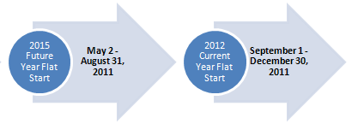
Proposed DWG Flat Start case building schedule
- Transition to Version 32-
  - Non-Wind Flat Start successfully performed in Version 32.
  - Wind Flat Start
    - One wind model not converted to v32. The manufacturer’s wind model will be replaced with a PSSE generic wind model.
- 2011 Future Year Flat Start Update – Starting this month. The inclusion of wind models and PSSE version to be used will be reviewed at June DWG meeting. This Flat Start case will be based on the most recent 2015 Summer On-Peak case posted by SSWG.

