ERCOT Operations Report
May 2011 ROS & OWG

Frequency Control
Time | Freq(Hz) | Duration (s)
5/1/2011 0:12 | 59.880 | 142 | Gen Deviation -600 in 1.5 min; out of URS
5/1/2011 20:04 | 59.885 | 4 | Unit trip with 503 MW
5/4/2011 7:10 | 59.885 | 8 | Unit trip with 350 MW
5/5/2011 23:09 | 59.898 | 4 | Gen Deviation -500 in 1.5 min; out of URS
5/11/2011 14:04 | 59.864 | 56 | Unit trip with 729 MW
5/14/2011 0:11 | 59.898 | 15 | Out of URS
5/14/2011 15:19 | 60.126 | 120 | Gen Deviation 400 in 1 min; out of DRS
5/15/2011 21:06 | 59.897 | 16 | Gen Deviation -400 in 30 sec; out of URS
5/16/2011 8:06 | 59.869 | 24 | Unit trip with 470 MW
5/19/2011 5:53 | 60.108 | 85 | Gen Deviation 400 in 1 min; out of DRS
5/19/2011 14:08 | 59.720 | 212 | Unit trip with 1163 MW
5/20/2011 19:35 | 59.856 | 48 | Unit trip with 660 MW
5/21/2011 11:42 | 59.838 | 56 | Unit trip with 690 MW
5/22/2011 10:59 | 60.120 | 116 | Gen Deviation 400 in 1 min; out of DRS
5/23/2011 17:34 | 59.820 | 144 | Unit trip with 529 MW
5/26/2011 10:07 | 59.860 | 40 | Unit trip with 442 MW
5/28/2011 0:06 | 59.867 | 128 | Gen Deviation -1000 in 2 mins; out of URS
5/28/2011 11:22 | 59.873 | 84 | Unit trip with 445 MW; out of URS
5/28/2011 23:10 | 59.876 | 276 | Gen Deviation -700 in 2 mins; out of URS
5/29/2011 22:00 | 59.866 | 157 | Gen Deviation -600 in 2 min; out of URS
5/29/2011 22:03 | 59.751 | 196 | Unit trip with 761 MW; out of URS
5/30/2011 0:09 | 59.899 | 4 | Gen Deviation -1000 in 3 mins; out of URS
5/31/2011 13:23 | 59.890 | 12 | Unit trip with 274 MW;out of URS
5/31/2011 22:04 | 59.894 | 4 | Gen Deviation -800 in 1 min
Note: Time of frequency excursions outside the range of +/- 0.1 Hz.

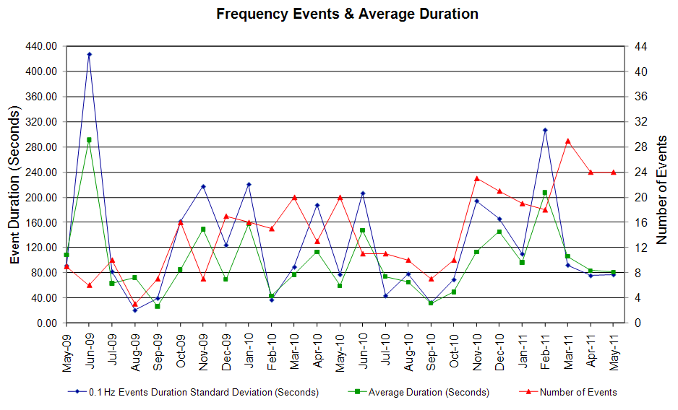
Deployed Responsive (Reported Above)
Time deployed | Stop Time | Duration | Max | Details
5/14/11 0:10:08 | 5/14/11 0:29:13 | 0:19:05 | 640
5/15/11 21:04:22 | 5/15/11 21:15:17 | 0:10:55 | 957
5/20/11 5:10:33 | 5/20/11 5:26:53 | 0:16:20 | 400 | Out of URS & limited SCED room.
5/31/11 23:05:04 | 5/31/11 23:11:05 | 0:06:01 | 176 | Out of URS & limited SCED room.

RUC Capacity Purchases
Weather Zone | Unit Days
COAST | 100
EAST | 4
FAR WEST | 41
NORTH | 3
NORTH CENTRAL | 39
SOUTH | 4
SOUTH CENTRAL | 18
Grand Total | 209
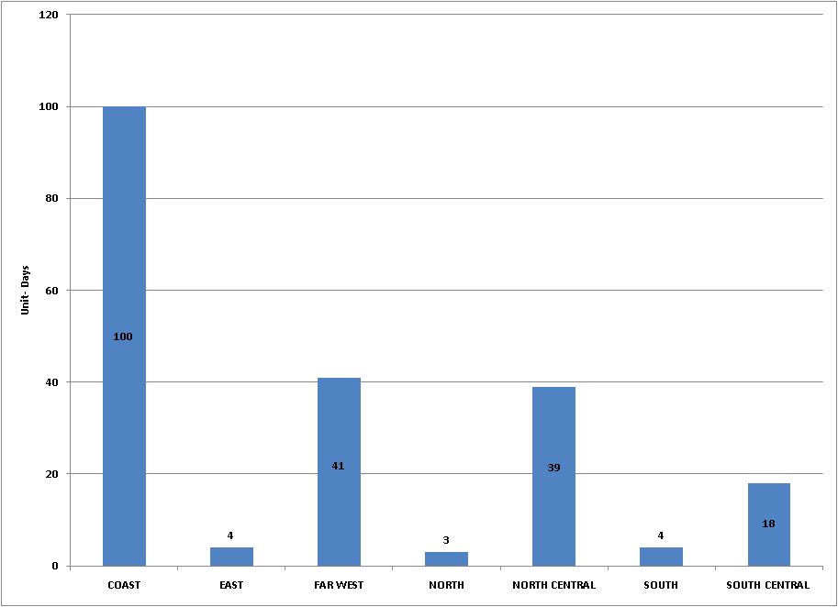

SCED Congestion Management Activity
Congestion affected by outages Remedial action plan has been developed for the element
Contingency | Overloaded Element | Days
Bluff Creek 345/138 kV Transformer 2 | Nicole - Oak Creek CSW 138 kV | 22
Willow Valley Switch - Lamesa 138 kV | Ackerly Vealmoor Switch - Ackerly 69 kV | 18
DCKT Greens Bayou - Gable & Hardy - Crocket 138 kV | Garrott - Midtown 138 kV | 16
Willow Valley Switch - Bluff Creek Switch 138 kV | Ackerly Vealmoor Switch - Ackerly 69 kV | 13
Jewett - Singleton 345 kV | Jack Creek- Tonkawa Switch 345 kV | 10
Austrop - Lost Pines 345 kV | Fayette - Holman 345 kV | 7
Orange Grove - Lon Hill 138 kV | Sinton - Skidmore 69 kV | 6
Marion -Zorn And -Clear Springs | Seguin-Seguin West 138 kV | 6
Austrop -Garfield And -Zorn | Austrop 345/138 kV Auto | 6
Willow Valley Switch - Lamesa 138 kV | Sparenburg - Lamesa 69 kV | 5
Fort Stockton - Barilla 138 kV | Fort Stockton Switch - Barilla 69 kV | 5
Graham SES - Long Creek 345 kV | Seymour - Bomarton 69 kV | 5
Willow Valley Switch - Bluff Creek Switch 138 kV | Ackerly Vealmoor Switch - Ackerly 69 kV | 3
Jewett – Singleton 345 kV | Gibbons Creek - Singleton 345 kV | 3
Orange Grove - Lon Hill 138 kV | Lon Hill - Smith 69 kV | 3
Meadow - PH Robinson 345 kV | TNN Alvin - Alvin 138 kV | 3
San Miguel 345/138 kV Transformer | La Quinta - Lobo 138 kV | 3
Formosa 138/69 kV AT1 | Formosa 138/69 kV AT2 | 3
DCKT STP - Hillje And STP - Whitepoint 345 kV | Blessing - Lolita 138 kV | 3
Cuero - Yoakum 138 kV | Cuero - Cuero Highway 69 kV | 3
Jewett – Singleton 345 kV | Gibbons Creek - Singleton 345 kV | 2
Meadow - PH Robinson 345 kV | North Alvin - Hastings TNP 138 kV | 2
Moss Switch - Holt Switch 138 kV | Odessa North - Odessa Basin Switch 138 kV | 2
Lytton Spring-Zorn And Austro | Turner - Buda 138 kV | 2
Sigmor - San Miguel 138 kV | Lon Hill - Smith 69 kV | 2
Elm Mott - Tradinghouse SES 345 kV | Rogers Hill - Elm Mott 138 kV | 2
Coppell - Lewisville Switch 138 kV | Roanoke West - Roanoke Switch 138 kV | 2
Odessa North - Odessa Basin Switch 69 kV | Holt Switch - Ector Shell Tap 69 kV | 2
PH Robinson 345/138 kV AT2 | PH Robinson 345/138 kV AT1 | 2
Lon Hill - Mathis Sub 69 kV | Sinton - Skidmore 138 kV | 2
George West Switching Station - Orange Grove Switching Station 138 kV | Orange Grove Switch-Orange Grove Sub 69 kV | 2
Basecase | Tenaska Gateway - Mt Enterprise 345 kV | 1
Basecase | Bowie - Johnson Switch 69 kV | 1
Orange Grove - Lon Hill 138 kV | Skidmore - Chase Field Tap 69 kV | 1
Moss Switch - Holt Switch 138 kV | Odessa North 138/69 kV AT | 1
DCKT Lytton Springs - Zorn And Austro | Lockhart - Luling 138 kV | 1
DCKT Odessa High Voltage - Morgan Creek SES &Quail Switch 345 kV | McDonald Road - Forsan Tap 138 kV | 1
DCKT Odessa High Voltage - Morgan Creek SES &Quail Switch 345 kV | Morgan SES - Cosden 138 kV | 1
DCKT Odessa High Voltage - Morgan Creek SES &Quail Switch 345 kV | Forsan Tap - Crmwd 7 Tap 138 kV | 1
DCKT Greens Bayou - King 345 kV | Greens Bayou 345/138 kV AT2 | 1
Beeville - Mathis 69 kV | Sinton - Skidmore 138 kV | 1
DCKT Austrop - Sandow Switch 345 kV | Taylor - Taylor West 138 kV | 1
Comanche Peak Unit 1 & 2 | Sinton - Skidmore 138 kV | 1
Oklaunion - Riley 345 kV | Vernon - Grayback 69 kV | 1
Pawnee - Lon Hill 345 kV | Sinton - Skidmore 138 kV | 1
PH Robinson - Southshore TNP 138 kV | Dickinson - League City TNP 138 kV | 1
Jewet - Lake Creek SES 138 kV | Richland - Wortham Junction 69 kV | 1
DCKT Watermill Switch - Limes-ne 345 kV | Limestone - Jewet 345 kV | 1
Pawnee - Cole- Creek 345 kV | Cole- - Kennedy Switch 138 kV | 1
Morgan SES 345/138 kV AT4 | Morgan SES 345/138 kV AT1 | 1
Sun Switch - Golden Switch 138 kV | China Grove Switch - Bluff Creek Switch | 1
Sandow Switch - Taylor 138 kV | Sandow Switch 345/138 kV AXFMR2 | 1
Big Brown SES - Jewet 345 kV | Big Brown SES - Jewet 345 kV | 1
Meadow - Oasis 345 kV | Garrott - Midtown 138 kV | 1
Dyann - East Bernard 138 kV | Texas Gulf Sulphur - New Gulf 138 kV | 1
Greenbelt - Comanche Switch TNP 138 kV | Texas City Water Treat - Intercity TNP 69 kV | 1
Holt Switch 138/69 kV AT1 | Odessa North - North Cowden 69 kV | 1
Lobo - San Miguel 345 kV | Freer - San Diego 69 kV | 1
Jollyville - Avery Ranch 138 kV | Gabriel - Glasscock 138 kV | 1
DCKT Tradinghouse SES - Venus Switch 345 kV | Jewet - Rattlesnake Road Switch 345 kV | 1
Gabriel –Glasscock & Rivery 138 kV | Gabriel 138/69 kV AT | 1
DCKT Skyline - Marion And Elmcreek 345 kV | Schertz - Parkway 138 kV | 1
Batesville 138/69 kV AT3 | Asherton 138/69 kV AT1 | 1
Pawnee - San Miguel 345 kV | Pawnee 345/138 kV AT | 1

Generic Transmission Limits (GTL’s)
GTL | Days
West – North | 28
North – Houston | 1

New RAP, PCAP (Date indicates last update of RAP, PCAP not implementation date.)
None

SPS (RAS) (New, Modified, Removed)
None

New Procedures/Forms/Operations Bulletins
Date | Subject | Bulletin No.
05/11/2011 | Resource Desk V1 Rev6 | 534

Load Shed Incidences
None

EEA
None

System Voltage Problems
None

Application Issues

05/12 00:05 ERCOT issued an Emergency notice due to SCED failure.

Communication Issues
None

ERCOT peak (Unofficial)
05/31 17:00 57,286 MW

Yearly MTLF Error Comparison
Yearly Mid-Term (Hourly) Load Forecast Error Comparison for the ERCOT Forecast
Month | MAPE for MTLF at 16:00 Day-Ahead
Month | 2008 | 2009 | 2010 | 2011
January | 3.30 | 4.11 | 3.78 | 2.91
February | 3.59 | 3.49 | 3.79 | 3.46
March | 3.29 | 3.24 | 2.24 | 2.02
April | 2.45 | 2.66 | 2.47 | 3.55
May | 3.01 | 2.90 | 2.63 | 3.27
June | 2.81 | 2.89 | 2.84 | NA
July | 2.55 | 2.83 | 2.39 | NA
August | 3.66 | 3.07 | 2.29 | NA
September | 4.99 | 3.68 | 3.14 | NA
October | 2.79 | 2.92 | 2.37 | NA
November | 2.60 | 1.93 | 3.46 | NA
December | 4.54 | 3.70 | 2.60 | NA
Annual Average | 3.29 | 3.11 | 2.83 | 3.04

OCN, Advisory, Watch & Emergency Notices
Capacity
Date | Start | Event
5/1/2011 | 00:10 | ERCOT issued an Advisory due to Physical Responsive Capability (PRC) below 3000 MW.
5/1/2011 | 00:15 | ERCOT issued a Watch for PRC below 2500 MW.
5/3/2011 | 00:08 | ERCOT issued an OCN for a Projected Reserve Capacity Shortage for HE 0800–0900
5/3/2011 | 05:51 | ERCOT issued an OCN for a Projected Reserve Capacity Shortage for HE 0900–1200
5/5/2011 | 09:35 | ERCOT issued an Advisory due to PRC below 3000 MW.
5/7/2011 | 16:56 | ERCOT issued an Advisory due to PRC below 3000 MW.
5/7/2011 | 18:00 | ERCOT issued an Advisory due to PRC below 3000 MW.
5/13/2011 | 15:00 | ERCOT issued an Advisory due to PRC below 3000 MW.
5/13/2011 | 23:16 | ERCOT issued an Advisory due to PRC below 3000 MW.
5/14/2011 | 00:17 | ERCOT issued a Watch for PRC below 2500 MW.
5/14/2011 | 09:25 | ERCOT issued an OCN for a Projected Reserve Capacity Shortage for HE 1500–1800.
5/14/2011 | 13:45 | ERCOT issued an Advisory due to PRC below 3000 MW.
5/14/2011 | 13:45 | ERCOT issued an OCN for a Projected Reserve Capacity Shortage for HE 1900–2400.
5/14/2011 | 14:04 | ERCOT issued an OCN for a Projected Reserve Capacity Shortage for HE 1900– 2400.
5/14/2011 | 20:52 | ERCOT issued an OCN for a Projected Reserve Capacity Shortage for HE 1 – 3, 9 – 24 5/15/11.
5/15/2011 | 20:05 | ERCOT issued an Advisory due to PRC below 3000 MW.
5/15/2011 | 21:08 | ERCOT issued a Watch for PRC below 2500 MW.
5/16/2011 | 15:18 | ERCOT issued an Advisory due to PRC below 3000 MW.
5/17/2011 | 11:27 | ERCOT issued an OCN for a Projected Reserve Capacity Shortage for HE 1700–1900.
5/18/2011 | 01:55 | ERCOT issued an OCN for a Projected Reserve Capacity Shortage for HE 1600–2400.
5/20/2011 | 01:06 | ERCOT issued an OCN for a Projected Reserve Capacity Shortage for HE 1300–1800.
5/20/2011 | 05:08 | ERCOT issued an Advisory due to PRC below 3000 MW.
5/20/2011 | 05:16 | ERCOT issued a Watch for PRC below 2500 MW.
5/20/2011 | 13:15 | ERCOT issued an Advisory due to PRC below 3000 MW.
5/21/2011 | 03:15 | ERCOT issued an OCN for a Projected Reserve Capacity Shortage for HE 1600–2400.
5/21/2011 | 21:00 | ERCOT issued an Advisory due to PRC below 3000 MW.
5/22/2011 | 03:50 | ERCOT issued an OCN for a Projected Reserve Capacity Shortage for HE 1400–2200.
5/22/2011 | 10:41 | ERCOT issued an Advisory due to PRC below 3000 MW.
5/23/2011 | 02:25 | ERCOT issued an OCN for a Projected Reserve Capacity Shortage for HE 1600–1900.
5/23/2011 | 08:34 | ERCOT issued an OCN for a Projected Reserve Capacity Shortage for HE 1600–2200.
5/25/2011 | 08:46 | ERCOT issued an OCN for a Projected Reserve Capacity Shortage for HE 1600 –1800.
5/27/2011 | 16:52 | ERCOT issued an Advisory due to PRC below 3000 MW.
5/27/2011 | 17:55 | ERCOT issued an OCN for a Projected Reserve Capacity Shortage for HE 1400–2000 05/28/2011.
5/28/2011 | 11:50 | ERCOT issued an OCN for a Projected Reserve Capacity Shortage for HE 1400–1900.
5/28/2011 | 11:58 | ERCOT issued an Advisory due to PRC below 3000 MW.
5/31/2011 | 05:00 | ERCOT issued an OCN for a Projected Reserve Capacity Shortage for HE 1600–1900.
5/31/2011 | 13:43 | ERCOT issued an Advisory due to PRC below 3000 MW.
5/31/2011 | 22:38 | ERCOT issued an Advisory due to PRC below 3000 MW.

Transmission Watch
05/02 16:00 ERCOT issued a Transmission Watch for North – Houston VSAT.

Emergency Notice

05/03 08:00 ERCOT issued an Emergency Notice for South Houston area due to moving a Qualified Facility (QF) below its LSL.

Texas RE Event Analysis

05/01 20:04 ERCOT experienced the simultaneous loss of three generating units and two units ran-back (resulting in the loss of approximately 503 MW within the first minute of the event), when a 345KV line tripped along the coast in South Texas. The cause was insulator flashover due to contamination on wind farm owned equipment within the 345KV line protection zone.

05/08 15:53 ERCOT experienced multiple forced transmission outages (one 345KV Bus, one 345/138KV Autotransformer, and six 345KV lines) and two unit outages (resulting in the loss of approximately 425 MW tripped within the first minute of the event) due to a vacuum bottle interrupter on a capacitor bank switch failure. This failed interrupter placed a sustained “C” phase to ground fault on the low side breaker of a 345/138 KV autotransformer. This initiated the operation of the autotransformer lockout relays which cleared the 345 KV bus.

05/11 12:46 ERCOT experienced the simultaneous loss of one 345KV line and five generating units (resulting in the loss of approximately 210 MW within the first minute of the event) due to inclement weather in the area at the time of the fault. This inclement weather was characterized by heavy rain, dangerous thunderstorms, severe hail and lightning. Severe weather caused a phase A-B to Ground fault, which tripped the 345KV line.

05/12 15:38 ERCOT experienced the simultaneous loss of three generating units (resulting in the loss of approximately 147 MW within the first minute of the event), when the 345KV line tripped (C-phase-to-ground fault) due to weather storm in the area

05/19 14:07 ERCOT experienced a NERC Reportable Disturbance Control Standard (DCS) Event for loss of 1,163 MW of generation. System frequency recovered to 60 Hz in approximately 5 minutes and 45 seconds.

05/20 06:29 ERCOT experienced the simultaneous loss of one 345KV line and five generating units (resulting in the loss of approximately 156 MW within the first minute of the event) due to severe weather and lightning.

05/27 01:48 There was a fault of the Amoco-Apache 138KV transmission line due to contamination and tracking over the insulator. 13,751 distribution customers and 13 industrial customers in the Texas City and La Marque area were affected due to a mis-operation of the protective devices at Greenbelt Switching Station. Power was restored to all customers by 3:11 AM.

