SCR Number | 765 | SCR Title | Public Aggregated Wind Dashboard
Timeline | Urgent | Action |  | Recommended Approval
Date of Decision |  | May 19, 2011
Proposed Effective Date |  | Upon system implementation.
Priority and Rank Assigned |  | Priority – Critical; Rank – 9.25
Supporting Protocol or Guide Section(s) |  | Not applicable.
Other Document Reference/Source |  | MIS Dashboard User Guide
System Change Description |  | This System Change Request (SCR) proposes the development of a new wind aggregated dashboard available to the public that displays the following on both the system-wide and regional level in graphical form:  - Aggregate Wind-powered Generation Resource (WGR) Power Output  - Aggregate Short-term Wind Power Forecast (STWPF), from both the current and Day-Ahead  - Aggregate Wind-powered Generation Resource Production Potential (WGRPP), from both the current and Day-Ahead  - Aggregate Current Operating Plan (COP) High Sustained Limits (HSLs) for On-line WGRs, from both the current and Day-Ahead  System-wide and regional WGR output data would also be displayed on the dashboard. These values will update with each Security-Constrained Economic Dispatch (SCED) run and represent a current snapshot of the aggregate WGR output.
Reason for System Change |  | This SCR will provide a public graphical representation of the amount of wind generation forecasted and produced in the ERCOT Transmission Grid for all markets.  With substantial amounts of wind capacity located in ERCOT, the ability to view wind generation in near Real-Time will allow Market Participants and consumers to anticipate the impact of variations in wind production on market prices. Timely information about how actual wind production compares to forecasts will help Market Participants manage the resulting market fluctuations. Wind power brings unique challenges to the electrical market. A public dashboard would help the market adapt to deal with these challenges.
Overall Market Benefit |  | Additional public data transparency.
Overall Market Impact |  | Unknown.
Consumer Impact |  | To be determined.
Procedural History |  | - On 4/18/11, SCR765 was posted.  - On 4/20/11, the motion to grant SCR765 Urgent status failed via WMS e-mail vote.  - On 5/11/11, ERCOT comments were posted.  - On 5/11/11, WMS considered SCR765.  - On 5/18/11, a preliminary Impact Analysis was posted.  - On 5/19/11, PRS considered the 5/11/11 WMS Report and preliminary Impact Analysis for SCR765.
WMS Decision |  | On 5/11/11, WMS unanimously voted to grant SCR765 Urgent status. WMS then unanimously voted to recommend approval of SCR765 as amended by the 5/11/11 ERCOT comments and to forward SCR765 to PRS. All Market Segments were present for the votes.
WMS Discussion |  | On 5/11/11, the 5/11/11 ERCOT comments were discussed. ERCOT Staff recommended removing the requirement to provide regional level data from SCR765 and submitting the change in a separate SCR. ERCOT Staff commented that this would reduce the implementation timeline for SCR765, while still providing Market Participants with the aggregated wind displays and dashboards; and would allow ERCOT to study the impact that the deployment of the displays and dashboards will have on its infrastructure and whether additional capacity will be required to provide the regional level data.
PRS Decision |  | On 5/19/11, PRS unanimously voted to endorse and forward the 5/11/11 WMS Report and preliminary Impact Analysis for SCR765 to TAC with a recommended priority of Critical and a rank of 9.25. All Market Segments were present for the vote.
Summary of PRS Discussion |  | On 5/19/11, ERCOT Staff explained that there were concerns raised by Market Participants regarding the implementation of the full dashboard; that the SCR was modified to display information on a system-wide level only; and that information would be updated with each SCED execution instead of hourly. It was pointed out that the information was publicly available to Market Participants in the zonal market; however, in the Nodal market, it is currently only available to Digital Certificate holders.

Quantitative Impacts and Benefits
Assumptions | 1 | Expected to be a Real-Time data point as it was in zonal.
Assumptions | 2
Assumptions | 3
Assumptions | 4
Market Cost |  | Impact Area | Monetary Impact
Market Cost | 1
Market Cost | 2
Market Cost | 3
Market Cost | 4
Market Benefit |  | Impact Area | Monetary Impact
Market Benefit | 1 | Allows for better liquidity in the Real-Time Market (RTM). | Undefined.
Market Benefit | 2
Market Benefit | 3
Market Benefit | 4
Additional Qualitative Information | 1 | Greater market data transparency in operations of Intermittent Renewable Resources (IRRs) (WGRs).
Additional Qualitative Information | 2 | Transmission planning – better understanding of how wind generation operates (looking at how much to model).
Additional Qualitative Information | 3
Additional Qualitative Information | 4
Other Comments | 1
Other Comments | 2
Other Comments | 3
Other Comments | 4

Sponsor
Name | Jackie Ashbaugh on behalf of the Market Information System (MIS) User Group
E-mail Address | jashbaugh@ercot.com
Phone Number | 512-248-3937
Cell Number
Company | ERCOT
Market Segment | Not applicable.

Market Rules Staff Contact
Name | Sandra Tindall
E-Mail Address | stindall@ercot.com
Phone Number | 512-248-3867

Comments Received
Comment Author | Comment Summary
ERCOT 051111 | Proposed revisions to remove the requirement to display regional level information, which would reduce the implementation time lines of the aggregated wind display and dashboards, and recommended that the request for the Regional Wind Dashboards be submitted in a separate SCR.

Business Case for Proposed System Change

Issue:
A public wind dashboard would make it possible to view the actual and forecasted wind energy at a glance. It is also desired that the dashboard provide aggregate Wind-powered Generation Resource (WGR) output data with a granularity finer than the one hour data that is currently provided in the Market Information System (MIS) Secure Area.

Resolution:
Developing this dashboard and making it available to the public would provide Real-Time visibility into the part wind plays in the ERCOT Transmission Grid. The dashboard will display information on a system-wide level in graphical form:
- Hourly Average Aggregated WGR Net MW Output
- Day-Ahead (16:00 snapshot) Aggregate Short-term Wind Power Forecast (STWPF)
- Day-Ahead (16:00 snapshot) Aggregate Wind-powered Generation Resource Production Potential (WGRPP)
- Day-Ahead (16:00 snapshot) Aggregate Current Operating Plan (COP) High Sustained Limits (HSLs) for On-line WGRs
- Current Aggregate Short-term Wind Power Forecast (STWPF)
- Current Aggregate Wind-powered Generation Resource Production Potential (WGRPP)
- Current Aggregate Current Operating Plan (COP) High Sustained Limits (HSLs) for On-line WGRs
In addition, the dashboard legend will also display Real-Time WGR output data on a system-wide level. This data will be updated with each Security-Constrained Economic Dispatch (SCED) run and will represent the latest snapshot of the aggregate wind output.
The actual WGR output displayed in the graph will continue to be hourly average data to allow the user to properly compare the forecast to the observed power. An example of what the dashboard will look for the system-wide information is provided below.

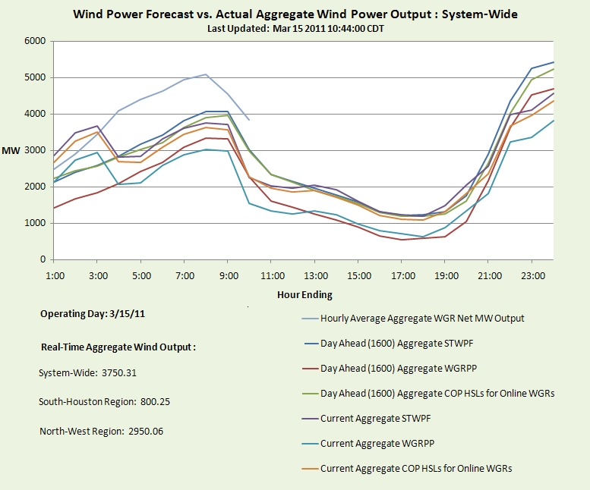
**Numbers in dashboard example above are not representative of actual data in ERCOT systems.

