SCR Number | 765 | SCR Title | Public Aggregated Wind Dashboard

Date | May 11, 2011

Submitter’s Information
Name | Dan Roehl
E-mail Address | droehl@ercot.com
Company | ERCOT
Phone Number | 512-248-4244
Cell Number
Market Segment | NA

Comments

ERCOT submits these comments to recommend that the requirement for the proposed dashboards identified in System Change Request (SCR765), Public Aggregated Wind Dashboard, to display regional level information be removed from SCR765, proposing that the wind dashboards will only show the Aggregated Wind Values along with the five-minute data. Removal of the regional level information from SCR765 will reduce the implementation and delivery time lines allowing for the aggregated wind display and dashboards to be available to Market Participants sooner. This request will also allow ERCOT to monitor the performance impact of ERCOT.com and gather usage statistics to determine if infrastructure changes may be necessary to support the additional regional dashboards. ERCOT recommends that the Regional Wind Dashboards be submitted in a separate SCR to be considered for implementation after the Aggregated Dashboard usage monitoring.

Revised Business Case for Proposed System Change

Issue:
A public wind dashboard would make it possible to view the actual and forecasted wind energy at a glance. It is also desired that the dashboard provide aggregate Wind-powered Generation Resource (WGR) output data with a granularity finer than the one hour data that is currently provided in the Market Information System (MIS) Secure Area.

Resolution:
Developing this dashboard and making it available to the public would provide Real-Time visibility into the part wind plays in the ERCOT Transmission Grid. The dashboard will display information on a system-wide level in graphical form:
- Hourly Average Aggregated WGR Net MW Output
- Day-Ahead (16:00 snapshot) Aggregate Short-term Wind Power Forecast (STWPF)
- Day-Ahead (16:00 snapshot) Aggregate Wind-powered Generation Resource Production Potential (WGRPP)
- Day-Ahead (16:00 snapshot) Aggregate Current Operating Plan (COP) High Sustained Limits (HSLs) for On-line WGRs
- Current Aggregate Short-term Wind Power Forecast (STWPF)
- Current Aggregate Wind-powered Generation Resource Production Potential (WGRPP)
- Current Aggregate Current Operating Plan (COP) High Sustained Limits (HSLs) for On-line WGRs
In addition, the dashboard legend will also display Real-Time WGR output data on a system-wide level. This data will be updated with each Security-Constrained Economic Dispatch (SCED) run and will represent the latest snapshot of the aggregate wind output.
The actual WGR output displayed in the graph will continue to be hourly average data to allow the user to properly compare the forecast to the observed power. An example of what the dashboard will look for the system-wide information is provided below.

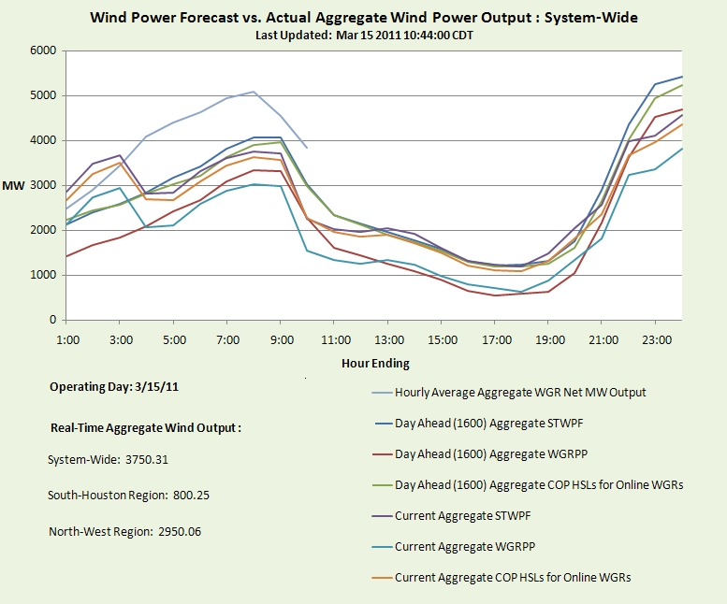
**Numbers in dashboard example above are not representative of actual data in ERCOT systems.

