- 2010 Stability Book – Documents Flat Start Cases developed in 2010. Approved.
- Current Year Flat Start Update
  - Current Year Non-Wind Flat Start – Approved.
  - Current Year Wind Flat Start – Posted for Pass 1 Review.
- 2011 Stability Book
  - Non-Wind Flat Start – Draft Pending.
- 2011 Flat Start Schedule:
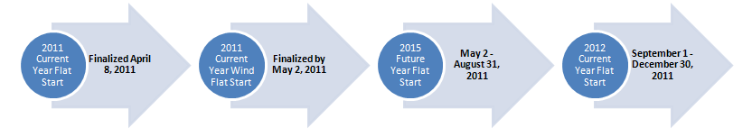
Proposed DWG Flat Start case building schedule
- Transition to Version 32-
  - Non-Wind Flat Start successfully performed in Version 32.
  - Wind Flat Start
    - One wind model not converted to v32. ERCOT working with manufacturer and owner
- 2011 Future Year Flat Start Update – No Update this month.
- Submitted DWG proposal for procedures to be included in the Planning Guides. This submission contained no substantive changes to the proposal reviewed by DWG in 2010.

