ERCOT Operations Report
Apr 2011 ROS & OWG

Frequency Control
Time | Freq(Hz) | Duration (s)
4/1/2011 23:06 | 59.887 | 64 | Gen Deviation -1100 in 3 mins; out of URS
4/4/2011 5:58 | 60.113 | 132 | Gen Deviation +600 in 2 mins; out of DRS
4/5/2011 19:02 | 60.113 | 69 | Gen Deviation + 500 in 1 min; out of DRS
4/5/2011 19:05 | 60.124 | 72 | Gen Deviation + 400 in 1 min; out of DRS
4/5/2011 22:02 | 59.720 | 324 | Unit trip with 716 MW; out of URS
4/7/2011 0:00 | 59.883 | 80 | Gen Deviation -500 in 2 mins; out of URS
4/7/2011 5:58 | 60.105 | 24 | Gen Deviation +800 in 2 mins; out of DRS
4/7/2011 23:59 | 59.876 | 112 | Gen Deviation -500 in 1 min; out of URS
4/11/2011 1:32 | 59.782 | 176 | Unit trip with 978 MW; out of URS
4/13/2011 5:58 | 60.103 | 12 | Gen Deviation +1000 in 2 mins
4/13/2011 6:05 | 59.892 | 20 | Gen Deviation -1000 in 2 mins
4/14/2011 0:09 | 59.845 | 168 | Gen Deviation -800 in 2 mins; out of URS
4/15/2011 5:56 | 60.116 | 112 | Gen Deviation +800 in 2 mins; out of DRS
4/15/2011 11:29 | 59.876 | 8 | Unit trip with 440 MW
4/18/2011 22:02 | 59.895 | 12 | Gen Deviation -700 in 1 min
4/20/2011 0:08 | 59.884 | 100 | Gen Deviation -1500 in 2mins; out of URS
4/20/2011 13:41 | 59.829 | 60 | Unit trip with 830 MW
4/24/2011 0:01 | 59.894 | 20 | Gen Deviation -900 in 1 min
4/27/2011 0:00 | 59.889 | 34 | Gen Deviation -600 in 1 min; out of URS
4/27/2011 4:51 | 59.804 | 116 | Unit trip with 775 MW
4/27/2011 23:27 | 59.795 | 80 | Unit trip with 690 MW
4/30/2011 4:42 | 59.882 | 8 | Unit trip with 338 MW
4/30/2011 12:12 | 59.885 | 12 | Unit trip with 440 MW
4/30/2011 21:58 | 59.872 | 184 | Gen Deviation -500 in 1 min; out of URS
Note: Time of frequency excursions outside the range of +/- 0.1 Hz.

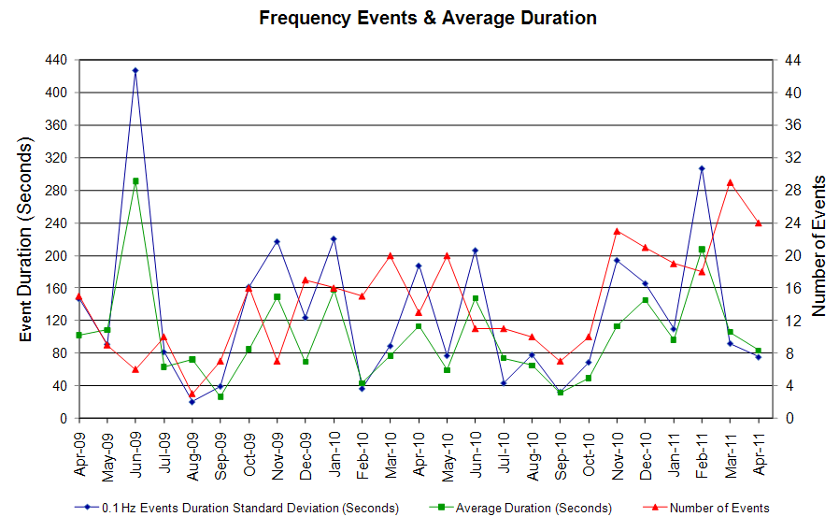
Deployed Responsive (Reported Above)
None

RUC Capacity Purchases

Weather Zone | Unit Days
COAST | 27
EAST | 2
FAR WEST | 49
NORTH CENTRAL | 26
SOUTH | 2
SOUTH CENTRAL | 11
WEST | 20
Grand Total | 137
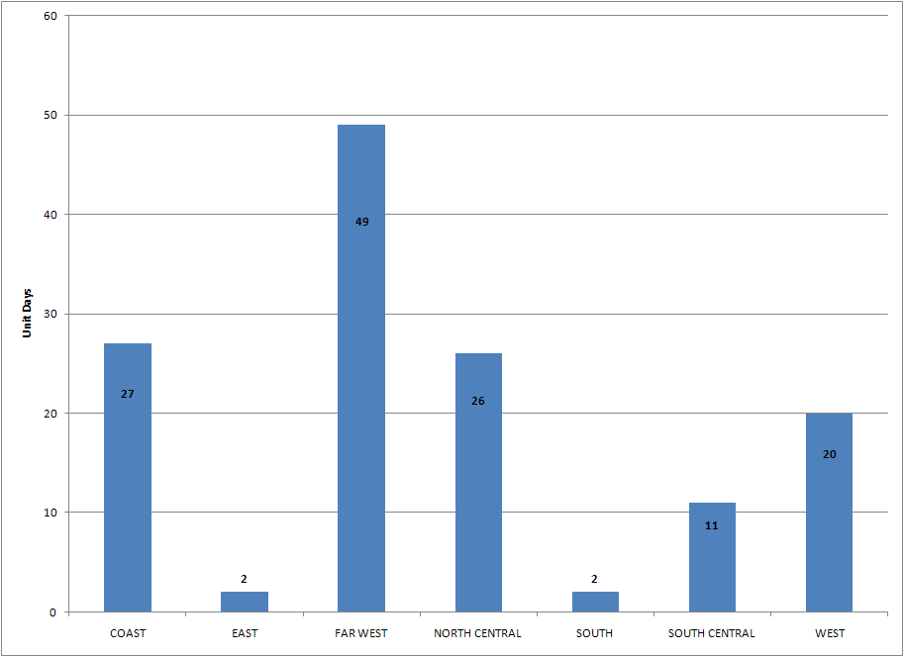

SCED Congestion Management Activity
Congestion affected by outages Remedial action plan has been developed for the element
Contingency | Overloaded Element | Days
DCKT Graham SES - Long Creek 345 kV | Paint Creek - Murray 138 kV | 19
Barilla - Fort Stockton 138 kV | Fort Stockton Switch - Barilla 69kV | 18
Orange Grove Switching Station - Lon Hill 138 kV | Sinton - Skidmore 138kV | 6
DCKT Singleton - Zenith 345 kV | Singleton - Tomball 345 kV | 6
Willow Valley Switch - Bluff Creek Switch 138kV | Ackerly Vealmoor Switch - Ackerly 69kV | 5
DCKT Singleton - Tomball & Roans prairie 345 kV | Singleton - Zenith 345 kV | 4
Georgwst To George West Switching Station 138 KV | Orange Grove Switch - Orange Grove Sub 69KV | 4
BASE CASE | Bowie - Johnson Switch 69 kV | 3
Aspermont - Spur 138kV | Spur 138/69kV AXFMR1 | 3
DCKT Long Creek - Sweetwater Cogen & Abilene Mulberry Creek 345 kV | Paint Creek - Murray 138 kV | 3
DCKT Greens Bayou - Gable & Hardy - Crocket 138 kV | Garrott - Midtown 138kV | 2
DCKT Graham SES - Long Creek 345 kV | Putnam - Leon Switch 138 kV | 2
Bosque Switch -Whitney 138 kV | Lake Whitney-Whitney 69KV | 2
Pawnee - Coleto Creek 345 kV | Coleto Creek - Victoria 138 kV | 2
Lon Hill Transformer Winding | Koch Up 69A1 | 2
DCKT Long Creek - Sweetwater Cogen & Abilene Mulberry Creek 345 kV | Breckenridge - Morton Valley 69 kV | 2
Pawnee - San Miguel 345 kV | Pawnee XFMR | 2
DCKT Singleton - Zenith 345 kV | Kuykendahl-King 345KV | 2
Fort Mason - Gillespie 138 kV | Gillespie - Phillips Mason Tap 69 kV | 2
DCKT Comanche Peak SES - Johnson Switch & Parker Switch - Everman Switch | Rocky Creek – Wolf Hollow 345 kV | 2
DCKT Jewet-Singleton 345KV | Jack Creek-Tonkawa Switch 345KV | 2
BASE CASE | Martin Lake SES XFMR1 | 1
BASE CASE | Martin Lake SES XFMR2 | 1
BASE CASE | Martin Lake SES XFMR3 | 1
BASE CASE | Sutton - Tabor 69 kV | 1
DCKT Greens Bayou - Gable & Hardy - Crocket 138 kV | Garrott - Midtown 138kV | 1
DCKT Morgan SES - Quail Switch & Longshore Switch 345 kV | Sprayberry Switch - Midland Downtown 138 kV | 1
DCKT Odessa High Voltage - Morgan Creek SES &Quail Switch 345 kV | Sprayberry Switch - Midland Downtown 138 kV | 1
DCKT Odessa High Voltage - Morgan Creek SES &Quail Switch 345 kV | Morgan Creek SES 345/138 XFMR 4L | 1
DCKT Odessa High Voltage - Morgan Creek SES &Quail Switch 345 kV | San Angelo Concho - San Angelo Mathis Field 69 kV | 1
DCKT Holt Switch-Amoco North Cowden T-N Cowden Amoco-Moss Switch | Odessa North - Odessa Basin Switch 138kV | 1
DCKT Holt Switch-Amoco North Cowden T-N Cowden Amoco-Moss Switch | Odessa North 138/69kV AXFMR1 | 1
DCKT STP - Hillje & Whitepoint 345 kV | Sinton - Skidmore 138kV | 1
Cagnon Auto 3 (H/L/T) | Cagnon 4 (H/L/T) | 1
Lamesa-Willow Valley Switch 138KV | Ackerly-Ackerly Vealmoor Switch 69 kV | 1
Lamesa-Willow Valley Switch 138KV | Ackerly - Ackerly Lyntegar 69 kV | 1
DCKT Nueces Bay - Koch Up River & Lon Hill 138 kV | Westside - McKenzie 138 kV | 1
DCKT Cagnon - Calavers & Braunig 345 kV | Calavers - Skyline 345 kV | 1
DCKT Garfield - Onion Creek & Hicross 138 kV | Austrop 345/138kV AT1 | 1
DCKT Watermill - Desoto Switch & Cedar Hill Switch 345 kV | Amelia - UT Southwest Medical Center 138 kV | 1
Kendall 345/138 kV AXFMR | Comfor - Raybar 138 kV | 1
West Levee 345/138 kV AXFMR1 | Industrial Blvd - Compton Street 138 kV | 1
DCKT Tradinghouse - Venus Switch 345 kV | Elmot - Rogers Hill 138 kV | 1
Sun Switch - Golden Switch 138 kV | China Grove Switch - Bluff Creek Switch | 1
Odessa North - Odessa Basin Switch 69kV | Holt Switch - Ector Shell Tap 69kV | 1
Lon Hill Transformer Winding | Koch Up River 69A1 | 1
Bluff Creek Auto T2_H ,T2_L & T2_T | Nicole - Oak Creek CSW 138 kV | 1
Oran Sub - Barton Switch 138 kV | Graham switch - Graham | 1
Batesville-Crystal City Switch 69 kV | Uvalde Auto1 | 1
Batesville XFMR | Uvalde Auto2 | 1
Wichita Falls Transformer Winding | Wichita Falls-Lake Wichita Falls | 1
DCKT Elm Creek - San Miguel 345 kV | Coleto Creek - Kennedy Switch | 1
DCKT Royse Switch - Farmersville 345 kV | Anna Switch - Collin SES 345 kV | 1
Batesville - Pearsall 138 kV | Pearsall XFMR | 1
Rodd Field - Barney Davis 138 kV | Airline - Cabaniss 138 kV | 1
Uvalde - West Batesville 138 kV | Uvalde AXFMR1 | 1
La Quinta-Lobo 138KV | Falfurrias Auto1 69KV | 1
Victoria-Magruder 69KV | Victoria - North Victoria 69 kV | 1
Northbelt - THW | White Oak - Airline 138 kV | 1
DCKT Centerville Road Switch-Lake Hubbard SES 138 kV | Lake Hubbard SES – St. Augustine Tap 138 kV | 1
DCKT PH Robinson - Center 345 kV | Alvin Sub - North Alvin TNP 138 kV | 1
North Alvin - Hastings 138 kV | Alvin Sub - North Alvin TNP 138 kV | 1
Lytton Springs 345/138 kV AXFMR #3 | Lytton Springs 345/138 kV AXFMR #2 | 1
Morgan Creek - Bitter Creek 345 kV | Sterling City - Sterling County 69 kV | 1
San Angelo Red Creek-Twinbute 345KV | Twinbute AXFMRT1 | 1
Teco-Blodgett 138KV | Garrott - Midtown 138kV | 1
DCKT Marion-Zorn & Clear Springs 345KV | Columbus-Stafford 69KV | 1
DCKT Marion-Zorn & Clear Springs 345KV | Seguin-Seguin West 138KV | 1
Ingleside Cogen Switch – Du Pont Ingleside 138 kV | Du Pont Ingleside - Ingleside Cogen Switch 138 kV | 1
Comanche Switch - Brownwood Switch 138KV | Brownwood-Brownwood South 138KV | 1

Generic Transmission Limits (GTL’s)
GTL | Days
West – North | 27

New RAP, PCAP (Date indicates last update of RAP, PCAP not implementation date.)
None

SPS (RAS) (New, Modified, Removed)
None

New Procedures/Forms/Operations Bulletins
Date | Subject | Bulletin No.
04/22/2011 | Transmission and Security Desk V1 Rev6 | 533
04/22/2011 | Shift Supervisor Desk V1 Rev4 | 532
04/22/2011 | Resource Desk V1 Rev5 | 531
04/22/2011 | RUC Desk V1 Rev5 | 530
04/22/2011 | Real Time Desk V1 Rev6 | 529
04/22/2011 | DC Tie Desk V1 Rev4 | 528

Load Shed Incidences
None

EEA
None

System Voltage Problems
None

Application Issues
04/05 19:01 ERCOT issued an Emergency Notice due to SCED failure.

Communication Issues
None

ERCOT peak (Unofficial)
04/19 17:00 50,704 MW

Yearly MTLF Error Comparison
Yearly Mid-Term (Hourly) Load Forecast Error Comparison for the ERCOT Forecast
Month | MAPE for MTLF at 16:00 Day-Ahead
Month | 2008 | 2009 | 2010 | 2011
January | 3.30 | 4.11 | 3.78 | 2.91
February | 3.59 | 3.49 | 3.79 | 3.46
March | 3.29 | 3.24 | 2.24 | 2.02
April | 2.45 | 2.66 | 2.47 | 3.55
May | 3.01 | 2.90 | 2.63 | NA
June | 2.81 | 2.89 | 2.84 | NA
July | 2.55 | 2.83 | 2.39 | NA
August | 3.66 | 3.07 | 2.29 | NA
September | 4.99 | 3.68 | 3.14 | NA
October | 2.79 | 2.92 | 2.37 | NA
November | 2.60 | 1.93 | 3.46 | NA
December | 4.54 | 3.70 | 2.60 | NA
Annual Average | 3.29 | 3.11 | 2.83 | 2.98

OCN, Advisory, Watch & Emergency Notices
Capacity
Date | Start | Event
4/2/2011 | 22:34 | ERCOT issued an Advisory due to Physical Responsive Capability (PRC) below 3000 MW.
4/10/2011 | 12:13 | ERCOT issued an Advisory due to PRC below 3000 MW.
4/14/2011 | 15:51 | ERCOT issued an Advisory due to PRC below 3000 MW.
4/17/2011 | 14:31 | ERCOT issued an OCN for a Projected Reserve Capacity Shortage for HE 1900 - 2200.
4/19/2011 | 3:39 | ERCOT issued an OCN for a Projected Reserve Capacity Shortage for HE 1500 - 2000.
4/19/2011 | 15:25 | ERCOT issued an Advisory due to PRC below 3000 MW.
4/23/2011 | 8:20 | ERCOT issued an OCN for a Projected Reserve Capacity Shortage for HE 1300 - 2000.
4/23/2011 | 12:28 | ERCOT issued an Advisory due to PRC below 3000 MW.
4/24/2011 | 9:30 | ERCOT issued an Advisory due to PRC below 3000 MW.
4/28/2011 | 14:47 | ERCOT issued an Advisory due to PRC below 3000 MW.
4/29/2011 | 16:49 | ERCOT issued an Advisory due to PRC below 3000 MW.
4/30/2011 | 12:53 | ERCOT issued an Advisory due to PRC below 3000 MW.
4/30/2011 | 14:37 | ERCOT issued a Watch for PRC below 2500 MW.

Transmission Watch
04/02 - 04/28 ERCOT issued Transmission Watch due to a 345 KV line continuous planned outage at Oklaunion substation.

Texas RE Event Analysis

04/05 22:02 ERCOT experienced a simultaneous loss of one 345 KV line and five generating units (resulting in the loss of approximately 716 MW within the first minute of the event) due to software bug was found in the filter configuration of the series capacitor settings.

04/08 06:08 ERCOT experienced a simultaneous loss of three generating units and one unit run-back (resulting in the loss of approximately 289 MW within the first minute of the event), when the 345 KV line tripped due to due to salt and dirt contamination on the insulators of the overhead 345 KV bus.

04/09 00:34 ERCOT experienced a simultaneous loss of one 345 KV bus, one 138 KV bus, one 345/138 KV autotransformer, and two 345 KV lines due to the B-phase Current Transformer (CT) associated with live tank circuit breaker experienced a failure and fire.

04/11
00:35-02:19 ERCOT experienced multiple forced transmission (two 345 KV lines, and eight 138 KV lines) and three units outages (resulting in the loss of approximately 978 MW tripped within the first minute of the event) associated with a severe thunderstorms that moved into the Dallas Fort Worth area. This event caused a frequency deviation of 0.246 HZ (59.791 HZ).

04/26 16:13 ERCOT experienced a simultaneous loss of four generating units and one unit run-back (resulting in the loss of approximately 586 MW within the first minute of the event). Investigation is currently on-going.

