      - Example: CR Submits Missing Transactions to ERCOT

- The CR selects the Submit tab (Fig 4.1a)
- From the Submit Tree, select Missing TXNs

Fig 4.1a
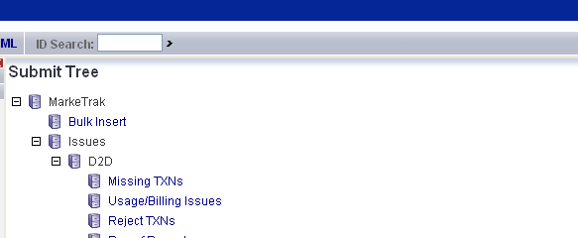

- The following fields must be populated for successful submission of Day to Day issue sub type Missing TXNs: (Fig 4.1b)

(For this example, the submitter selects ERCOT)
Assignee
ESI ID
Original Tran ID - BGN02 of the 814_01, 814_16 or 814_24
Last Tran ID Received
Tran Type

NOTE: The Comments field is optional. Please include any additional information in this box. . New field added: Service Period Start Date. Although optional it is encouraged to be populated.

- Select OK.

Fig 4.1b
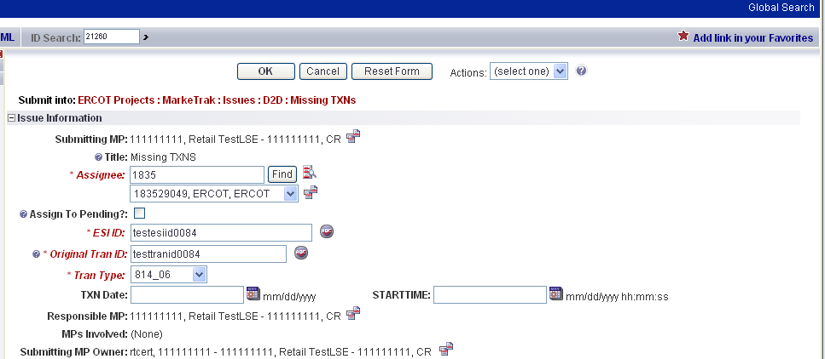

- The issue enters ERCOT’s queue in a state of New- ERCOT and is visible only by the Submitting CR and ERCOT.
- The Submitting CR can “Withdraw” the issue at this point. (Fig 4.1c)

Fig 4.1c
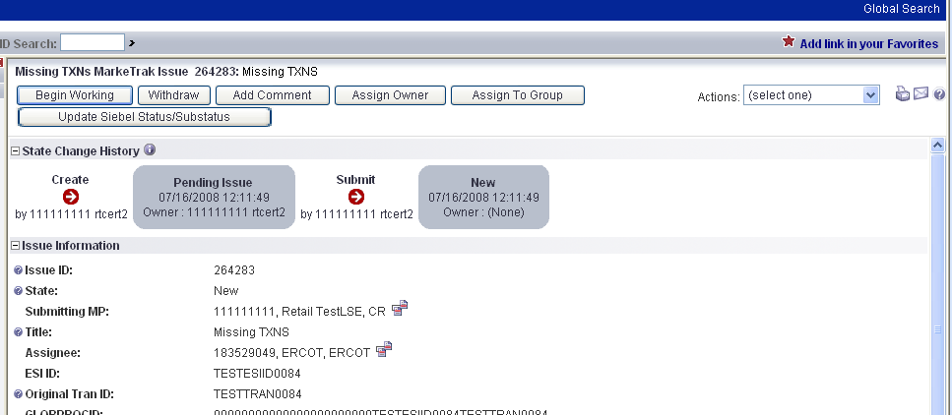

- ERCOT selects Begin Working and the issue is transitioned in a new state of In Progress-Assignee. (Fig 4.1d)
- At this point, the Submitting CR can no longer Withdraw the issue.

Note: After the initial “Begin Working” is selected and the “Withdraw” is not available or the issue is not in a “Complete” state, if the submitting MP feels a resolution is no longer needed, the “Close” button can be selected. Comments will be required with this transition.
All work will stop on the issue at this point.

Fig 4.1d
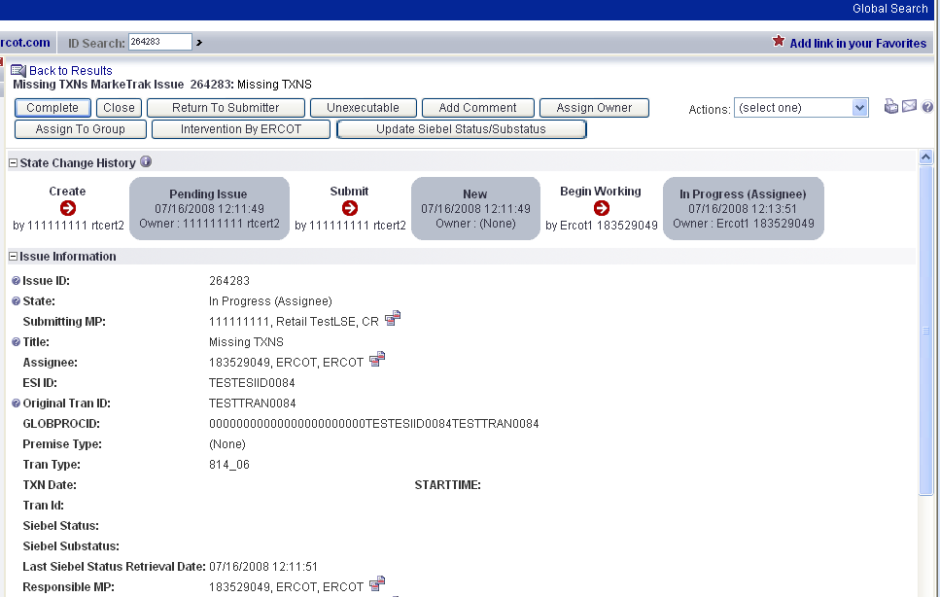

- ERCOT reviews the issue and has the below options: (Fig 4.1e)

- Unexecutable which results in state Unexecutable- Pending Complete, requires comments upon transition.
- Return to Submitter which requires comments and then the issue is transitioned back to the Submitter for additional comments
- Complete, which transitions to a state of Pending Complete.

Fig 4.1e

If ERCOT selects Complete, the issue will transition to the Submitter in a state of Pending Complete. The Submitter then has the option to close the issue by selecting Complete or the issue will be auto closed in 14 calendar days.

- In this example, if after researching, ERCOT finds the missing transaction was not received at ERCOT, then ERCOT would select Unexecutable add comments and the issue would be transitioned back to the Submitter.

- The Submitter has the choice to Re-Assign to the TDSP or back to ERCOT as the Assignee. In this example the CR selects Begin Working then selects Re-assign (Fig 4.1f) to add the TDSP as the Assignee. The Tran Type field should be updated appropriately. For example, the issue submitted to ERCOT was for the 814_05, when reassigned to the TDSP the Tran Type would be changed to 814_04. The issue would be transitioned as New in the TDSP’s queue.

Fig 4.1f
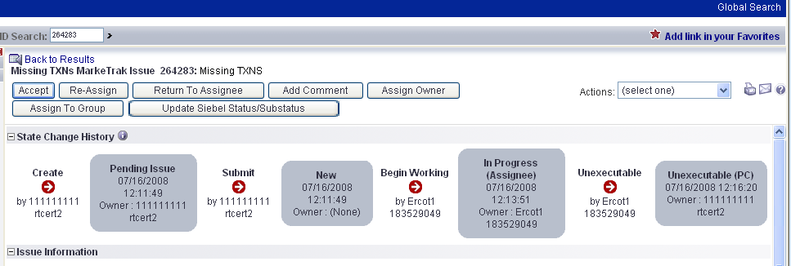

- The TDSP would click on Begin Working and the issue is transitioned to the state of In Progress (Assignee).
- The TDSP reviews the issue and chooses one of the following options (Fig 4.1g):
• Unexecutable, which results in state Unexecutable- Pending Complete, requires comments upon transition.
• Return to Submitter, which requires comments and then the issue is transitioned back to the Submitter for additional comments
• Complete, which transitions to a state of Pending Complete.

Fig 4.1g
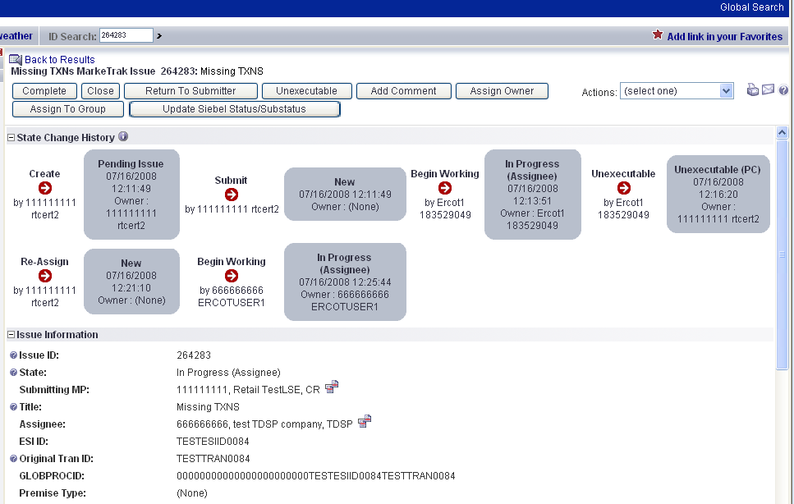

- TDSP selects the transition Complete and enters the Tran Id in the Tran Id field and select OK. The issue is transitioned to the Submitter in a state of Pending Complete. The Submitter then has the option to close the issue by selecting Complete or the issue will be auto closed in 14 calendar days.

4.2 Day to Day Issues – Usage/Billing Issues

4.2.1 Required Fields for Usage Billing
Refer to Section 10 – Bulk Insert Appendix - D2D Issues

4.2.2 Definition of Usage/Billing Issues
4.2.2.1 Examples of Usage/Billing Issues

- Questions pertaining to point-to-point transactions (such as 810s) with TDSPs, excluding the 867 Contingency Plan
- If a CR is missing an 867_03 usage transaction
- If a CR is missing an 867_03 Final transaction
- If a CR is missing an 810 transaction
- If a CR is missing an 867_03 and an 810 transaction
- If a CR has a billing issue pertaining to Load or Generation (dispute) - question relating to bill calculations and/or tariff assignments

4.2.3 Submitting Usage/Billing Issues

A CR or a TDSP can submit this sub type.

4.2.3.1 Example: A CR submits Usage/Billing to the TDSP

- The CR selects the Submit tab (Fig 4.2a)
- From the Submit Tree, select Usage/Billing

Fig 4.2a
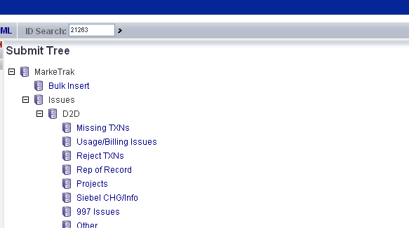

- The following fields must be populated for successful submission of Day to Day issue sub type Usage/Billing Issues:

(For this example, the submitter selects the TDSP.)
Assignee
ESIID
Original Tran ID (Optional except for 867_03 Final) - BGN02 of the 814_01, 814_16 or 814_24. The TDSP will see it as the BGN06 of the 814_03/814_25.
Tran Type
Explanation of 00, 01 and 05
867_03 Monthly 00 - original
867_03 Monthly 01 – cancel, or retract
867_03 Monthly 05 – rebill, replace
Transaction Date – if “Missing” is chosen then it is also the same as the Service period start date
Missing/Dispute
Last Tran ID Received – If Missing is chosen then this should be a required field
Tran ID (Required when the issue is designated as a dispute)
IDR/NIDR
Start Time = Service Period Start Date

NOTE: The Comments field is optional. Please include any additional information in this box. New field added: Stop Time = Service Period Stop Date. Although optional it is encouraged to be populated. If left blank it will be assumed that the Stop date is the date up to the most current read date.

- To expedite the request a couple of drop down boxes have been added.
  - IDR/NIDR – drop down box used to designate whether the transaction is tied to an IDR or NIDR account
  - Missing/Dispute - drop down box used to designate whether the transaction is missing or is being disputed by the CR

- Select OK. (Fig 4.2b)

Fig 4.2b
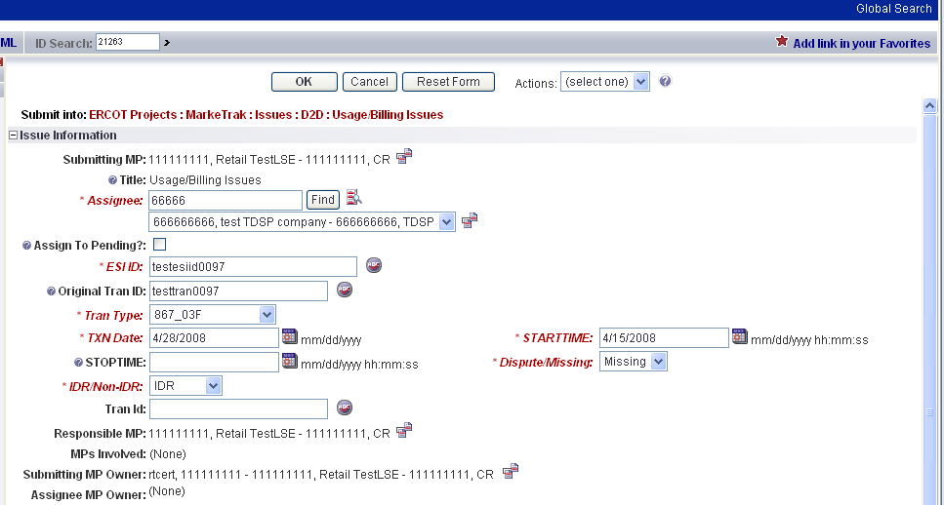

- The issue enters TDSP queue in a state of New and is visible only by the Submitting CR and TDSP.
- The Submitting CR can Withdraw the issue at this point. (Fig 4.2c)

Fig 4.2c
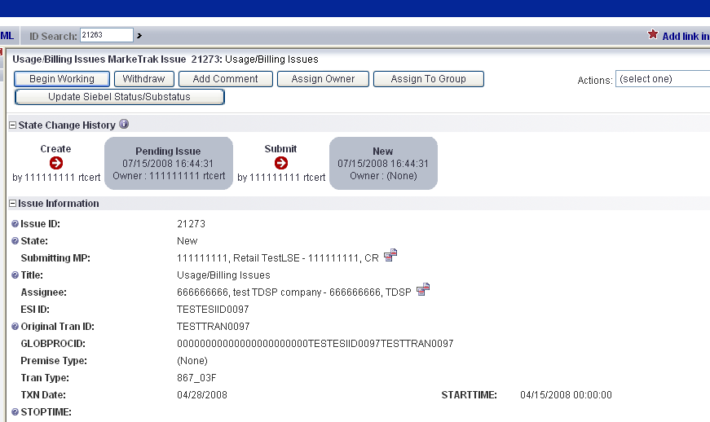

- The TDSP selects Begin Working and the issue is transitioned in a new state of In Progress-Assignee. (Fig 4.2d)
- At this point, the Submitting CR can no longer Withdraw the issue.

Note: After the initial “Begin Working” is selected and the “Withdraw” is not available or the issue is not in a “Complete” state, if the submitting MP feels a resolution is no longer needed, the “Close” button can be selected. Comments will be required with this transition.
All work will stop on the issue at this point.

Fig 4.2d
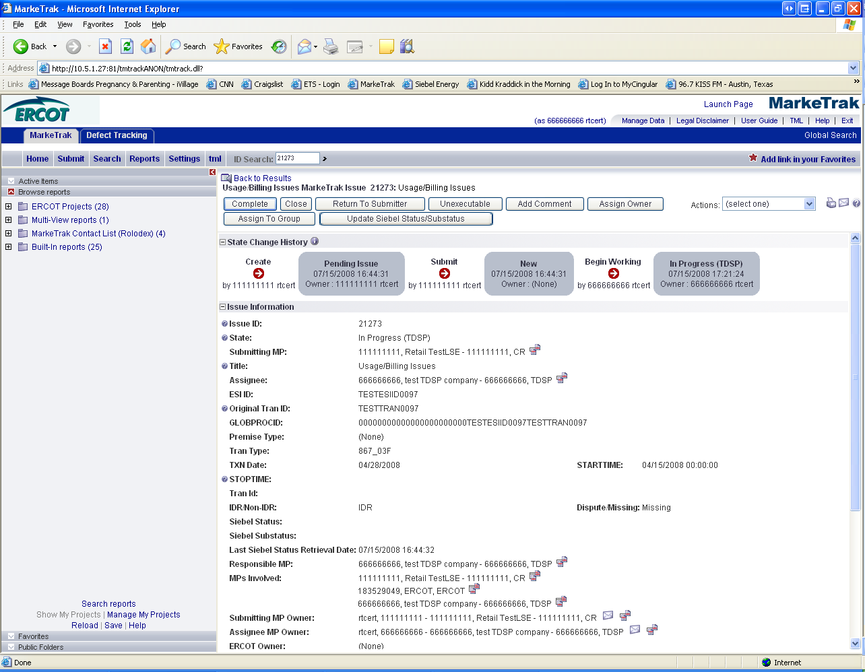

- TDSP reviews the issue and has the options: (Fig 4.2e)
  - Unexecutable, which results in state Unexecutable- Pending Complete – requires comments
  - ‘Return to Submitter which requires comments and then the issue is transitioned back to the Submitter for additional information
  - Complete which transitions to a state of Pending Complete. The Submitter has the option to close the issue by selecting Complete or the issue will be auto closed in 14 calendar days.

Fig 4.2e

- In this example the TDSP selects Complete and the issue is transitioned to the submitting CR in a state of Pending Complete. If the issue was designated as Missing, during the “Complete” transaction, the TDSP is required to provide the Tran ID of the missing transaction. In addition, if issue covers multiple service periods , information regarding those transactions should be provided in the comments.
- The Submitting CR has the option to close the issue by selecting Accept or the issue will be Auto Closed in 14 Calendar days. (Fig 4.2f)

Fig 4.2f


