 |  |  |  | System Planning Division
Monthly Status Report
to
Reliability and Operations Subcommittee
for
March 2011

 |  | Report Highlights
Item
1. | - ERCOT is currently tracking 203 active generation interconnection requests totaling over 64,000 MW. This includes over 37,000 MW of wind generation.
2. | - ERCOT is currently reviewing proposed transmission improvements with a total cost of $555.6 Million  - Transmission Projects endorsed in 2011 total $23.6 Million  - All projects (in engineering, routing, licensing and construction) total approximately $9.5 Billion  - Transmission Projects energized in 2011 total about $174.0 million

Table of Contents
1. Generation Interconnection 1
1.1 New Generation Registering for Commercial Operations 1
1.2 Publicly Disclosed Generation Interconnection Projects 4
1.3 Generation Projects Undergoing Full Interconnection Studies (not otherwise public) 6
1.4 Wind Generation 8
2. Regional Planning Group Project Reviews 10
3. Congestion Costs 11
4. Wind Generation as a Percent of Load 13
5. Planning Model Activities 14
6. Other Notable Activities 15

1. Generation Interconnection
Additional information regarding detailed generation interconnection and impact studies is contained in the “Generation Project Interconnection Information” folder in the “Operations and System Planning” area on the ERCOT website: http://planning.ercot.com/login/login.

New Signed Generation Interconnection Agreements

Los Vientos (11INR0033a/11INR0033b) 400 MW Wind in Cameron County

Magic Valley (formerly Willacy Wind, 10INR0060) 200 MW Wind in Willacy County

New Generation Registering for Commercial Operations
The total installed wind capacity is reported as 9,400 MW by the resource owners through the registration process. Installed capacity in North, South and West is 228 MW, 1216 MW, and 7956 MW respectively. 856 MW is able to switch between the West and South zones.

Summary of Active Generation Interconnection Requests

GENERATION INTERCONNECTION REQUESTS CURRENTLY BEING PROCESSED
Currently tracking 203 active generation interconnection or change requests
As of March 31, 2011 | North | South | West | Total
Security Screening Study | 2 | 7 | 8 | 17
SSS Completed | 1 | 3 | 17 | 21
Full Interconnect Study | 18 | 10 | 79 | 107
FIS Completed | 5 | 9 | 6 | 20
Interconnect Agreement Completed | 7 | 9 | 3 | 16
Capacity under Interconnection Agreements | 5,092 | 4,344 | 520 | 9,956
Capacity for Grid, MW | 18,690 | 12,779 | 33,109 | 64,578
Wind Capacity, MW | 3,457 | 3,999 | 30,061 | 37,517

Fuel Type | Confidential Projects (MW) | Projects Under Full Study (MW) | Projects w/ Interconnect Agreement/Public Letter (MW) | Grand Total (MW)
Gas-CombinedCycle |  |  | 5,297 | 12,235
Gas-All Other |  |  |  | 403
Total Gas | 11 | 7,330 | 5,297 | 12,638
Nuclear |  |  | 5,900 | 5,900
Coal |  | 1,740 | 3,210 | 4,950
Wind | 3,410 | 28,188 | 5,919 | 37,517
Solar | 566 | 877 |  | 1,443
Biomass |  | 50 | 100 | 150
Other |  | 740 | 1,240 | 1,980
Grand Total | 3,987 | 38,925 | 21,666 | 64,578

Publicly Disclosed Generation Interconnection Projects
The table below summarizes the publicly disclosed generation projects for the ERCOT region.
(Status: IA=Interconnect Agreement, PL=Public Letter, XX= cancelled)
Generation Interconnections as of March 31, 2011
INR | SiteName | Status | County | Region | COD | Fuel Type |  | MW For Grid | Change from Last Report
09INR0029 | CFB Power Plant Units 11&12 | IA | Calhoun | South | Apr-11 |  | Coal | 260
08INR0065 | Buffalo Gap 4 and 5 | PL | Nolan | West | Apr-11 |  | Wind | 465
10INR0010 | Jack County 2 | IA | Jack | North | Sep-11 |  | Gas-CC | 565 | Date
09INR0034 | Gatesville Wind Farm | PL | Coryell | North | Dec-11 |  | Wind | 200
12INR0003 | Throckmorton Wind Farm | PL | Throckmorton | West | Dec-11 |  | Wind | 400
08INR0038 | M Bar Wind | PL | Andrews | West | Dec-11 |  | Wind | 194
08INR0025 | Pistol Hill Energy Center | PL | Ector | West | Dec-11 |  | Wind | 300
06INR0012b | Sherbino Mesa Wind Farm 2 | IA | Pecos | West | Jan-12 |  | Wind | 150
09INR0001 | Sandy Creek 1 | IA | McLennan | North | Feb-12 |  | Coal | 925
08INR0062 | Archer-Young | IA | Young | West | Mar-12 |  | Wind | 250
11INR0084 | 2W Whatley Phase 1 | PL | Ector | West | Mar-12 |  | Wind | 45
09INR0007 | Nacogdoches Project | IA | Nacogdoches | North | Apr-12 |  | Biomass | 100
07INR0004 | Pampa Energy Center | PL | Gray | West | May-12 |  | Coal | 165
09INR0037 | Scurry County Wind III | PL | Scurry | West | Jun-12 |  | Wind | 350
09INR0024 | B&B Panhandle Wind | PL | Carson | West | Jun-12 |  | Wind | 1001
10INR0060 | Willacy Wind Project | IA | Willacy | South | Jun-12 |  | Wind | 202 | New
05INR0015b | Gulf Wind 2 | PL | Kenedy | South | Jul-12 |  | Wind | 400
12INR0004 | Fort Concho Wind Farm | PL | Tom Green | West | Jul-12 |  | Wind | 400
12INR0043 | 2W Whatley Phase 2 | PL | Ector | West | Aug-12 |  | Wind | 290
08INR0011 | Senate Wind Project | IA | Jack | North | Sep-12 |  | Wind | 150
08INR0018 | Gunsight Mountain | IA | Howard | West | Dec-12 |  | Wind | 120
11INR0033a | Los Vientos Phase 1 | IA | Cameron | South | Dec-12 |  | Wind | 200 | New
11INR0033b | Los Vientos Phase 2 | IA | Cameron | South | Dec-12 |  | Wind | 200 | New
06INR0022c | Penascal Wind Farm 3 | IA | Kenedy | South | Dec-12 |  | Wind | 202
05INR0015c | Gulf Wind 3 | PL | Kenedy | South | Dec-13 |  | Wind | 400
10INR0020a | Panda Temple Power | IA | Bell | North | Feb-14 |  | Gas-CC | 780
06INR0006 | Cobisa-Greenville | IA | Hunt | North | May-14 |  | Gas-CC | 1792
10INR0022 | Pondera King Power Project | IA | Harris | South | Jun-14 |  | Gas-CC | 1380
14INR0005 | White Stallion Energy Center | PL | Matagorda | South | Jul-14 |  | Coal | 1200
10INR0020b | Panda Temple Power | IA | Bell | North | May-15 |  | Gas-CC | 780
12INR0016a | Las Brisas Energy Center | IA | Nueces | South | Jul-15 |  | Other | 620
14INR0002 | Coleto Creek Unit 2 | IA | Goliad | South | Jan-16 |  | Coal | 660
15INR0008 | STP 3 and 4 | PL | Matagorda | South | Jun-16 |  | Nuclear | 2700
12INR0016b | Las Brisas Energy Center | IA | Nueces | South | Jul-16 |  | Other | 620
15INR0002 | Comanche Peak 3 and 4 | PL | Somervel | North | Dec-18 |  | Nuclear | 3200
 |  |  |  |  |  |  | Total | 21,666

County Location of Installed Generation and Interconnection Requests (all fuels)

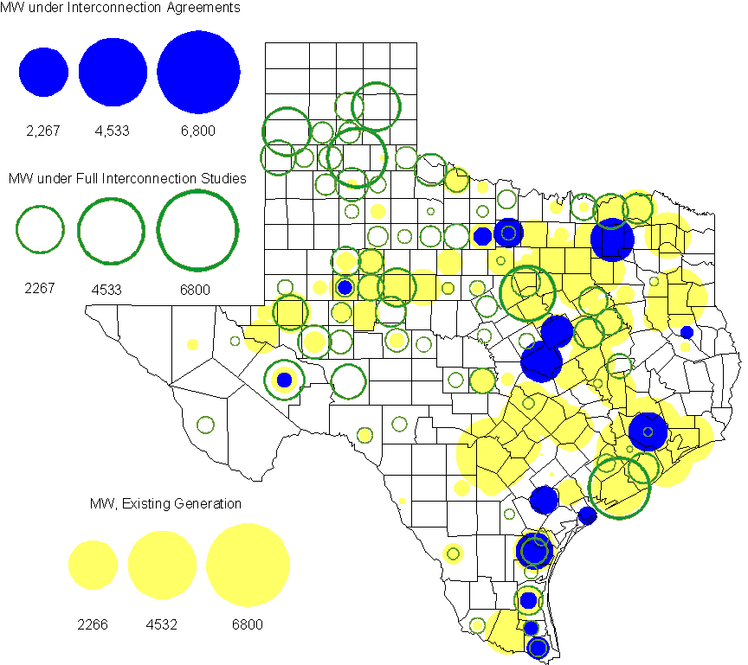

Generation Projects Undergoing Full Interconnection Studies (not otherwise public)

INR | County | Capacity | COD | Fuel |  | INR | County | Capacity | COD | Fuel
09INR0061 | Kent | 258 | TBD | Wind |  | 09INR0054 | Stonewall | 149 | TBD | Wind
10INR0048 | Hardeman | 1,000 | TBD | Wind |  | 10INR0054 | Palo Pinto | 36 | TBD | Wind
10INR0079 | Nolan | 60 | TBD | Wind |  | 10INR0016 | Childress | 150 | TBD | Wind
10INR0029 | Hood | 810 | TBD | Gas |  | 10INR0052a | Knox | 21 | TBD | Wind
10INR0013 | Upton | 400 | TBD | Wind |  | 10INR0041 | Floyd | 135 | TBD | Wind
09INR0074 | Motley | 70 | TBD | Wind |  | 11INR0029 | Throckmorton | 200 | TBD | Wind
10INR0042 | Mason | 170 | TBD | Wind |  | 10INR0032 | Navarro | 775 | TBD | Gas
10INR0051 | Brazoria | 200 | TBD | Wind |  | 10INR0080 | Presidio | 144 | TBD | Solar
10INR0077 | Callahan | 101 | TBD | Wind |  | 10INR0033 | Armstrong | 399 | TBD | Wind
10INR0019 | Deaf Smith | 609 | TBD | Wind |  | 10INR0008 | Pecos | 500 | TBD | Wind
07INR0013 | Coke | 200 | TBD | Wind |  | 11INR0076 | Archer | 94 | TBD | Wind
11INR0088 | Brazos | 45 | TBD | Gas |  | 11INR0085 | Nolan | 106 | TBD | Wind
11INR0050 | Crosby | 149 | TBD | Wind |  | 11INR0086 | Travis | 60 | TBD | Solar
11INR0075 | Fort Bend | 15 | TBD | Coal |  | 11INR0037 | Smith | 50 | May-11 | Biomass
11INR0062 | Nueces | 149 | May-11 | Wind |  | 11INR0061 | Presidio | 90 | May-11 | Solar
11INR0060 | Tom Green | 90 | May-11 | Solar |  | 11INR0058 | Pecos | 135 | May-11 | Solar
09INR0050 | Fannin | 1,200 | Jun-11 | Gas |  | 11INR0091 | Webb | 92 | Jun-11 | Wind
11INR0065 | Nueces | 240 | Jun-11 | Wind |  | 11INR0057 | Cameron | 165 | Jun-11 | Wind
11INR0054 | San Patricio | 161 | Jun-11 | Wind |  | 10INR0089 | Harris | 40 | Jun-11 | Other
11INR0019 | Upton | 200 | Jun-11 | Wind |  | 10INR0023 | Haskell | 386 | Jun-11 | Wind
08INR0020 | Eastland | 200 | Jun-11 | Wind |  | 11INR0006 | Lamar | 579 | Jul-11 | Gas
11INR0040 | freestone | 640 | Aug-11 | Gas |  | 11INR0079a | Clay | 200 | Sep-11 | Wind
11INR0039 | Starr | 201 | Sep-11 | Wind |  | 11INR0047 | Deaf Smith | 600 | Sep-11 | Wind
10INR0081b | Clay | 19 | Oct-11 | Wind |  | 10INR0062a | Pecos | 80 | Oct-11 | Wind
10INR0021 | Grayson | 646 | Nov-11 | Gas |  | 11INR0094 | Kent | 100 | Nov-11 | Solar
11INR0090 | Howard | 60 | Nov-11 | Solar |  | 08INR0049 | Clay | 50 | Dec-11 | Wind
11INR0071 | Harris | 7 | Dec-11 | Gas |  | 11INR0067 | Cameron | 78 | Dec-11 | Wind
11INR0070 | Reeves | 50 | Dec-11 | Solar |  | 11INR0043 | Coke | 300 | Dec-11 | Wind
11INR0025 | Crockett | 400 | Dec-11 | Wind |  | 11INR0005 | Upton | 500 | Dec-11 | Wind
10INR0082 | Travis | 30 | Dec-11 | Solar |  | 09INR0048 | Jack | 100 | Dec-11 | Wind
12INR0033 | Motley | 150 | Jan-12 | Wind |  | 12INR0021 | Edwards | 165 | Jan-12 | Wind
10INR0085 | Ector | 40 | Jan-12 | Solar |  | 10INR0018 | Madison | 550 | Mar-12 | Gas
12INR0042 | Deaf Smith | 400 | Mar-12 | Wind |  | 12INR0045 | Kleberg | 135 | Mar-12 | Wind
12INR0075 | Wilbarger | 499 | Apr-12 | Wind |  | 12INR0007 | Lamar | 296 | May-12 | Gas
11INR0049 | Wharton | 275 | May-12 | Gas |  | 10INR0081a | Clay | 30 | May-12 | Wind
09INR0031 | Ector | 275 | May-12 | Gas |  | 12INR0006 | Limestone | 875 | Jun-12 | Coal
12INR0053 | Crockett | 615 | Jun-12 | Wind |  | 08INR0031 | Childress | 100 | Jun-12 | Wind
12INR0026 | Randall | 400 | Oct-12 | Wind |  | 08INR0041 | Coke | 200 | Oct-12 | Wind
12INR0035 | Nueces | 249 | Nov-12 | Wind |  | 08INR0054 | Comanche | 401 | Dec-12 | Wind
12INR0072 | Kinney | 100 | Dec-12 | Wind |  | 11INR0081 | Live Oak | 72 | Dec-12 | Wind
12INR0057 | Ector | 40 | Dec-12 | Solar |  | 12INR0005 | Floyd | 1,100 | Dec-12 | Wind
09INR0025 | Concho | 180 | Dec-12 | Wind |  | 08INR0042 | Coke | 200 | Dec-12 | Wind
12INR0029 | Swisher | 500 | Dec-12 | Wind |  | 12INR0027 | Gray | 200 | Jan-13 | Wind
10INR0024 | Briscoe | 2,940 | Jan-13 | Wind |  | 13INR0010a | Parmer | 200 | Jan-13 | Wind
12INR0034 | Borden | 342 | Mar-13 | Wind |  | 11INR0083B | Crockett | 100 | Mar-13 | Wind
11INR0082B | Val Verde | 150 | Mar-13 | Wind |  | 10INR0056 | Borden | 249 | Mar-13 | Wind
09INR0058 | Howard | 250 | Mar-13 | Wind |  | 12INR0018 | Gray | 500 | Apr-13 | Wind
13INR0020a | Glasscock | 200 | May-13 | Wind |  | 10INR0062b | Pecos | 220 | May-13 | Wind
09INR0051 | Borden | 249 | Jun-13 | Wind |  | 09INR0041 | Mitchell | 300 | Jun-13 | Wind
13INR0023 | Ector | 240 | Jul-13 | Gas |  | 13INR0016 | Deaf Smith | 251 | Aug-13 | Wind
13INR0025 | Randall | 150 | Sep-13 | Wind |  | 11INR0083A | Crockett | 50 | Sep-13 | Wind
11INR0082A | Val Verde | 50 | Sep-13 | Wind |  | 13INR0005 | Carson | 600 | Oct-13 | Wind
13INR0004 | Deaf Smith | 500 | Oct-13 | Wind |  | 13INR0028 | Hale | 392 | Nov-13 | Gas
11INR0013 | Mills | 150 | Dec-13 | Wind |  | 13INR0017 | Childress | 200 | Dec-13 | Wind
13INR0007 | Pecos | 200 | Dec-13 | Wind |  | 12INR0002a | Briscoe | 200 | Dec-13 | Wind
10INR0009 | Castro | 300 | Dec-13 | Wind |  | 09INR0077 | Reagan | 500 | Dec-13 | Wind
09INR0073 | Scurry | 200 | Dec-13 | Wind |  | 13INR0006 | Gray | 750 | Jan-14 | Wind
08INR0019c | Gray | 250 | Jan-14 | Wind |  | 08INR0019b | Gray | 250 | Jan-14 | Wind
08INR0019a | Gray | 250 | Jan-14 | Wind |  | 13INR0010b | Parmer | 500 | Jan-14 | Wind
13INR0020b | Glasscock | 150 | May-14 | Wind |  | 10INR0015 | Mitchell | 350 | May-14 | Wind
14INR0003 | Nolan | 850 | Jun-14 | Coal |  | 14INR0006 | Floyd | 151 | Oct-14 | Wind
13INR0021 | Llano | 600 | Dec-14 | Gas |  | 14INR0001 | Pecos | 500 | Dec-14 | Wind
12INR0002b | Briscoe | 200 | Dec-14 | Wind |  | 13INR0010c | Parmer | 500 | Jan-15 | Wind
15INR0011b | Borden | 38 | Dec-15 | Solar |  | 15INR0011a | Borden | 112 | Dec-15 | Wind
12INR0002c | Briscoe | 350 | Dec-15 | Wind |  | 16INR0002 | Brazoria | 700 | Jun-17 | Other

Wind Generation
Wind Capacity Installed by Year

County Location of Installed Capacity and Interconnection Requests (Wind only)

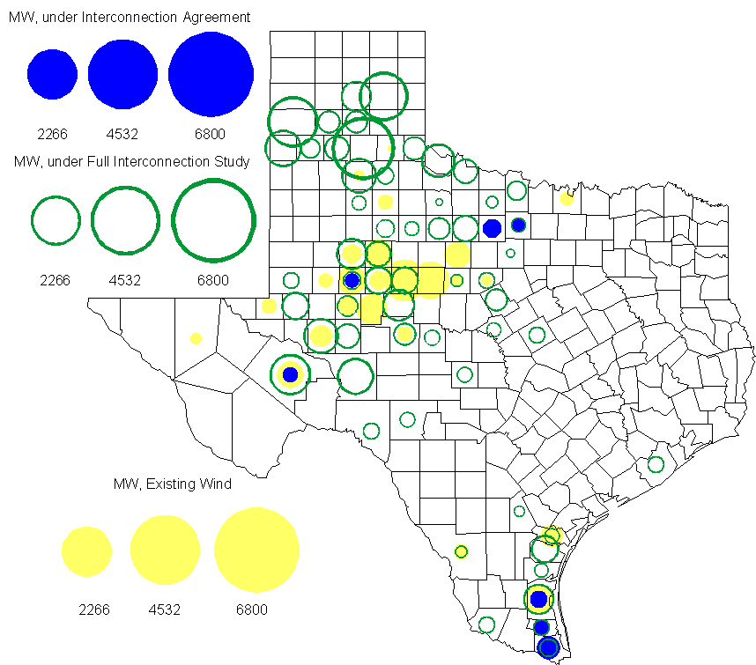

Regional Planning Group Project Reviews

- Brazos Electric Cooperative has submitted a project to move some load that is currently being served by the Entergy Texas system into the ERCOT system. The project would involve disconnecting the subject load from the Entergy Texas system, constructing a new 345/ 138 kV substation in ERCOT, upgrading an existing 69 kV line in the ERCOT system and constructing two new 138 kV lines to serve the load from the ERCOT system. The estimated cost of this project is $51.1 M. This Tier 1 project is currently undergoing ERCOT Independent Review.

- CenterPoint Energy has submitted the 2014 Houston Area Dynamic Reactive Project to address the need for additional dynamic reactive compensation in the Houston area. This project calls for dynamic reactive devices at two locations (on the CenterPoint’s transmission system), with the compensation devices to be in service before summer peak 2014. The approximate cost for this project is $125 Million, depending on the selected dynamic reactive device technology. This Tier 1 project is currently undergoing ERCOT Independent Review.

- American Electric Power Service Corporation has submitted the Laredo to the lower Rio Grande Valley 345 kV Project to improve reliability of the lower Rio Grande Valley transmission system. This project proposes a new 345kV transmission line to be constructed from Laredo to the lower Rio Grande Valley to provide a third 345kV source to the area with an in-service date in the 2016/2017 timeframe. The estimated cost for this project is $379.5 Million. This Tier 1 project is currently in the comment phase.

- Oncor and WETT has submitted a project with proposed changes to the Lamesa Area Upgrade project. The original Lamesa Area Upgrade Project was reviewed and approved by RPG previously. As per the RPG Charter and Procedures changes to already-approved projects will be processed as Tier 3 project. This Tier 3 project is currently in the comment phase.

Congestion Costs
Dollars shown in RUC Make Whole payment graph are settlement quality.

OOMC and RUC net Make Whole payment in million$

Monthly Average MCPE and LMP

Binding Constraints - February 2011
Contingency | Binding Element | Number of 5-min intervals | Shadow Price Range $/MWh | Estimated Congestion Cost $ (Shadow Price*Limit) | Transmission Project | Clearance
Nelson Sharpe - Ajo 345kV | Lon Hill - North Edinburg 345kV | 78 | 0 - 4500 | 31,689,757
BASE CASE | Valley Import | 150 | 0 - 5000 | 30,105,744
Denton - Argyle & West Denton 138kV | West Denton - Jim Cristal 138kV | 329 | 234 - 3500 | 20,313,041 | 5YTP [2009-R11]
BASE CASE | West to North Stability Limit | 1908 | 0 - 1162 | 9,767,701 | CREZ
West Levee Switch 345/138kV AT1 | West Levee Switch 345/138kV AT2 | 98 | 0 - 3500 | 9,073,730 | 5YTP [2009-R21]
Chamber - King & Cedar Bayou - Northbelt 345kV | Center - PH Robinson 345kV | 78 | 0 - 4500 | 6,386,600
Kendall 345/138kV AT2 | Kendall 345/138kV AT1 | 225 | 0 - 4500 | 4,434,846 | Kendall Autotransformer Replacement  [12TPIT0024] | Kendall 345/138kV AT2
Twin Oak Switch - Gibbons Creek & Jack Creek 345kV | Twin Oak Switch - Jewet 345kV | 85 | 1 - 4500 | 4,215,057
Braunig - Toyota & Valley 138kV,  DCKT WB Tuttle - Austin Road 138kV, Fern Street - Ball Park 138kV, Nacogdoches Road - Skyline 138kV | Five Points - Westside CPS 138kV | 1444 | 0 - 3500 | 3,660,830 | Westside substation equipment upgrade [12TPIT0054] | Outage on Cagnon - Marbach 138kV
Kiowa Switch - Kiamichi 345kV | Kiowa Switch - Kiamichi 345kV | 6 | 4500 - 4500 | 2,736,638

Binding Constraints - January to February 2011
Contingency | Binding Element | Number of 5-min intervals | Shadow Price Range $/MWh | Estimated Congestion Cost $ (Shadow Price*Limit) | Transmission Project | Clearance
BASE CASE | Valley Import | 273 | 0 - 5000 | 41,457,339
Nelson Sharpe - Ajo 345kV | Lon Hill - North Edinburg 345kV | 78 | 0 - 4500 | 31,689,757
BASE CASE | West to North Stability Limit | 6595 | 0 - 2833 | 30,330,806 | CREZ
Denton - Argyle & West Denton 138kV,  Fort Worth - W_Dent 138kV | West Denton - Jim Cristal 138kV | 383 | 40 - 3500 | 22,404,765 | 5YTP [2009-R11]
West Levee Switch 345/138kV AT1 | West Levee Switch 345/138kV AT2 | 98 | 0 - 3500 | 9,073,730 | 5YTP [2009-R21]
Chamber - King & Cedar Bayou - Northbelt 345kV | Center - PH Robinson 345kV | 78 | 0 - 4500 | 6,386,600
Braunig - Toyota & Valley 138kV,  DCKT WB Tuttle - Austin Road 138kV, Fern Street - Ball Park 138kV, Nacogdoches Road - Skyline 138kV, Streich - Braunig 138kV,  Calavers -Streich 138kV | Five Points - Westside CPS 138kV | 2037 | 0 - 3500 | 5,108,772 | Westside substation equipment upgrade [12TPIT0054] | Outage on Cagnon - Marbach 138kV, Marbach - Valley 138kV
Kendall 345/138kV AT2 | Kendall 345/138kV AT1 | 225 | 0 - 4500 | 4,434,846 | Kendall Autotransformer Replacement  [12TPIT0024] | Kendall 345/138kV AT2
Twin Oak Switch - Gibbons Creek & Jack Creek 345kV | Twin Oak Switch - Jewet 345kV | 85 | 1 - 4500 | 4,215,057
Lon Hill - North Edinburg 345KV | Rio Hondo 345kV Series Capacitor 1 | 15 | 460 - 4500 | 3,251,815

Wind Generation as a Percent of Load
One-hour average of total wind power output as a percentage of ERCOT load.
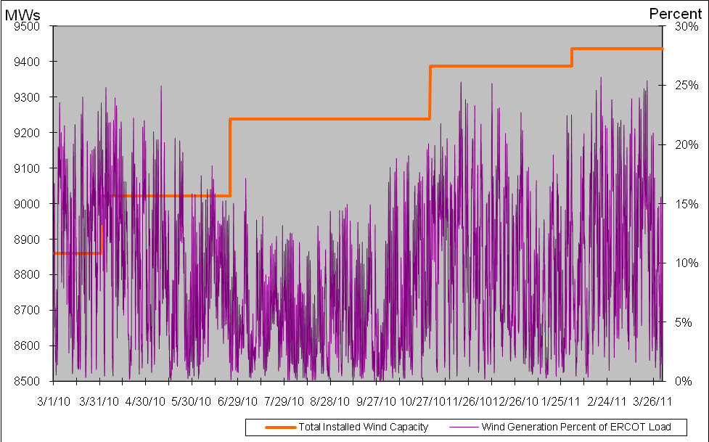

Planning Model Activities
- ERCOT and SSWG agreed on a timeline and strategy to complete Data Set A. Per the SSWG Supplemental Procedures, ERCOT will provide the NMMS model for Generation and Private Utility Networks that it has received in RARFs and output using the Topology Processor. ERCOT will be assigned and will use a new six digit bus number range above 100,000 and will use up to 12 characters for the bus name for generation buses. The bus name will be a concatenation of the NMMS Unit Name preceded by an underscore and as much of the NMMS Station Name that will fit within the 12 character limitation.
- ERCOT has submitted the first two parts of SCR760 as enhancements to Siemens following ERCOT Board approval in March 2011. The two parts submitted were items 7 and 8. In the following table, the color red will be used to show status of Not Submitted, meaning that the SCR sub part has not been submitted to Siemens as a Service Request. Yellow will indicate that the SCR sub part has been submitted. The color will remain yellow and the status will change in order to Submitted, Planning (Siemens writing code and asking for information), Release (Siemens produces first code to test), and Testing (code has completed internal test and is moving through release management). The color will change to green and the status will change to Production when the code has been tested and installed on the machines that ERCOT uses to produce Topology Processor output for Planning and CRR.
SCR Sub Part | SCR Description | Status
SCR760-1 | Upgrade to PSS/E v32 | Not Submitted
SCR760-2 | Distribution Capacitor banks | Not Submitted
SCR760-3 | Zero Impedance Line Ratings | Not Submitted
SCR760-4 | Associate Loads and Capacitor banks with the correct CNG | Not Submitted
SCR760-5 | Additional Transformer Data for Planning | Not Submitted
SCR760-6 | FACTS Devices | Not Submitted
SCR760-7 | Assign valid PSSE IDs to Breakers/  Switches/ Series Devices | Submitted
SCR760-8 | Phase shift of Autos for short circuit studies | Submitted
SCR760-9 | Multisection Line Grouping | Not Submitted

Other Notable Activities
- The 2010 Five-Year Transmission Plan (5YTP) studies final report was posted to the ERCOT Planning and Operations Information website on March 23, 2011.

- Transient Stability Study for 2011 winter off-peak conditions: As part of the annual reliability assessment of the network, a transient stability study is being performed on an ERCOT 2011 winter off-peak case.

