ERCOT Operations Report
March 2011 ROS & OWG

Frequency Control

Time | Freq(Hz) | Duration (s)
3/3/2011 11:17 | 59.842 | 88 | Unit trip with 440 MW
3/3/2011 19:03 | 60.133 | 150 | Out of DRS.
3/8/2011 23:06 | 59.898 | 16 | Gen Deviation -500 in 2 mins
3/9/2011 5:57 | 60.107 | 108 | Gen Deviation +1100 in 3 mins
3/14/2011 5:58 | 60.174 | 400 | Gen Deviation +1300 in 4 mins
3/14/2011 6:09 | 59.801 | 164 | Multiple Unit trips with 910 MW
3/14/2011 7:08 | 59.855 | 64 | Multiple Unit trips with 651 MW
3/14/2011 22:02 | 59.851 | 252 | Gen Deviation -1500 in 5 mins; out of URS
3/15/2011 5:59 | 60.148 | 291 | Gen Deviation +1400 in 5 mins
3/16/2011 5:56 | 60.110 | 88 | Gen Deviation +700 in 2 mins
3/16/2011 20:45 | 59.867 | 12 | Unit trip with 420 MW
3/16/2011 23:06 | 59.883 | 156 | Gen Deviation -800 in 3 mins
3/17/2011 5:56 | 60.109 | 36 | Gen Deviation +800 in 3 mins
3/17/2011 22:03 | 59.877 | 88 | Gen Deviation -700 in 1 min
3/19/2011 22:05 | 59.891 | 18 | Gen Deviation -400 in 4 mins
3/22/2011 15:46 | 59.886 | 16 | Unit ran back by 400 MW; out of URS
3/23/2011 14:46 | 59.719 | 12 | Unit trip with 1014 MW
3/23/2011 14:48 | 59.861 | 104 | Unit trip with 390 MW
3/24/2011 13:59 | 59.796 | 104 | Unit trip with 570 MW
3/25/2011 4:05 | 59.896 | 36 | Gen Deviation -500 in 2 mins
3/25/2011 16:13 | 59.814 | 100 | Multiple Unit trips with 586 MW
3/25/2011 22:00 | 59.879 | 204 | Gen Deviation -1200 in 5 mins
3/26/2011 19:50 | 59.875 | 16 | Unit trip with 500 MW
3/27/2011 0:01 | 59.896 | 16 | Gen Deviation -500 in 2 mins
3/27/2011 22:01 | 59.893 | 96 | Gen Deviation -600 in 2 mins
3/28/2011 22:05 | 59.868 | 156 | Gen Deviation -500 in 1 min; out of URS
3/29/2011 6:43 | 59.753 | 72 | Unit trip with 750 MW
3/30/2011 5:57 | 60.129 | 152 | Gen Deviation +700 in 2 mins; out of DRS
3/31/2011 12:21 | 59.861 | 56 | Unit trip with 420 MW
Note: Time of frequency excursions outside the range of +/- 0.1 Hz.

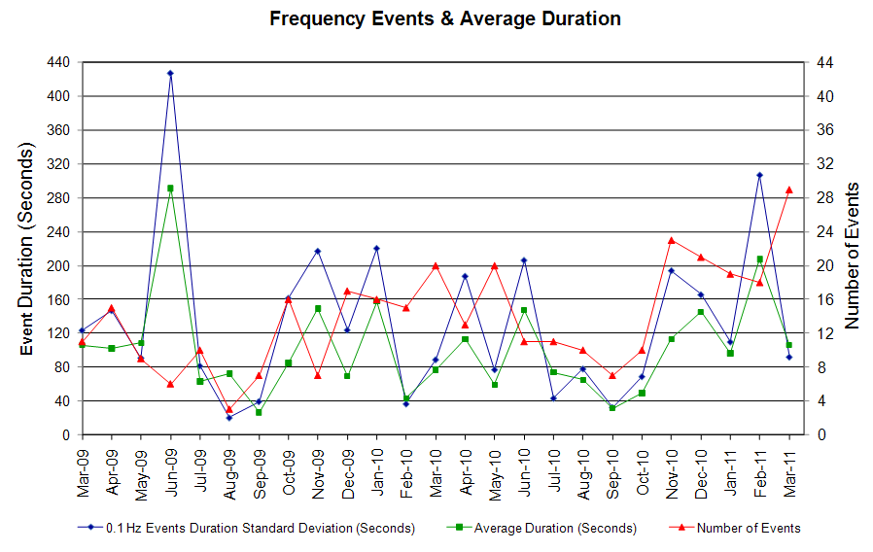

Deployed Responsive (Reported Above)

Time deployed | Stop Time | Duration | Max | Details
3/14/11 22:05:10 | 3/14/11 22:10:38 | 0:05:28 | 319
3/17/11 22:04:57 | 3/17/11 22:11:53 | 0:06:56 | 400
3/23/11 14:46:57 | 3/23/11 14:51:36 | 0:04:39 | 405
3/25/11 16:13:39 | 3/25/11 16:16:58 | 0:03:19 | 330

RUC Capacity Purchases

Weather Zone | Unit Days
COAST | 8
EAST | 1
FAR WEST | 15
NORTH CENTRAL | 7
SOUTH | 10
SOUTH CENTRAL | 20
Grand Total | 61
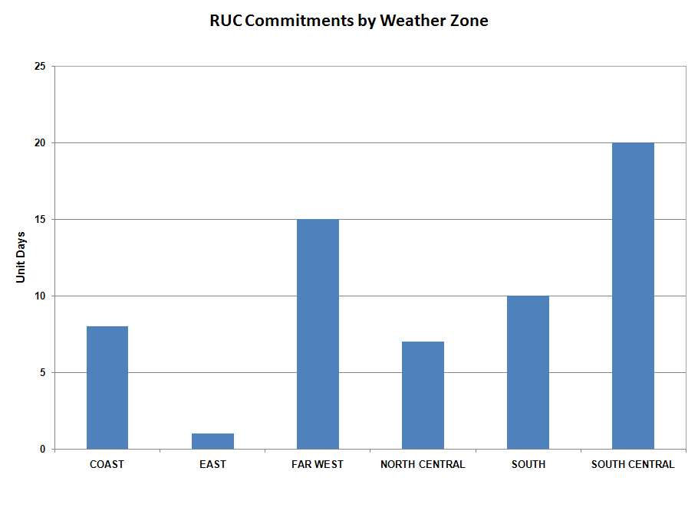
SCED Congestion Management Activity

Congestion affected by outages Remedial action plan has been developed for the element
Contingency | Overloaded Element | Days
Bluff Creek Auto T2_H ,T2_L & T2_T | Nicole - Oak Creek CSW 138Kv | 25
Fort Stockton - Barilla 138kV | Barilla - Fort Stockton Switch 69 kV | 12
Willow Valley Switch - Exxon Sharon Ridge 138 kV | Ackerly Vealmoor Switch - Ackerly 69 kV | 9
Odessa North - Odessa Basin Switch 69kV | Holt Switch - Ector Shell Tap 69kV | 8
Pawnee - Lon Hill 345 kV | Sinton - Skidmore 138 kV | 7
Base case | No Trees Switch - No Trees Wind farm 138 kV | 4
Gail - Key Sub 138 kV | Ackerly Vealmoor Switch - Ackerly 69 kV | 4
Holt Switch-Amoco North Cowden T-N Cowden Amoco-Moss Switch | Odessa North 138/69kV AXFMR1 | 3
DCKT Singleton - Tomball & Roans Prairie 345kV | Singleton - O'brien 345kV | 2
Aspermont - Spur 138 kV | Spur 138/69 kV AXFMR | 2
Odessa EHV Switch - Morgan Creek SES & Quail Switch 345kV | Ackerly Vealmoor Switch - Ackerly 69kV | 2
Gail - Key Sub 138 kV | Ackerly - Ackerly Lyntegar 69 kV | 2
Graham SES - Long Creek & Cook Field 345kV | Leon Switch - Putnam 138 kV | 2
Lon Hill 345/138 kV AXFMR | Nelson Sharpe - Celanese Bishop 138kV | 2
DCKT Singleton - Tomball & Roans Prairie 345kV | Singleton - Zenith 345kV | 1
Lon Hill - Nelson Sharpe 345 kV | Nelson Sharpe PS | 1
Graham SES - Long Creek & Cook Field 345kV | Bomarton - Seymour 69kV | 1
Morgan Creek SES - Sun Switch 138Kv/6474 | Colorado City - China Grove Switch 69Kv/6685 | 1
Coleto Creek Generator 1 | Blessing - Lolita 138 kV | 1
Royse Switch - Forney Switch 345 kV | Forney Switch 345/138 kV AXFMR 3 | 1
DCKT Calavers - Braunig & Cagnon 345 kV | Calaveras to Skyline 345 kV | 1
STP Units 1 &2 | Blessing - Lolita 138 kV | 1
Lon Hill 345/138 kV AXFMR | Celanese Bishop - Kleberg CSW 138 KV | 1
Ajo - Rio Hondo 345 kV | Celanese Bishop - Kleberg CSW 138 KV | 1
Oklaunion - Abilene Mulberry Creek 345 kV | Lake Pauline 138/69 kV AXFMR | 1

Generic Transmission Limits (GTL’s)

GTL | Days
West – North | 26
Valley Import | 3

New RAP, PCAP (Date indicates last update of RAP, PCAP not implementation date.)
None

SPS (RAS) (New, Modified, Removed)
03/28 Allen Switch – Ben Davis 138 kV SPS modified.

New Procedures/Forms/Operations Bulletins

Date | Subject | Bulletin No.
03/25/2011 | Transmission and Security Desk V1 Rev5 | 527
03/25/2011 | Reliability Unit Commitment Desk V1 Rev4 | 526
03/25/2011 | Resource Desk V1 Rev4 | 525
03/25/2011 | Real Time Desk V1 Rev5 | 524
03/25/2011 | Shift Supervisor Desk V1 Rev523 | 523
03/25/2011 | DC Tie Desk V1 Rev3 | 522

Load Shed Incidences
None

EEA
03/23 14:50 ERCOT issued an EEA Level 1. ERCOT cancelled EEA Level 1 at 15:23.

System Voltage Problems
None

Application Issues
03/05 10:13 ERCOT issued an Emergency Notice due to EMS and SCED failure.

Communication Issues
None

ERCOT peak (Unofficial)
03/23 18:00 40,162 MW

Yearly MTLF Error Comparison

Yearly Mid-Term (Hourly) Load Forecast Error Comparison for the ERCOT Forecast
Month | MAPE for MTLF at 16:00 Day-Ahead
Month | 2008 | 2009 | 2010 | 2011
January | 3.30 | 4.11 | 3.78 | 2.91
February | 3.59 | 3.49 | 3.79 | 3.46
March | 3.29 | 3.24 | 2.24 | 2.02
April | 2.45 | 2.66 | 2.47 | NA
May | 3.01 | 2.90 | 2.63 | NA
June | 2.81 | 2.89 | 2.84 | NA
July | 2.55 | 2.83 | 2.39 | NA
August | 3.66 | 3.07 | 2.29 | NA
September | 4.99 | 3.68 | 3.14 | NA
October | 2.79 | 2.92 | 2.37 | NA
November | 2.60 | 1.93 | 3.46 | NA
December | 4.54 | 3.70 | 2.60 | NA
Annual Average | 3.29 | 3.11 | 2.83 | 2.79

OCN, Advisory, Watch & Emergency Notices
Capacity

Date | Start | Event
3/2/2011 | 3:43 | ERCOT issued an OCN for a Projected Reserve Capacity Shortage for HE 1100-2100.
3/3/2011 | 11:41 | ERCOT issued an Advisory due to Physical Responsive Capability (PRC) below 3000 MW.
3/4/2011 | 6:45 | ERCOT issued an OCN for a Projected Reserve Capacity Shortage for HE 1300-1700.
3/4/2011 | 10:15 | ERCOT issued an Advisory due to PRC below 3000 MW.
3/6/2011 | 6:22 | ERCOT issued an OCN for a Projected Reserve Capacity Shortage for HE 0900-1500.
3/8/2011 | 6:30 | ERCOT issued an OCN for a Projected Reserve Capacity Shortage for HE 1100-2100.
3/9/2011 | 1:31 | ERCOT issued an OCN for a Projected Reserve Capacity Shortage for HE 1900-2400.
3/9/2011 | 10:12 | ERCOT issued an Advisory due to PRC below 3000 MW.
3/10/2011 | 6:05 | ERCOT issued an OCN for a Projected Reserve Capacity Shortage for HE 0800-2000.
3/10/2011 | 7:00 | ERCOT issued an Advisory due to PRC below 3000 MW.
3/12/2011 | 3:24 | ERCOT issued an OCN for a Projected Reserve Capacity Shortage for HE 1400 -2000.
3/12/2011 | 12:48 | ERCOT issued an Advisory due to PRC below 3000 MW.
3/13/2011 | 3:08 | ERCOT issued an OCN for a Projected Reserve Capacity Shortage for HE 2000-2100.
3/13/2011 | 13:48 | ERCOT issued an Advisory due to PRC below 3000 MW.
3/14/2011 | 12:42 | ERCOT issued an OCN for a Projected Reserve Capacity Shortage for HE 2000-2400.
3/15/2011 | 11:48 | ERCOT issued an OCN for a Projected Reserve Capacity Shortage for HE 2100-2200.
3/17/2011 | 12:17 | ERCOT issued an OCN for a Projected Reserve Capacity Shortage for HE 1600-2400.
3/18/2011 | 3:00 | ERCOT issued an OCN for a Projected Reserve Capacity Shortage for HE 1600-2400.
3/18/2011 | 14:15 | ERCOT issued an Advisory due to PRC below 3000 MW.
3/19/2011 | 22:22 | ERCOT issued an Advisory due to PRC below 3000 MW.
3/20/2011 | 20:00 | ERCOT issued an Advisory due to PRC below 3000 MW.
3/22/2011 | 7:15 | ERCOT issued an Advisory due to PRC below 3000 MW.
3/23/2011 | 12:26 | ERCOT issued an OCN for a Projected Reserve Capacity Shortage for HE 1700-1900.
3/23/2011 | 15:45 | ERCOT issued an Advisory due to PRC below 3000 MW.
3/24/2011 | 7:05 | ERCOT issued an Advisory due to PRC below 3000 MW.
3/24/2011 | 9:20 | ERCOT issued an OCN for a Projected Reserve Capacity Shortage for HE 1700-2200.
3/25/2011 | 7:01 | ERCOT issued an Advisory due to PRC below 3000 MW.
3/25/2011 | 14:02 | ERCOT is issuing an OCN for a Projected Reserve Capacity Shortage for HE 1600-1800.
3/25/2011 | 7:01 | ERCOT issued an Advisory due to PRC below 3000 MW.
3/25/2011 | 14:00 | ERCOT issued an OCN for a Projected Reserve Capacity Shortage for HE 1600-1800.
3/26/2011 | 3:00 | ERCOT issued an OCN for a Projected Reserve Capacity Shortage for HE 1700-1900.
3/26/2011 | 11:42 | ERCOT issued an Advisory due to PRC below 3000 MW.
3/27/2011 | 22:17 | ERCOT issued an Advisory due to PRC below 3000 MW.
3/28/2011 | 7:02 | ERCOT issued an Advisory due to PRC below 3000 MW.
3/29/2011 | 22:10 | ERCOT issued an Advisory due to PRC below 3000 MW.
3/31/2011 | 16:10 | ERCOT issued an Advisory due to PRC below 3000 MW.

Transmission Watch
03/04 16:27 ERCOT issued transmission watch for the post contingency loss of Lobo to San Miguel 345 kV line overloads Freer to San Diego 69KV line. Cancelled the watch at 18:12.

Texas RE Event Analysis
03/14 06:09 ERCOT experienced a simultaneous loss of one 345 KV Bus and two generating units (resulting in the loss of approximately 922 MW within the first minute of the event) due to a thunderstorm.

03/14 07:08 ERCOT experienced a simultaneous loss of two 345 KV lines and five generating units (resulting in the loss of approximately 651 MW within the first minute of the event). A root-cause evaluation is currently on-going to determine the cause of the trip.

03/23 14:46 ERCOT experienced a simultaneous loss of one 345 KV Bus, causing the loss of four 345 KV lines, one 345/138 KV Autotransformer and two combined cycle Resources (resulting in the loss of approximately 1,014 MW within the first minute of the event). At 14:50 ERCOT implemented Level 1 of its Energy Emergency Alert (EEA) as PRC dropped below 2,300 MW. ERCOT requested 1,873 MW of Non-Spin at 14:58. By 15:14 PRC was above 3,000 MW and EEA Level 1 was cancelled at 15:23. This event caused a frequency deviation of 0.3 Hz (59.700 Hz) at 14:46:50 per ERCOT ISO High-Speed Frequency Recorder Data. Frequency recovered within 5 minutes and 40 seconds to 60 Hz at 14:52:30.

03/25 16:13 ERCOT experienced a simultaneous loss of four generating units and one unit run-back (resulting in the loss of approximately 586 MW within the first minute of the event). Investigation is currently on-going.

03/30 04:02 ERCOT experienced a simultaneous loss of three 138 KV lines and one DC-Tie. Investigation is currently on-going.

